IEEE P802.15
Wireless Personal Area Networks

Project | IEEE P802.15 Working Group for Wireless Personal Area Networks (WPANs)
Title | TG3e Comment Resolution for i-23 of Sponsor Ballot
Date Submitted | 13, Sep. 2016
Source | [ Kondou, Keitarou; Akiyama, Keiji]  [Sony Semiconductor Solutions Corp.]  [1-7-1 Konan, Minato-ku, Tokyo Japan] | Voice: [ +81-3-6748-4001]  Fax: [ +81-3-6748-4268]  E-mail: [Keitarou.Kondo@sony.com , Keiji.Akiyama@sony.com ]
Re: | In response to i-23 from consolidated sponsor ballot comments (15-16-0585-00-003e)
Abstract | Add rule for HRCP Beacon Generation as specified in section 7.6 of the baseline spec.
Purpose | [Description of what the author wants P802.15 to do with the information in the document.]
Notice | This document has been prepared to assist the IEEE P802.15. It is offered as a basis for discussion and is not binding on the contributing individual(s) or organization(s). The material in this document is subject to change in form and content after further study. The contributor(s) reserve(s) the right to add, amend or withdraw material contained herein.
Release | The contributor acknowledges and accepts that this contribution becomes the property of IEEE and may be made publicly available by P802.15.
Comment

Comment # | Page | Subclause | Line | Comment | Must Be Satisfied | Proposed Change
i-23 |  | 7.6.2 |  | Add rule for HRCP Beacon Generation as specified in section 7.6.2 of the baseline spec. | Yes | As commented.

Resolution:
Modify the text from 7.6.
Add the text from following page.
Change the title of Section 7.6 as follows

7.6 Synchronization for piconet

Insert Section 7.6a at the end of the Section 7.6

7.6a Synchronization for pairnet

All HRCP DEVs within a pairnet shall be synchronized to the HRCP PNC’s clock during PPSP. The beacon sent at the beginning of every superframe contains the information necessary to time-synchronize the DEVs in the pairnet. See 6.3.1 for the definition of the timing parameters sent in the beacon.

Each DEV in the pairnet, including the HRCP PNC, shall reset its superframe clock to zero at the beginning of the beacon preamble, as shown in Figure 7-41a. All times in the superframe shall be measured relative to the beginning of the beacon preamble. If a DEV does not hear a beacon, it should reset its superframe clock to zero at the instant where it expected to hear the beginning of the beacon preamble.

After association, PPPP is used instead of CAP, and the end time is the same as the end of the superframe. Therefore, no synchronization is necessary.

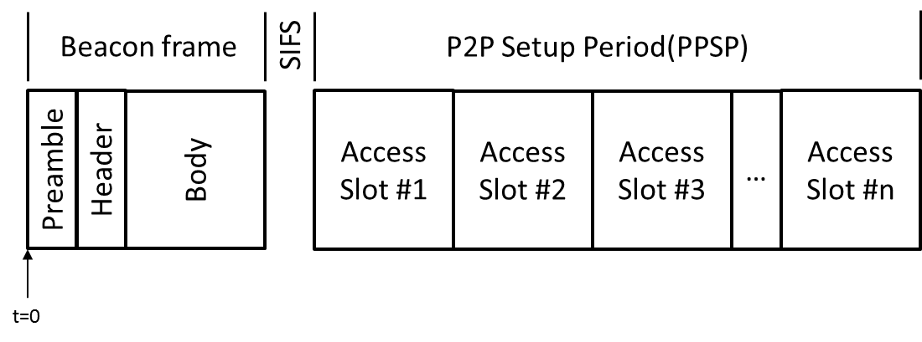
Figure 7-41a Pairnet timing relative to the beacon

7.6a.1 Time accuracy

A compliant implementation shall maintain the accuracy of the timer to be at least as accurate as pClockAccuracy.

7.6a.2 Beacon generation

The HRCP PNC shall send a beacon at the beginning of each superframe using the Beacon frame described in 6.3.1 before the reception of Association Request command. An extended beacon shall not support.

The HRCP PNC shall transmit the beacon such that the time between beacons is the superframe duration with an error of no more than pClockAccuracy times the superframe duration. The change of the superframe position or duration shall not support.

7.6a.3 Beacon Information announcement

The HRCP PNC sends several IEs in its beacons to inform the DEVs in the pairnet about constant or temporary conditions. Some of these IEs are listed in Table 7-2a.

Table 7-2a—IEs included in beacons as needed

IE | Format | Usage
MIMO Information IE | 6.4.37 | 11a.2.8.1
Higher Layer Information IE | 6.4.38 | 7.3a.3

