IEEE P802.15
Wireless Personal Area Networks

Project | IEEE P802.15 Working Group for Wireless Personal Area Networks (WPANs)
Title | TG3e Comment Resolution for i-17 of Sponsor Ballot
Date Submitted | 26, Sep. 2016
Source | [ Kondou, Keitarou; Akiyama, Keiji]  [Sony Semiconductor Solutions Corp.]  [1-7-1 Konan, Minato-ku, Tokyo Japan] | Voice: [ +81-3-6748-4001]  Fax: [ +81-3-6748-4268]  E-mail: [Keitarou.Kondo@sony.com , Keiji.Akiyama@sony.com ]
Re: | In response to i-17 from consolidated sponsor ballot comments (15-16-0585-00-003e)
Abstract | Frequency Band expansion prepared for future use
Purpose
Notice | This document has been prepared to assist the IEEE P802.15. It is offered as a basis for discussion and is not binding on the contributing individual(s) or organization(s). The material in this document is subject to change in form and content after further study. The contributor(s) reserve(s) the right to add, amend or withdraw material contained herein.
Release | The contributor acknowledges and accepts that this contribution becomes the property of IEEE and may be made publicly available by P802.15.
List of contributors

Name | Affiliation
Keitarou Kondou | Sony Semiconductor Solutions Corp.
Keiji Akiyama | Sony Semiconductor Solutions Corp.
Ken Hiraga | NTT Corporation

Comment

Comment # | Page | Subclause | Line | Comment | Must Be Satisfied | Proposed Change
i-17 |  | 11a.1.4 |  | With the possibility of future channel expansion, what needs to be done now? | Yes | Revisit channel assignment table to ensure it can be extended when more channels become available.
i-14 | 40 | 6.4.11b | 57 | The DEV Capability is formatted as Figure 6-88b, but Figure 6-88b contains structure that is 6 octets long, but this only specifies that DEV Capability is 5 octets long. | Yes | Change length from 5 to 6.
i-15 | 41 | 6.4.11c | 42 | The Operation Parameter is specified to be formatted as Figure 6-88k, but the lengths do not match. Figure 6-88k is 6-octets, and 6-88j says it is 5-octets. | Yes | Change length from 5 to 6.
i-226 | 40 | 6.4.11b | 57 | Octets:5 --> Octets: 6 | No | Octets:5 --> Octets: 6

Resolution:
i-17: Accept the comment. To support , modify frequency table in 11a.1.4 and update and modify the IE for Capability and simplify it.

i-14, 15 and 226: Revise the comments. Clarify the number of octets to be assigned for these fields after applying the resolutions provided for the sponsor ballot. The required modification for capability fields are also provided in this document.
Update Strategy:

[802.15.3e Frequency Expansion]

- Add CHNL_ID 5-16 referring the style of proposal for 802.11ay.
- Channel assignments are as follows;

Channel BW
Frequency
(
GHz
)
2
.
16
GHz
4
.
32
GHz
6
.
48
GHz
8
.
64
GHz
#
1
#
2
#
3
#
4
#
5
#
6
#
7
#
9
#
11
#
8
#
10
#
12
#
13
#
14
#
15
#
16
Channel BW
For Single channel
For Bonding or
Frequency Aggregation
By using “SC Channel Aggregation field”,
it can be used as single channel aggregation
Aggregation Case 1: Pattern 0-1: Aggregation with single channel

Channel BW
Frequency
(
GHz
)
2
.
16
GHz
Channel BW
#
2
#
4
#
2
#
4
#
6
pattern0
pattern1
Aggregation Rule 1:
All Aggregation pattern shall include CHNL_ID 2.
Aggregation Rule 2:
For Single channel aggregation, 1 empty channel shall include
between channels.
(consecutive single channel aggregation are realized by Bonding
channel and “SC Channel Aggregation field”)
Aggregation Case 2: 2Ch or 3ch Bonding + Aggregation

Channel BW
Frequency
(
GHz
)
4
.
32
GHz
#
7
#
9
#
8
#
10
Channel BW
#
7
#
10
#
11
#
8
#
12
#
14
pattern2
pattern3
pattern4
pattern5
pattern6
Modification of the draft:

Insert or modify the 802.15.3e draft D04 as follows:

11a.1.4 RF channelization

Replace Table 11a-1 as follows;

Table 11a-1—HRCP PHY channelization
CHNL_ID | Start frequency | Center frequency | Stop frequency
1 | 57.240 GHz | 58.320 GHz | 59.400 GHz
2 | 59.400 GHz | 60.480 GHz | 61.560 GHz
3 | 61.560 GHz | 62.640 GHz | 63.720 GHz
4 | 63.720 GHz | 64.800 GHz | 65.880 GHz
5 | 65.880 GHz | 66.960 GHz | 68.040 GHz
6 | 68.040 GHz | 69.120 GHz | 70.200 GHz
7 | 57.240 GHz | 59.400 GHz | 61.560 GHz
8 | 59.400 GHz | 61.560 GHz | 63.720 GHz
9 | 61.560 GHz | 63.720 GHz | 65.880 GHz
10 | 63.720 GHz | 65.880 GHz | 68.040 GHz
11 | 65.880 GHz | 68.040 GHz | 70.200 GHz
12 | 57.240 GHz | 60.480 GHz | 63.720 GHz
13 | 59.400 GHz | 62.640 GHz | 65.880 GHz
14 | 63.720 GHz | 66.960 GHz | 70.200 GHz
15 | 57.240 GHz | 61.560 GHz | 65.880 GHz
16 | 59.400 GHz | 63.720 GHz | 68.040 GHz
Note: CHNL_ID 9,10,11,14 are only used for channel aggregation.

6.4.11a HRCP PNC Capability IE

Replace Figure 6-88a as follows;
Octets: 67
HRCP PNC Capability
Figure 6-88a— HRCP PNC Capability IE Content field format

Replace Figure 6-88b as follows;

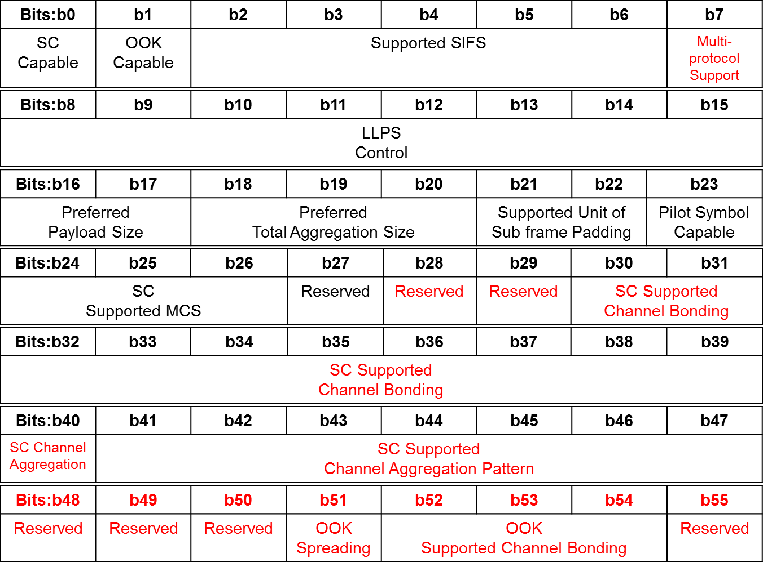
Figure 6-88b— HRCP PNC Capability field format

Insert the following text after the last paragraph on the page 36

The Multi-protocol Support field shall be set to one if the SC-PHY DEV supports the Multi-protocol HRCP Data Frame, as defined in 6.3.5a.1 and 6.3.5a.2, and shall be set to zero otherwise.

Replace the text in the fifth paragraph on the page 39 as follows;

The SC Supported Channel Bonding field indicates the number of bonded channels supported by the SC-PHY DEV . The SC Supported Channel bonding field shall be formatted as illustrated in Figure 6-88f.

Replace Figure 6-88f as follows;
Bits: b0 | b1 | b2 | b3 | b4 | b5 | b6 | b7 | b8 | b9
CHNL_ID 7 is supported | CHNL_ID 8 is supported | CHNL_ID 9 is supported | CHNL_ID 10 is supported | CHNL_ID 11 is supported | CHNL_ID 12 is supported | CHNL_ID 13 is supported | CHNL_ID 14 is supported | CHNL_ID 15 is supported | CHNL_ID 16 is supported
Figure 6-88f—SC Supported Channel Bonding field format

Replace the first paragraph after Figure 6-88f as follows;

The SC Channel Aggregation field only applies when the CHNL_ID is between 7 and 16 inclusive. In that case, the field shall be set to one if channel aggregation is supported or zero if channel bonding is supported.

Replace Figure 6-88g as follows;
Bits: b0 | b1 | b2 | b3 | b4 | b5 | b6
pattern0 | pattern1 | pattern2 | pattern3 | pattern4 | pattern5 | pattern6
Figure 6-88g—SC Supported Channel Aggregation pattern field format

Replace Table 6-17f

Table 6-17f—Channel Aggregation Patterns for SC PHY in Figure 6-88g
CHNL_ID | 2 | 4 | 6 | 7 | 8 | 10 | 11 | 12 | 14
pattern0 | ✓ | ✓
pattern1 | ✓ | ✓ | ✓
pattern2 |  |  |  | ✓ | ✓
pattern3 |  |  |  |  | ✓ | ✓
pattern4 |  |  |  | ✓ |  | ✓
pattern5 |  |  |  |  | ✓ |  | ✓
pattern6 |  |  |  |  |  |  |  | ✓ | ✓

6.4.11b HRCP DEV Capability IE

Replace Figure 6-88i as follows;
Octets: 67
HRCP DEV Capability
Figure 6-88i—HRCP DEV Capability IE Content field format

Insert the following text after the third paragraph on the page 41

The Multi-protocol Support field is defined in 6.4.11a.

6.4.11c HRCP Operation Parameters IE

Replace Figure 6-88j as follows;
Octets: 67
Operation Parameter
Figure 6-88j—HRCP Operation Parameters IE Content field format

Replace Figure 6-88k as follows;

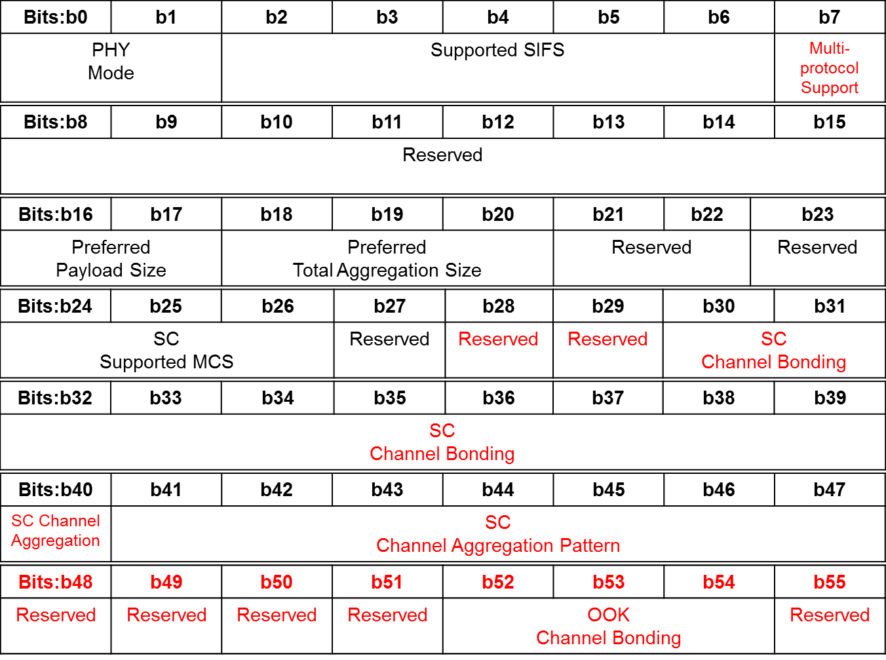
Figure 6-88k—Operation Parameters field format

Insert the following text after the second paragraph on the page 42

The Multi-protocol Support field is defined in 6.4.11a. The Multi-protocol Support field shall be set to one if the both of the Multi-protocol Support field in HRCP PNC capability IE and HRCP DEV capability IE are set to one and shall be set to zero otherwise.

Insert the following text after the first paragraph on the page 43

The SC Channel Aggregation field only applies when the CHNL_ID is between 7 and 16 inclusive. In that case, the field shall be set to one if channel aggregation is used or zero if channel bonding is used.

Replace Figure 6-88l as follows;
Bits: b0 | b1 | b2 | b3 | b4 | b5 | b6 | b7 | b8 | b9
CHNL_ID 7 is used | CHNL_ID 8 is used | CHNL_ID 9 is used | CHNL_ID 10 is used | CHNL_ID 11 is used | CHNL_ID 12 is used | CHNL_ID 13 is used | CHNL_ID 14 is used | CHNL_ID 15 is used | CHNL_ID 16 is used
Figure 6-88l—SC Channel Bonding field format

