IEEE P802.15
Wireless Personal Area Networks

Project | IEEE P802.15 Working Group for Wireless Personal Area Networks (WPANs)
Title | Revised draft of Cyclic-superframe structure
Date Submitted | July 20, 2016
Source | Seong-Soon Joo (ETRI) | E-Mail:[ssjoo@etri.re.kr]
Re:
Abstract | This document is a revised draft of 5.1.1.2 Cyclic-superframe structure.
Purpose | This document provides the input for the TG8 WG recirculation letter ballot draft.
Notice | This document does not represent the agreed views of the IEEE 802.15 Working Group or IEEE 802.15.8 Task Group. It represents only the views of the participants listed in the “Source(s)” field above. It is offered as a basis for discussion and is not binding on the contributing individual(s) or organization(s). The material in this document is subject to change in form and content after further study. The contributor(s) reserve(s) the right to add, amend or withdraw material contained herein.
Release | The contributor acknowledges and accepts that this contribution becomes the property of IEEE and may be made publicly available by P802.15.
Patent Policy | The contributor is familiar with the IEEE-SA Patent Policy and Procedures:  <http://standards.ieee.org/guides/bylaws/sect6-7.html#6> and  <http://standards.ieee.org/guides/opman/sect6.html#6.3>.  Further information is located at <http://standards.ieee.org/board/pat/pat-material.html> and  <http://standards.ieee.org/board/pat>.

- Overview
- Normative references
- Definitions
  - Definitions
cyclic-superframe: A periodic time interval comprised of superframes with two defined patterns of active and inactive periods that are repeated in a defined sequence.

  - Acronyms and abbreviations
CSS cyclic-superframe size
DP discovery period
NSA number of superframes pattern A
NSB number of superframes pattern B
PP peering period
SP synchronization period

- General description
  - General
  - Components of IEEE 802.15.8 PAC
  - Network Topologies
  - Architecture
  - Functional Overview
    - Superframe structure
      - Cyclic-superframe
Cyclic-superframes reduce power consumption and avoid interference in PAC networks, as defined in 5.1.1.2.
A cyclic-superframe enables a PAC network to set which periods in a superframe are active or inactive. During an inactive period, PDs are set to sleep.
A PD’s higher layer may select a particular configuration of a cyclic-superframe structure to be used by the MAC and PHY. For instance, in order to reduce interference among neighboring PAC networks, cyclic-superframes are selected with different patterns of active and inactive periods.

- MAC protocol
  - MAC functional description
    - Channel access
      - Superframe
      - Cyclic-superframe
A cyclic-superframe is a periodic time interval comprised of superframes. A cyclic-superframe contains multiple superframes with active and inactive periods. During an inactive period, a PD may go to sleep mode in order to save power and reduce interference.
Each period of each superframe, except the synchronization period, is configured whether to be active or inactive. A cyclic-superframe shall be formed from sixteen possible combinations of active and inactive periods as illustrated in Figure 1 ae. The four-bit indicator is set to indicate thesactive period fof DP, PP, CAP, and CFP in a superframe, as described in.1Figure 4—Accessible period indicator.
A PAC group initiator selects pattern for superframes pattern A and superframe pattern B out of sixteen combinations.
In order to form a cyclic-superframe with combinations of active and inactive periods in multiple superframes, two types of superframes are defined: superframe pattern A and superframe pattern B. Both types of superframes can take the same combinations of active and inactive periods. The first superframe to appear in a cyclic-superframe shall be the superframe pattern A. After placing all the superframes pattern A from the start of a cyclic-superframe, superframes pattern B shall be placed contiguously, as shown in Figure 1 b).
The cyclic-superframe structure shall be described by the cyclic-superframe size (CSS), the number of superframes pattern A (NSA), the number of superframes pattern B (NSB), the active period in superframe pattern A, and the active period in superframe pattern B. The maximum cyclic-superframe size is 255 superframes.

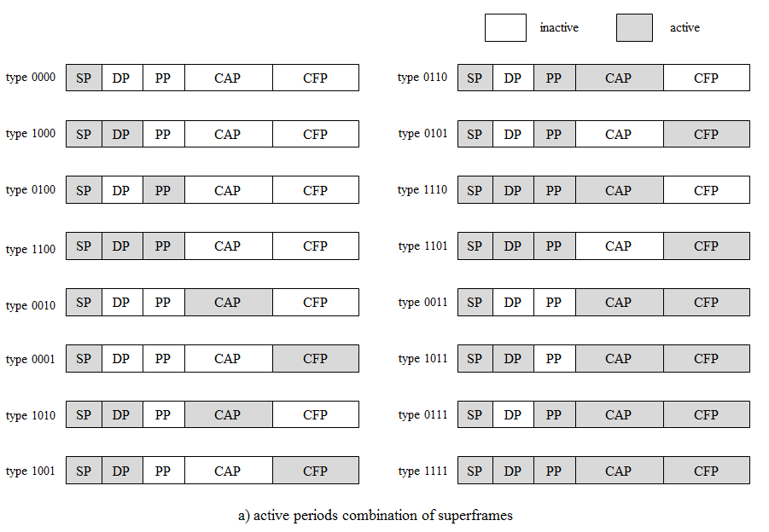

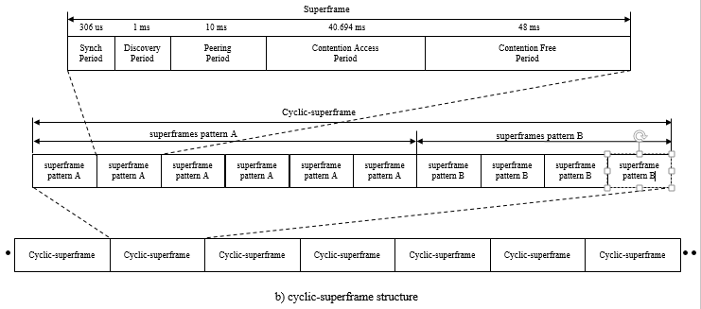
Figure 1—Cyclic-superframe structure for PAC

The cyclic-superframe structure of a PAC group is selected according to the service type of a PAC group and the phase of peer aware communication: synchronization, discovery, peering, and data transmission phase. The actual configuration of a cyclic-superframe structure is provided from higher layers and out of the scope of the standard.

Once the configuration of the cyclic-superframe structure is passed to the MAC from higher layers, tThe configuration of the cyclic-superframestructure is maintained by the initiator of discovery phase or peeringphase, or data transmission phase. A PD shall be instructed to set the cyclic-superframe structure through MLME-GROUP-START.request primitive, MLME-DISCOVERY.request primitive, MLME-PEERING.request primitive, and MCPS-DATA.request primitive with the CyclicSuperframeStructure descriptor parameter. It consists of the cyclic-superframe size, the number of superframes pattern A, the active period in superframes pattern A, and the active period in superframes pattern B. The cyclic-superframe shall be used and repeated for all communication sessions defined in the standard, between one-to-one peers or one-to-many peers, or many-to-many peers of a PAC group until unless the configuration of the cyclic-superframe structure is changed.
The initiator of a communication phase session shall advertise the cyclic-superframe structure with the Cyclic-superframe descriptor IE, as defined in 5.2.4.3.1.
The Cyclic-superframe descriptor IE shall be sent in a dDiscovery request command frame, or pPeering request command frame, or dData frame. The nNeighboring PAC groups networks operating within communication range can collect advertised cyclic-superframe structure by parsing scanning the active accessible periods of theira cyclic-superframe and inform to the next high layer. will store this information for selecting the time to start a new cyclic-superframe structure in the future.Such higher layers will select the configuration of the cyclic-superframe that, for instance, minimizes interference, etc. Annex G (Informative) describes how higher layers may compute such selection.
type of secondary superframe, andWhen receiving the MLME-DISCOVERY.request primitive with the CyclicSuperframeStructure descriptor parameter, the MAC sublayer sets the PIB with the value of the cyclic-superframe structure descriptor and sets the start time of a cyclic-superframe. The MAC sublayer inserts the Cyclic-superframe descriptor IE to the MAC header of the Discovery Request command frame. The MAC sublayer schedules the access to active period of a superframe of a cyclic-superframe for transmitting the command frame.
When receiving the Discovery Request command frame with the Cyclic-superframe descriptor IE, the MAC sublayer shall sets the PIB with the value of Cyclic-superframe size field, Number of superframes pattern APrimary superframe Number field, Active period in superframe pattern A Primary superframe Type field, Number of superframes pattern B field, and Active period in superframe pattern B Secondary superframe Typefield. The MAC sublayer notifies the reception of the cyclic-superframe structure to the higher layer with the MLME-DISCOVERY.indication primitive. The MAC sublayer calculates the next start of a cyclic-superframe structure with the values of Sequence Number field and of Cyclic-superframe size field. The MAC sublayer and starts to schedule theo access toa active periods in of asuperframes pattern A and pattern B of thea cyclic-superframe. During inactive periods the PD may go to sleep mode.
When receiving the MLME-PEERING.request primitive with the CyclicSuperframeStructure descriptor parameter, the MAC sublayer sets the PIB with the value of the cyclic-superframe structure descriptor and sets the start time of a cyclic-superframe. The MAC sublayer inserts the Cyclic-superframe descriptor IE to the MAC header of the Peering Request command frame. The MAC sublayer schedules the access to active period of a superframe of a cyclic-superframe for transmitting the frames.
When receiving the Peering Request command frame with the Cyclic-superframe descriptor IE, the MAC sublayer notifies the reception of the cyclic-superframe structure to the higher layer with the MLME-PEERING.indication primitive. The MAC sublayer shall set the PIB with the value of Cyclic-superframe descriptor IE. The MAC sublayer calculates the start of a cyclic-superframe with the values of Sequence Number field and Cyclic-superframe size field. The MAC sublayer starts to schedule the access to active period of a superfame of a cyclic-superframe for transmitting the frames. The cyclic-superframe structure is maintained until de-peering.

Several examples of a cyclic-superframe structure are shown in Figure 2. Figure 5 a) shows a cyclic-superframe with two superframes pattern A each with the SP active (b4’0000), followed by two superframes pattern B, each with the SP active (b4’0000). This example cyclic-superframe could be used during synchronization.

Figure 5 b) shows a cyclic-superframe with three superframes pattern A each with the SP active (b4’0000), followed by one superframe pattern B with SP, DP, PP and CAP active (b4’1110). This example cyclic-superframe could be used for supporting discovery every four superframes.

Figure 5 c) shows a cyclic-superframe with five superframes pattern A, each with SP and DP active (b4’1000), followed by one superframe pattern B with SP, DP and CAP active (b4’1011). This example cyclic-superframe could be used for supporting energy efficient data transmission by transmitting a data frame over the CAP every six superframes.
Figure 5 d) shows a cyclic-superframe with 3 superframes pattern A each with SP, DP, PP and CFP active (b4’1101), followed by six superframes pattern B with SP active (b4’0000). This example cyclic-superframe could be used for supporting burst reliable data transmission by using three consecutive data frames transmissions over the CFP, before sleeping for the duration of six superframes.

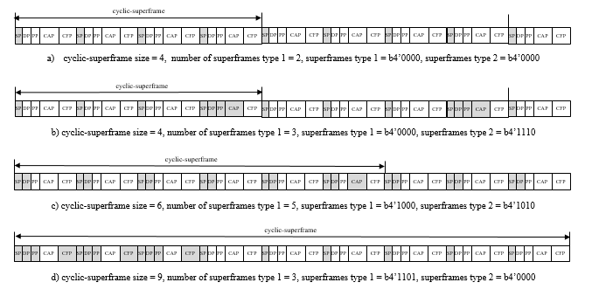
Figure 2—Example cyclic-superframe structures

    - Starting and maintaining PACs

  - MAC frame formats
    - Device addresses
    - General MAC frame format

    - Format of individual frame types
    - Information Elements (IEs)
      - General IE format
      - IE list termination

      - Header IEs
The Header IEs are defined in Table 1, Table 2 and Table 3, one table for each of the IE classes. These tables are ordered by IE ID number with a description for each and reference to the sub-clause that defines the IE and its usage.
Table 1—Class 0 Header IEs
Class 0  Header IE ID | IE Description | Acronym | Sub-clause
0 | Header IE list terminator. | - | 5.2.4.2
1 | Cyclic-superframe descriptor IE | - | 5.2.4.3.1
2 to 15 | Reserved | - | -

Table 2—Class 1 Header IEs
Class 1  Header IE ID | IE Description | Acronym | Sub-clause
0 | Link-ID Assignment IE | - | Error: Reference source not found
0 to 511 | Reserved | - | -

Table 3—Class 3 Header IEs
Class 3  Header IE ID | IE Description | Acronym | Sub-clause
0 to 15 | Reserved | - | -

        - Cyclic-superframe descriptor IE
The Cyclic-superframe descriptor IE Content field shall be formatted as illustrated in Figure 3.
Octets: 1 | 1 | 1 | Bits: 0-3 | 4-7
Sequence Number | Cyclic-superframe Size | Number of Superframes  Pattern A | Superframe  Pattern A | Superframe  Pattern B
Figure 3—The Cyclic-superframe descriptor IE Content field format
The Sequence Number field contains the sequence number of the superframe sending Cyclic-superframe descriptor IE counting from the start of a cyclic-superframe.
The Cyclic-superframe Size field contains the number of superframes in a cyclic-superframe.
The Number of Superframes Pattern A field contains the number of superframes pattern A in a cyclic-superframe.
The Superframe Pattern A field contains the active period in superframe pattern A, which shall be set as indicated in Figure 4.
The Superframe Pattern B field contains the active period in superframe pattern B, which shall be set as indicated in Figure 4.

Bit : 0 | 1 | 2 | 3
Discovery Period State | Peering Period State | CAP State | CFP State
Figure 4—Accessible period indicator
The Discovery Period State field shall set to one when discovery period of a superframe is active. Otherwise it is set to zero.
The Peering Period State field shall set to one when peering period of a superframe is active. Otherwise it is set to zero.
The CAP State field shall set to one when contention access period of a superframe is active. Otherwise it is set to zero.
The CFP State field shall set to one when contention free period of a superframe is active. Otherwise it is set to zero.

  - Synchronization procedure

  - Discovery

  - Peering

  - Communication period

  - MAC commands

