IEEE P802.15
Wireless Personal Area Networks

Project | IEEE P802.15 Working Group for Wireless Personal Area Networks (WPANs)
Title | Resolutions for clause 5 MAC protocol
Date Submitted | July 18th, 2016
Source | Marco Hernandez, Huan-Bang Li, Fumihide Kojima (NICT)
Response | In response to Call for Contributions to TG8
Abstract
Purpose | For discussion in TG8
Notice | This document has been prepared to assist the IEEE P802.15. It is offered as a basis for discussion and is not binding on the contributing individual(s) or organization(s). The material in this document is subject to change in form and content after further study. The contributor(s) reserve(s) the right to add, amend or withdraw material contained herein.
Release | The contributor acknowledges and accepts that this contribution becomes the property of IEEE and may be made publicly available by P802.15.

Contents
1. TBD 2

- MAC protocol
      - Cyclic superframe
A cyclic-superframe contains multiple superframes with active and inactive periods. During an inactive period, a PD may go to sleep mode in order to save power and reduce interference.
Each period of each superframe, except the synchronization period, is configured whether to be active or inactive. . A cyclic-superframe shall be formed from twelve possible combinations of active and inactive periods as illustrated in Error: Reference source not found a)e . The four-bit indicator is set to indicate the active period forf DP, PP, CAP, and CFP inf a superframe,, as described in 5.2.4.3.1.Error: Reference source not found.
In order to form combinations of active and inactive periods in multiple superframes, two types of superframes are defined: superframe type 1 and superframe type 2. Both types of superframes can take the same combinations of active and inactive periods illustrated in Figure 4 a).

e.
The cyclic superframe structure shall be described by the duration of cyclic-superframe (DCS), the number of superframes type 1 (NS1), the number of superframes type 2 ( NS2), the active period in superframe type 1 and the active period of superframe type 2 (see 5.2.4.3.1). The maximum duration of a cyclic-superframe is 255 superframes.
Examples of a cyclic-superframe formation are shown in Figures 4 b) and 4 c).

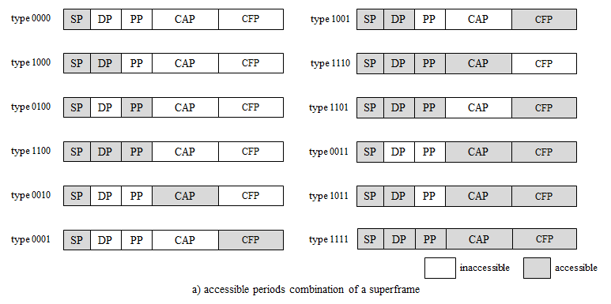
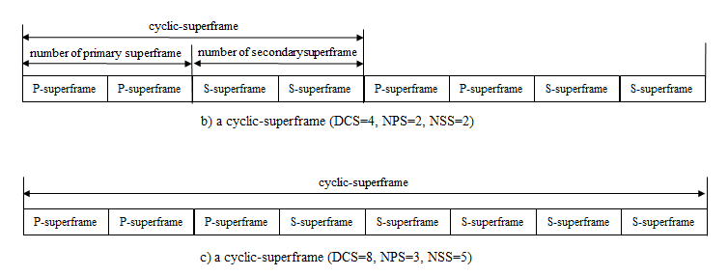
Figure 4
The actual configuration of a cyclic-superframe structure is provided from higher layers and out of the scope of the standard.

Once the configuration of the cylic-superframe structure is passed to the MAC from higher layers, the cyclic-superframe is indicated by the initiator of discovery or peering , or data transmission. A PD shall be instructed to set the cyclic-superframe structure through MLME-GROUP-START.request primitive, or MLME-DISCOVERY.request primitive, MLME-PEERING.request primitive, or MCPS-DATA.request primitive with the CyclicSuperframeStructure descriptor parameter.Such descriptor parameter consists of the duration of cyclic-superframe, the number of superframes type 1, active period in superframe type 1 , and the active period in superframe type2 The cyclic-superframe configuration shall be used and repeated for all communication sessions defined in the standard unless the cyclic-superframe structure is changed.
When receiving the Discovery request command frame with the Cyclic-superframe descriptor IE, the MAC sublayer shall set the PIB with the value of Cyclic-superframe Duration field, Number of superframes type 1 field, Active period in superframe type 1 field, Number of superframes type 2 field, and Active period in superframe type 2 field. The MAC sublayer notifies the reception of the cyclic-superframe structure to the higher layer with the MLME-DISCOVERY.indication primitive. The MAC sublayer calculates the start of a cyclic-superframe with the values of Sequence Number field and Cyclic-superframe Duration field. , The MAC sublayer starts to schedule the access to active periods in superframes type 1 and type 2 of the cyclic-superframe. During inactive periods the PD may go to sleep mode.
The initiator of a communication session shall advertise the specification of a cyclic-superframe structure with the Cyclic-superframe descriptor IE, as defined in Error: Reference source not found. Such Cyclic-superframe descriptor IE consists of four bytes and is formed by the the Sequence number field, theDuration of cyclic-superframe field, the number of superframes type 1 field, the active period in superframe type 1 field, and the active period in superframes type 2 field. .
The Cyclic-superframe descriptor IE can be contained in a Discovery request command frame, Peering request command frame, or Data frame. Neighboring PAC networks operating within communication range can collect advertised cyclic-superframe structure by parsing the active periods of their cyclic-superframe and inform to the next high layer. Such higher layers will select the configuration of the cyclic-superframe that, for instance, minimizes interference, etc. Annex G (Informative) describes how higher layers may compute such selection.

Several examples of cyclic-superframe structures are shown in Figure 5 a) shows a cyclic-superframe with 2 superframes type 1 each with the SP active (b4’0000), followed by 2 superframes type 2, each with the SP active (b4’0000). This example cyclic-superframe could be used during synchronization.
Figure 5 b) shows a cylic-superframe with 3 superframes type 1 each with the SP active (b4’0000), followed by one superframe type 2 with SP, DP, PP and CAP active (b4’1110). ). This example cyclic-superframe could be used for supporting discovery every 4 superframes.
Figure 5 c) shows a cyclic-superframe with 5 superframes type 1, each with SP and DP active (b4’1000), followed by one superframe type 2 with SP, DP and CAP active (b4’1011). This example cyclic-superframe could be used for supporting QoS guaranteed and energy efficient data transmission by transmitting a data frame over the CAP every six superframes (that configuration/decision is taken in higher layers).
Figure 5 d) shows a cyclic-superframe with 3 superframes type 1 each with SP, DP, PP and CFP active (b4’1101), followed by 6 superframes type 2 with SP active (b4’0000). This example cyclic-superframe could be used for supporting burst reliable data transmission by using three consecutive data frames transmissions over the CFP, before sleeping for the duration of six superframes (that configuration/decision is taken in higher layers).

.
The configuration of DCS and NPS for a cyclic-superframe depends on frequency of message transmission or data rate. If a discovery request message needs to be transmitted every X ms, DCS will be set as nearest integer of X divided by aSuperframeDuration and NPS will be set as 1, and the PP and CAP of primary superframe are set to accessible. If one-to-one peer needs a best effort Y bps data rate link with a data frame arrived every Z ms and the average transmission rate in a CAP of a superframe is AvgRateCAP, DCS will be set as nearest integer of Z divided by aSuperframeDuration and NPS will be set as nearest integer of Y divided by AvgRateCAP, and the CAP of primary superframe is set to accessible.

5.4 Discovery
Discovery is the procedure for a PD to either: detect the discovery information of other PDs in the surroundings, possibly without association, or to advertise a PD’s presence by sending discovery information. The discovery information can be dedicated to particular PDs (previously discovered) that request such [dedicated] discovery information.

