IEEE P802.15
Wireless Personal Area Networks
TG3e Coexistence Assurance Document
Date: 2016-06-15
Author(s):
Name | Affiliation | Address | Phone | Email
Andrew Estrada | Sony | 16535 via Esprillo  MZ-1088  San Diego, CA 92127 | +1 (858) 829-3146 | Andrew.Estrada@am.sony.com
Abstract
This serves as the Coexistence Assurance (CA) document for TG3e as required by the CSD.

Introduction
This document addresses the coexistence of IEEE 802.15.3e as required by the CSD [2]. The relevent section is outlined below:

  - A WG proposing a wireless project shall demonstrate coexistence through the preparation of a Coexistence Assurance (CA) document unless it is not applicable.

The following list summarizes the features employed by 802.15.3e to enhance coexistence with other mm-wave receivers.

- The channelization is the same as 802.11ad and 802.15.3c
- The spectrum mask is similar to 802.11ad, which is a relaxed version of 802.15.3c
- The communication range is 10 cm or less.
- The transmitter uses a low EIRP to present minimal interference to other systems.
- Fast Association.
- Disassociation procedure when distance exceeds 10 cm.

The following sections describe these features further.

Channelization
802.15.3e adopts the same common channelization as specified for 802.15.3c and 802.11ad as well as ECMA-387 and WirelessHDTM. As claimed by [4], this common channelization forms the basis for harmonized coexistence of these systems in unlicensed bands.

Shown below is the channelization specified by 802.15.3e [1], included here for convenience.

- —HRCP PHY channelization
CHNL_ID | Start frequencyª | Center frequency | Stop frequencyª
1 | 57.240 GHz | 58.320 GHz | 59.400 GHz
2 | 59.400 GHz | 60.480 GHz | 61.560 GHz
3 | 61.560 GHz | 62.640 GHz | 63.720 GHz
4 | 63.720 GHz | 64.800 GHz | 65.880 GHz
5 | 59.400 GHz | 61.560 GHz | 63.720 GHz
6 | 57.240 GHz | 60.480 GHz | 63.720 GHz
7 | 57.240 GHz | 61.560 GHz | 65.880 GHz

In the above table, Channel ID 1 through 4 are identical to the common channelization used by the other standards previously mentioned. Channel ID 5 through 7 represent different bonding combinations of those common channels. Bonding is an optional feature.

In addition, 802.15.3e specifies a similar spectral mask as 802.11ad, as shown below.

The transmitted spectrum shall adhere to the transmit spectrum mask shown below from subclause 11a.1.5 of [1]:

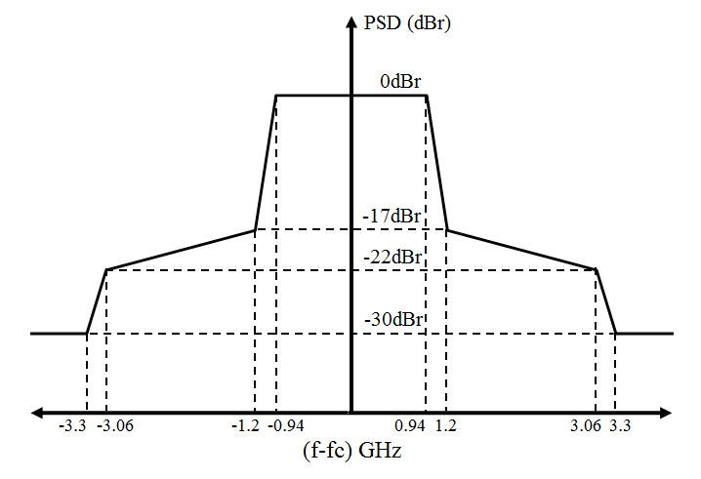

For systems that do not use bonding, the common channelization and the spectral mask reduces ACI with other wireless systems.

In addition, in regulatory domains that allow operation in more than one channel, different 802.15.3e links can use different channels, further reducing interference.

Short Communication Range

The target communication range of 802.15.3e is about 10 cm. The target range of other mm-wave systems like 802.15.3c or 802.11ad is much larger, about 10 m. In addition, the receiver sensitivities of these systems are similar as shown in the following table. Hence, the path lossbetween 802.15.3e devices can be expected to be about 40 dB lower than those of other systems, allowing significantly reduced transmit power and EIRP. This lower transmit power is another factor reducing interference considerably.

Table 1: Comparison of range of minimum required receiver sensitivities for 60 GHz systems
Specification | Min | max
802.15.3e | −66 | −44
802.15.3c | −70 | −46
802.11ad | −78 | −47

Fast Association

802.15.3e is designed for devices to associate in less than 2 ms in order to facilitate short duration connections only as required to transfer data between two devices. Once data transfer is complete, the two devices can disassociate. There is no need to maintain an active network outside of this transaction time, further minimizing interference to other receivers.

Disassociation Procedure
802.15.3e Disassociation behavior is described as follows:
“When an HRCP DEV determines that the distance between the peer HRCP DEV is more than 10 cm apart, the HRCP DEV should send a Disassociation Request command."
This feature limits communication to a range of 10 cm or less. Once devices are disassociated, further emissions are limited to a periodic beacon.

Acronyms
- ACI Adjacent Channel Inteference
- DEV Device
- HRCP High Rate Close Proximity
- MCS Modulation and Coding Scheme

References

[1] Draft P802.15.3e
[2] 15-14-0716-07-003e-sg3e-draft-csd.docx
[3] IEEE Std 802.15.3c-2009
[4] 15-09-0022-09-003c-coexistence-assurance.pdf

