IEEE P802.15
Wireless Personal Area Networks

Project | IEEE P802.15 Working Group for Wireless Personal Area Networks (WPANs)
Title | Revised text for cyclic-superframe structure of PAC MAC
Date Submitted | Jan. 18, 2016
Source | Seong-Soon Joo (ETRI) | E-Mail:  [ssjoo@etri.re.kr]
Re:
Abstract | This document is a revised draft for defining cyclic-superframe structure of the PAC.
Purpose | This document provides the input for the draft PAC specification.
Notice | This document does not represent the agreed views of the IEEE 802.15 Working Group or IEEE 802.15.8 Task Group. It represents only the views of the participants listed in the “Source(s)” field above. It is offered as a basis for discussion and is not binding on the contributing individual(s) or organization(s). The material in this document is subject to change in form and content after further study. The contributor(s) reserve(s) the right to add, amend or withdraw material contained herein.
Release | The contributor acknowledges and accepts that this contribution becomes the property of IEEE and may be made publicly available by P802.15.
Patent Policy | The contributor is familiar with the IEEE-SA Patent Policy and Procedures:  <http://standards.ieee.org/guides/bylaws/sect6-7.html#6> and  <http://standards.ieee.org/guides/opman/sect6.html#6.3>.  Further information is located at <http://standards.ieee.org/board/pat/pat-material.html> and  <http://standards.ieee.org/board/pat>.

Draft txtGorRPorSTD for varTitlePAR

IMPORTANT NOTICE: IEEE Standards documents are not intended to ensure safety, security, health, or environmental protection, or ensure against interference with or from other devices or networks. Implementers of IEEE Standards documents are responsible for determining and complying with all appropriate safety, security, environmental, health, and interference protection practices and all applicable laws and regulations.
This IEEE document is made available for use subject to important notices and legal disclaimers.
These notices and disclaimers appear in all publications containing this document and may
be found under the heading “Important Notice” or “Important Notices and Disclaimers
Concerning IEEE Documents.” They can also be obtained on request from IEEE or viewed at http://standards.ieee.org/IPR/disclaimers.html.
- Overview
- Normative references
- Definitions
  - Definitions
cyclic-superframe: A periodic time interval comprised of the primary and secondary superframes.

  - Acronyms and abbreviations

- General description
  - General
  - Components of IEEE 802.15.8 PAC
  - Network Topologies
  - Architecture
  - Functional Overview

- MAC protocol
  - MAC functional description
    - Channel access
      - Superframe

      - Cyclic-Superframe
The cyclic-superframe structure is used for a PD to adjust transceiver wakeup timing for energy efficient QoS supported transmission and for avoiding interference among PAC groups.
A cyclic-superframe is a cycle of a set of consecutive superframes. A superframe consists of a synchronization period (SP), a discovery period (DP), a peering period (PP), a CAP, and a CFP. Each period of a superframe can be set to active or inactive state to form different types of superframe. The value of superframe type is described by the period state descriptor, as defined in 5.2.4.3.1. Figure 1 a) illustrates example types out of 32 possible superframes.
A cyclic-superframe consists of superframes of two categories: primary superframe and secondary superframe. Depending on the order of position in the cyclic-superframe, each superframe can be named either “primary superframe” or “secondary superframe”. Primary or secondary superframes can take any superframe type.
The cyclic superframe structure is described by the duration of cyclic-superframe (DCS), the number of primary superframe (NPS), the number of secondary superframe (NSS), the type of primary superframe, and the type of secondary superframe.
Primary and secondary superframes shall be allocated in a cyclic-superframe with one of distribution types:
- Distribution type 0: after all primary superframes are placed, secondary superframes are placed contiguously
- Distribution type 1: primary superframes and secondary superframes are placed uniformly over a cyclic-superframe; a cyclic-superframe is started with a primary superframe and a secondary superframe is placed after NPS/NSS primary superframes
The distribution type shall be determined by DCS and NPS. If NPS is less than the half of DCS, distribution type 0 is applied for allocating primary and secondary superframes, as shown in Figure 4 b). Otherwise, distribution type 1 is applied, as shown in Figure 4 c).
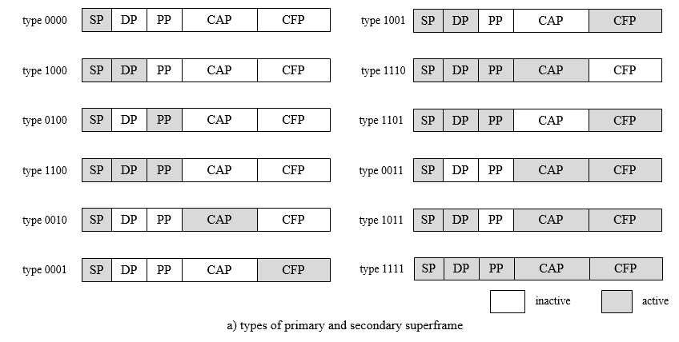
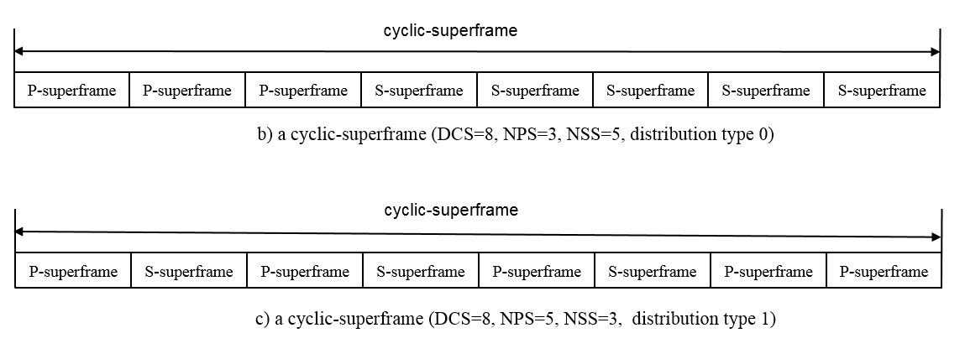
Figure 1—The cyclic-superframe structure for PAC

The format of cyclic-superframe shall be set by the higher layer. The higher layer designs a cyclic-superframe for supportingin the consideration of the following questions:
- how many discovery command frames will be sent in a certain interval
- how many peering command frames will be sent in a certain interval
- on which period and how many data frames will be transmitted in a certain interval
- how to minimize the wake-up time
- how to avoid interference with other PAC groups

Several examples of a cyclic-superframe structure are shown in Figure 2.
In synchronization phase, to power transceiver be on only for the SP of all the superframes, the type of primary superframe and the type of secondary superframe are set to b4’0000 as shown in Figure 5 a). The synchronization phase is ended when the format of cyclic-superframe is changed to enter the discovery phase. In discovery phase, to let discovery and peering be performed for every four superframes, the values of DCS, NPS, the type of primary superframe, and the type of secondary superframe are set to 8, 6, b4’0000, and b4’1100 respectively, as shown in Figure 5 b).
In data transmission phase, according to the required data rate and QoS for a peer link or a peer group, the cyclic-superframe structure can support QoS guaranteed energy efficient data transmission by selecting a transmission period and configuring transmission interval. As an example, for medium rate best effort data transmission, the higher layer may choose a CAP for transmitting a data frame and select six superframes long cyclic-superframe, five superframes long primary superframe, SP and DP active for the primary superframe, and CAP active for the secondary superframe, as shown in Figure 5 c). With this configuration, one data frame is transmitted over CAP for every five inactive superframes. For burst reliable data transmission, three consecutive data transmission before sleeping for six inactive superframes are carried over CFP by specifying the cyclic-superframe structure with DCS set to 9, NPS set to 3, the type of primary superframe set to b4’1101, and the type of secondary superframe set to b4’0000, as shown in Figure 5 d).
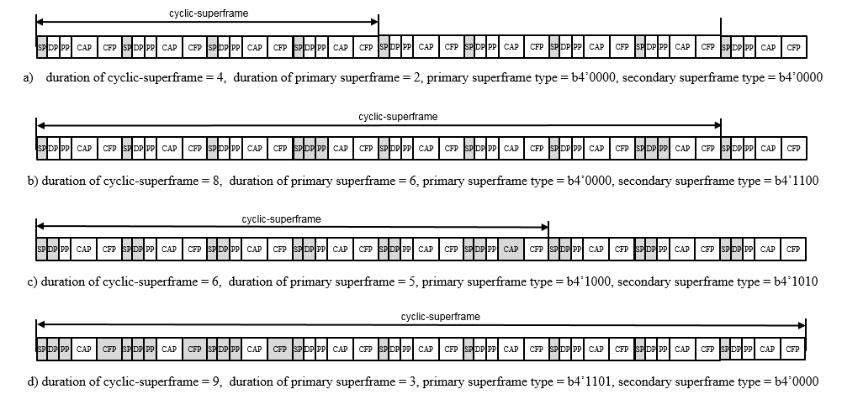
Figure 2—Example cyclic-superframe structures

The cyclic-superframe structure is specified by the initiator of synchronization phase, discovery phase, peering phase, and data transmission phase. A PD is instructed to set the cyclic-superframe structure through MLME-Synchronization.request primitive, MLME-Discovery.request primitive, MLME-GroupStart.request primitive, MLME-Peering.request primitive, and MCPS-Data.request primitive. The cyclic-superframe shall be repeated between one-to-one peers, one-to-many peers, or many-to-many peers until the cyclic-superframe structure is changed. The initiator shall select the time to start a new cyclic-superframe structure that minimizes the interference caused by this new cyclic-superframe to neighbor peer groups.
The specification of a cyclic-superframe structure shall be advertised with Cyclic-superframe descriptor IE, which is four bytes long header IE with the duration of cyclic-superframe, the number of primary superframe, the type of primary superframe, the type of secondary superframe, and the sequential order of superframe sending Cyclic-superframe descriptor IE. The Cyclic-superframe descriptor IE can be contained in a discovery request command frame, peering request command frame, or data frame.
The start of a cyclic-superframe is detected by the sequential order of superframe sending Cyclic-superframe descriptor IE.

    - Starting and maintaining PACs

  - MAC frame formats
    - Device addresses
    - General MAC frame format

    - Format of individual frame types
    - Information Elements (IEs)
      - General IE format
      - IE list termination

      - Header IEs
        - Cyclic-superframe descriptor IE
The Cyclic-superframe descriptor IE Content field shall be formatted as illustrated in Figure 3.
Octets: 1 | 1 | 1 | Bits: 0-3 | 4-7
Sequential Order | Cyclic-superframe Duration | Primary superframe Number | Primary superframe Type | Secondary superframe Type
Figure 3—The Cyclic-superframe descriptor IE Content field format
The Sequential Order field contains the sequential order of superframe sending Cyclic-superframe descriptor IE from the start of a cyclic-superframe.
The Cyclic-superframe Duration field contains the number of superframes in a cyclic-superframe.
The Primary superframe Number field contains the number of primary superframe.
The Primary superframe Type field contains the type of primary superframe, which shall be set as indicated in Figure 4.
The Secondary superframe Type field contains the type of secondary superframe, which shall be set as indicated in Figure 4.

Bit : 0 | 1 | 2 | 3
Discovery Period State | Peering Period State | CAP State | CFP State
Figure 4—Period state descriptor
The Discovery Period State field shall set to one when discovery period of a superframe is active.
The Peering Period State field shall set to one when peering period of a superframe is active.
The CAP State field shall set to one when contention access period of a superframe is active.
The CFP State field shall set to one when contention free period of a superframe is active.

- MAC services
  - MLME-SAP primitives
    - PIB access

    - Discovery primitives
These primitives are used for the discovery of neighboring PDs.
      - MLME-Discovery.Request
The primitive requests a PD to perform discovery. The properties of this primitive are:
MLME.Discovery.Request{
DiscoveryMode;
DiscoveryInfo;
ChannelPage;
ScanChannels;
CyclicSuperframeStructure;
}
The primitive parameters are defined in Table 1.
Table 1—MLME.Discovery.Request parameters
Property | Type | Valid range | Description
DiscoveryMode | Enumeration | TX, RX | Indicates transmission or reception of discovery information.
DiscoveryInfo | Array of PAC IDs descriptors | As defined in Table 2 | Indicates the discovery information.
ChannelPage | Integer | Any valid channel page as defined in Table TBD | The channel page on which to attempt discovery.
ChannelNumber | Integer | Any valid channel number as defined in Table TBD | The channel number on which to attempt discovery.
ScanChannels | Array of integers | Any valid channel number as defined in Table TBD | The channel numbers to be used for discovery.
CyclicSuperframeStructure | Cyclic-superframe structure descriptor | As defined in Table 3 | Indicates the structure of cyclic-superframe

In RX mode, channelNumber is zero.
Discovery descriptors are defined in Table 2.
Table 2—PAC ID description
Property | Type | Valid range | Description
Device_ID | MAC address | PD specific | MAC address of the PD.
MulticastGroup_ID | Integer | 0 to 2¹⁶−1 | Multicast Group addresss of PAC network
Application_ID | char | 14 octets | Application name, user name, login.

Cyclic-superframe structure descriptors are defined in Table 3.
Table 3—Cyclic-superframe structure descriptor
Property | Type | Valid range | Description
Cyclic-superframe duration | Integer | 1 octet | Number of superframes in a cyclic-superframe.
Primary superframe number | Integer | 1 octet | Number of primary superframe.
Primary superframe type | Integer | As defined in Figure 4  (5.2.4.3.1) | Type of primary superframe.
Secondary superframe type | Integer | As defined in Figure 4  (5.2.4.3.1) | Type of secondary superframe.

      - MLME.Discovery.Confirm
This primitive requests association with given PD. The properties of this primitive are:
MLME.Discovery.Confirm{
DiscoveryMode;
DiscoveryInfo;
ChannelPage;
ScanChannels;
CyclicSuperframeStructure;
Status;
}
The primitive parameters are defined in Table 4.
Table 4—MLME.Discovery.Confirm parameters
Property | Type | Valid range | Description
DiscoveryMode | Enumeration | TX, RX | Indicates transmission or reception of discovery information.
DiscoveryInfo | Array of PAC IDs descriptors | As defined in Table 2 | Indicates discovery information.
ChannelPage | Integer | Any valid channel page as defined in Table TBD | The channel page on which discovery was attempted.
ChannelNumber | Integer | Any valid channel number as defined in Table TBD | The channel number on which discovery was attempted
ScanChannels | Array of integers | Any valid channel number as defined in Table TBD | The channel numbers used for discovery.
CyclicSuperframeStructure | Cyclic-superframe structure descriptor | As defined in Table 3 | Indicates the structure of cyclic-superframe
Status | Enumeration | SUCCESS, FAIL, DISCOVERY_IN_PROGRESS | Status of the discovery request

    - Peering primitives
These primitives are used when a PD becomes associated with another PD.
      - MLME.Peering.Request
This primitive requests association with given PD. The properties of this primitive are:
MLME.Peering.Request{
ChannelNumber;
ChannelPage;
MulticastGroup_ID;
DestinationAddress;
CyclicSuperframeStructure;
}
The primitive parameters are defined in Table 5.
Table 5—MLME.Peering.Request parameters
Property | Type | Valid range | Description
ChannelNumber | Integer | As defined in Table TBD | The channel number on which to attempt peering.
ChannelPage | Integer | As defined in Table TBD | The channel page on which to attempt peering.
MulticastGroup_ID | Integer | 0 to 2¹⁶ −1 | Group ID of destination PD.
DestinationAddress | MAC address | PD specific | Address of the PD with which to peer.
CyclicSuperframeStructure | Cyclic-superframe structure descriptor | As defined in Table 3 | Indicates the structure of cyclic-superframe

      - MLME.Peering.Confirm

      - MLME.Peering.Indication
The primitive is used to indicate the reception of a peering request command. The properties of this primitive are:
MLME.Peering.Indication{
PD_ID;
PHYcapability;
CyclicSuperfameStructure;
}
The primitive parameters are defined in Table 6.
Table 6—MLME.Peering.Indication parameters
Property | Type | Valid range | Description
PD_ID | MAC address | PD specific | Address of the PD requesting peering.
PHYcapability | Enumeration | LOW_MOBILITY, HIGH_MOBILITY, GFSK, UWB_BPM_BPSK, UWB_OOK | Operational capability of the PD requesting peering.
CyclicSuperframeStructure | Cyclic-superframe structure descriptor | As defined in Table 3 | Indicates the structure of cyclic-superframe

    - De-peering primitives

    - Frame error notification primitives

    - Reset MAC sublayer
These primitives are used to reset the MAC sublayer. The execution is implementation specific.

    - Receiver enable

    - Channel scanning
This primitive is used to initiate a channel scan over a given list of channels. The properties of this primitive are:

    - Group configuration
These primitives are used to initiate a PAC Group or to begin using a new superframe configuration.
      - MLME.GroupStart.Request
This primitive is also used by a PD already peered with an existing PAC Group to begin using a new superframe configuration. The properties of this primitive are:
MLME.GroupStart.Request{
GroupID;
InitiatorID;
ChannelNumber;
ChannelPage;
StartTime;
SuperframeOrder;
CyclicSuperframeStructure;
}
The primitive parameters are defined in Table 7.
Table 7—MLME.GroupStart.Request parameters
Property | Type | Valid range | Description
Initiator_ID | MAC address | PD specific | The address of the initiator PD
MulticastGroup_ID | Integer | 0 to 2¹⁶ −1 | Group ID of initiator PD.
ChannelNumber | Integer | Any valid channel number a defined in Table TBD | The channel number to use.
ChannelPage | Integer | Any valid channel page as defined in Table TBD | The channel page to use.
StartTime | Unsigned integer | 0 to (2²⁴ −1) | The time at which to begin transmitting the synchronization period. If this parameter is equal to 0, the synchronization period will begin immediately. Otherwise, the specified time is relative to the received synchronization period of the current initiator PD.
CyclicSuperframeStructure | Cyclic-superframe structure descriptor | As defined in Table 3 | Indicates the structure of cyclic-superframe

      - MLME.GroupStart.Confirm

      - MLME.GroupStart.Indication
The primitive is used to indicate the reception of GroupStart request command. The properties of this primitive are:

MLME.GroupStart.Indication{
PD_ID;
PHYcapability;
CyclicSuperframeStructure;
}
The primitive parameters are defined in Table 8.
Table 8—MLME.GroupStart.Indication parameters
Property | Type | Valid range | Description
PD_ID | MAC address | PD specific | Address of the PD requesting GroupStart.
PHYcapability | Enumeration | LOW_MOBILITY, HIGH_MOBILITY, GFSK, UWB_BPM_BPSK, UWB_OOK | Operational capability of the PD requesting GroupStart.
CyclicSuperframeStructure | Cyclic-superframe structure descriptor | As defined in Table 3 | Indicates the structure of cyclic-superframe

    - Synchronization
      - MLME.Synchronization.Request
The primitive requests to synchronize with other PDs by acquiring and tracking their synchronization signal. The properties of this primitive are:
MLME.Synchronization.Request{
ChannelNumber;
ChannelPage;
TrackMode;
CyclicSuperframeStructure;
}
The primitive parameters are defined in Table 9.
Table 9—MLME.Synchronization.Request parameters
Property | Type | Valid range | Description
ChannelNumber | Integer | As defined in Table TBD | The channel number on which to attempt synchronization.
ChannelPage | Integer | As defined in Table TBD | The channel page on which to attempt synchronization.
TrackMode | Boolean | TRUE, FALSE | TRUE if the PD is to synchronize from the next synchronization period. FALSE if the PD is to synchronize with only the next synchronization period.
CyclicSuperframeStructure | Cyclic-superframe structure descriptor | As defined in Table 3 | Indicates the structure of cyclic-superframe

When the primitive is received by the MLME, it will set phyCurrentPage and phyCurrentChannel equal to the values of the ChannelPage and ChannelNumber, respectively. If the TrackMode parameter is equal to TRUE, the MLME will track the synchronization period, i.e., enable its receiver just before the expected time of synchronization period. If the TrackMode parameter is equal to FALSE, the MLME will locate the synchronization period, but not continue to track it.
If this primitive is received by the MLME while it is currently tracking the synchronization period, the MLME will not discard the primitive but will treat it as a new synchronization request.

      - MLME.Synchronization.Confirm
      - MLME.SynchronizationLoss.Indication

    - Channel sounding

  - MAC data service
    - MCPS.Data.Request
The primitive requests the transfer of data to another PD. The properties of this primitive are:
MCPS-DATA.Request {
phyModeSelection;
SourceAddress;
DestinationAddress;
MulticastGroup_ID;
MSDUlength;
MSDUHandle;
TransmitTimeOut;
DataType;
DataRate;
PurgeMode;
AckTX;
Ranging;
IeList;
RequestRriTx;
CyclicSuperframeStructure;
}
The primitive parameters are defined in Table 10.
Table 10—MCPS-DATA.Request parameters
Property | Type | Valid range | Description
SourceAddress | MAC address | PD specific | The address of the PD from which the frame originated.
phyModeSelection | Enumeration | LOW-MOBILITY, HIGH_MOBILITY, GFSK, UWB_BPM_BPSK, UWB_OOK | PHY selection
DestinationAddress | MAC address | PD specific | Address of the PD for which the frame is intended.
MulticastGroup_ID | Integer | 0 to 2¹⁶ −1 | Group ID of a PAC network.
MSDUlength | Integer | TBD | MDSU length in octets.
MSDUhandle | Integer | TBD | Integer number identifying the MSDU.
TransmitTimeOut | Integer | TBD | The maximum allowed delay in microseconds from when the data is presented to the SAP until the frame has finished transmission and the acknowledgment, if required, is received.
DataType | Enumeration | AUDIO, VIDEO, DATA | Indicates the type of data that is sent in the stream.
DataRate | Integer | TBD | Indicates the data rate
PurgeMode | Boolean | TRUE, FALSE | If TRUE, the MSDU in the transaction buffer corresponding to MSDUhandle, is discarded from the transaction buffer.
AckTX | Boolean | FALSE, TRUE | This parameter is present only when phyModeSelection is UWB.  TRUE if acknowledged transmission is used,  FALSE otherwise.
Ranging | Boolean | FALSE, TRUE | This parameter is present only when phyModeSelection is UWB.  TRUE if ranging bit in PHR is to be set,  FALSE otherwise.
IeList | Set if IEs as described in  Array of integers (IEs) | As described in Table TBD | This parameter is present only when phyModeSelection is UWB.  Determines/supplies the IEs to be sent, including:  RRRT IE, RRTD IE, RPRT IE, RRTM IE, RCDT IE and RTOF IE
RequestRrtiTx | Boolean | TRUE, FALSE | This parameter is present only when phyModeSelection is UWB.  This parameter requests that the PD inserts an RRTI IE in the sent data frame. If the MCPS-DATA.request is early enough the data frame shall be sent at the configured macRngRrtiTime otherwise shall be sent as soon as possible thereafter.
CyclicSuperframeStructure | Cyclic-superframe structure descriptor | As defined in Table 3 | Indicates the structure of cyclic-superframe

    - MCPS.Data.Confirm

    - MCPS.Data.Indication
The primitive indicates the reception of data from another PD. The properties of this primitive are:
MCPS.Data.Indication{
phyModeSelection;
SourceAddress;
DestinationAddress;
MulticastGroup_ID;
MSDUlength;
CQI;
DataSequenceNumber;
DataRate;
TxRangingCounter;
RxRangingCounter;
IeList;
AoaAzimuth;
AoaElevation;
AoaPresent;
Rssi;
CyclicSuperframeStructure;
}

The primitive parameters are defined in Table 11.
Table 11—MCPS.Data.Indication parameters
Property | Type | Valid range | Description
SourceAddress | MAC address | PD specific | The address of the PD from which the frame originated.
DestinationAddress | MAC address | PD specific | Address of the PD for which the frame is intended.
MulticastGroup_ID | Integer |  | Group ID of PAC network.
MSDUlength | Integer | TBD | MDSU length in octets.
CQI | Integer | 0 – 4 | CQI value measured during reception of the PSDU. TBD
DataSequenceNumber | Integer | TBD | Data number sequence of the received data frame.
DataRate | Integer | TBD | Indicates the data rate.
RxRangingCounter | Unsigned Integer | 0 to (2³² −1)  TBD | This parameter is present only when phyModeSelection is UWB.  The timestamp of the received data frame
TxRangingCounter | Unsigned Integer | TBD | This parameter is present only when phyModeSelection is UWB.  If the received frame had the AR bit set, then this is the timestamp of the transmitted acknowledgement frame, otherwise this parameter is invalid.
IeList | Set if IEs as described in  Array of integers (IEs) | As described in | This parameter is present only when phyModeSelection is UWB.  Reports the IEs received including:  RRRT IE, RRTD IE, RRTI IE, RPRT IE, RRTM IE, RCDT IE and RTOF IE
AoaAzimuth | Float | -π to +π | This parameter is present only when phyModeSelection is UWB.  AOA of the received signal in azimuth measured in radians, relative to some PD specific axis defined by its antenna arrangement or orientation. This parameter is valid only when the AoaPresent parameter is either AZIMUTH or BOTH.
AoaElevation | Float | -π to +π | This parameter is present only when phyModeSelection is UWB.  AOA of the received signal in elevation measured in radians. This parameter is valid only when the AoaPresent parameter is either ELEVATION or BOTH.
AoaPresent | Enumeration | NONE,  BOTH,  AZIMUTH,  ELEVATION | This parameter is present only when phyModeSelection is UWB.  Indicates validity of AoaAzimuth and AoaElevation parameter. Where AOA is not supported this parameter value shall be NONE.
Rssi | Integer | 0 to 255 | This parameter is present only when phyModeSelection is UWB.  The received signal strength for received frame. This is a measure of the RF power level at the antenna based on the gain setting in the RX chain and the measured signal level in the channel. For the UWB PHY the RSSI value is measured during the frame Preamble and locked when a valid SFD is detected. A value of zero indicates that RSSI measurement is not supported or was not measured for this frame.
CyclicSuperframeStructure | Cyclic-superframe structure descriptor | As defined in Table 3 | Indicates the structure of cyclic-superframe

  - PAC information base (PIB)
The PIB comprises the fields required to manage the MAC sublayer and PHY layer of a PD, and presented in Table 12.
The fields associate to the PHY layer and MAC sublayer use the prefix phy and mac, respectively. Constants are READ_ONLY.
Table 12—PIB fields
Field | Type | Range | Default | Description
.  .  . |  |  |  | .  .  .

