IEEE P802.15
Wireless Personal Area Networks

Project | IEEE P802.15 Working Group for Wireless Personal Area Networks (WPANs)
Title | Text of three clauses prepared for MCO related TG10 routing procedure
Date Submitted | July 28, 2015
Source | [Jaehwan Kim (ETRI), Jaebeom Kim (Ajou Univ.), Soo-Young Chang (CSUS) and Sangsung Choi (ETRI)]  [ETRI, Ajou Univ. and CSUS] | E-mail: [sychang@ecs.csus.edu]  Phone: [+1 530 574 2741]
Re:
Abstract | Three clauses for MCO related L2R routing procedure
Purpose | To provide a text for TG10 L2R draft
Notice | This document has been prepared to assist the IEEE P802.15. It is offered as a basis for discussion and is not binding on the contributing individual(s) or organization(s). The material in this document is subject to change in form and content after further study. The contributor(s) reserve(s) the right to add, amend or withdraw material contained herein.
Release | The contributor acknowledges and accepts that this contribution becomes the property of IEEE and may be made publicly available by P802.15.

Introduction

This document was prepared to provide more information regarding MCO related routing procedure for TG10 L2R routing in the hope that the text in this document can be included in the L2R draft to help the readers understand the routing procedure better.

The following three clauses were prepared for this procedure:

5.2.6 US/DS multi-channel route establishment for TMCTP

When the MCO field in the L2R-D IE is set to 1, the L2R spans more than one PAN operating on different channels and the MCO Descriptor field is present in the TC IE for IEEE 802.15.4m TMCTP. In TMCTP (Multi-channel) environment, each device transmits TC IE by using its operation channels as described in 4.3. In MCO enabled L2R, the each coordinator send a TC IE with MCO information that indicates the operation channels of the device. When a device receives a TC IE with valid MCO descriptor, it stores the channel information of the TC IE sender to NT. If MCO is used for US/DS routes, the operation channel information of the neighbor device is stored to corresponding neighbor in NT to identification operation channel of the next-hop device in the routing path. This channel information utilized for DATA-DATA frame processing procedure to find a valid packet for data transmission in current operation channel of the device. The multi-channel data transmission procedure is shown in figure 19.

Modify figure 19 as below (RED)
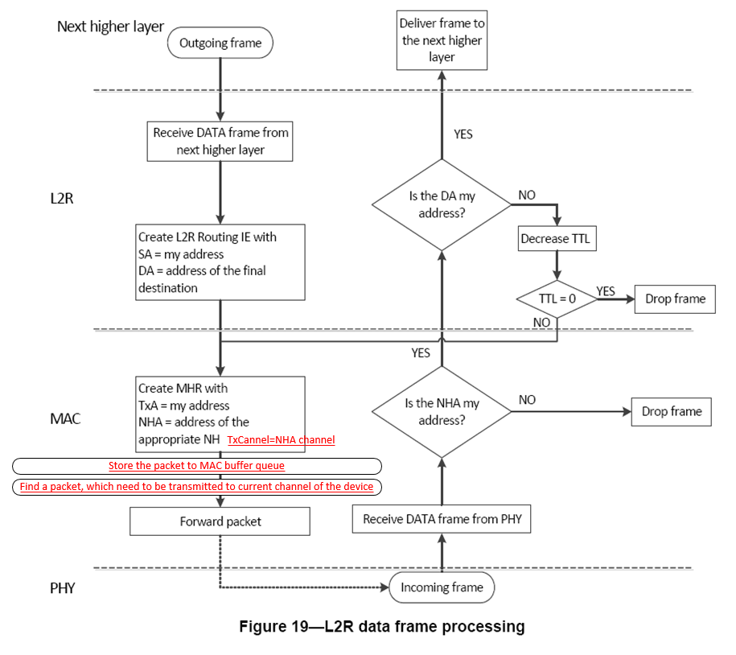

5.3.5 L2R Route maintenance with MCO
The route between source and destination can be constructed through different channels of the devices between PANs. The channel information of the device periodically transmitted to its neighbor by using TC IE with TMCTP superframe period and each device can update its neighbor channel using received TC IE. Also, the RA IE, P2P RQ and P2P RP includes channel information of the device to notify the operation channel. This channel information is utilized to identify operation channel of the neighbor (next-hop of forwarder) in the routing path of the packet.

5.4.1.5 L2R Routing with MCO
A L2R mesh tree may be a part of a PAN or may span across several PANs defined in TVWS Multi-Channel Tree topology (TMCTP).

In TMCTP, the operation channel of each PAN coordinator in the region is configured by infrastructure connected super (first) PAN coordinator. Figure 1 shows an example of TMCTP topology and P2P L2R in multichannel environment.

In this figure, each PAN coordinator uses the two channels as parent and own channels and these channels are periodically switched by using TMCTP superframe. The TMCTP superframe is bounded by network beacons sent by the SPC. The active portion of the TMCTP superframe is composed of a beacon, a CAP, a CFP and a BOP. An example of a TMCTP superframe including the BOP is illustrated in Figure 2. The BOP is composed of one or more DBSs. A DBS is used to communicate beacons between the parent PAN coordinator and the child PAN coordinator.

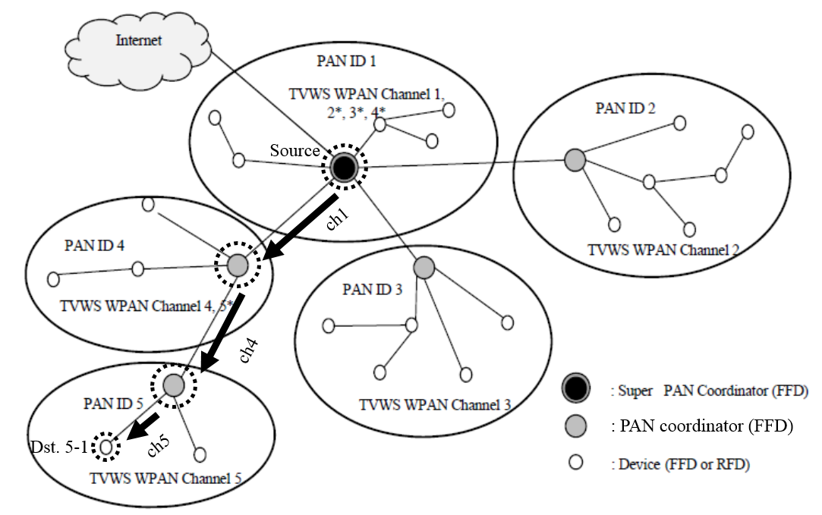
Figure 1—Example of the IEEE 802.15.4m TMCTP and L2R (DS route)

Figure 2 shows an example of the multichannel routing in TMCTP topology as presented in Figure 1. In this case, the super PAN coordinator operates on the dedicated channel, which is channel 1, and switches into the dedicated channel of the child PAN coordinator 2, 3, and 4 at their Dedicate Beacon Slot (DBS). Similarly the PAN coordinator 4 operates on the dedicated channel, which is channel 4, and switches into the dedicated channel of the child PAN coordinator 5 at its DBS. In this Multi-Channel Operation (MCO) in L2R, each device (including PAN coordinator and PAN device) exchanges the parent-channel and its own channel by using MCO Descriptor field in TC IE (6.2.2.2). The device must send a TC IE using its all operation channels and device that receives a TC IE stores the channel information to NT. For example, PAN ID 1 (Super PAN coordinator) in figure 2 sends a single TC IE, but PAN ID 2, 3, 4 and 5 send two TC IE by using its operation channels. If the ID 1 want to sends a packet to device 5-1 (t₀), then it can directly send to next hop route PAN ID 4 (PAN coordinator). However, the forwarder device PAN ID 4 need to wait a next CAP&CFP periods because its current operation cannel is not same as next hop device PAN ID 5 (t₁). PAN ID 5 also wait next periods to send a received packet for device 5-1 (t₂). To identify the operation channel of the device with neighbor address, L2R store the operation channel of the device.

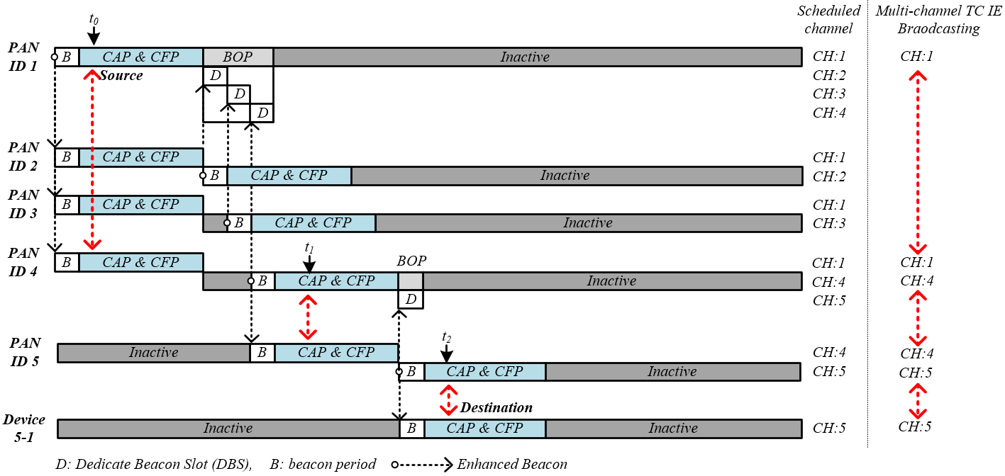
Figure 2— Example L2R route construction in IEEE 802.15.4m TMCTP

