IEEE P802.15
Wireless Personal Area Networks

Project | IEEE P802.15 Working Group for Wireless Personal Area Networks (WPANs)
Title | Draft text for superframe structure of PAC MAC
Date Submitted | July 10, 2015
Source | Seong-Soon Joo (ETRI)  Byung-Jae Kwak (ETRI) | E-Mail:  [ssjoo@etri.re.kr]
Re:
Abstract | This document is a draft for defining cyclic-superframe structure of the PAC.
Purpose | This document provides the input for the draft PAC specification.
Notice | This document does not represent the agreed views of the IEEE 802.15 Working Group or IEEE 802.15.8 Task Group. It represents only the views of the participants listed in the “Source(s)” field above. It is offered as a basis for discussion and is not binding on the contributing individual(s) or organization(s). The material in this document is subject to change in form and content after further study. The contributor(s) reserve(s) the right to add, amend or withdraw material contained herein.
Release | The contributor acknowledges and accepts that this contribution becomes the property of IEEE and may be made publicly available by P802.15.
Patent Policy | The contributor is familiar with the IEEE-SA Patent Policy and Procedures:  <http://standards.ieee.org/guides/bylaws/sect6-7.html#6> and  <http://standards.ieee.org/guides/opman/sect6.html#6.3>.  Further information is located at <http://standards.ieee.org/board/pat/pat-material.html> and  <http://standards.ieee.org/board/pat>.

Draft txtGorRPorSTD for varTitlePAR

IMPORTANT NOTICE: IEEE Standards documents are not intended to ensure safety, security, health, or environmental protection, or ensure against interference with or from other devices or networks. Implementers of IEEE Standards documents are responsible for determining and complying with all appropriate safety, security, environmental, health, and interference protection practices and all applicable laws and regulations.
This IEEE document is made available for use subject to important notices and legal disclaimers.
These notices and disclaimers appear in all publications containing this document and may
be found under the heading “Important Notice” or “Important Notices and Disclaimers
Concerning IEEE Documents.” They can also be obtained on request from IEEE or viewed at http://standards.ieee.org/IPR/disclaimers.html.
- Overview
- Normative references
- Definitions
  - Definitions
  - Acronyms and abbreviations
- General description
  - General
  - Components of IEEE 802.15.8 PAC
  - Network Topologies
  - Architecture
  - Functional Overview

- MAC protocol
  - MAC functional description
    - Channel access
      - Superframe
      - Cyclic-Superframe
The superframe structure can be expanded by considering consecutive multiple superframes as a single cyclic-superframe, as shown in Figure x1. Each superframe in a cyclic-superframe can be specified as active or inactive. For an active superframe, it is specified which periods are accessible, CAP or CFP or both periods. For an inactive superframe, CAP and CFP are not accessible and it is specified whether discovery period (DP) and peering period (PP) are accessible or not.
The specification of a cyclic-superframe shall be set by the next higher layer with a primitive containing attributes: length of cyclic-superframe (i.e. number of superframes in a cyclic-superframe), accessible period(s) in active superframe (i.e. CAP, CFP, both), accessible period(s) in inactive superframe (i.e. none, DP, PP, both), and number of active superframes. The distribution of active superframes in a cyclic-superframe is determined by the attribute of accessible period in inactive superframe. If accessible period in inactive superframe is none, active superframes are appeared consecutively from the start of a cyclic-superframe for the number of active superframe. If accessible period in inactive superframe is one or more, active superframes are distributed evenly in a cyclic-superframe.
The specification of a cyclic-superframe is advertised by PDs joined a PAC network with conveying in a peering request command frame or peering response command frame. The start of a cyclic-superframe is set by the next superframe after sending or receiving a peering response command frame.

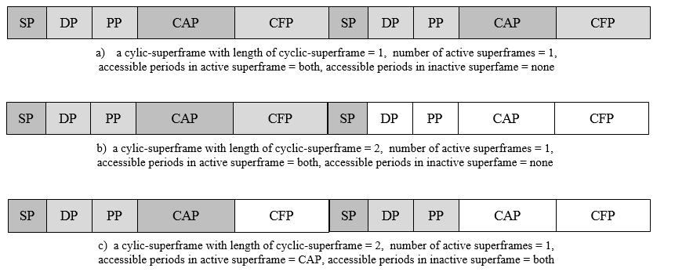
Figure x1—The cyclic-superframe structure of PAC

    - Starting and maintaining PACs

  - MPDU formats
    - General MPDU format
      - Frame Check Sequence (FCS)

