IEEE P802.15
Wireless Personal Area Networks

Project | IEEE P802.15 Working Group for Wireless Personal Area Networks (WPANs)
Title | Resource slot request command
Date Submitted | May 11th, 2015
Source | Marco Hernandez, Huan-Bang Li, Igor Dotlić, Ryu Miura (NICT)
Response | In response to Call for Contributions to TG8
Abstract
Purpose | For discussion in TG8
Notice | This document has been prepared to assist the IEEE P802.15. It is offered as a basis for discussion and is not binding on the contributing individual(s) or organization(s). The material in this document is subject to change in form and content after further study. The contributor(s) reserve(s) the right to add, amend or withdraw material contained herein.
Release | The contributor acknowledges and accepts that this contribution becomes the property of IEEE and may be made publicly available by P802.15.

Contents
1. Reference signals 2

    - ReS request command
The ReS request command is used by an associated device a peered PD that is requesting the allocation of a new ReS or the deallocation of an existing ReS. from the PAN coordinator. Only devices PDs that have a short address shall send this command. (TBD)

The ReS request command shall be formatted as illustrated in Table 1.

- —ReS request command format
X octets | 1 octet | 1 octet
MHR fields | Command identifier | ReS characteristics

      - MHR fields
MHR fields: destination addressing mode field, source addressing mode field, frame pending field, Source PAC identifier field, source address field, and AR field (acknowledgment request).
The destination addressing mode field shall be set to indicate that destination addressing information is not present, and the source addressing mode field shall be set to indicate short addressing (extended addressing) TBD
- —Addressing mode field
*Addressing mode | Description
00 | PAC identifier and address fields are not present
01 | Reserved
10 | Address field contains a short address (16 bit) TBD
11 | Address field contains an extended address (64 bit) TBD
*source, destination.

Frame pending field shall be set to zero and ignored upon reception, and the AR field shall be set to one.
The source PAC identifier field shall contain the value of macPACId TBD, and the Source Address field shall contain the value of macShortAddress (macExtendedAddress) TBD.
      - ReS characteristic field
The ReS characteristics field shall be formatted as illustrated in Table 3.

- —ReS characteristic field format
Bits | 0-3 | x-y | x-y | x-y
Attribute | ReS length | ReS direction | Type | Reserved

The ReS length field shall contain the number of superframe slots being requested for the ReS.
The ReS direction field shall be set to one if the ReS is to be a receive-only ReS. Conversely, this field shall be set to zero if the ReS is to be a transmit-only ReS. The ReS direction is defined relative to the direction of data frame transmissions by the PD.
The characteristics type field shall be set to one if the characteristics refer to a ReS allocation or zero if the characteristics refer to a ReS deallocation.

    - For discussion
IEEE 802 MAC addresses with EUI-48:
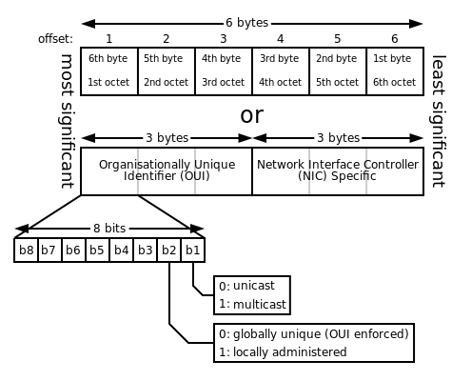

EUI-64 Format:
When a EUI-64 is provided by an authorized assignee of these values (i.e., by an assignee of an MA-L, MA-M or MA-S, (MAC Address block Large, Medium, small) the most- significant 24, 28 or 36 bits of EUI-64 are assigned to the organization/company by the IEEE RA. The least-significant bits are the extension identifier assigned by the organization/company.
Example: assuming that an organization’s IEEE- assigned MA-S value is 00-1B-C5-05-3_{hex} and the organization/company- selected extension identifier for a given component is 1-23-45-67_{hex}. The EUI-64 value generated from these two numbers is 00-1B-C5-05-31-23-45-67.
IEEE encourages using EUI-64, due to the limited space of EUI-48.

