IEEE P802.15
Wireless Personal Area Networks

Project | IEEE P802.15 Working Group for Wireless Personal Area Networks (WPANs)
Title | Security Section Pictures
Date Submitted | 30 January, 2015
Source | Tero Kivinen  INSIDE Secure  Eerikinkatu 28  FI-00180 Helsinki  Finland | Voice: +358 20 500 7800  Fax: +358 20 500 7801  E-mail: kivinen@iki.fi
Re: | Security section pictures
Abstract | Pictures relating to the security section. These are not normative, but might help understanding security section.
Purpose | Security Section pictures
Notice | This document has been prepared to assist the IEEE P802.15. It is offered as a basis for discussion and is not binding on the contributing individual(s) or organization(s). The material in this document is subject to change in form and content after further study. The contributor(s) reserve(s) the right to add, amend or withdraw material contained herein.
Release | The contributor acknowledges and accepts that this contribution becomes the property of IEEE and may be made publicly available by P802.15.

Security PIB

This pictures describes security PIB tables (table 153-159) in graphical format. This picture also adds two new tables needed for Information Element security, and reorganizes tables bit better.

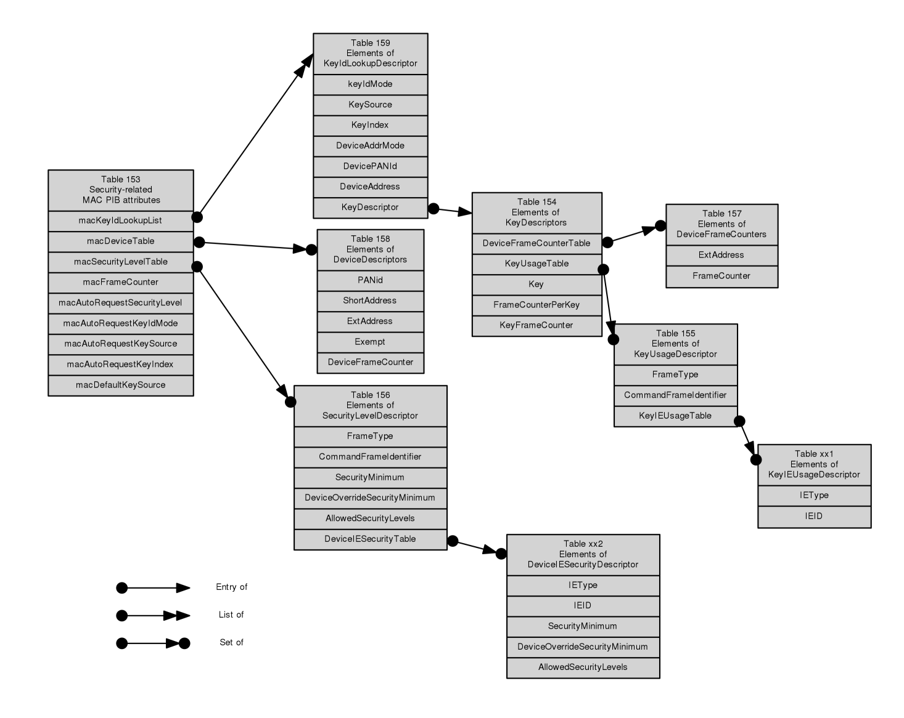

Outgoing frame security procedure

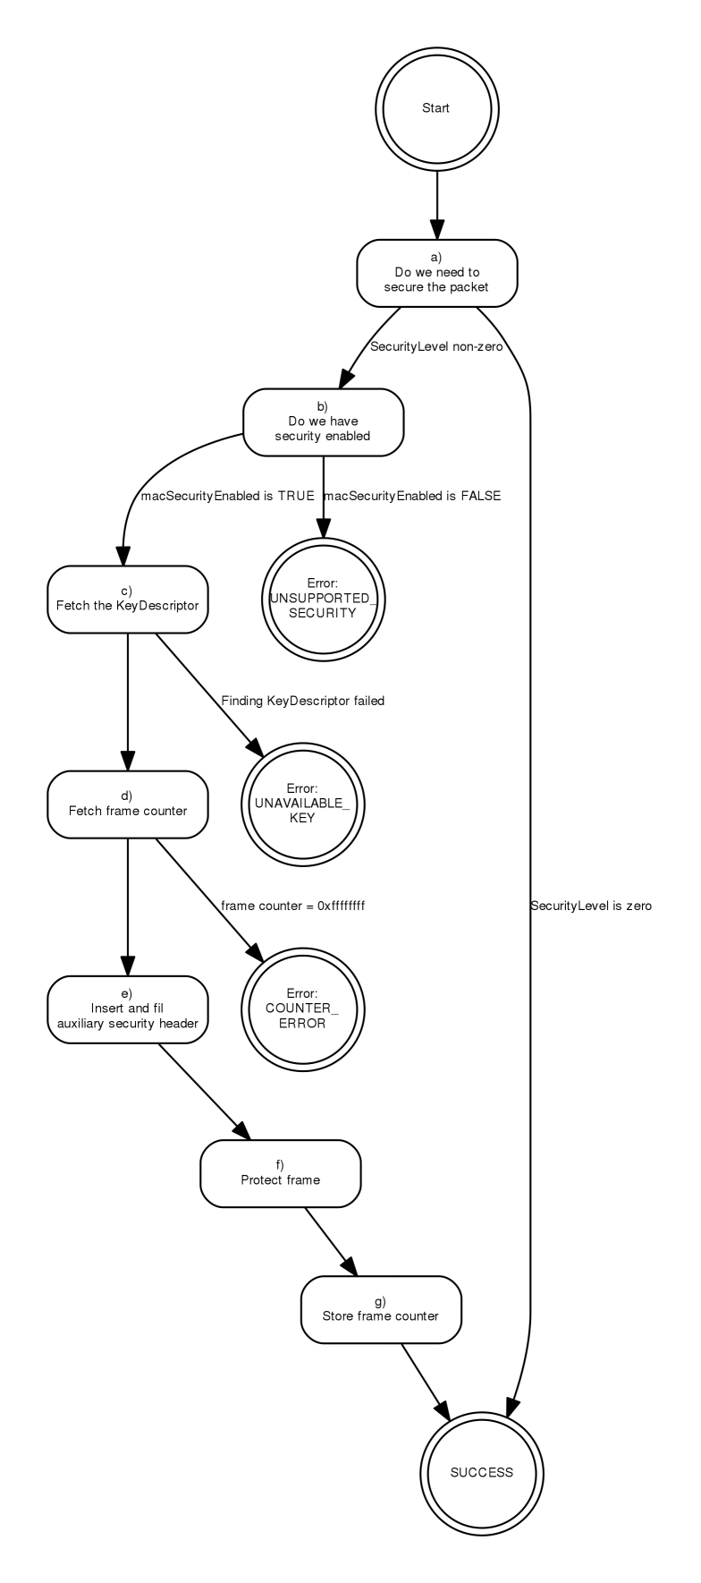

Incoming frame security procedure
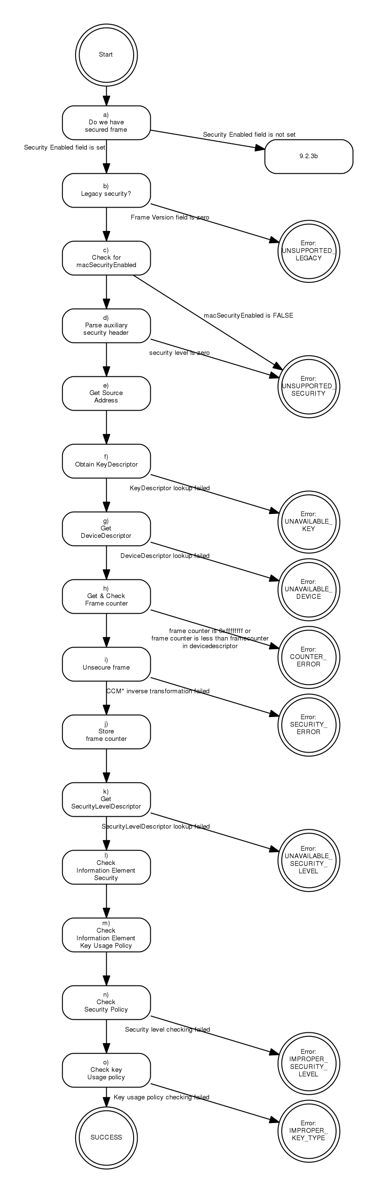

Incoming frame security procedure for security level zero frames

