IEEE P802.15
Wireless Personal Area Networks

Project | IEEE P802.15 Working Group for Wireless Personal Area Networks (WPANs)
Title | IEEE P802.15.TG4e Call For Applications
Date Submitted | 4 November 2014
Source | [Arthur Astrin]  1051 Greenwood Avenue  Palo Alto, CA 94301  [Ryuji Kohno]  79-5 Tokiwadai, Hodogaya-ku, Yokohama, Japan 240-8501 | Voice: [+1 650 704 2517]  E-mail: [astrin@ieee.org]  Voice : [+81 45 339 5528]  E-mail : [kohno@ynu.ac.jp]
Re: | [IEEE P802.15 IG DEP was formed with the charter of drafting a standard for dependable communication.]
Abstract | [The following submission is a call for interest, participation, applications and proposals from the IEEE, Industry, and Academia.]
Purpose | [Request for formal submissions to the P802.15 IG DEP]
Notice | This document has been prepared to assist the IEEE P802.15. It is offered as a basis for discussion and is not binding on the contributing individual(s) or organization(s). The material in this document is subject to change in form and content after further study. The contributor(s) reserve(s) the right to add, amend or withdraw material contained herein.
Release | The contributor acknowledges and accepts that this contribution becomes the property of IEEE and may be made publicly available by P802.15.
CALL FOR INTEREST AND APPLICATIONS

Introduction and background for this call for interest.

In some applications there are benefits of wireless over wired communication:

Wireless links require no connectors.
As a communication channel they cannot be cut, corrode or be fatigued to a breakage.
Nodes can be installed in rotating machinery, such a car tires. Similar applications could be done with wires, by using commutating contacts, but these wear out and are unreliable.
Since there are no connectors or wires, the overall system weighs less, often by hundreds of pounds. This is important in airplanes and cars.
Many applications requiring node mobility can only be realistically implemented with wireless links, e.g. cell phone.

Challenges of the wireless links

Wireless links can be obstructed by objects moving to block the communications channel. This can be mitigated by using multiple communications paths.
Links are subject to interference and jamming, which can increase errors in communication. Many modern wireless communication protocols have mitigated this.
Nodes still require wires for power, unless they can be powered by a battery or an energy harvesting system.

Many current wireless standards were designed without the consideration for link dependability. There are essentially two ways of increasing dependability. One is by improved by design. The other is by how an application is used. We are interested in those areas that can be designed.

An example of improving dependability by changing how something is used is the following: a cell phone sometimes does not work inside buildings. However users have learned that by walking towards windows they can sometimes restore the link. This additional movement is an example of restoration of link and allows for increased dependability.
Design examples, which can be captured in a standard include things like:

- Use of acknowledgments in protocols.
- Positive error detection (reducing undetected errors and their consequences).
- Implicit and explicit channel reservation.
- Adapting to changing conditions in a standardized manner.
- etc.

We seek more information for this category.

The IEEE P802.15 Interest Group (IG-DEP) has determined there is an opportunity for a standard that enhances communications dependability. Parties are requested to submit application ideas and communications link requirements. Examples of applications that could benefit from the standard include automotive, aircraft, trains, medical and other. The Interest Group is looking to identify key performance requirements and functional attributes needed to support these applications. Specifically, we would like answers to the following questions:

- Would a good wireless solution benefit your application?
  - If yes, please describe the benefits you would like to realize.
- Have you tried wireless solutions?
  - What worked and what did not (be specific).
- What is missing with what you tried?
- What are the essential performance requirements for your applications’ communications link, whether that link is wired or wireless?

Also please indicate if you would be interested in participation of the development of this standard.

Top five applications will receive prizes.

Please indicate your interest and send application by email to Arthur Astrin (astrin@ieee.org), Ryuji Kohno (kohno@ynu.ac.jp) and Jussi Haapola (jhaapola@ee.oulu.fi). You are invited to present them at the IEEE 802 meeting at Berlin, Germany (March 8-13, 2015).
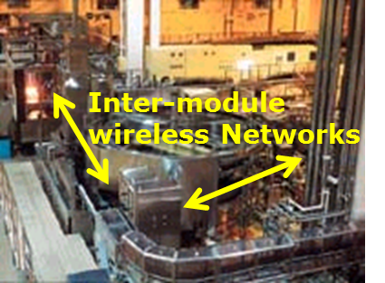
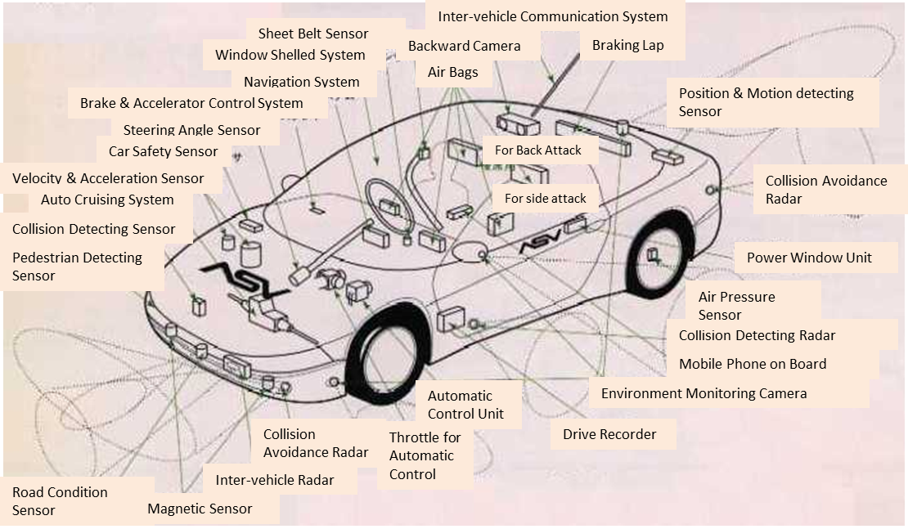
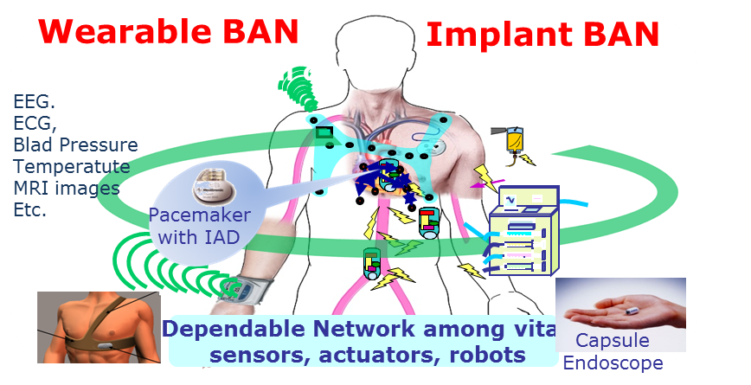
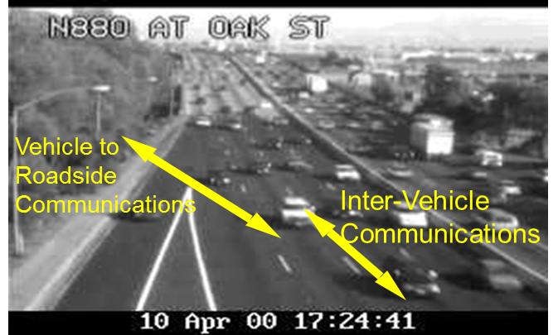
Use case1; Dependable Sensing and Controlling inside a Car Improving Current CAN and LIN
Use case2; Dependable Sensing and Controlling for Line of Factory Automation
Use case3; Dependable Sensing and Controlling for Wearable and Implantable Medical Devices
Use case4; Dependable Sensing and Controlling for Vehicle Communications

