IEEE P802.15
Wireless Personal Area Networks

Project | IEEE P802.15 Working Group for Wireless Personal Area Networks (WPANs)
Title | IEEE P802.15.TG4e Call For Applications
Date Submitted | 16 September 2014
Source | [Arthur Astrin]  1051 Greenwood Avenue  Palo Alto, CA 94301 | Voice: [+1 650 704 2517]  E-mail: [astrin@ieee.org]
Re: | [IEEE P802.15 IG DEP was formed with the charter of drafting a standard for dependable communication.]
Abstract | [The following submission is a call for interest, participation, applications and proposals from the IEEE, Industry, and Academia.]
Purpose | [Request for formal submissions to the P802.15 IG DEP]
Notice | This document has been prepared to assist the IEEE P802.15. It is offered as a basis for discussion and is not binding on the contributing individual(s) or organization(s). The material in this document is subject to change in form and content after further study. The contributor(s) reserve(s) the right to add, amend or withdraw material contained herein.
Release | The contributor acknowledges and accepts that this contribution becomes the property of IEEE and may be made publicly available by P802.15.
CALL FOR INTEREST AND APPLICATIONS

Introduction and background for this call for interest.

In some applications there are benefits of wireless over wired communication:

Wireless links require no connectors
As a communication channel they cannot be cut, corrode or be fatigued to a breakage
Node can be installed in rotating machinery, such a car tires. Such applications could be done with wires, by using commutating contacts, but these wear out and are unreliable.
Since there are no connectors or wires, the overall system weighs less, often hundreds of pounds. This is important in airplanes and cars.
Many applications requiring node mobility can only be realistically implemented with wireless, i.e. cell phone.

Drawbacks of the wireless links

Wireless links can be obstructed by objects moving into the channel. This can be mitigated by using multiple paths.
Links are subject to interference and jamming, which can increase errors in communication. Many modern wireless communication protocols have mitigated this.
Nodes still require wires for power, unless they can be powered by a battery or an energy harvesting system.

Many current wireless standards were designed without the consideration of link dependability. For example the cell phone sometimes do not work inside buildings, however we have learned that by walking towards windows we can sometimes restore the link. This additional movement is an example of restoration of link and allows for increased dependability.

As a result of the IEEE P802.15 Interest Group (IG-DEP) effort, we believe that there is a need for a dependable communication standard, optimized to serve a variety of applications, including automotive, aircraft, trains, medical and other. We seek conformation of this belief by inviting indications of interest in wireless dependability, seeking to improve the link reliability, beyond current existing standards. Also please indicate if you would be interested in participation of the development of this standard.

The Interest Group is looking to identify key performance requirements/functional attributes, needed to support these applications. Parties are requested to submit application ideas. Top five applications will receive prizes.

Please submit your interest indication and application descriptions to the Arthur Astrin (astrin@ieee.org), Ryuji Kohno (kohno@ynu.ac.jp) and Jussi Haapola (jhaapola@ee.oulu.fi) by March 15, 2015 (just prior to IEEE 802 Plenary Session in Berlin, Germany).
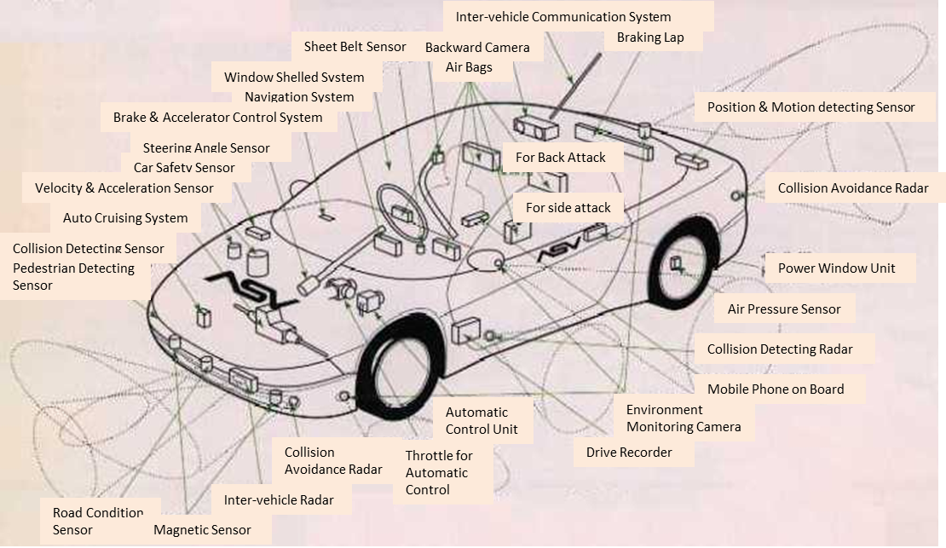
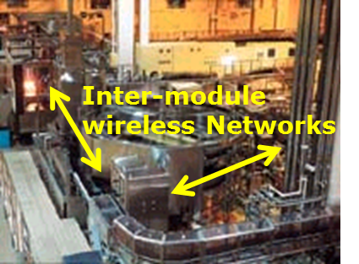
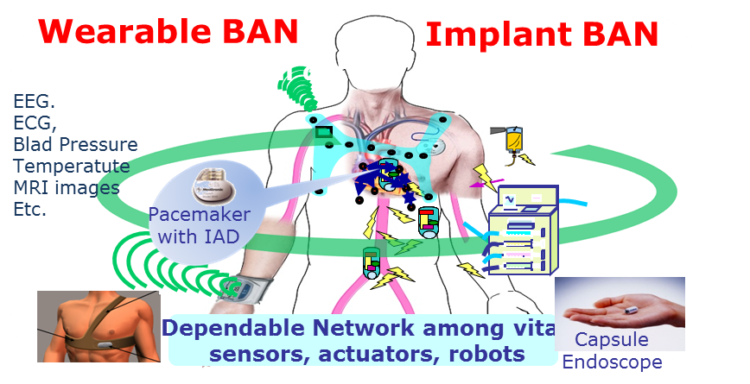
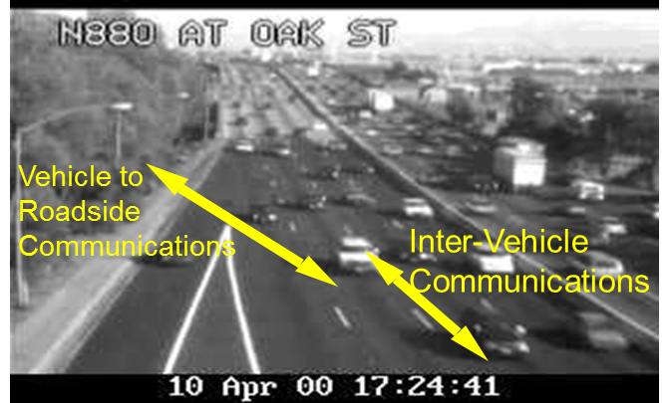
Use case1; Dependable Sensing and Controlling inside a Car improving current CAN and LIN
Use case2; Dependable Sensing and Controlling for Line of Factory Automation
Use case3; Dependable Sensing and Controlling for Wearable and Implantable devices
Use case4; Dependable Sensing and Controlling for Vehicle Communications

