IEEE P802.15
Wireless Personal Area Networks

Project | IEEE P802.15 Working Group for Wireless Personal Area Networks (WPANs)
Title | NICT’s MAC Proposal Document in Response to Call For Contribution
Date Submitted | March 12, 2014
Source | Huan-Bang Li, Marco Hernandez, Igor Dotlić, Ryu Miura (NICT)
Re: | In response to Call for Contributions to TG8
Abstract | MAC proposal document is summarized.
Purpose | For discussion in TG8
Notice | This document has been prepared to assist the IEEE P802.15. It is offered as a basis for discussion and is not binding on the contributing individual(s) or organization(s). The material in this document is subject to change in form and content after further study. The contributor(s) reserve(s) the right to add, amend or withdraw material contained herein.
Release | The contributor acknowledges and accepts that this contribution becomes the property of IEEE and may be made publicly available by P802.15.

Table of contents
1. Abbreviations and Acronyms 3
2. General Descriptions 4
2.1 Reference Model 4
2.2 General MAC format 4
3. MAC Layer 5
3.1 Overview 5
3.2 Common mode 5
3.3 Discovery 5
3.4 Emergency Message Management 7
3.5 Superframe Structure 7
3.6 Association 8
4. Group Operation 8
4.1 I-PD Procedure 10
4.2 J-PD Procedure 11

- Abbreviations and Acronyms
For the purposes of this document, the following abbreviations and acronyms apply.
CAP: contention access period
CCA: clear channel assessment
CFP: contention free period
I-PD: Initiator PD
I-PD seen by J-PD: TS beacon received
J-PD: Joiner PD
J-PD Joined: Received TB beacon with ID in list
TB: temporary beacon
TS: trigger signal

- General Descriptions
  - Reference Model
The operation of the PAC system will be defined in a conventional way as a set of interacting modules, such as in Figure 1 given below.

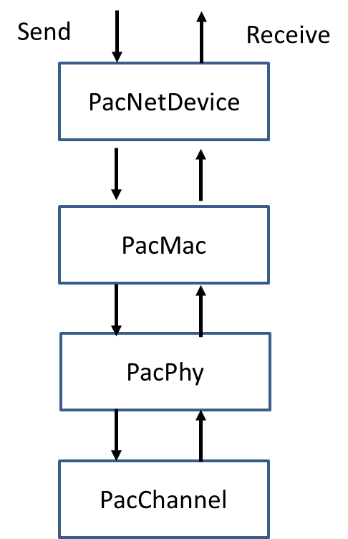

Figure 1. Communication Layer Model

  - General MAC format
A MAC frame consists of a fixed-length MAC header, a variable-length MAC frame body, and a fixed-length FCS field as shown in Figure 2. The MAC frame body has an octet length L_FB such that 0 ≤ L_FB ≤ pMaxFrameBodyLength, and is present only if it has a nonzero length.

Figure 2 MAC frame format

- MAC Layer
This clause describes the proposed MAC contents.
  - Overview
For a given frequency band adopted by PAC, a common mode shall be defined. All PDs must implement the common mode to guarantee interoperability among PDs. Common mode used in different frequency bands needs not necessarily be the same. Besides common mode, a PD should be able to operate at a number of selected operation modes or in all operation modes. An operation mode will operate using a superframe structure that will be described in sub-clause 3.4.
  - Common mode
A common mode shall use a assigned fixed RF channel, and have fixed PHY parameters including modulation, channel coding, and data rate.
Common mode shall give the highest priorities for the following operation.
- Broadcasting/sending emergency message.
- Initiating a PAC group through sending short signal/message.

Any PD is allowed to send emergency message through common mode. Any PD is allowed to send short signal/message (TS: triggering signal) to initiate a PAC group to support a fully distributed, decentralized, and self-organized system. Usage of Common mode should be limited or avoid for an established PAC group.

  - Discovery
The discovery procedure is described as follows.
- There is no global clock for common mode. An initiator PD (I-PD) broadcasts a short signal/message on its own clock. Hereafter, we refer to the short signal/message broadcasted over common mode as a trigger signal (TS).
- Length of a TS that is broadcasted via the common mode shall be within the maximum length T_{coMAX_send} (duration of TS). Re-broadcasting of a TS shall be after a minimum duration T_{coMIN_duration} (period of TS), as illustrated in Figure 3.1

Figure 3.1 Duration and period of TS.
- An I-PD shall perform CCA before broadcasting a TS. The minimum CCA time is T_{coMIN_cca}.
  - When CCA reports a clear channel at time t_{k}, the I-PD shall send TS at t_{k} +T_{coMIN_duration} and stop after sending the last TS at t_{k} + N_{co_send} ×T_{coMIN_duration}, as shown in Figure 3.2. Where, N_{co_send} is an integer randomly selected within [1, N_{coMAX_send}], and N_{coMAX_send} is the maximum number that a TS can be repeatedly broadcasted in an iteration. After an iteration, N_{co_send} is reset for the next iteration.

Figure 3.2 Maximum transmission number of TS.
  - After 3A), the I-PD shall perform CCA again before further broadcasting. When CCA reports a clear channel, the I-PD repeats (iteration) procedure 3A) again.
  - Procedure of 3B) will be iterated until the upper layers stop the iteration.
  - In each iteration, the group clock provides the information of start time, t_{_start}, of TS which is synchronized to the first broadcasted TS, as well as the information of the current TS time, t_{_now}. The latter is the start time of TS in the current iteration, as illustrated in Figure 3.3.

Figure 3.3 Iteration of TS.
  - Emergency Message Management
For emergency message, the following parameters can be applied.
  - PD shall broadcast emergency message directly via common mode under constraints 2-3 when required (e.g., asked by upper layer).
  - An emergency message could have a maximum length of T_{coMAX_send} multiplied by m (integer).
  - The repetition interval of an emergency message could be T_{coMIN_duration} divided by k (integer).
For example, typical value of m and k can be selected from

1 ≤ m ≤ 3
and

2 ≤ K ≤ 4.

  - Superframe Structure
In order to facilitate usage of common mode and operation mode, a superframe structure as shown in Figure 3.4 is given.
The superframe structure consists of a temporary beacon (TB), a contention-free period (CFP), and a contention access period (CAP). The clock of TB is synchronized to the first TS. The length of a superframe is equal to T_{coMIN_duration}.
The length of TB needs to be decided according to the data size assigned but it is much larger than TS. CAP is used by J-PD as backoff interval in the group operation to be described shortly. CFP is used for group communication among PDs in the group.

Figure 3.4 Superframe structure.

  - Association
The association procedure is described as follows.
- The I-PD broadcasts an invitation (active scanning) with TS including information of necessary IDs, selected operation mode (including channel), and a group clock.
- When a joiner PD (J-PD) scans the invitation (passive scanning) at common mode, it moves to the selected operation mode announced in (i). Accounting from the start of TS, the joining PD waits for a duration of TB+CFP. Then, it sends joining request including its ID information with a random backoff within a duration of CAP.
- When a J-PD scans the TS in an iteration, it should calculate the difference between t_{_now} and t_{_start}. If t_{_start} is within a CAP, the J-PD takes random backoff between t_{_start} and the end of CAP and sends joining request. If t_{_start} is out of a CAP, it waits until the next CAP before sending request, as illustrated in Figure 3.5.
- I-PD scans the selected operation mode (passive scanning), registers the J-PDs and distributes a list of the registered PDs within the temporary beacon (TB) at the selected operation mode.
- J-PDs that had sent joining requests but are not included in the distributed PDs list should repeat the process of (ii) and (iii).

Figure 3.5 Association procedure illustration.

- Group Operation
Group operation with an operation mode is based on a superframe structure. The group operation procedure is illustrated in Figure 4.1.
- The I-PD broadcasts group forming invitation (active scanning) within a TS including information of necessary IDs, selected operation mode (including channel), and group clock.
- When a J-PD scans the invitation (passive scanning) at common mode, it moves to the selected operation mode that was announced by I-PD. Accounting from the start of TS, the J-PD waits for a duration of TB+CFP. Then, it sends joining request including its ID information with a random backoff within a duration of CAP.
- When a J-PD scans the TS in an iteration, it will calculate the difference between t_now and t_start. If t_start is within a CAP, the J-PD takes random backoff between t_start and the end of CAP and sends joining request. If t_start is out of a CAP, it waits until the next CAP before sending request.
- I-PD scans the selected operation mode (passive scanning), registers the J-PDs and distributes a list of the registered PDs within the temporary beacon (TB) at the selected operation mode. J-PDs that had sent joining requests but are not included in the distributed PDs list should repeat the joining process.

Contention Access Period
Joining nodes will choose a random time in the contention period to transmit a JoinRequest packet. They will repeat the transmission if they are not included in the next GroupAnnounce transmission from the PD.

Contention-Free Period (TBD)
After joining the group, nodes will transmit packets in the contention free part of the superframe. The contention-free period could use token-based polling, as in the PCF of IEEE802.11, or fixed slot assignment.

Figure 4.1 Group operation procedure.

The I-PD and J-PD procedures are respectively illustrated in the follows.

  - I-PD Procedure
This sub-clause illustrates the I-PD procedure as given in Figure 4.2.
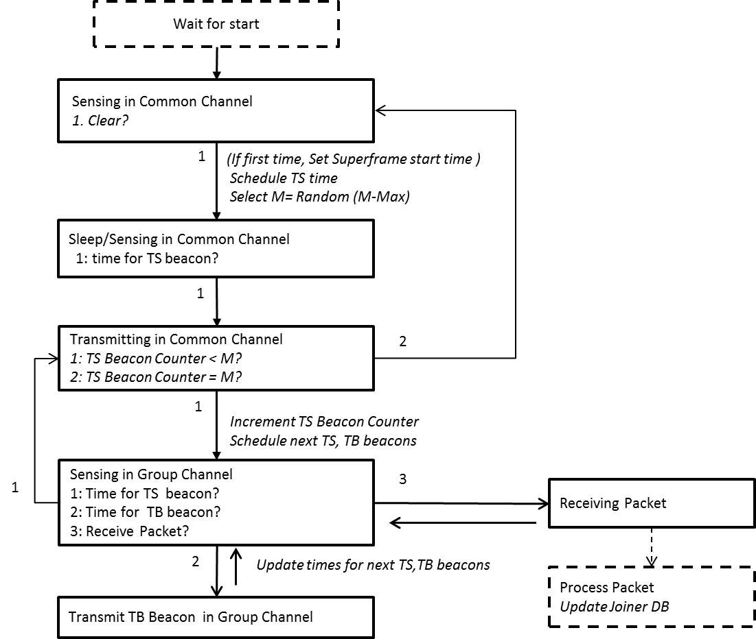

Figure 4.2 I-PD procedure illustration.

  - J-PD Procedure
This sub-clause illustrates the J-PD procedure as given in Figure 4.3.

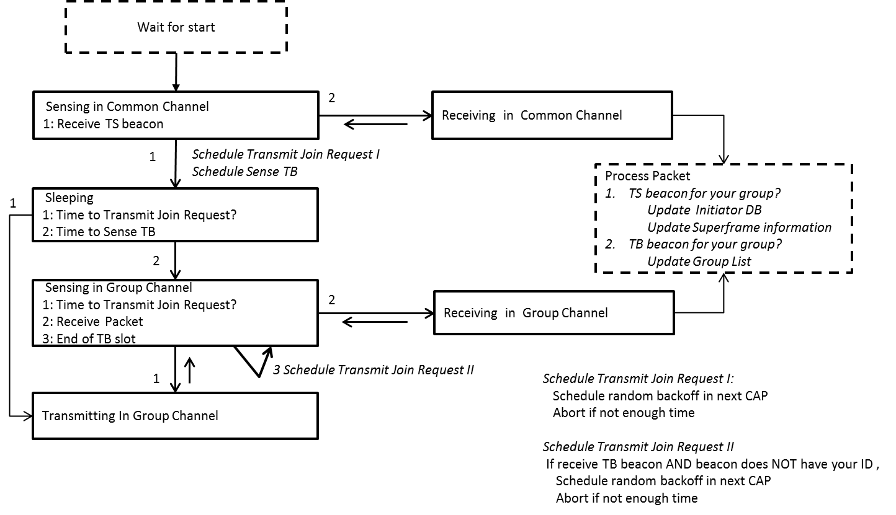

Figure 4.3 J-PD procedure illustration.

