IEEE P802.15
Wireless Personal Area Networks

Project | IEEE P802.15 Working Group for Wireless Personal Area Networks (WPANs)
Title | TG4n Coexistence Assurance Document
Date Submitted | 23 January 2014
Source | Liang Li, Arthur Astrin, Ken Mori
Re: | IEEE 802.15.4n
Abstract | Analysis on coexistence of IEEE 802.15.4n with other IEEE 802 systems within the same frequency band
Purpose | To address the coexistence capability of IEEE 802.15.4n to satisfy requirements of the IEEE 802.19 Work Group and IEEE 802 Executive Committee to determine if a proposed IEEE 802 standard has made a reasonable effort to be able to coexist with devices compliant to other IEEE 802 standards in their operating band.
Notice | This document has been prepared to assist IEEE P802.15 coexistence. It is offered as a basis for discussion and is not binding on the contributing individual(s) or organization(s). The material in this document is subject to change in form and content after further study. The contributor(s) reserve(s) the right to add, amend or withdraw material contained herein.
Release | The contributor acknowledges and accepts that this contribution becomes the property of IEEE and may be made publicly available by P802.15.

Table of Contents
1 Scope 1
2 References 1
3 Acronyms and abbreviations 2
4 IEEE 802.15.4n amendment overview 2
4.1 Operating frequency bands 2
4.2 Modulation parameters 3
4.3 Coexistence mechanisms 3
5 Other IEEE 802 standards occupying same frequency bands 4
6 Coexistence scenarios and analysis 4
6.1 Methodology 4
6.1.1 Path loss model 4
6.1.2 PER for IEEE 802.15.4n 5
6.2 Coexistence with IEEE 802.15.4c devices 5
6.3 Transmit power spectral density (PSD) mask 6
6.4 Receiver sensitivity 6
6.5 Receiver interference rejection 6
7 Discussions and conclusion 7

Scope
The IEEE 802.19 Work Group has mandated that new wireless standards developed under IEEE 802 be accompanied by a Coexistence Assurance document. In [3], guidelines are provided for how coexistence can be quantified based on predicted packet error rates among IEEE 802 wireless devices. A detailed discussion of coexistence and coexistence methods can be found in IEEE Standard 802.15.2-2003 [2]. Hence, this coexistence assurance document is provided by the IEEE 802.15.4n Task Group to satisfy the requirements of the IEEE 802.19 Work Group and IEEE 802 Executive Committee.
The Ministry of Industry and Information Technology (MIIT) of the People's Republic of China has approved the 174-216 MHz, 407-425 MHz and 608-630 MHz bands for medical information transmission.
The IEEE 802.15 Task Group 4n defines an amendment to the IEEE Standard 802.15.4 [4], including changes to the Medium Access Control (MAC) layer and additions to the PHY layer to support these bands. This amendment will enable devices to be used on or near a body in compliance with the Chinese Medical Band (CMB) Rules. The IEEE 802.15.4n Amendment is only valid for the People's Republic of China (CN) and therefore this document will only address coexistence within the People's Republic of China. At the time of writing of this document, this band cannot be used by CMB devices outside of the People's Republic of China.
Chinese Medical Band (CMB) devices operating within these bands conform to a set of rules [1] specified in China, Ministry of Industry and Information Technology Doc: 423-2005, which restrict use of the band to only medical, non-voice use under direction of a healthcare practitioner, among other requirements.
This document addresses the coexistence of the IEEE 802.15.4n CMB band systems with other IEEE 802 standards operating in the same frequency bands. It addresses the interference caused by IEEE 802.15.4n devices to these existing systems, and the interference from these existing standards with IEEE 802.15.4n.

References
- Ministry of Industry and Information Technology of the People’s Republic of China document No. 423 (2005) available at: http://www.miit.gov.cn/n11293472/n11295310/n11297428/11637344.html
- IEEE Std 802.15.2TM-2003, “Coexistence of Wireless Personal Area Networks with Other Wireless Devices Operating in Unlicensed Frequency Band”
- S. Shellhammer, “Writing a Coexistence Assurance Document,” IEEE 802.19-09/0001r0, 2009.
- IEEE Std 802.15.4TM-2011.
- S. Shellhammer, “Estimating of Packet Error Rate Caused by Interference – A Coexistence Assurance Methodology,” IEEE 802.19-05/0028r2, 2005.
- J .G. Proakis, Digital Communications 4th edition, 2000.
- Doc 15-12-0105-02-4n-Translaiton of Chinese-MIIT-Doc423-2005.doc
- Doc 15-13-0313-03-4n-Chinese-Radio-Regulation-Discussion.doc
- Doc 15-12-0471-04-4n-summary-of-interference-on-Chinese-Medical-bands.doc

Acronyms and abbreviations

AWN Affected Wireless Network
BAN Body Area Network
BCH Bose, Ray-Chaudhuri, Hocquenghem Code
BER Bit Error Rate
CCA Clear Channel Assessment
D-MPSK Differential M-ary Phase Shift Keying
DSSS Direct Sequence Spread Spectrum
ED Energy Detection
IWN Interfering Wireless Network
LQI Link Quality Indicator
CMB Medical Body Area Network Service
OOB Out-of-band
O-QPSK Offset Quadrature Phase Shift Keying
PER Packet Error Rate
SINR Signal to Interference plus Noise Ratio
SIR Signal to Interference Ratio

IEEE 802.15.4n amendment overview

Operating frequency bands
The allocated frequency band for the IEEE 802.15.4n Amendment is:

Band Identifier (MHz) | Frequency band (MHz)
195 | 174-216
416 | 407-425
619 | 608-630

Modulation parameters
The IEEE 802.15.4n CMB consists of two PHYs: O-QPSK and GFSK. Modulation parameters in the frequency bands are shown in Error: Reference source not found.

Band Identifier (MHz) | Frequency band(MHz) | Spreading parameters |  | Data parameters
Band Identifier (MHz) | Frequency band(MHz) | Chip rate (kchip/s) | Modulation | Bit rate (kb/s) | Symbol rate (ksymbol/s) | Symbols
195 | 174-216 | 1000 | O-QPSK | 250 | 62.5 | 16-ary orthogonal
195 | 174-216 | 1000 | O-QPSK | 500 | 125 | 8-ary orthogonal
416 | 407-425 | 1000 | O-QPSK | 250 | 62.5 | 16-ary orthogonal
416 | 407-425 | 1000 | O-QPSK | 500 | 125 | 8-ary orthogonal
619 | 608-630 | 1000 | O-QPSK | 250 | 62.5 | 16-ary orthogonal
619 | 608-630 | 1000 | O-QPSK | 500 | 125 | 8-ary orthogonal
Table 1 – IEEE 802.15.4n Frequency bands and data rates for CMB O-QPSK PHY
Band Identifier (MHz) | Frequency band(MHz) | Spreading parameters |  | Data parameters
Band Identifier (MHz) | Frequency band(MHz) | Chip rate (kchip/s) | Modulation | Bit rate (kb/s) | Symbol rate (ksymbol/s) | Symbols
195 | 174-216 | --- | GFSK (common) | 50 | 1.0 | Binary
195 | 174-216 | --- | GFSK (optional) | 100 | 0.5 or 1.0 | Binary
195 | 174-216 | --- | GFSK (optional) | 200 | 0.5 or 1.0 | Binary
416 | 407-425 | --- | GFSK (optional) | 50 | 1.0 | Binary
416 | 407-425 | --- | GFSK (optional) | 100 | 0.5 or 1.0 | Binary
416 | 407-425 | --- | GFSK (common) | 200 | 0.5 or 1.0 | Binary
619 | 608-630 | --- | GFSK (optional) | 50 | 1.0 | Binary
619 | 608-630 | --- | GFSK (optional) | 100 | 0.5 or 1.0 | Binary
619 | 608-630 | --- | GFSK (optional) | 200 | 0.5 or 1.0 | Binary
Table 2 – IEEE 802.15.4n Frequency bands and data rates for CMB GFSK PHY
Error: Reference source not found shows the modulation and channel parameters for the standard-defined PHY operating modes for the 195 MHz, 416 MHz, and 619 MHz bands. A device shall support mode #5 and may additionally support modes #1 to #4.

Frequency band | Parameter | Mode  #1 | Mode  #2 | Mode  #3 | Mode  #4 | Mode  #5
174-216MHz  407-425MHz  608-630MHz | Data rate (kb/s) | 100 | 100 | 200 | 200 | 50
174-216MHz  407-425MHz  608-630MHz | Modulation index | 0.5 | 1.0 | 0.5 | 1.0 | 1.0
174-216MHz  407-425MHz  608-630MHz | Channel spacing (kHz) | 500 | 500 | 500 | 500 | 500
Table 3 – IEEE 802.15.4n CMB GFSK modulation and channel parameters

Coexistence mechanisms
The coexistence mechanisms for the CMB band specified in the IEEE 802.15.4n standard are:
- Clear Channel Assessment (CCA)
  - Energy detection and/or carrier sense
- Dynamic channel selection
- Low Duty cycle
- Limited transmission power
- Modulation
  - Direct sequence spread spectrum (DSSS) with half-sine pulse shaping
- ED and LQI
- Channelization Scheme
  - Channel alignment between IEEE 802.15.4n O-QPSK and IEEE 802.15.4n GFSK
  - Configurable channelization scheme to minimize co-channel operations with IEEE 802.15.4

Other IEEE 802 standards occupying same frequency bands
The frequency bands are 174-216 MHz, 407-425 MHz and 608-630 MHz bands. There are no other frequency bands used by the IEEE 802.15.4n Amendment.

Coexistence scenarios and analysis
This clause presents the analysis of the interference caused by IEEE 802.15.4n CMB devices to the IEEE 802 standard devices identified in section 5, and vice versa. Note that the interferer parameters chosen in the following sub-clauses are chosen for the purpose of coexistence analysis in this CA document and are a sub-set of the available modes.

Methodology
In order to quantify the coexistence performance, the techniques described in Shellhammer [3] and [5] have been adopted. The coexistence assurance methodology predicts the PER of an affected wireless network (AWN), in the presence of an interfering wireless network (IWN). In its simplest form, the methodology assumes an AWN and an IWN, each composed of a single transmitter and a receiver. The methodology takes as input a path loss model, a BER function for the AWN, and in some case predicted temporal models for packets generated by the AWN and for packets generated by the IWN. Based on these inputs, the methodology predicts the PER of the AWN as a function of the physical separation between the IWN transmitter and the AWN receiver.
The appeal of the coexistence assurance methodology is that multiple networking standards can be characterized and compared with just a few parameters, notably:
- Bandwidth of AWN and IWN devices
- Path loss model for the networks
- PER as a function of SIR of AWN devices

Path loss model
The coexistence methodology uses the path loss model described in IEEE 802.15.2-2003 [2], which stipulates a two-segment function with a path loss exponent of 2.0 for the first 8 meters and then a path loss exponent of 3.3 thereafter. The equations for determining the path loss are given in Table 3. The model does not apply below about 0.5 meters due to near-field and implementation effects [2].

Equation | Condition
Path loss = 40.2 + 20 log₁₀(d) | 0.5 m ≤ d ≤ 8 m
Path loss = 58.2 + 33log₁₀(d/8) | d > 8 m
Table 3 – Path loss (dB) at 2.4 GHz versus distance (m)
The path loss versus distance is shown in Figure 1 [5].
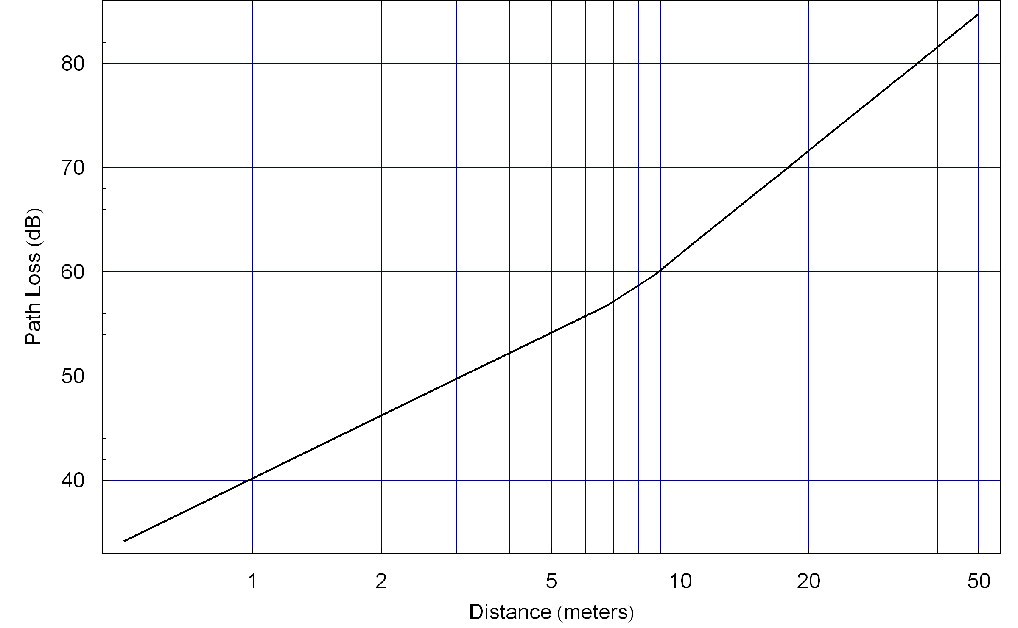
Figure 1 – Path loss curve for 2.4 GHz band

PER for IEEE 802.15.4n
The PER for the 2450 MHz O-QPSK PHY in IEEE 802.15.4 is calculated from a BER model. The BER (P_{b}) is given as a function of SIR as follows [4]:

$P_{b}=\left(\frac{8}{\text{15}}\right)\left(\frac{1}{\text{16}}\right)\sum_{j=2}^{\text{16}}{{\left(−1\right)}^{j}\left(\begin{matrix}\text{16} \\ j\end{matrix}\right)\text{exp}\left(\text{20}\text{SIR}\left(\frac{1}{j}−1\right)\right)}$ (1)
From the computed BER, the PER is obtained as shown in the Equation (2).
$\text{PER}=1−{\left(1−P_{b}\right)}^{L}$ (2)
where L is the number of bits in a packet and the typical length of an IEEE 802.15.4n packet is 22 octets [4].

Coexistence with IEEE 802.15.4c devices
The top edge of the CMB band at 619 MHz lies adjacent to the 779 - 787 MHz band. This band is used by IEEE standards such as IEEE 802.15.4. It is therefore important to consider the likely impact of CMB devices that are operating adjacent to other IEEE 802 wireless systems.
The MIIT rules [1] for CMB devices specify that transmitter out-of-band (OOB) emissions are attenuated in accordance with [7]. This requires that the emissions at in 619 band do not interfere with 779-787 band.

Transmit power spectral density (PSD) mask

In general, when operating in the 176 MHz, 407MHz and 608MHz bands, the transmitted spectral products shall be less than the limits specified in Error: Reference source not found.
For both relative and absolute limits, average spectral power shall be measured using a 100 kHz resolution bandwidth. For the relative limit, the reference level shall be the highest average spectral power measured within ±600 kHz of the carrier frequency f_{c}.

Frequency | Relative Limit | Absolute limit
|f-f_{c}| > 1.2 MHz | -20 dB | -20dBm
- Table 4 – IEEE 802.15.4n PSD Limitation among channels
However, there are some special limitations for spurious radio emission on the Chinese radio regulation in Bibliography. These spurious emission details related to Chinese approved radio bands for medical signal transmission are shown in [7], [8] and [9].

Receiver sensitivity

Under the conditions specified in Table 69 (8.1.7), a compliant device shall be capable of achieving the sensitivity values given in Error: Reference source not found or better.
Frequency band (MHz) | RateMode
Frequency band (MHz) | 0 | 1
176-214 | -85 | -82
407-425 | -85 | -82
608-630 | -85 | -82
Table 5 – IEEE 802.15.4n required receiver sensitivity (dBm) for both RateMode modulations

Receiver interference rejection

There are multiple receiver interference caused by CMB O-QPSK compliant signals, and TV, industry and commercial in the same bands.
The interfering signal shall be a CMB O-QPSK compliant signal with the following characteristics:
- Pseudo-random PSDU
- SpreadingMode set to DSSS
- The same chip rate as the desired signal
- Chip-whitening enabled

The TV, industry and commercial interference are:
- On 176-216 MHz band, the major interferences are sourced from: Digital TV, and Wireless Microphone
- On 407-425 MHz band, the major interferences are sources from Interphone (Walkie-talkie)
- On 608-630 MHz band, the major interferences are sources from Digital TV.

The details of TV, industry and commercial interference are described in Annex K.
The interference-to-signal ratio (ISR) is the ratio of the signal power of an interferer relative to the signal power of the desired signal.
The adjacent channel rejection shall be measured as follows: the desired signal shall be a CMB O-QPSK compliant signal of pseudo-random PSDU data. For a given RateMode, the desired signal is input to the receiver at a level 3 dB above the maximum allowed receiver sensitivity of Error: Reference source not found.
The TV rejection shall be measured as follows: at CCA detection time, if the receiver ED level is higher ED threshold desired by user, there may be TV or other industry or commercial interference on same channel or band.
The detection methods of TV, industry and commercial interference are outside the scope of this standard.

Discussions and conclusion
This document has presented an analysis of the coexistence between the IEEE 802.15.4n Amendment and IEEE 802.15.4 systems. The results of the analysis as presented in figure 4 indicate that distances of over 12m and 40m are required to protect IEEE 802.15.4n and IEEE 802.15.4 systems respectively. This is notable since it is expected that these two systems may be used together in close proximity around the human body. It would appear that the separation distance to protect IEEE 802.15.4n is unaffected by the data rate that is used.
However the analysis has focused on the worst case “on-channel” situation where both systems are operating on the same center frequency with 100% duty cycle. It is expected that the typical duty cycle will be less than 20%. The dynamic channel selection feature of IEEE 802.15.4n would minimize the probability of such worst case in practice. When devices are not operated on the same center frequency it is the adjacent and alternate channel performance of the receiver of the device that becomes important.
For IEEE 802.15.4 devices the adjacent channel rejection is 17 dB at a 121.4 kbps data rate [7]. No figure is defined for the alternate channel. This would suggest that once IEEE 802.15.4n devices are operated in the adjacent channel of IEEE 802.15.6 and beyond, safe operating distances of a few meters and below may be possible. It should be noted that the channel plan for the IEEE 802.15.4n Amendment was developed to be in alignment with the channel raster of IEEE 802.15.4. There is therefore the potential for an IEEE 802.15.4 device to operate between two IEEE 802.15.4n channels.
For IEEE 802.15.4n devices the adjacent channel rejection is 0dB and for the alternate channel the rejection figure is 30 dB [3]. The alternate channel figure indicates with suitable channel separation, IEEE 802.15.4 devices can be operated at distances well below 1m.
IEEE 802.15.4n devices can be operated at a transmit power of 10 dBm in the CMB bands and this requires an increase in the distance to over 96 m to protect IEEE 802.15.4 devices. In this situation the OOB emission limits on IEEE 802.15.4n devices will however allow IEEE 802.15.4 devices in the 2360-2390 MHz to operate at 1.7m separation.
As a victim, 802.15.4n GFSK has comparable BER performance with the other 802 GFSK systems; 802.15.4n DSSS has much better BER performance than the other 802 DSSS systems due to the high spreading factor values. As an interferer, either 802.15.4n GFSK or 802.15.4n DSSS has similar performance impact to the other 802 systems at the same transmitting power level. However the performance degradation to the other systems can become significant as the transmitting power is increased up to the possible maximum 10dBm. This requires more physical distance from other 802 systems if an 802.15.4n system is designed to operate at a high transmitting power level.

