IEEE P802.15
Wireless Personal Area Networks

Project | IEEE P802.15 Working Group for Wireless Personal Area Networks (WPANs)
Title | NICT Impulse Radio Ultra-Wideband PHY Proposal to IEEE 802.15.8 (text for the Framework Doc.)
Date Submitted | Nov 2013
Source | Igor Dotlic, Huan-Bang Li, Marco Hernandez and Ryu Miura (NICT) | E-Mail: [dotlic@nict.go.jp]
Re: | TG8 Call for Proposals (CFP) (15-13-0069-05-0008)
Abstract | This is the text of the NICT Impulse Radio Ultra-Wideband PHY proposal to IEEE 80215.8.
Purpose | This document provides the details of the NICT IR-UWB PHY proposal to IEEE 802.15.8
Notice | This document does not represent the agreed views of the IEEE 802.15 Working Group or IEEE 802.15.8 Task Group. It represents only the views of the participants listed in the “Source(s)” field above. It is offered as a basis for discussion and is not binding on the contributing individual(s) or organization(s). The material in this document is subject to change in form and content after further study. The contributor(s) reserve(s) the right to add, amend or withdraw material contained herein.
Release | The contributor acknowledges and accepts that this contribution becomes the property of IEEE and may be made publicly available by P802.15.
Patent Policy | The contributor is familiar with the IEEE-SA Patent Policy and Procedures:  <http://standards.ieee.org/guides/bylaws/sect6-7.html#6> and  <http://standards.ieee.org/guides/opman/sect6.html#6.3>.  Further information is located at <http://standards.ieee.org/board/pat/pat-material.html> and  <http://standards.ieee.org/board/pat>.

- Table of Contents
Concepts and architecture 3
Topology 3
Reference model 3
MPDU structure 3
Multiple access 3
Synchronization procedure 3
Discovery procedure 3
Peering procedure 3
Scheduling 4
QoS 4
Interference management 4
Transmit power control 4
Multicast 4
Broadcast 4
Multi-hop operation 4
Relative positioning 4
Power management 4
Security 4
Coexistence 4
Higher layer interaction 4
Channelization 4
1.1.1.Operating frequency bands 4
Duplex schemes 5
Multiplex schemes 5
Frame structure 5
2.1.1.Discovery frame structure 5
2.1.2.Data frame structure 5
Modulation and coding scheme (MCS) 5
2.1.3.Pulse shape and duration 5
2.1.4.Packet structure 5
2.1.5.SHR Structure 6
2.1.6.Symbol structure 6
2.1.7.Channel coding and data rates 6
7
Fig. 4.: Concatenated coding scheme used. 7
2.1.8.Symmetrical Double-sided Two-way Ranging. 7
Multiple antennas 7

Overview
The 802.15.8 specification shall be developed according to the P802.15.8 Peer Aware Communication (PAC) project authorization request (PAR), document number 15-12-0063r2 and Five Criteria (5c), document number 15-12-0064r1, which were approved by the IEEE-SA in March of 2012.

Definitions

Abbreviations and acronyms
PD PAC Device

General descriptions
This clause provides the basic framework of PDs. The framework serves as a guideline in developing the functionalities of PDs and their interactions specified in detail in the subsequent clauses.

Concepts and architecture

Topology

Reference model

MAC layer

MPDU structure

Multiple access
e.g. Contention-based access, Contention-free access

Synchronization procedure

Discovery procedure

Peering procedure

Scheduling

QoS

Interference management

Transmit power control

Multicast

Broadcast

Multi-hop operation

Relative positioning

Power management

Security

Coexistence

Higher layer interaction

Physical layer

Channelization

Operating frequency bands
We are using higher UWB band of 6 – 10.25 GHz as specified in “Technical Guidance for 802.15.8 Proposals.” We are proposing a single channel in upper UWB band for the system to maximize allowed Tx power level. Channel location and bandwidth are determined by regulation at a given Geo.

Duplex schemes

Multiplex schemes
(e.g. CDMA, OFDMA)

Frame structure

Discovery frame structure

Data frame structure

Modulation and coding scheme (MCS)

Pulse shape and duration
We do not define a specific pulse shape in order to allow different low-complexity pulse generators.
Furthermore, operating bands are not defined will be different at different Geos.
Pulse shape is constrained
In spectrum by the local regulations.
In duration by the Duty Cycle (DC) of no more than DC=1/32=3.1%.

Packet structure

SHR
PHR
PPDU

Fig. 1: Packet structure.

As Fig, 1. shows, packet consists of SHR – Synchronization Header, PHR – PHY Header and PPDU – Physical Layer Protocol Data Unit.

SHR Structure

Preamble
SFD
Fig. 2. SHR structure.

Preamble consists of M=8 times repetition of the sequence S_{i}. S_{i} is one of the Gold sequences of length 31. Since set of Gold sequences of length 31 has 33 sequences, there are 33 virtual channels available per physical channel. Gold sequences of length 31 have relatively short length with good circular autocorrelation properties.
Synchronization Frame Delimiter (SFD) represents inversion of S_{i} used in the preamble.

Symbol structure
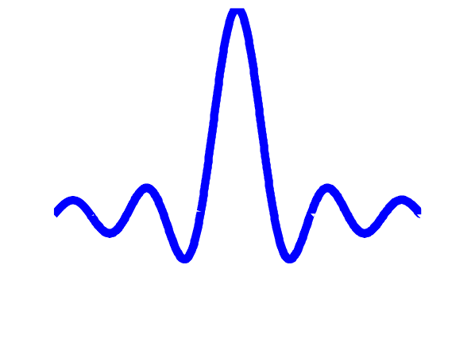
Fig. 3. Symbol structure

Symbol structure is shown in Fig. 3. The whole packet, is transmitted using the same symbol structure regardless of the data rate used with On-Off Keying (OOK) modulation. For , where is the symbol index, the same symbol duration of is used. Transmitted pulse waveform is denoted . Hence, transmitted signal for the -th transmitted symbol is

(1)

where is transmitted bit and is pseudo-random sequence used in to flatten the spectrum of the transmitted signal, while for is set. Pseudo-random sequence used is the same Gold sequence used in PR and SFD for .

Channel coding and data rates
RS coder
Bit interleaver
Conv. coder
Modulator
Fig. 4.: Concatenated coding scheme used.

Coding is concatenation of outer Reed-Solomon RS₆(63,55) codes and inner convolutional codes. Different data rates have different convolutional coding as in Table 1.

Data rate (Kbps) | 54.56 | 109.12 | 218.25 | 436.51 | 873.02
Conv. coding rate | 1/4 | 1/4 | 1/4 | 1/2 | 1/1
Chips per symbol | 4 | 2 | 1 | 1 | 1
Table 1.: Data rates used with convolutional coding rates and number of chips per symbol.

Table 2. provides detailed specification of the convolutional codes used. Bit interleaver used is algebraic bit interleaver specified in the UWB PHY of the IEEE 802.15.6-2012 standard for Body Area Networks.

Conv. coding rate | ½ | ¼
Constrained length | 3 | 4
Generators in octal | 5 7 | 13 15 15 17
Free distance | 8 | 13
Table 2.: Convolutional codes used.

Symmetrical double-sided two-way ranging
Tround1
Tprop
Treply1
t
Tprop
Tprop
t
Tround2
Treply2
Device 1
Device 2
Tprop

Fig. 4. Principle of symmetrical double-sided two-way ranging.

As Fig. 4. shows, symmetrical double-sided two-way ranging is achieved by measuring two round trip times: round trip time from device 1 to device 2 denoted and round trip time from device 2 to device 1 denoted .
denotes propagation time that is being estimated, while and represent reply times of device 1 and 2 respectively. Hence, estimate is calculated as follows
. (2)
If relative errors of timing at device 1 and 2 are denoted and it follows that
(3)
(4)
(5)
(6)
Thus error of estimation is:
(7)
Hence, relative error of the range estimation is also in the same order of magnitude as and , which for crystal oscillators is usually around 20 ppm.

Multiple antennas

