IEEE P802.15
Wireless Personal Area Networks

Project | IEEE P802.15 Working Group for Wireless Personal Area Networks (WPANs)
Title | Draft 0.1
Date Submitted | [Nov. 06, 2013]
Source | [Liang Li, Eggert Dietmar,  Kenichi Mori, Masahiro Kuroda, Andy Bottomley, Shin Hara, Rick Powell] | Voice: [ 949-813-7909]  Fax: [ ]  E-mail: [liangli@vinnotech.com,  Dietmar.Eggert@atmel.com  mori.ken1@jp.panasonic.com,  andy.bottomley@microsemi.com  shinsukehara0122@gmail.com  marsh@nict.go.jp  Rick.Powell@microsemi.com]
Abstract | This document is a contribution to work done thus far by TG4n
Purpose | This document is contribution in preparing a draft for letter ballot.
Notice | This document has been prepared to assist the IEEE P802.15. It is offered as a basis for discussion and is not binding on the contributing individual(s) or organization(s). The material in this document is subject to change in form and content after further study. The contributor(s) reserve(s) the right to add, amend or withdraw material contained herein.
Release | The contributor acknowledges and accepts that this contribution becomes the property of IEEE and may be made publicly available by P802.15.

IEEE Standard for
Local and metropolitan area networks—

Part 15.4: Low-Rate Wireless Personal Area
Networks (WPANs)

Amendment X: Physical Layer Utilizing Dedicated Chinese Medical Bands (176-214, 407-425, 608-630 MHz)

NOTE— The editing instructions contained in this amendment define how to merge the material contained therein into the existing base standard and its amendments to form the comprehensive standard.

The editing instructions are shown in bold italic. Four editing instructions are used: change, delete, insert, and replace.
Change is used to make corrections in existing text or tables. The editing instruction specifies the location of the change and describes what is being changed by using strikethrough (to remove old material) and underscore (to add new material).
Delete removes existing material. Insert adds new material without disturbing the existing material. Deletions and insertions may require renumbering. If so, renumbering instructions are given in the editing instruction. Replace is used to make changes in figures or equations by removing the existing figure or equation and replacing it with a new one. Editing instructions, change markings, and this NOTE will not be carried over into future editions because the changes will be incorporated into the base standard.

Abstract: This amendment to IEEE Standard 802.15.4-2011 provides two PHYs (O-QPSK and GFSK) that support device monitoring, control applications on Chinese approved radio bands for medical signal transmission (176-214 MHz, 407-425 MHz, and 608 – 630 MHz). In addition, the amendment describes only those MAC modifications needed to support the implementation of the PHYs.

Keywords: low data rate, low power, LR-WPAN, PAN, personal area network, radio frequency, RF, wireless personal area network, WPAN, MBAN, CMB.

2. Normative references

Insert the following new reference alphabetically into Clause 2:

China, Ministry of Industry and Information Technology Doc: 423-2005 ---- Technical Requirements for Micro-power (short- distance) Radio Devices in the 174 – 214, 407-425, and 608-630 MHz Bands.

3. Definitions, Acronyms, and Abbreviations

3.2 Acronyms and abbreviations

Insert the following acronyms alphabetically into 3.2:

DSSS direct sequence spread spectrum
MBAN medical body area network
PCA priority channel access
QPSK quadrature phase-shift keying
GFSK Gaussian filtered frequency-shift keying
CMB China medical band
TB total backoff
TID transaction identifier
TRLE time-slot relaying based link extension
BT bandwidth time duration product
ED Energy detection

4. General description

Insert the following new sub clause (4.1b) after 4.1a:

4.1b Introduction to medical body area network services on Chinese approved bands

The Ministry of Industry and Information Technology of the People's Republic of China has approved the 174-216 MHz, 407-425 MHz and 608-630 MHz bands for medical information transmission.

Chinese Medical Band (CMB) devices operating within these bands must conform to a set of rules specified in above rules issued by Ministry of Industry and Information Technology of the People's Republic of China, which restrict use of the band to only medical, non-voice use under direction of a healthcare practitioner, among other requirements.

This standard is applied to define the devices operating on Chinese approved bands for medical signals.

As one user within these bands, CMB devices are required to protect all users and accept possible interference from other users (such as Digital TV).

4.5.4 Improving probability of successful delivery

Insert the following after 4.5.4.1:

In the CMB environment, such as hospitals, some critical medical messages may have higher priorities than other messages such as network maintenance. Even among medical messages, the priorities of messages are different and may be so defined by users.

8. General PHY requirements
8.1 General requirements and definition Add the following items at the end of the second dashed list in 8.1 as shown:

- CMB O-QPSK PHY: direct sequence spread spectrum (DSSS) PHY employing offset quadrature phase shift keying (O-QPSK) modulation, operating in the 195 MHz bands, 416 MHz and 619 MHz as defined in Clause 21.1.
- CMB GFSK PHY: Gaussian frequency-shift keying (GFSK) PHY operating in the 195MHz,416MHz and 619MHz bands as defined in Clause 21.2.

8.1.1 Operating frequency range

Add new tables shown below after Table 66. Table 66a shows frequency bands for devices supporting the CMB O-QPSK PHY. Table 66b shows frequency bands for devices supporting the CMB GFSK PHY.

Insert the following new row before 780 DSSS as shown in Table 66:

Table 66a—Frequency bands and data rates for CMB and O-QPSK PHY

Band Identifier (MHz) | Frequency band(MHz) | Spreading parameters |  | Data parameters
Band Identifier (MHz) | Frequency band(MHz) | Chip rate (kchip/s) | Modulation | Bit rate (kb/s) | Symbol rate (ksymbol/s) | Symbols
195 | 174-216 | 1000 | O-QPSK | 250 | 62.5 | 16-ary orthogonal
195 | 174-216 | 1000 | O-QPSK | 500 | 125 | 8-ary orthogonal
416 | 407-425 | 1000 | O-QPSK | 250 | 62.5 | 16-ary orthogonal
416 | 407-425 | 1000 | O-QPSK | 500 | 125 | 8-ary orthogonal
619 | 608-630 | 1000 | O-QPSK | 250 | 62.5 | 16-ary orthogonal
619 | 608-630 | 1000 | O-QPSK | 500 | 125 | 8-ary orthogonal

Table 66b — Frequency bands and data rates for CMB GFSK PHY

Band Identifier (MHz) | Frequency band(MHz) | Spreading parameters |  | Data parameters
Band Identifier (MHz) | Frequency band(MHz) | Chip rate (kchip/s) | Modulation | Bit rate (kb/s) | Modulation Index | Symbols
195 | 174-216 | --- | GFSK (common) | 50 | 1.0 | Binary
195 | 174-216 | --- | GFSK  (Optional) | 100 | 0.5 or 1.0 | Binary
195 | 174-216 | --- | GFSK  (Optional) | 200 | 0.5 or 1.0 | Binary
416 | 407-425 | --- | GFSK (common) | 50 | 1.0 | Binary
416 | 407-425 | --- | GFSK  (Optional) | 100 | 0.5 or 1.0 | Binary
416 | 407-425 | --- | GFSK  (Optional) | 200 | 0.5 or 1.0 | Binary
619 | 608-630 | --- | GFSK (common) | 50 | 1.0 | Binary
619 | 608-630 | --- | GFSK  (Optional) | 100 | 0.5 or 1.0 | Binary
619 | 608-630 | --- | GFSK  (Optional) | 200 | 0.5 or 1.0 | Binary

8.1.2 Channel assignments

Insert the following new subclause (8.1.2.15) after 8.1.2.14:

8.1.2.15 Channel numbering for CMB PHYs

A channel page (phyCurrentPage; 9.3) value of 14 indicates the CMB PHYs. A device that implements more than one operation mode, as described by channels page 14, may have multiple channel page 14 entries in the phyCMBPageEntriesSupported table. The channels are defined by phyCMBChannelsSupported. The PHY PIB attributes are defined in 9.3.

Channel Page  14 | Frequency  band  (Table 66a) | Modulation Scheme =  CMB GFSK  (Table 66b) | List of GFSK operating mode supported  (Table 21.2.3)
Channel Page  14 | Frequency  band  (Table 66a) | Modulation Scheme =  CMB O-QPSK  (Table 66a) | Rate modes supported  (Table 66a)

Figure 64a Channel page structure for channel page 14.

8.1.2.15.1 Channel numbering for O-QPSK PHY

For O-QPSK PHY, each communication channel of MBAN occupies 2MHz band,

- For channel page 14, 21 channels numbered zero to twenty are available across the 195 MHz band.

The center frequencies of these channels are defined as follows:
Fc = 175 + 2 k in megahertz, for k = 0, 1, …, 20

- For channel page 14, 9 channels numbered zero to eight are available across the 416 MHz band.

The center frequencies of these channels are defined as follows:

Fc = 408 + 2 k in megahertz, for k = 0, 1, …, 8

- For channel page 14, 11 channels numbered zero to ten are available across the 619 MHz band.

The center frequencies of these channels are defined as follows:

Fc = 608 + 2 k in megahertz, for k = 0, 1, …, 10

8.1.2.16.2 Channel numbering for GFSK PHY

For CMB GFSK PHY, each communication channel occupies 500 kHz band,

- For channel page 14, 84 channels numbered zero to eighty three are available across the 195 MHz band.

The center frequencies of these channels are defined as follows:

Fc = 174.5+0.5*k megahertz, for k = 0, 1, …, 83

- For channel page 14, 36 channels numbered zero to thirty five are available across the 416 MHz band.

The center frequencies of these channels are defined as follows:

Fc = 407.5 + 0.5 k in megahertz, for k = 0, 1, …, 35

- For channel page 14, 44 channels numbered zero to forty three are available across the 619 MHz band.

The center frequencies of these channels are defined as follows:

Fc = 607.6 + 0.5 k in megahertz, for k = 0, 1, …, 43

where k is the channel number.

8.2 General radio specifications

8.2.7 Clear channel assessment (CCA)

Add the third paragraph of 8.2.7 as indicated:

The CCA parameters are subject to the following criteria:

Except for the CMB O-QPSK PHY, the Energy detection (ED) threshold shall correspond to a received signal power of at most 10 dB greater than the specified receiver sensitivity for that PHY. For the CMB O-QPSK PHY, the ED threshold shall comply with the specification in 21.1.3.4.13.

9. PHY services

9.2 PHY constants

Add Table 70 (the entire table is not shown) as indicated:

Table 70—PHY constants

Constant | Description | Value
aMaxPHYPacketSize | The maximum PSDU size (in octets) the PHY shall be able to receive. | 127 for all CMB PHYs
aTurnaroundTime | RX-to-TX or TX-to-RX turn- around time (in symbol periods), as defined in 8.2.1 and 8.2.2. | 12 for CMB O-QPSK PHY  TBD for CMB GFSK PHY

9.3 PHY PIB attributes

Change Table 71 (the entire table is not shown) as indicated:

Table 71— PHY PIB attributes

Attribute | Type | Range | Description
phyCMBChannelsSupported | List of channels |  | The list of channel number supported when phyCurrentPage = 14
phyMaxCMBChannelSupported | Integer | 0-83 | The maximum channel number supported by the CMB devices.  20 for CMB O-QPSK PHYs (see 8.1.2.15.1)  83 for CMB GFSK PHYs (see 8.1.2.16.2)  Values of 84 – 127 are reserved.
phyCurrentCMBPageEntry | CMB PHY mode | As shown in Figure 64a | Defines the current frequency band, modulation scheme, and particular PHY mode when phyCurrentPage =14

21. CMB PHY

Two PHYs are specified in order to support CMB applications: O-QPSK, as described in 21.1, and GFSK, as described in 21.2.

21.1 O-QPSK PHY specification

The O-QPSK PHY is described in the following subclauses.

21.1.1 PPDU format

For convenience, the PPDU structure is presented so that the leftmost field as written in this standard shall be transmitted or received first. All multiple octet fields shall be transmitted or received least significant octet first, and each octet shall be transmitted or received least significant bit (LSB) first.

The PPDU shall be formatted as illustrated in Figure 21.1.1

Octets
4 | 2 | 3 | variable
Preamble | SFD | As defined in 21.1.1.3 | PSDU
SHR |  | PHR | PHY payload

Figure 21.1.1—Format of CMB O-QPSK PHY PPDU

21.1.1.1 Preamble field

The length of the preamble for the O-QPSK PHYs shall be 8 symbols (i.e., 4 octets), and the bits in the Preamble field shall be binary zeros.

21.1.1. 2 SFD field

The SFD is a field indicating the end of the SHR and the start of the packet data. The SFD shall be formatted as illustrated in Table 21.1.1

Table 21.1.1—Format of the SFD field for CMB O-QPSK PHY

Bit 0 | 1 | 2 | 3 | 4 | 5 | 6 | 7 | 8 | 9 | 10 | 11 | 12 | 13 | 14 | 15
1 | 1 | 1 | 0 | 1 | 0 | 1 | 1 | 0 | 1 | 1 | 0 | 0 | 0 | 1 | 0

21.1.1.3 PHR field

The PHR field is descripted in Figure 21.1.2. All multi-bit fields are unsigned integers and shall be processed MSB first.

Bit string index | 0 | 1 | 2 – 8 | 9 – 15 | 16 - 23
Bit mapping | SM | RM0 | R6 -- R0 | L6–L0 | H7–H0
Field name | Spreading mode | Rate Mode | Reserved | Frame Length | HCS

Figure 21.1.2 — Format of the PHR for CMB O-QPSK PHY

For the 195 MHz, 416 MHz, and 618 MHz frequency bands, the SpreadingMode (SM) field shall be set to one if DSSS is used for PSDU spreading (variable SpreadingMode set to DSSS, as described in 21.3.2.4). Otherwise, the SM field shall be set to zero if DSSS is used for PSDU spreading (variable SpreadingMode set to DSSS, as described in 21 .3.2.4).

The O-QPSK PHY supports up to two different PSDU rate modes within each frequency band, and the rate mode is given by the RateMode field (RM0). Table 21.1.2 shows the mapping of the bit values to the RateMode. The Frame Length field (L6–L0) specifies the total number of octets contained in the PSDU (prior to FEC encoding).

Table 21.1.2 —Rate mode mapping of CMB O-QPSK PHY

RM₀ | RateMode
0 | 0
1 | 1

The Header Check Sequence (HCS) field (H7–H0) is calculated over the first 16 PHR bits, where b₀ is the PHR bit at bit string index 0 and is the PHR bit atb₁₅ bit string index 15, as described in Figure 21.1.2. The HCS field is defined as

$(H_{7},H_{7},\text{.}\text{.}\text{.},H_{1},H_{0})=(r_{0},r_{1},\text{.}\text{.}\text{.},r_{6},r_{7})$ (21.1.1)

for certain coefficients$r_{0},r_{1},\text{.}\text{.}\text{.},r_{6},r_{7}$. The computation of those coefficients is shown by the following algorithm.

The HCS shall be calculated using the following standard generator polynomial of degree 8:
$$G_{8}(x)=x^{8}+x^{2}+x+1$$

The HCS shall be calculated as follows:
— Let$M(x)=b_{0}x^{\text{15}}+b_{1}x^{\text{14}}+\text{.}\text{.}\text{.}+b_{\text{14}}x+b_{\text{15}}$ be the polynomial representing the sequence of bits for which the checksum is to be computed.
— Multiply M(x) by$x^{8}$, giving the polynomial .
— Divide modulo 2 by the generator polynomial,$G_{8}(x)$ to obtain the remainder polynomial, $R(x)=r_{0}x^{7}+r_{1}x^{6}+\text{.}\text{.}\text{.}+r_{6}x+r_{7}$
The HCS field is given by the coefficients of the remainder polynomial as shown in Equation (21.1.1). An example HCS is shown in Figure 21.1.3.

Bit string index | 0 | 1 | 2 - 8 | 9-15 | 16-23
Bit mapping | SM | RM₀ | R6-R₀ | L₆-L₀ | H₇-H₀
Example value | 1 | 1 | 000000 | 0101010 | 01111000

Figure 21.1.3 —Example HCS for CMB OQPSK

A typical implementation is depicted in Figure 21.1.4

CRC-8 Generator Polynomial: $G_{8}(x)=x^{8}+x^{2}+x+1$
.
1) Initialize the remainder register$(r_{0},r_{1},\text{.}\text{.}\text{.},r_{0},r_{7})$ to zero.
2) Shift the sequence$b_{0},b_{1},\text{.}\text{.}\text{.},b_{\text{15}}$ into the divider beginning with$b_{0}$ .
3) After the last bit, $b_{\text{15}}$ , is shifted into the divider, the remainder register contains the HCS: $(r_{0},r_{1},\text{.}\text{.}\text{.},r_{6},r_{7})=(H_{7},H_{7},\text{.}\text{.}\text{.},H_{1},H_{0})$ .

Figure 21.1.4—Typical HCS implementation for CMB O-QPSK

21.1.3.1.4 PSDU field

The PSDU field carries the payload data of the PHY packet.

21.1.3.2 Modulation and coding for CMB O-QPSK PHY

21.1.3.2.1 Reference modulator diagram

Figure 21.1.5 shows one reference modulator diagram for the CMB O-QPSK PHY.

The inputs to the reference modulator are the bit sequences of the SHR field, the PHR field, and the PSDU field.

Figure 21.1.5 — Reference Diagram of CMB O-QPSK PHY

21.1.3.2.2 SHR coding and spreading

A SHR sequence includes SFD bits and preamble bits. The spreading is (16,4) DSSS bit-to-chip mapping . The parameters are shown in Table 21.1.5.

21.1.3.2.3 PHR coding and spreading

The PHR field, consisting of 24 information bits, as described in Figure 21.1.2. A SHR sequence includes SFD bits and preamble bits. The spreading is (16, 4) DSSS bit-to-chip mapping. The parameters are shown in Table 21.1.5.

21.1.3.2.4 PSDU coding and spreading for DSSS

Figure 21.1.5 shows the signal flow when DSSS is applied to the PSDU (Spreading Mode set to DSSS). The supported PSDU parameters for SpreadingMode DSSS are shown in Table 21.1.3.

Depending on the frequency band and RateMode, the output sequence of the bit-to-chip mapper shall be whitened, as described in 21.1.3.2.6.

The relationship between the RateMode and the DataRate parameters of the MCPS-DATA.request primitive are described in Table 46.

21.1.3.2.5 DSSS bit-to-chip mapping

Tables: 21.1.3 and 21.1.4 show (N, 4) DSSS bits-to-chip mapping.

Table 21.1.3—(8, 4) DSSS bit-to-chip mapping

Data Symbol  (decimal) | Chip Values for (8,4) DSSS  (c₀ c_{1 …} c₆ c₇)
0 | 0 0 0 0 0 0 0 1
1 | 1 1 0 1 0 0 0 0
2 | 0 1 1 0 1 0 0 0
3 | 1 0 1 1 1 0 0 1
4 | 1 1 1 0 0 1 0 1
5 | 0 0 1 1 0 1 0 0
6 | 1 0 0 0 1 1 0 0
7 | 0 1 0 1 1 1 0 1
8 | 1 0 1 0 0 0 1 0
9 | 0 1 1 1 0 0 1 1
10 | 1 1 0 0 1 0 1 1
11 | 0 0 0 1 1 0 1 0
12 | 0 1 0 0 0 1 1 0
13 | 1 0 0 1 0 1 1 1
14 | 0 0 1 0 1 1 1 1
15 | 1 1 1 1 1 1 1 0

Table 21.1.4—(16, 4) DSSS bit-to-chip mapping

Data Symbol  (decimal) | Chip Values for (16,4) DSSS  (c₀ c_{1 …} c₁₄ c₁₅)
0 | 0 0 1 1 1 1 1 0 0 0 1 0 0 1 0 1
1 | 0 1 0 0 1 1 1 1 1 0 0 0 1 0 0 1
2 | 0 1 0 1 0 0 1 1 1 1 1 0 0 0 1 0
3 | 1 0 0 1 0 1 0 0 1 1 1 1 1 0 0 0
4 | 0 0 1 0 0 1 0 1 0 0 1 1 1 1 1 0
5 | 1 0 0 0 1 0 0 1 0 1 0 0 1 1 1 1
6 | 1 1 1 0 0 0 1 0 0 1 0 1 0 0 1 1
7 | 1 1 1 1 1 0 0 0 1 0 0 1 0 1 0 0
8 | 0 1 1 0 1 0 1 1 0 1 1 1 0 0 0 0
9 | 0 0 0 1 1 0 1 0 1 1 0 1 1 1 0 0
10 | 0 0 0 0 0 1 1 0 1 0 1 1 0 1 1 1
11 | 1 1 0 0 0 0 0 1 1 0 1 0 1 1 0 1
12 | 0 1 1 1 0 0 0 0 0 1 1 0 1 0 1 1
13 | 1 1 0 1 1 1 0 0 0 0 0 1 1 0 1 0
14 | 1 0 1 1 0 1 1 1 0 0 0 0 0 1 1 0
15 | 1 0 1 0 1 1 0 1 1 1 0 0 0 0 0 1

21.1.3.2.6 Chip whitening

When SpreadingMode is set to DSSS, the PSDU chip sequence shall be whitened, depending on the frequency band and RateMode, as shown in Table 21.1.5. This improves spectral properties of modes with low spreading gain or insufficient spectral properties (i.e., notches) of the spreading codes. For all other modes, no chip whitening shall be applied.

Table 21.1.5 ---Chip Whitening for DSSS

Frequency band (MHz) | RateMode
176-214 | 1
407-425 | 1
608-630 | 1

Chip whitening is the modulo-2 addition of a chip of the PSDU at the output of the bit-to-chip mapper with the value of a cyclic m-sequence of length for m = 9. This shall be performed by the transmitter and is described by

Where
is the raw PSDU chip being whitened
is the whitened chip

Index k starts at 0, referring to the first chip of the PSDU at the output of the bit-to-chip mapper and is increased by one at every chip interval. Figure 21.1.6 shows the whitening process. At k = 0, the register shall be initialized with

Figure 21.1.6 —Chip whitening

21.1.3.2.7 Modulation parameters for O-QPSK

A chip value shall be mapped into a binary real-valued symbol out of {–1,1} by the mapping

$$ζ(c)=\left\{\begin{matrix}−1,\text{ck}=0 \\ +1,\text{ck}=1\end{matrix}\right.$$

In the 195 MHz, 416 MHz, and 619 MHz bands, a raised cosine pulse shape with roll-off factor of r = 0.8 is used to represent each baseband symbol and is described by

21.1.3.4 CMB O-QPSK PHY RF requirements

21.1.3.4.1 Operating frequency range

The CMB O-QPSK PHY operates in the following Chinese approved radio bands for medical signal transmission:

— 174–216 MHz
— 407--425 MHz
— 608--630 MHz

21.1.3.4.2 Transmit power spectral density (PSD) mask

In general, when operating in the 176-214 MHz, 407-425 MHz and 608-630 MHz bands, the transmitted spectral products shall be less than the limits specified in Table 21.1.6. For both relative and absolute limits, average spectral power shall be measured using a 100 kHz resolution bandwidth. For the relative limit, the reference level shall be the highest average spectral power measured within ±600 kHz of the carrier frequency fc.

Table 21.1.6--- PSD Limitation among channels

Frequency | Relative Limit | Absolute limit
|f-f_{c}| > 1.2 MHz | -20 dB | -20dB

However, there are some special limitation for spurious radio emission on the Chinese radio regulation Annex I. These spurious emission details related to Chinese approved radio bands for medical signal transmission are shown in Annex J.

21.1.3.4.3 Receiver sensitivity

Under the conditions specified in Table 21.1.7, a compliant device shall be capable of achieving the sensitivity values given in Table 21.1.8 or better.

Table 21.1.7---The conditions for calculating CMB receiver sensitive

Term | Definition of term | Conditions
Receiver Sensitivity | Lowest input power for which the PER conditions are met | - PSDU length = 20 octets  - PER < 1%  - Power measured at antenna terminals  - Interference not present

Table 21.1.8--- Required receiver sensitivity (dBm) for two RateMode modulation

Frequency band (MHz) | RateMode
Frequency band (MHz) | 0 | 1
176-214 | -85 | -82
407-425 | -85 | -82
608-630 | -85 | -82

21.1.3.4.4 Receiver interference rejection

There are multiple receiver interference caused by CMB O-QPSK compliant signals, and TV, industry and commercial in the same bands.

The interfering signal shall be a CMB O-QPSK compliant signal with the following characteristics:
— Pseudo-random PSDU
— SpreadingMode set to DSSS
— The same chip rate as the desired signal
— Chip-whitening enabled

The TV, industry and commercial interference are:

- On 176-216 MHz band, the major interferences are sourced from: Digital TV, and Wireless Microphone
- On 407-425 MHz band, the major interferences are sources from Interphone (Walkie-talkie)
- On 608-630 MHz band, the major interferences are sources from Digital TV.

The details of TV, industry and commercial interference are described in Annex K.

The interference-to-signal ratio (ISR) is the ratio of the signal power of an interferer relative to the signal power of the desired signal.

The adjacent channel rejection shall be measured as follows: the desired signal shall be a CMB O-QPSK compliant signal of pseudo-random PSDU data. For a given RateMode, the desired signal is input to the receiver at a level 3 dB above the maximum allowed receiver sensitivity of Table 21.1.8.

The TV rejection shall be measured as follows: at CCA detection time, if the receiver ED level is higher ED threshold desired by user, there may be TV or other industry or commercial interference on same channel or band.

The detection methods of TV, industry and commercial interference are beyond IEEE802.15.4N standard.

21.1.3.4.5 Tx-to-Rx turnaround time

The CMB O-QPSK PHY shall meet the requirements for TX-to-RX turnaround time as defined in 8.2.1.

21.1.3.4.6 Rx-to-Tx turnaround time

The CMB O-QPSK PHY shall meet the requirements for RX-to-TX turnaround time as defined in 8.2.2.

21.1.3.4.7 Error-vector magnitude (EVM) definition

A transmitter shall have EVM values of less than 35% when measured for 1000 chips. The EVM measurement shall conform to 8.2.3.

21.1.3.4.8 Transmit center frequency and symbol tolerance

The transmit center frequency tolerance shall be ±40 ppm maximum.

21.1.3.4.9 Transmit power

A transmitter shall be capable of transmitting at least -3 dBm. Devices should transmit lower power when possible in order to reduce interference to other devices and systems.

The maximum transmit power is limited by local regulatory bodies.

21.1.3.4.10 Receiver maximum input level of desired signal

The CMB O-QPSK PHY shall have a receiver maximum input level greater than or equal to -20 dBm using the measurement defined in 8.2.4.

21.1.3.4.11 Receiver ED

The CMB O-QPSK PHY shall provide the receiver ED measurement as described in 8.2.5.

21.1.3.4.12 Link quality indicator

The CMB O-QPSK PHY shall provide the LQI measurement as described in 8.2.6.

21.1.3.4.13 Clear channel assessment (CCA)

The CMB O-QPSK PHY shall use one of the CCA methods as described in 8.2.7.

The detection time, aCCATime (as defined in 9.2), for clear channel assessment (CCA) is shown in Table 188;

The ED threshold shall correspond to a received signal power of at most –79 dBm, when applying CCA Mode 1 or CCA Mode 3, as defined in 8.2.7.

Table 21.1.8—CCA duration for CMB O-QPSK PHY

Frequency band (MHz) | aCCA Time (# of symbols)
176-216 | 8
407-425 | 8
608-630 | 8

21.2 GFSK PHY specification

The CMB GFSK PHY is described in the following subclauses.

21.2.1 Physical Protocol Data Unit (PPDU) format for CMB GFSK PHY

The CMB GFSK PPDU shall support the format shown in Figure 21.2.1.

The Synchronization Header (SHR), PHY header (PHR), and PHY payload are treated as bit strings of length n, numbered b0 on the left and bn-1 on the right. When transmitted, they are processed b0 first to bn-1 last, without regard to their content or structure.
All reserved fields shall be set to set to zero upon transmission and shall be ignored upon reception.

 |  | Octets
 |  | 2 | Variable
Preamble | SFD | As defined in 21.2.1.3 | PSDU
SHR |  | PHR | PHY payload

Figure 21.2.1— Format of the CMB GFSK PHY PPDU

21.2.1.1 Preamble field

The Preamble field shall contain phyFSKPreambleLength (as defined in 9.3) multiples of the 8-bit sequence “01010101” for CMB GFSK.

21.2.1.2 Start of Frame Delimiter (SFD)

The SFD for CBM GFSK shall be a 2-octets sequence selected from the list of values shown in Table 21.2.1. Devices that do not support FEC shall support the SFD associated with uncoded (PHR + PSDU) and a value of zero for the PIB attribute phyMRFSKSFD, as defined in 9.3; these devices may also support the SFD associated with uncoded (PHR + PSDU) and a value of one for the PIB attribute phyMRFSKSFD. Devices that support FEC shall support both SFDs associated with a value of zero for the PIB attribute phyMRFSKSFD; these devices may additionally support both SFDs associated with a value of one for the PIB attribute phyMRFSKSFD.
The SFD is transmitted starting from the leftmost bit (i.e., starting with b0).

Table 21.2.1—CMB GFSK PHY SFD values for GFSK

 | SFD value for coded  (PHR + PSDU)  (b0–b15) | SFD value for uncoded  (PHR + PSDU)  (b0–b15)
phyMRFSKSFD = 0 | 0110 1111 0100 1110 | 1001 0000 0100 1110
phyMRFSKSFD = 1 | 0110 0011 0010 1101 | 0111 1010 0000 1110

21.2.1.3 PHR

The format of the PHR is shown in Figure 21.2.2. All multi-bit fields are unsigned integers and shall be processed MSB first.

The FCS Type field (FCS) indicates the length of the FCS field described in 5.2.1.9 that is included in the MPDU. Table 21.2.2 shows the relationship between the contents of the FCS Type field and the length of the transmitted FCS.

Bit string Index | 0-2 | 3 | 4 | 5-8 | 9-15
Bit mapping | R₀-R₂ | FCS | DW | R₅-R₈ | L₆-L₀
Field name | Reserved | FCS Type | Data Whitening | Reserved | Frame Length

Figure 21.2.2—Format of the PHR for CMB GFSK

Table 21.2.2—Relationship between FCS Type field and transmitted FCS length

FCS Type field value | Transmitted FCS length
0 | 4-octets
1 | 2-octets

The Data Whitening field (DW) indicates whether data whitening of the PSDU is used upon transmission. When data whitening is used, the Data Whitening field shall be set to one. It shall be set to zero otherwise. Data whitening shall not be applied to the SHR or PHR.

The Frame Length field (L10–L0) specifies the total number of octets contained in the PSDU (prior to FEC encoding, if enabled). The most significant bit (leftmost) shall be transmitted first.

21.2.1.4 PHY Service Data Unit (PSDU) field

The PSDU field carries the data of the PPDU.

21.2.2 Modulation and coding for CMB GFSK PHY

21.2.2.1 Gaussian Filter definition

The transmission pulse shape p(t) for CMB GFSK PHY shall be constrained by the shape of a normalized cross-correlation function (t) with a standard reference Gaussian filter whose pulse shape r(t) given by the next formula.

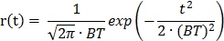

where BT is 0.7 and t is normalized by the symbol duration.

The normalized cross-correlation (t) between two waveforms, p(t) and r(t), is defined as

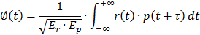

where E_{r} and E_{p} are the energies of r(t) and p(t) respectively.

In order for CMB GFSK PHY transmitter to be compliant with this standard, the transmitted pulse p(t) shall have a magnitude of the cross-correlation function |  (τ)| whose main lobe is greater than or equal to 0.96, when integrated over a period of at least 2×0.5 time.

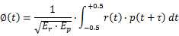

The modulation for the CMB GFSK PHY is a 2-level Gaussian filtered FSK that meets the transmit spectral mask, as defined in 21.2.4.4. GFSK with a BT value of 0.7 should be used in Mode #1 -- #5.

Table 21.23 shows the modulation and channel parameters for the standard-defined PHY operating modes for the 195 MHz, 416 MHz, and 619 MHz bands. A device shall support operating mode #1 and may additionally support operating modes #1 to #4.

Table 21.2.3—CMB GFSK modulation and channel parameters

Frequency band | Parameter | Operating mode  #1 | Operating mode  #2 | Operating mode  #3 | Operating mode  #4 | Operating mode  #5
174-216MHz  407-425MHz  608-630MHz | Data rate (kb/s) | 100 | 100 | 200 | 200 | 50
174-216MHz  407-425MHz  608-630MHz | Modulation index | 0.5 | 1.0 | 0.5 | 1.0 | 1.0
174-216MHz  407-425MHz  608-630MHz | Channel spacing (KHz) | 500 | 500 | 500 | 500 | 500

21.2.2.2 Reference modulator diagram

The functional block diagram in Figure 21.2.3 is provided as a reference for specifying the CMB GFSK PHY data flow processing functions. The subclause number in each block refers to the subclause that describes that function. Each bit shall be processed using the bit order rules defined in 20.2.1.

When FEC is enabled, the PHR and PSDU shall be processed for coding as a single block of data, as described in 21.2.2.7. When data whitening is enabled, the scrambling shall be only applied over the PSDU, as described in 21.2.3.

All fields in the PPDU shall use the same symbol rate and modulation order, unless otherwise specified elsewhere in this standard.

Figure 21.2.3—CMB GFSK FEC, data whitening, and modulator functions

21.2.2.3 Bit-to-symbol mapping

The nominal frequency deviation, △f, shall be

$$(\frac{\text{symbol} \text{rate} × \text{mod}\text{ulation} \text{index}}{2})$$

The symbol encoding for CMB GFSK PHY is shown in Table 21.2.4, where the frequency deviation, fdev, is equal to △f for filtered 2FSK.

Table 21.2.4—CMB GFSK symbol encoding

2-level
Symbol (binary) | Frequency deviation
0 | –fdev
1 | +fdev

21.2.2.4 Modulation quality

Modulation quality shall be measured by observing the frequency deviation tolerance and the zero crossing tolerance of the eye diagram caused by a PN9 sequence of length 511 bits.

21.2.2.5 Frequency deviation tolerance

Modulation frequency tolerance is measured as a percentage of the frequency deviation, fdev, dictated by the modulation index. In the case of filtered 2FSK, the measured frequency deviation, f, at Ts / 2 shall be constrained to the range 70% fdev < |f| < 130% fdev, as shown in Figure 21.2.4, where Ts is the symbol time.

Figure 21.2.4—Eye diagram for filtered 2FSK

21.2.2.6 Zero crossing tolerance

In the case of filtered 2FSK, the excursions for the zero crossings for all trajectories of the eye diagram shall be constrained to within ±12.5% of the symbol time Ts, as shown in Figure 21.2.4.

21.2.2.7 Forward error correction (FEC)

FEC is optional. If the SFD indicates that FEC is used, as described in Table 21.2.1, then the FEC is applied to the PHR and PSDU as a single block of data.

Two types of FEC may be applied: a recursive and systematic code (RSC) or a non-recursive and non-systematic code (NRNSC). The use of RSC or NRNSC coding shall be controlled by the PIB attribute phyFSKFECScheme, as defined in 9.3.

When the SFD value indicates a coded packet, FEC shall be employed on the PHR and PSDU bits, applying either a 1/2-rate systematic or nonsystematic convolution coding with constraint length K = 4, and using the following two generator polynomials:

G0 x = 1+x+x²+x³

G1 x = 1+x²+x³

The total number of bits to be encoded, N, is obtained by summing up the size of the PHR (LPHR), the length of the PSDU (LPSDU is equal to the content of the Frame Length field in Figure 114), the number of tail bits (LTAIL), and the number of padding bits (LPAD). N shall be computed as follows:

N=LPHR+LPSDU+LTAIL+LPAD

Note that LPSDU is zero in the case of a mode switch packet.

Immediately after encoding the PHR and PSDU, a termination sequence with length LTAIL = 3 bits shall be inserted into the encoder, as shown in Figure 21.2.6. The tail bits are required to return the encoder to the zero state.

PHR | PSDU | Tail bits  (T₀ T₁ T₂)

Figure 21.2.5—Data block extension with tail bits prior to coding

The value of the tail bits are dependent on the coding scheme and shall be set as shown in Table 21.2.5.

Table 21.2.5—Tail bit pattern for the RSC and NRNSC encoders

Memory state  (M0–M2) | Tail bits
Memory state  (M0–M2) | RSC  (T0 T1 T2) | NRNSC  (T0 T1 T2)
000 | 000 | 000
001 | 100 | 000
010 | 110 | 000
011 | 010 | 000
100 | 111 | 000
101 | 011 | 000
110 | 001 | 000
111 | 101 | 000

LPAD shall be computed as follows:

LPAD=5, when $\frac{L_{\text{PHR}}+L_{\text{PSDU}}}{8}$ is odd

LPAD=13, when $\frac{L_{\text{PHR}}+L_{\text{PSDU}}}{8}$is even

Padding bit patterns should not contain a long series of ‘1’s or ‘0’s. Figure 21.2.6 and Figure 21.2.7 illustrate examples of such patterns. The RSC encoder is shown in Figure 21.2.8, and the NRNSC encoder is shown in Figure 21.2.9.

PHR | PSDU | Tail bits  (T₀ T₁ T₂) | 5-bit padding pattern  01011

Figure 21.2.6—An example of extension with padding bits prior to encoding, when (LPHR+LPSDU)/8 is odd

PHR | PSDU | Tail bits  (T₀ T₁ T₂) | 13-bit padding pattern  0 1011 0000 1011

Figure 21.2.7—An example of extension with padding bits prior to encoding, when (LPHR+LPSDU)/8 is even

Figure 21.2.8—The recursive and systematic code (RSC) encoder

Figure 21.2.9—Non-recursive and non-systematic code (NRNSC) encoder

For an input sequence of bits with length N, B={b_{i}, I∊ [0,1,2,…,N-1]} , the i_{th} input bit shall be represented as bi and be fed into memory state M0, M1, and M2 in that order. The tail bits Ti and the pad bits shall be inserted once the encoding of PHR and PSDU is complete. The output sequence S also comprises N code-symbols.

S={s(0), s(1), s(2), ….,s(N-1)}={u₀¹, u₀⁰,…,u_{i}¹, u_{i}⁰, u_{i+1}¹, u_{i+1}⁰,…, u_{N-1}¹,u_{N-1}⁰ }

Each code-symbol is denoted by s(i)={ u_{i}¹, u_{i}⁰}, for all i=0,…N-1, where s(i) is the i_{th} output code-symbol due to the i_{th} input bit u_{i}¹ and u_{i}⁰ indicate the first and second output bits of the convolutional encoder, respectively. The code-symbol s(i) shall precede the code-symbol s(i + 1) and the code bit u_{i}¹ shall precede the code bit u_{i}⁰ .

For the RSC encoder, the first and the second output bits of the encoder shall be generated in the following
way:

$$u_{i}^{1}=b_{i}⊕(b_{i−1}⊕b_{i−2}⊕b_{i−3})⊕b_{i−2}⊕b_{i−3}$$

$$u_{i}^{0}=b_{i}$$

where $⊕$ stands for modulo-2 addition.

For the NRNSC encoder, the first and the second output bits of the encoder shall be generated in the following way:

$$u_{i}^{1}=\overline{b_{i}⊕b_{i−2}⊕b_{i−3}}$$

$$u_{i}^{0}=\overline{b_{i}⊕b_{i−1}⊕b_{i−2}⊕b_{i−3}}$$

where the “overline” indicates the complement of the modulo-2 addition.

21.2.3 Data whitening for CBM GFSK PHY

Support for data whitening is optional.

When data whitening is enabled at the transmitter, the Data Whitening field of the PHR shall be set to one, as described in 21.2.1.3, and the whitened data shall be the exclusive or (XOR) of the PSDU with the PN9 sequence (x⁹ + x⁵ + x⁰), as described by the following equation:

$$E_{n}=R_{n}⊕\text{PN}9_{n}$$

where
En is the whitened bit
Rn is the data bit being whitened
PN9n is the PN9 sequence bit

For each packet transmitted with data whitening enabled, R₀ is the first bit of the PSDU and the index n increments for subsequent bits of the PSDU.

For packets received with the Data Whitening field of the PHR set to one, the receiver decodes the scrambled data in the following way:

$$R_{n}={\text{RE}}_{n}⊕\text{PN}9_{n}$$

Where
Rn is the PSDU bit after de-whitening
REn is the PSDU bit at the output of the Gaussian filtered FSK demodulator

The PN generator is defined by the schematic in Figure 21.2.10.

Figure 21.2.10—Schematic of the PN9 sequence generator

The seed in the PN9 generator shall be all ones: “111111111.” The PN9 generator shall be reinitialized to the seed after each packet (either transmit or receive).

The PN9 generator is clocked using the seed as the starting point and enabled after the first clock cycle. For example, the first 30 bits out of the PN9 generator, once it is enabled, would be as follows:

PN9n= 0₀, 0₁, 0₂, 0₃, 1₄, 1₅, 1₆, 1₇, 0₈, 1₉, 1₁₀, 1₁₁, 0₁₂, 0₁₃, 0₁₄, 0₁₅, 1₁₆, 0₁₇, 1₁₈, 1₁₉, 0₂₀, 0₂₁, 1₂₂, 1₂₃, 0₂₄, 1₂₅, 1₂₆, 0₂₇, 1₂₈, 1₂₉.

21.2.4 CMB GFSK PHY RF requirements

21.2.4.1 Operating frequency range

The CMB GFSK PHY operates in the bands given in Table 66b.

21.2.4.2 Radio frequency tolerance

The single-sided clock frequency tolerance T at the transmitter, in ppm, shall be as follows: +/- 50 ppm.

21.2.4.4 Transmit power spectral density mask

The transmit spectral content is the ratio of the total transmitted out-of-channel power to the total transmitted in-channel power in a given integration bandwidth.

The integration bandwidth shall be equal to1.5×R, where R is the symbol rate, expressed in units of hertz.

Out-of-channel power shall be measured at two offset frequencies relative to the carrier frequency. The offset frequencies M1 and M2 are defined as follows:

$$M_{1}=1\text{.}5×R×(1+h)$$

$$M_{2}=3×R×(1+h)$$

where h is the modulation index for 2-level modulation and three times the modulation index for 4-level modulation.

The transmit spectral content at M₁ and M₂ shall be less than TBD dB and TBD dB, respectively.

The modulated signal shall use a PN data pattern of 511 bits or longer.

The spectrum analyzer settings for this measurement shall be as follows: the resolution bandwidth is 1 kHz, the video bandwidth is 1 kHz or greater, and the detector is RMS.

In addition, the transmit spectrum density of CMB GFSK signal shall comply with the PSD mask requirement of Chinese Radio regulations as provided in Annex I and Annex J.

21.2.4.5 Receiver sensitivity

The CMB GFSK PHY receiver sensitivity shall be better than S, where S, for binary modulation, is defined as follows:
$$S=(S_{0}+\text{10}\text{log}[\frac{R}{R_{0}}])\text{dBm}$$
where
S₀ is –91 without FEC and –97 with FEC
R₀ is 50 kb/s
R is the bit rate in kb/s

See 8.1.7 for additional information on receiver sensitivity.

21.2.4.6 Receiver interference rejection

The adjacent designated channels are those on either side of the desired designated channel that are closest in frequency to the desired designated channel. The alternate designated channel is more than one removed from the desired designated channel in the operational frequency band.

The adjacent channel rejection shall be measured as follows: the desired signal shall be a compliant CMB GFSK PHY signal, as defined in Table 66b, of pseudo-random data at the center frequency of the desired channel. The desired signal is input to the receiver at a level 3 dB above the receiver sensitivity given in 21.2.4.5..

In either the adjacent or the alternate channel, a modulated signal in the center of that channel is input at the following level relative to the level of the desired signal:
— The adjacent channel rejection shall be greater than or equal to 10 dB. (need to check)
— The alternate channel rejection shall be greater than or equal to 30 dB. (need to check)

The test shall be performed for only one interfering signal at a time. The receiver shall meet the error rate criteria defined in 8.1.7 under these conditions.

21.2.4.7 TX-to-RX turnaround time

The CMB GFSK PHY shall meet the requirements for TX-to-RX turnaround time as defined in 8.2.1.

21.2.4.8 RX-to-TX turnaround time

The CMB GFSK PHY shall meet the requirements for RX-to-TX turnaround time as defined in 8.2.2.

21.2.4.9 Transmit power

A transmitter shall be capable of transmitting at least -3 dBm. Devices should transmit lower power when possible in order to reduce interference to other devices and systems.

The maximum transmit power is limited by local regulatory bodies.

21.2.4.10 Receiver maximum input level of desired signal

The CMB GFSK PHY shall have a receiver maximum input level greater than or equal to -20 dBm using the measurement defined in 8.2.4.

21.2.4.11 Receiver ED

The CMB GFSK PHY shall provide the receiver ED measurement as described in 8.2.5.

21.2.4.12 Link quality indicator (LQI)

The CMB GFSK PHY shall provide the LQI measurement as described in 8.2.6.

21.2.4.13 Clear channel assessment (CCA)

The CMB GFSK PHY shall use one of the CCA methods as described in 8.2.7.

Annex I Chinese MIIT DOC; 423-2005: technical requirement for micro-power (short- distance) radio devices (translation from Chinese Doc)

I.1 Specific technical coefficients

I.1.1 General micro-power (short distance) radio devices

Category A equipment

  - Operation frequency: 9 kHz-190 kHz
Emission limits of magnetic field strength:
9 kHz-50 kHz: 72dBuA/m (10 m Distance) (quasi-peak)
50 kHz-190 kHz: 72dBuA/m (10 m Distance) (3dB decreased in every octave band) (quasi-peak)

Category B equipment

- Operation frequency:
1.7-2.1MHz, 2.2-3.0MHz,
3.1-4.1MHz, 4.2-5.6MHz,
5.7-6.2MHz, 7.3-8.3MHz,
8.4-9.9MHz

- Emission limits of magnetic field strength 10 m distance away from the equipment is no more than 9dBuA/m(quasi-peak).
- Frequency offset tolerance: 100×10⁻⁶
- 6dB bandwidth of no more than 200 kHz.

Category C equipment

- Operation frequency: 6.765-6.795MHz, 13.553-13.567MHz, 26.957-27.283MHz
- Emission limits of magnetic field strength 10 m distance away from Tx device is no more than 42dBuA/m (quasi-peak)
- Frequency offset tolerance: 100×10⁻⁶
- Spurious radiation emission: For a Tx device operating at 13.553-13.567 MHz frequency, at both ends the emission limits of spurious radiation offsetting 140 kHz, is 9dBuA/m (at 10 m distance, quasi-peak)

Category D equipment

- Operation frequency: 315 kHz-30 MHz except the frequency bands of A, B, C Category equipment.
- Emission of magnetic field strength at 10 m distance away to one device :
315 kHz-1MHz: no more than -5dBuA/m (quasi-peak)
1MHz-30MHz: no more than -15dBuA/m (quasi-peak)

Category E equipment

- Operation frequency: 40.66-40.70MHz
- Transmitting power limit: 10mW (ERP)
- Frequency offset tolerance: 100×10⁻⁶

Category F equipment

Category F equipment refers to the short-distance radio devices working at 2400-2483.5MHz, rather than digital cordless telephone, Bluetooth device and wireless LAN equipment

- Operation frequency: 2400-2483.50MHz
- Transmitting power limit: 10mW (EIRP)
- Frequency offset tolerance: 75 kHz

Category G equipment

- Operation frequency: 24.00-24.25GHz
- Transmitting power limit: no more than 20mW (EIRP)

I.1.2 General wireless remote control devices
General Radio control devices are prohibited to apply on toys;

If the operation frequency of wireless remote control device is the same as ones of local voice and television broadcasting stations, this remote control device is prohibited locally.
If the wireless control device interfere local voice and television broadcasting, the device must be immediately stopped until the elimination of these interference, or movement to non-interference frequency bands.
- Operation frequency: 470-566MHz, 614-787MHz
- Transmitting power limit: 5mW (ERP)
- Occupied bandwidth: no greater than 1.0MHz

I.1.3 Wireless MIC and civilian wireless measuring instruments
Wireless MIC are applied for audio-visual training of education and cultural department, or disabled hearing aid at cinemas, concert halls, conference rooms and other public places, or a small radio device at tourist areas.

For less 5 sec duty cycle data transmission, 470-510 MHz is the operation frequency for civilian radio measuring instruments.

If above wireless device interferes local voice and television broadcasting, the device must be immediately stopped until the elimination of these interference, or movement to non-interference frequency bands.

For protecting biomedical telemetry equipment from the interference, the wireless MIC is not permitted in the hospital, which should be specified in a product manual of wireless MIC.

- Operation frequency and transmitting power:
  - Operation frequency: 87-108MHz. Transmitting power limit: 3mW (ERP)
  - Operation frequency: 75.4-76.0MHz, 84-87MHz. Transmitting power limit: 10mW (ERP)
  - Operation frequency: 189.9-223.0MHz. Transmitting power limit: 10mW (ERP)
  - Operation frequency: 470-510MHz, 630-787MHz. Transmitting power limit: 50Mw (ERP)

- Occupied bandwidth: no greater than 200kHz
- Frequency offset tolerance: 100×10⁻⁶

I.1.4 Biomedical telemetry device

Radio transmitting devices for the transmission of human or animal physiological phenomenon measured signals, used only in hospital or medical research institution. It should not interfere with radio astronomy services.

- Operation frequency: 174-216MHz, 407-425MHz, 608-630MHz
- Transmitting power limit: 10mW (ERP)
- Frequency offset tolerance: 100×10-6

I.1.5 Analog cordless telephone
  - Operation frequency:

Channel number | Panel  Frequency (MHz) | Cell phone Frequency (MHz)
1 | 45.000 | 48.000
2 | 45.025 | 48.025
3 | 45.050 | 48.050
4 | 45.075 | 48.075
5 | 45.100 | 48.100
6 | 45.125 | 48.125
7 | 45.150 | 48.150
8 | 45.175 | 48.175
9 | 45.200 | 48.200
10 | 45.225 | 48.225
11 | 45.250 | 48.250
12 | 45.275 | 48.275
13 | 45.300 | 48.300
14 | 45.325 | 48.325
15 | 45.350 | 48.350
16 | 45.375 | 48.375
17 | 45.400 | 48.400
18 | 45.425 | 48.425
19 | 45.450 | 48.450
20 | 45.475 | 48.475

  - Plane and cell phone transmitting power limit: 20mW (ERP)
  - Maximum frequency offset: 5KHz
  - Occupied bandwidth: no greater than 16 kHz
  - Frequency offset tolerance: 1.8 kHz
  - Antenna must be permanently fixed to phone or cell phone, and its length should not be more than 1 meters.

I.1.6 2.4 GHz band digital cordless telephone

- Operation frequency: 2400-2483.5MHz
- Average EIRP limit: 25mW
- Frequency tolerance: 20×10⁻⁶
- Digital cordless telephony whose operation frequency is 2400-2483.5MHz must employ FH mode, and the number of hopping channels is at least 75
- The duty period one channel must be no more than 0.4 second

I.1.7 Dedicated wireless rremote control device for control device for crane and mechanical transmission

Electromagnetic environment test must be carried out before device installation, in order to avoid interference or interfering with the operation of other similar devices, even resulting in accidents.
When dedicated wireless remote control device receives harmful interference, should stop using it immediately until the elimination of interference or adjustment to non-interference frequency.
For protection of radio astronomy service of Beijing Observatory and Ping Tang, Guizhou (Province) province, it is prohibited that devices whose operation frequency is within following range:

- Operation frequency:

230.700MHz, 223.700MHz, 230.975MHz, 223.975MHz
231.600MHz, 224.600MHz, 232.325MHz, 225.325MHz
230.100MHz, 223.100MHz, 232.025MHz, 225.025MHz

- Transmitting power limit: 20mW (ERP)
- Occupied bandwidth: no greater than 16 kHz
- Frequency tolerance: 4×10⁻⁶

I.1.8 Wireless industry remote control device
The device operation is limited at industrial plants (or buildings).

- Operation frequency

418.950MHz, 418.975MHz, 419.000MHz, 419.025MHz,
419.050MHz, 419.075MHz, 419.100MHz, 419.125MHz,
419.150MHz, 419.175MHz, 419.200MHz, 419.250MHz, 419.275MHz

- Transmitting power limit: 20mW (ERP)
- Occupied bandwidth: no greater than 16 kHz
- Frequency offset tolerance: 4×10⁻⁶

I.1.9 Wireless data transmission devices

For protection of radio astronomy service of Beijing Observatory and Ping Tang, Guizhou (Province) province, it is prohibited that devices whose operation frequency.

The operation of wireless data transmission devices is limited in buildings.

  - Operation frequency:

228.050MHz, 228.100MHz, 228.200MHz, 228.275MHz,
228.425MHz, 228.575MHz, 228.600MHz, 228.800MHz,
223.150MHz, 230.150MHz, 223.250MHz, 230.250MHz
223.275MHz, 230.275MHz, 224.050MHz, 231.050MHz
223.350MHz, 230.350MHz, 224.250MHz, 231.250MHz

  - Transmitting power limit: 10mW (ERP)
  - Occupied bandwidth: no greater than 16 kHz
  - Frequency offset tolerance: 4×10⁻⁶

I.1.10 Dedicated wireless transmission equipment for electronic hanging scale

- Operation frequency and occupied bandwidth:
  - Operation frequency: 223.300MHz, 224.900MHz, 230.050MHz, 233.050MHz, 234.050MHz. Occupied bandwidth: no greater than 50 kHz
  - Operation frequency: 450.0125MHz, 450.0625MHz, 450.1125MHz, 450.1625MHz, 450.2125MHz. Occupied bandwidth: no greater than 20 kHz

- Effective radiation power limit: 50mW (ERP)
- Frequency offset tolerance: 4×10⁻⁶

I.1.11Wireless control device for various types of civilian devices

These radio control devices are prohibited for toys and models.
- Operation frequency: 314-316MHz, 430-432MHz, 433.00-434.79MHz. Transmitting power limit: 10mW (ERP). Occupied bandwidth: no greater than 400 kHz
- Operation frequency: 779-787MHz. Transmitting power limit: 10mW (ERP)

I.1.12 Wireless remote control devices for toys and models control devices for toys and models

Radio controlled devices are limited for aircraft model, surface model of the vessel, the car model and other non-manned models as well as toys, but can’t be used for other kinds of wireless equipment.

- Operation frequency

26-27MHz band operation on vessel and the car models:

26.975MHz, 26.995MHz, 27.025MHz, 27.045MHz, 27.075MHz,
27.095MHz, 27.125MHz, 27.145MHz, 27.175MHz, 27.195MHz,
27.225MHz, 27.255MHz

40MHz band operation on vessel and the car models:

40.61MHz, 40.63MHz, 40.65MHz, 40.67MHz, 40.69MHz,
40.71MHz, 40.73MHz, 40.75MHz

40MHz band operation on aircraft model:

40.77MHz, 40.79MHz, 40.81MHz, 40.83MHz, 40.85MHz

72MHz band operation on aircraft model:

72.13MHz, 72.15MHz, 72.17MHz, 72.19MHz, 72.21MHz,
72.79MHz, 72.81MHz, 72.83MHz, 72.85MHz, 72.87MHz

- Transmitting power limit: 750mW (ERP)
- Occupied bandwidth: for the frequency band of 26-27MHz, no greater than 8 kHz. For the frequency band of 40MHz and 72MHz, no greater than 20 kHz
- Frequency offset tolerance: for the frequency band of 26-27MHz, no greater than 100×10⁻⁶. for the frequency band of 40MHz and 72MHz,no greater than 30×10⁻⁶
- Remote control devices for models must be one-way controller, and radio transmitting equipment should not be set on a model.
- For the requirements of electromagnetic environment, various types of remote control for models shall not be used in the range locating in a radius of 5000 m circle, around airport runway
- The remote control devices of models shall not transmit speech communication signals.
- After the release of radio control by the relevant state departments, remote control devices of models should not be used at a specific time, region.

I.1.13 Interphone (walk-talk)

The usage of interphone must follow the radio management regulations relevant to interphone.

- Operation frequency (Unit: MHz)

409.7500, 409.7625, 409.7750, 409.7875, 409.8000, 409.8125,
409.8250, 409.8375, 409.8500, 409.8625, 409.8750, 409.8875,
409.9000, 409.9125, 409.9250, 409.9375, 409.9500, 409.9625,
409.9750, 409.9875

- Modulation: F3E
- Transmitting power limit: 500mW (ERP)
- Frequency offset tolerance: 5×10⁻⁶
- Channel spacing: 12.5 kHz

I.1.14 Radar for vehicle location

- Operation frequency: 76-77GHz
- Peak EIRP limit: 55dBm

I.2 General requirements

  - Frequency Ranges for Measurement of Spurious radiation emission

Frequency range | Spurious radiation emission measurement frequency range:
Frequency range | Lower limit | Upper limit
9kHz-100MHz | 9kHz | 1GHz
100MHz-600MHz | 30MHz | 10 harmonic
600MHz-2.5GHz | 30MHz | 12.75GHz
2.5-13GHz | 30MHz | 26GHz
>13GHz | 30MHz | 2 harmonic

  - Spurious radiation emission limits (the demarcation between spurious radiation and out of band radiation is the bandwidth, which is ±2.5 multiples of operation channel band on carrier frequency)
    - Transmitter in transmission state at the maximum power

Frequency range | Test bandwidth | Limit | Detection method
9kHz-150kHz | 200Hz (6dB) | 27dBuA/m (10 meters)  (3 dB decreased per octave) | Quasi-peak
150kHz-10MHz | 9kHz (6dB) | 27dBuA/m (10 meters)  (3 dB decreased per octave) | Quasi-peak
10MHz-30MHz | 9kHz (6dB) | －3.5dBuA/m (10 meters) | Quasi-peak
30MHz-1GHz | 100kHz (3dB) | －36dBm | Effective value
1GHz-40GHz | 1MHz (3dB) | －30dBm | Effective value
>40GHz | 1MHz (3dB) | －20dBm | Effective value

    - Transmitter in standby or idle state

Frequency range | Test bandwidth | Limit | Detection method
9kHz-150kHz | 200Hz(6dB) | 6dBuA/m (10 meters)  (3 dB decreased per octave) | Quasi-peak
150kHz-10MHz | 9kHz(6dB) | 6dBuA/m (10 meters)  (3 dB decreased per octave) | Quasi-peak
10MHz-30MHz | 9kHz(6dB) | －24.5dBuA/m (10 meters) | Quasi-peak
30MHz-1GHz | 100kHz(3dB) | －47dBm | Quasi-peak
>1GHz | 1MHz(3dB) | －47dBm | Quasi-peak

NOTE---Magnetic field measurement is performed at open area and radiation power measurement is performed at full anechoic chamber.

For the equipment working frequency below 30 MHz, the emission state can be set to single frequency (SF) emission.

If specific technical specification does not match to general requirements, the specific technical specification is adopted.

  - Spurious radiation emission, in 48.5MHz-72.5MHz, 76MHz-108MHz, 167MHz-223MHz, 470MHz-566MHz or 606MHz-798MHz bands, should be less －54dBm.
  - The conduction harassment emission of power port, signal ports and telecommunication ports should be accordance with GB9254-1998 standard.
  - For the frequency bands above 30 MHz, the radiation power at the upper/lower limits of the specified working frequency is no more than －80dBm/Hz (EIRP). For the frequency bands below 30 MHz, the upper and lower boundaries of any working channel bandwidth (99% energy) can’t exceed the permitted specified ranges.

The manufacturers of micro-power (short distance) radio device should declare the extreme environmental conditions in normal usage, and in such conditions transmitting power and frequency tolerance should meet the requirements of this R

Annex J Further explanation of Chinese radio regulation on approved bands for medical signal transmission

J.1 The spurious radiation emission on different bands

- Transmitter in transmission state at the maximum power the spurious power level should be:
Frequency range | Test bandwidth | Limit | Detection method
30MHz-1GHz | 100kHz (3dB) | －36dBm | Effective value
1GHz-40GHz | 1MHz (3dB) | －30dBm | Effective value
>40GHz | 1MHz (3dB) | －20dBm | Effective value

Effective value is equal to average value.

- Transmitter in standby or idle state, the spurious power level should be:

Frequency range | Test bandwidth | Limit | Detection method
30MHz-1GHz | 100kHz(3dB) | －47dBm | Quasi-peak
>1GHz | 1MHz(3dB) | －47dBm | Quasi-peak

- The spurious radiation emission of any Transmitter, in 48.5MHz-72.5MHz, 76MHz-108MHz, 167MHz-223MHz, 470MHz-566MHz or 606MHz-798MHz bands, should be less than -54dBm/100KHz

The spurious radiation limitations are drawn in Figure J1.

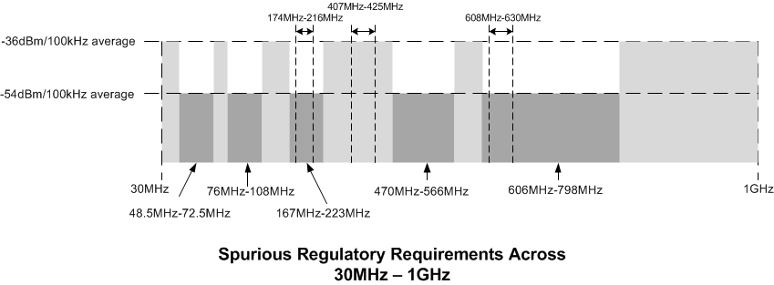
Figure J.1

J.2 The Tx spectrum mask on approved bands for medical signal transmission

  - On 174-216MHz and 608-630MHz Bands

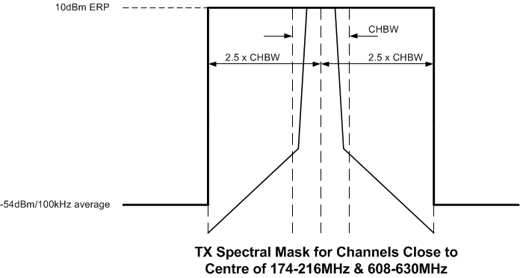
Figure J.2

  - On 407-425MHz and 608-630MHz Bands

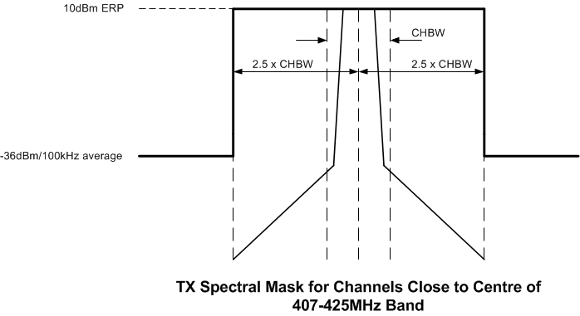
Figure J.3

  - CHBW: Channel Bandwidth.
  - 2.5 x CHBW:
    - Spurious radiation emission limits (the demarcation between spurious radiation and out of band radiation is the bandwidth, which is ±2.5 multiple of operation channel band on carrier frequency)

J.3 The radio power at upper/lower limits of operation bands

- In any Transmitter state (max, idle or standby), for the frequency bands above 30 MHz, the radiation power at the upper/lower limits of the specified working frequency is no more than －80dBm/Hz (EIRP). -80dBm/Hz (EIRP) is equal to -82.2dBm/Hz (ERP)

- The upper/lower limits of approved bands for medical signal transmission are {176MHz, 214 MHz}, {407 MHz, 425 MHz} and {608 MHz, 630 MHz} for Chinese medical bands.
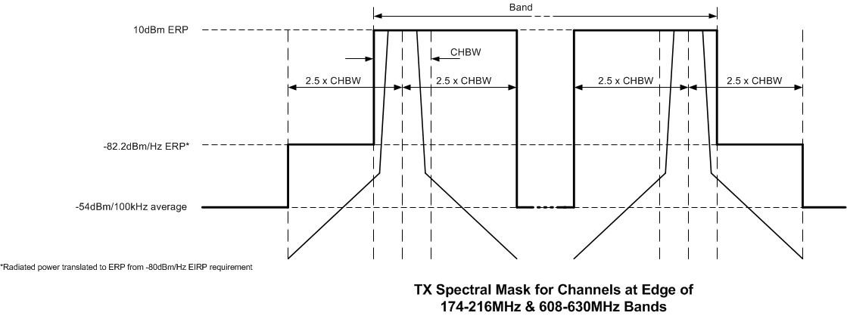
Figure J.4

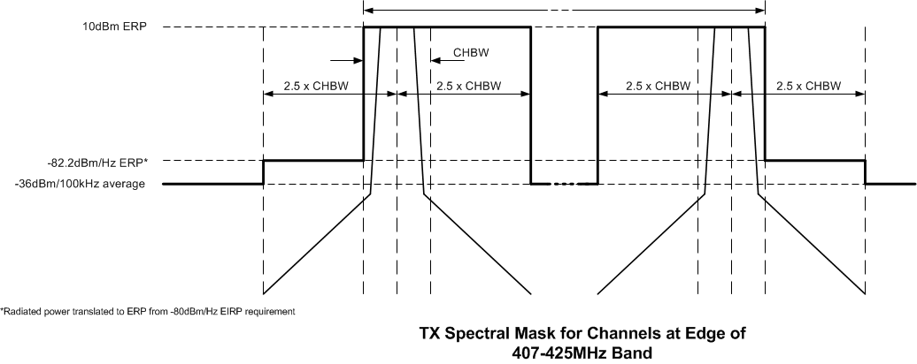
Figure J.5

Annex K Interferences and their models on Chinese approved bands for medical signal transmission

Table K.1 lists the possible interference on Chinese approved bands for medical signals

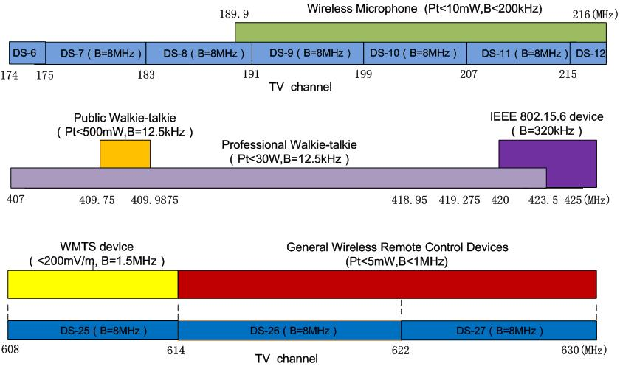

Figure K.1 —Interference on 174-216, 407-425 and 608-630 MHz Bands

K.1 Inference on 176-214 MHZ channel

On this band, the major interference are sourced from
- VHF Radio and TV
- Wireless Microphone

The inference signal model and spectrum of VHF Radio and TV, including its Chinese standard numbers are shown in Figure K.2:

 | Channel | Models based on Chinese Standards
Digital radio  and TV | DS-6：174-175MHz  DS-7：175-183MHz  DS-8：183-191MHz  DS-9：191-199MHz  DS-100：199-207MHz  DS-11：207-215MHz  DS-12：215-216MHz | DTMB(OFDM)  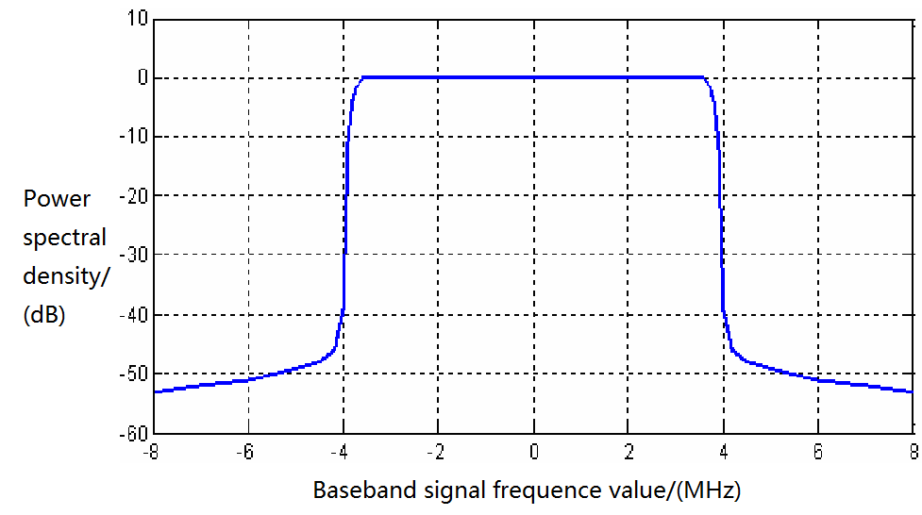  GB 20600—2006 Framing structure, Channel coding and modulation for digital television terrestrial broadcasting system
Analog radio and TV |  | CMMB(OFDM)  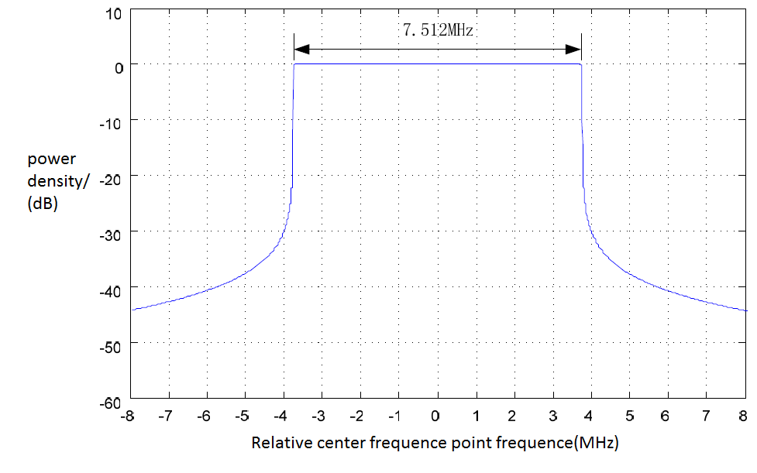  GY/T 220.1-2006 Mobile Multimedia Broadcasting Part 1：Framing Structure Channel Coding and Modulation for Broadcasting Channel
Remark: The analog radio and TV will stop in 2015.

Figure K.2—Interference spectrum and related Chinese standards

The model of microphone is shown in Figure K.3 and Figure K.4,
Figure K.3 is reference from FCC occupied bandwidth limit section 74.861 (e) (6)
Figure K.4 is reference from ETSI EN 300 422-1 V1.2.2 (2000-08)

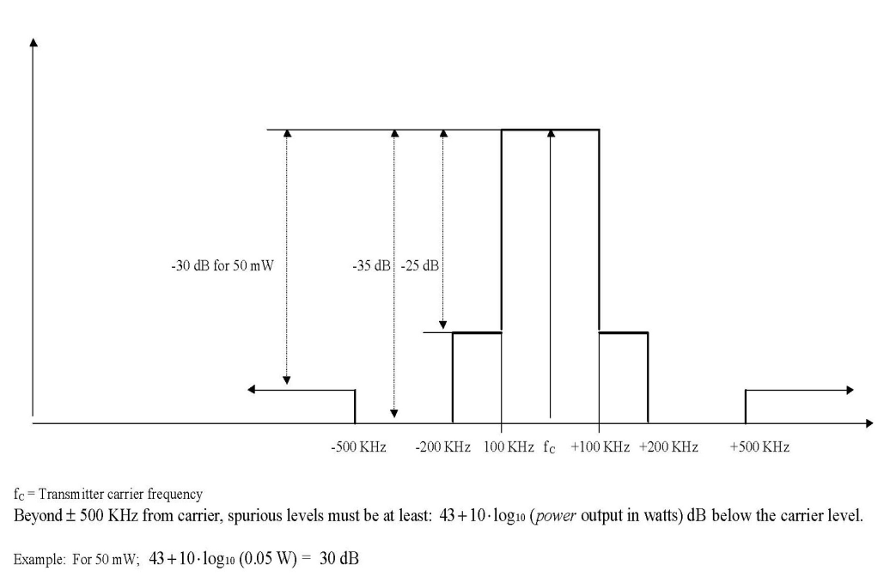
Figure K.3 —FCC OCCUPIED BANDWIDTH MASK

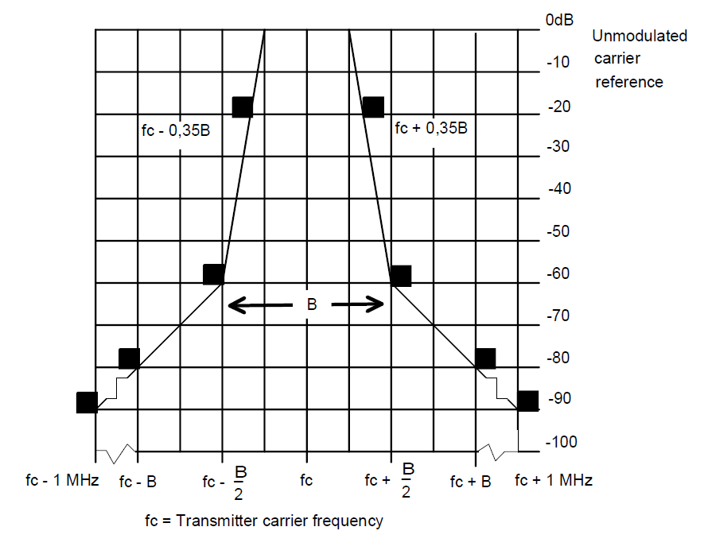
Figure K.4 —Spectral mask - Normalized to channel bandwidth

K.2 Inference on 407-425 MHZ channel

Interphone | Different Frequency Bands | Dedicated interphone  (Pt<30W) | 137-144、146-167、403-409.75、409.9875-423.5MHz
Interphone | Different Frequency Bands | Public interphone  (Pt<500mW) | 409.7500-409.9875MHz | Analog | Channel number:20  Operation frequency:409.7500-409.9875MHz  Channel spacing:12.5kHz  Modulation:8K5F3E
 |  |  |  | Digital | Channel spacing:12.5kHz 6.25kHz  multi-access mode : FDMA/TDMA
Interphone | Individual Technology | Analog interphone
Interphone | Individual Technology | Digital interphone  Standards: | DMR （base on TDMA）、DPMR （base on FDMA）、DSRR ,P25 standard

Figure K.5 — Inference on 407-425 MHZ band

The major interference on this band are sourced from
- Interphone (Walkie-Talkie)

The model of interphone is described as:

Baseband data in time domain

Carrier
modulation

RF signal

Baseband 4FSK
Modulation

Baseband signal
- This baseband data is based on frame format which set by DPMR standard.
Math model
x(t) is the baseband signal though the 4FSK

Information bits |  | Symbol | 4FSK deviation
Bit 1 | Bit 0 | Symbol | 4FSK deviation
0 | 1 | +3 | +1.944kHz
0 | 0 | +1 | +0.648kHz
1 | 0 | -1 | -0.648kHz
1 | 1 | -3 | -1.944kHz
Each of the four information bits is mapping with a cosine signal as, $Δf$is 4FSK deviation in the above figure, is selected as 30k Hz here according to the DPMR standard

K.3 Inferences on 608-630 MHZ band

The major interferences on this band are sourced from:

  - UHF Radio and TV
  - General Wireless Remote Control Devices
The model of digital TV is described in the Figure K.6

 | Channel | Chinese Standards
Digital radio  and TV | DS-25：608-614MHz  DS-26：614-622MHz  DS-27：622-630MHz | DTMB(OFDM)  GB 20600—2006 Framing structure, Channel coding and modulation for digital television terrestrial broadcasting system
Analog radio and TV | DS-25：608-614MHz  DS-26：614-622MHz  DS-27：622-630MHz | CMMB(OFDM)  GY/T 220.1-2006 Mobile Multimedia Broadcasting Part 1：Framing Structure Channel Coding and Modulation for Broadcasting Channel
Remark: The analog radio and TV will stop in 2015.
Figure K.6—Interference spectrum and related Chinese standards

