IEEE P802.15
Wireless Personal Area Networks

Project | IEEE P802.15 Working Group for Wireless Personal Area Networks (WPANs)
Title | NICT MAC Proposal Document
Date Submitted | July 7th, 2013
Source | Huan-Bang Li, Marco Hernandez, Igor Dotlić, Ryu Miura (NICT)
Re: | In response to Call for Proposals to TG8
Abstract | MAC proposal
Purpose | For discussion in TG8
Notice | This document has been prepared to assist the IEEE P802.15. It is offered as a basis for discussion and is not binding on the contributing individual(s) or organization(s). The material in this document is subject to change in form and content after further study. The contributor(s) reserve(s) the right to add, amend or withdraw material contained herein.
Release | The contributor acknowledges and accepts that this contribution becomes the property of IEEE and may be made publicly available by P802.15.

Content
1. General definitions 3
2. Overview 4
2.1 Communication Model 4
2.2 General MAC format 4
3. Common mode/channel and operation mode/channel 5
4. Group Operation 6
5. I-PD Procedure 8
6. J-PD Procedure 9

- General definitions
For the purposes of this document, the following terms and definitions apply.
CAP: contention access period
CCA: clear channel assessment
CFP: contention free period
I-PD: Initiator PD
I-PD seen by J-PD: TS beacon received
J-PD: Joiner PD
J-PD Joined: Received TB beacon with ID in list
TB: temporary beacon
TS: trigger signal

- Overview
  - Communication Model
The operation of the system will be defined in a conventional way as a set of interacting modules, such as in the figure below.

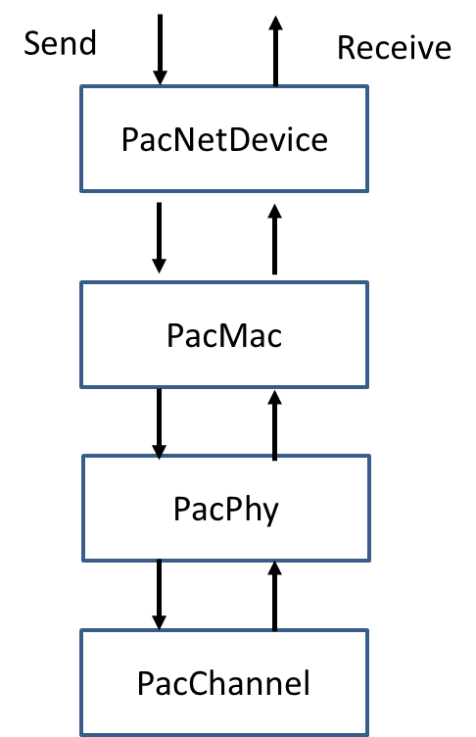
Figure 1. Communication Layer Model
  - General MAC format
A MAC frame consists of a fixed-length MAC header, a variable-length MAC frame body, and a fixed-length FCS field as shown in Figure 2. The MAC frame body has an octet length L_FB such that 0 ≤ L_FB ≤ pMaxFrameBodyLength, and is present only if it has a nonzero length.
Figure 2 MAC frame format

- Common mode/channel and operation mode/channel
PAC system has a common channel, and multiple operation channels. Common channel is used by the common mode. To decrease scanning latency, common mode with a specified RF channel shall be used only for starting discovery, or for initiating a PAC group through broadcasting short signal/message. Common mode shall not be used in operations or communications for an established PAC group. Emergency message shall be broadcasted at the common mode to guarantee efficient delivery.
There is no global clock for common channel. An I-PD broadcasts a short signal/message on its own clock. Hereafter, we refer to the short signal/message broadcasted over common channel as a trigger signal (TS). A TS shall be used under the following constraints and as illustrated in Figure 3.
- Length of a TS that is broadcasted via the common channel shall be within the maximum length T_{coMAX_send}.
- Re-broadcasting of a TS shall be after a minimum duration T_{coMIN_duration}.
- An I-PD shall perform CCA before broadcasting a TS. The minimum CCA time is T_{coMIN_cca}.
  - When CCA reports a clear channel at time t_{k}, the I-PD shall start broadcast of a TS at t_{k} +T_{coMIN_duration} and stop broadcast after broadcasting the last TS at t_{k} + N_{co_send} ×T_{coMIN_duration}.
where, N_{co_send} is an integer randomly selected within [1, N_{coMAX_send}], and N_{coMAX_send} is the maximum number that a TS can be repeatedly broadcasted in an iteration. After an iteration, N_{co_send} is reset for the next iteration.
  - After 3A), the I-PD shall perform CCA again before further broadcasting. When CCA reports a clear channel, the I-PD repeats (iteration) procedure 3A) again.
  - Procedure of 3B) will be iterated until the upper layers stop the iteration.
  - In each iteration, the group clock provides the information of start time, t_start, of TS which is synchronized to the first broadcasted TS, as well as the information of the current TS time, t_now. The latter is the start time of TS in the current iteration.

    - Illustration of constraint 3 (A)
    - Illustration of constraint 3 (B), (C)
Figure 3 Constraints of using TS.

- Group Operation
Group operation with an operation mode is based on a superframe structure. A superframe consists of a temporary beacon (TB), a contention free period (CFP), and a contention access period (CAP). The clock of TB is synchronized to the first TS as shown in Figure 4. The length of TB needs to be decided according to the data size assigned but it is much larger than TS. CAP is used by J-PD as backoff interval in the group operation to be described shortly. CFP is used for group communication among PDs in the group.

Contention Access Period
Joining nodes will choose a random time in the contention period to transmit a JoinRequest packet. They will repeat the transmission if they are not included in the next GroupAnnounce transmission from the PD.

Contention-Free Period (TBD)
After joining the group, nodes will transmit packets in the contention free part of the superframe. The contention-free period could use token-based polling, as in the PCF of IEEE802.11, or fixed slot assignment.

Figure 4 Superframe structure.

Figure 5 Group operation procedure.

The group operation procedure is shown in Figure 5. The I-PD broadcasts group forming invitation (active scanning) within a TS including information of necessary IDs, selected operation mode (including channel), and group clock.
When a J-PD scans the invitation (passive scanning) at common mode, it moves to the selected operation mode that was announced by I-PD. Accounting from the start of TS, the J-PD waits for a duration of TB+CFP. Then, it sends joining request including its ID information with a random backoff within a duration of CAP.
When a J-PD scans the TS in an iteration, it will calculate the difference between t_now and t_start. If t_start is within a CAP, the J-PD takes random backoff between t_start and the end of CAP and sends joining request. If t_start is out of a CAP, it waits until the next CAP before sending request.
I-PD scans the selected operation mode (passive scanning), registers the J-PDs and distributes a list of the registered PDs within the temporary beacon (TB) at the selected operation mode. J-PDs that had sent joining requests but are not included in the distributed PDs list should repeat the joining process.

- I-PD Procedure
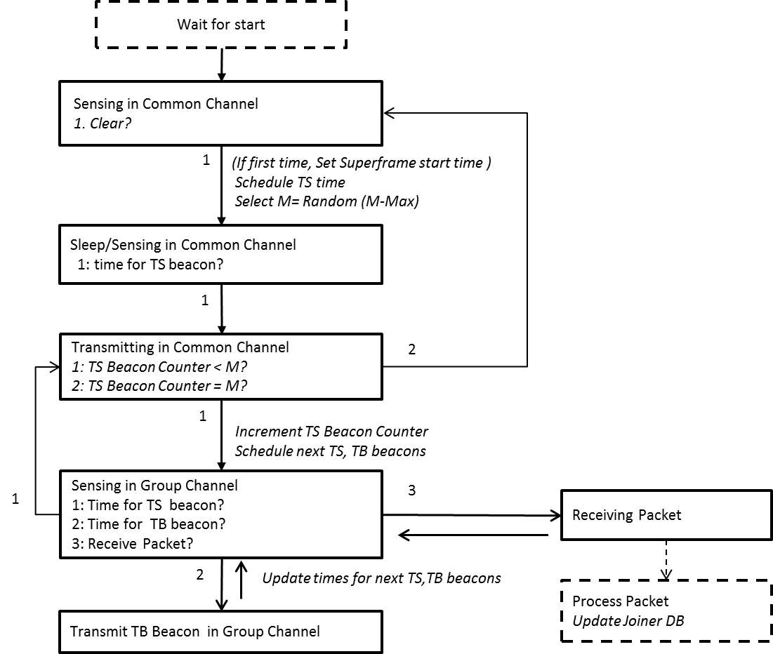

- J-PD Procedure
