IEEE P802.15
Wireless Personal Area Networks

Project | IEEE P802.15 Working Group for Wireless Personal Area Networks (WPANs)
Title | Chinese Radio Regulation Discussion around Chinese MIIT DOC 423-2005.
Date Submitted | [November , 2013]
Source | [Liang Li, Arthur Astrin, Andy Bottomley, Ken Mori]  [Vinno, Astrin Radio, MicroSemi, Panasonic]  [Room 202 Building D, Shangdi Xinxi Lu No.2 Pioneering Park, Haidian District, Beijing, China 100085,] | Voice: [ 949-813-7909 ]  Fax: [ ]  E-mail: [ liangli@vinnotech.com ]
Abstract | [During the November 2011 IEEE 802 Plenary 802.15 SG4n was formed to study and submit a Project Authorization Request along with the supporting 5 Criteria for the Chinese medical bands]
Purpose | [PAR to the P802.15 Working Group]
Notice | This document has been prepared to assist the IEEE P802.15. It is offered as a basis for discussion and is not binding on the contributing individual(s) or organization(s). The material in this document is subject to change in form and content after further study. The contributor(s) reserve(s) the right to add, amend or withdraw material contained herein.
Release | The contributor acknowledges and accepts that this contribution becomes the property of IEEE and may be made publicly available by P802.15.

1 The spurious radiation emission on different bands

- Transmitter in transmission state at the maximum power the spurious power level should be:
Frequency range | Test bandwidth | Limit | Detection method
30MHz-1GHz | 100kHz (3dB) | －36dBm | Effective value
1GHz-40GHz | 1MHz (3dB) | －30dBm | Effective value
>40GHz | 1MHz (3dB) | －20dBm | Effective value

Effective value is equal to average value.

- Transmitter in standby or idle state, the spurious power level should be:

Frequency range | Test bandwidth | Limit | Detection method
30MHz-1GHz | 100kHz(3dB) | －47dBm | Quasi-peak
>1GHz | 1MHz(3dB) | －47dBm | Quasi-peak

- The spurious radiation emission of any Transmitter, in 48.5MHz-72.5MHz, 76MHz-108MHz, 167MHz-223MHz, 470MHz-566MHz or 606MHz-798MHz bands, should be less than -54dBm/100KHz

The spurious radiation limitations are drawn in Figure J1.

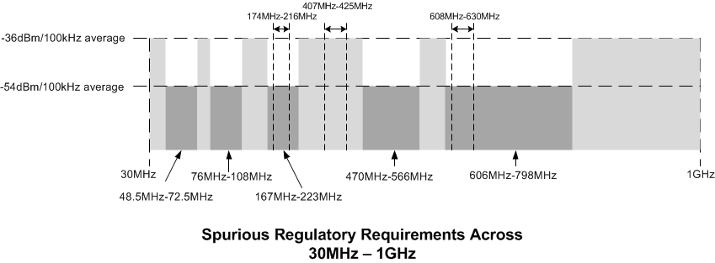
Figure J.1

2 The Tx spectrum mask on approved bands for medical signal transmission

  - On 174-216MHz and 608-630MHz Bands

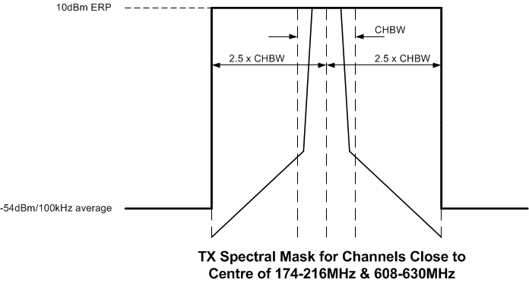
Figure J.2

  - On 407-425MHz and 608-630MHz Bands

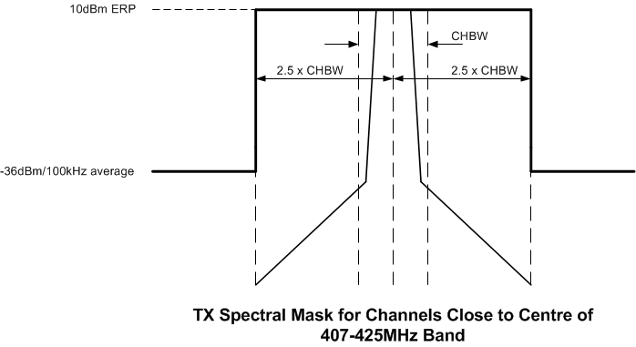
Figure J.3

  - CHBW: Channel Bandwidth.
  - 2.5 x CHBW:
    - Spurious radiation emission limits (the demarcation between spurious radiation and out of band radiation is the bandwidth, which is ±2.5 multiple of operation channel band on carrier frequency)

3 The radio power at upper/lower limits of operation bands

- In any Transmitter state (max, idle or standby), for the frequency bands above 30 MHz, the radiation power at the upper/lower limits of the specified working frequency is no more than －80dBm/Hz (EIRP). -80dBm/Hz (EIRP) is equal to -82.2dBm/Hz (ERP)

- The upper/lower limits of approved bands for medical signal transmission are {176MHz, 214 MHz}, {407 MHz, 425 MHz} and {608 MHz, 630 MHz} for Chinese medical bands.
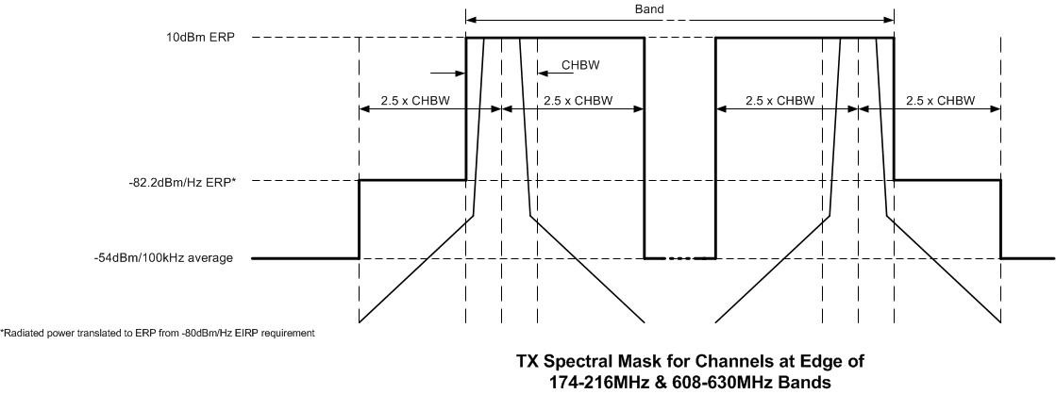
Figure J.4

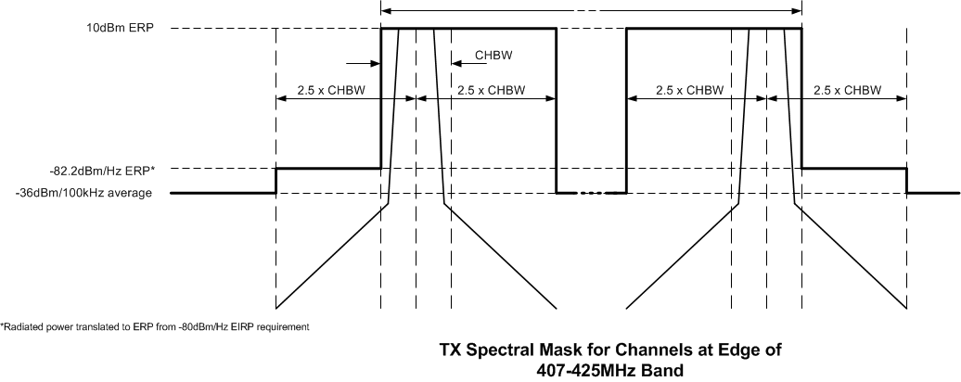
Figure J.5

