IEEE P802.15
Wireless Personal Area Networks

Project | IEEE P802.15 Working Group for Wireless Personal Area Networks (WPANs)
Title | Preliminary document for TG4n – Ranging Support for 4n
Date Submitted | [May, 2012]
Source | [Dietmar Eggert (ATMEL),  Liang Li (Vinnotech)]
Abstract | This document is a contribution to work done thus far by TG4n
Purpose | This document is contribution in preparing a draft for letter ballot.
Notice | This document has been prepared to assist the IEEE P802.15. It is offered as a basis for discussion and is not binding on the contributing individual(s) or organization(s). The material in this document is subject to change in form and content after further study. The contributor(s) reserve(s) the right to add, amend or withdraw material contained herein.
Release | The contributor acknowledges and accepts that this contribution becomes the property of IEEE and may be made publicly available by P802.15.

IEEE Standard for
Local and metropolitan area networks—

Part 15.4: Low-Rate Wireless Personal Area
Networks (WPANs)

Amendment X: Physical Layer Utilizing Dedicate Medical Bands (176-214, 407-425, 608-630 MHz)

NOTE—The editing instructions contained in this amendment define how to merge the material contained therein into
the existing base standard and its amendments to form the comprehensive standard.

The editing instructions are shown in bold italic. Four editing instructions are used: change, delete, insert, and replace.
Change is used to make corrections in existing text or tables. The editing instruction specifies the location of the change
and describes what is being changed by using strikethrough (to remove old material) and underscore (to add new material).
Delete removes existing material. Insert adds new material without disturbing the existing material. Deletions and
insertions may require renumbering. If so, renumbering instructions are given in the editing instruction. Replace is used
to make changes in figures or equations by removing the existing figure or equation and replacing it with a new one.
Editing instructions, change markings, and this NOTE will not be carried over into future editions because the changes
will be incorporated into the base standard.

2. Normative references

Insert the following new reference alphabetically into Clause 2:

China, Ministry of Industry and Information Technology Doc: 423-2005 ---- Technical Requirements for Micro-power (short- distance) Radio Devices in the 174 – 214, 407-425, 608-630 MHz Band.

3. Definitions, acronyms, and abbreviations

3.1 Definitions

Change the following definition as indicated:

MBAN medical body area network

3.2 Acronyms and abbreviations

Insert the following acronyms alphabetically into 3.2:

？？？？
DCSS discrete chirp spread spectrum

4. General description

Insert the following new sub clause (4.1b) after 4.1a: 2

4.1b Introduction to medical body area network (MBAN) services on Chinese approved bands

The Ministry of Industry and Information Technology of the People's Republic of China has
approved the 174-216 MHz, 407-425 MHz and 608-630 MHz bands for medical information transmission.

MBAN devices operating within these bands must conform to a set of rules specified in above rules issued by Ministry of Industry and Information Technology of the People's Republic of China, which restrict use of the band to only medical, non-voice use under direction of a healthcare practitioner, among other requirements.

As a one user in this band, MBAN devices are required to protect all users and accept possible interference from those users (such as Digital TV). .

Use of the band by the Digital TV is, in general, scheduled well in advance allowing MBAN users to share the band in an orderly manner.

5. MAC protocol

5.1 MAC functional description

5.1.8 Ranging

Insert the following new subclauses (5.1.8b–5.1.8b.4) after 5.1.8.6:
5.1.8b DCSS ranging using phase difference measurement
DCSS ranging using phase difference measurement is an optional feature.
The phase difference measurement supports two different types of ranging:
- Local phase difference measurement between a ranging originator and a ranging recipient, and
- Remote phase difference measurement initiated by a ranging coordinator and performed between ranging nodes (a ranging originator and a ranging recipient). It is not necessary for the ranging coordinator to support the DCSS PHY. The coordination channel required to control DCSS operation uses a PHY, applicable to the actual operating band used by the DCSS PHY, as already defined in this standard.
5.1.8b.1 Initialization of local phase difference measurement
In order to perform a local phase difference measurement between the ranging originator and the ranging recipient, the originator starts a frame exchange sequence between ranging nodes to negotiate the current ranging parameter set.
If the recipient does not accept the requested ranging parameters from the originator, or is currently not able to perform the requested phase difference measurement, it returns a frame including the rejection status of the current ranging request.
If the recipient accepts the requested ranging parameters from the originator, it returns the negotiated parameter set back to the originator. The originator then extracts the final ranging parameters set.
Once the involved nodes have agreed upon the ranging parameters set to be used, the actual, and possibly additional, phase difference measurement(s) is initiated by means of a dedicated start frame.
If any required response frame is not received from the ranging recipient, the MAC sublayer of the ranging originator notifies the next higher layer about the timeout condition.
For any frame transmitted by the originator, the source address is derived from the originator address information contained in the MLME-RANGING.request primitive. The destination address is derived from the recipient address information contained in the MLME-RANGING.request primitive.
5.1.8b.2 Data exchange after a local phase difference measurement
After the end of the actual phase difference measurement, the originator requests the measured ranging data from the recipient, and the recipient forwards its measured data to the originator. This is performed by means of a frame exchange. Afterwards, the MAC sublayer of the originator calculates the final result values and notifies the next higher layer about the results of the requested ranging measurement.
5.1.8b.3 Initialization of remote phase difference measurement
In order to perform a remote phase difference measurement, the ranging coordinator sends a frame to the ranging originator. This frame payload contains the requested ranging recipient address (based on the recipient address information in the MLME-RANGING.request primitive). Additionally, this frame contains the requested ranging parameter set.
If the requested ranging originator is not able to set up the requested ranging parameters, as given in 9.3, or if the requested ranging originator is currently not able to perform the requested phase difference measurement, it returns a frame including the rejection status of the current ranging request.
In case the requested ranging originator is currently involved in another phase difference measurement, it discards the received frame from the ranging coordinator. Therefore the ranging coordinator shall maintain a timer to detect a timeout condition for the requested ranging procedure. In this case, the MAC sublayer of the ranging coordinator notifies the next higher layer about the timeout condition.
If the requested ranging originator is able to proceed with the requested ranging measurement including the requested ranging parameter set, it follows the procedure as described for the local phase difference measurement initiation by means of the specific frame exchange.
For any frame transmitted by the coordinator, the source address mode is derived from the coordinator address mode contained in the MLME-RANGING.request primitive. The destination address is derived from the originator address information contained in the MLME-RANGING.request primitive.
5.1.8b.4 Data exchange after a remote phase difference measurement
Once the originator has received the measured ranging data from the recipient, it calculates the final result values. Afterwards, the originator reports the calculated ranging result values back to the ranging coordinator using a dedicated frame. The MAC sublayer of the ranging coordinator notifies the next higher layer about the received results of the requested ranging measurement.
In case the ranging coordinator does not receive a response from the requested originator within the phase difference measurement timeout, the MAC sublayer of the ranging coordinator notifies the next higher layer about the timeout condition.

6 MAC services

6.2 MAC management service

Insert the following new subclauses (6.2.25–6.2.25.2) after 6.2.24.2:
6.2.25 Ranging primitives
6.2.25.1 MLME-RANGING.request
The MLME-RANGING.request primitive allows the next higher layer to request a ranging measurement between an originator and a recipient node.
The semantics of this primitive are:
MLME-RANGING.request (
OrigAddrMode,
OrigPANId,
OrigAddr,
RecAddrMode,
RecPANId,
RecAddr,
CoordAddrMode,
RangingMode
)

The primitive parameters are defined in Table 44ii.

Table 44ii—MLME-RANGING.request parameters
Name | Type | Valid range | Description
OrigAddrMode | Enumeration | SHORT_ADDRESS,  EXTENDED_ADDRESS | The addressing mode of the requested ranging originator.
OrigPANId | Integer | 0x0000–0xffff | The PAN identifier of the requested ranging originator.
OrigAddr | Device  address | As specified by the OrigAddrMode parameter | The individual device address of the requested ranging originator.
RecAddrMode | Enumeration | SHORT_ADDRESS,  EXTENDED_ADDRESS | The addressing mode of the ranging recipient.
RecPANId | Integer | 0x0000–0xffff | The PAN identifier of the ranging recipient.
RecAddr | Device  address | As specified by the  RecAddrMode parameter | The individual device address of the ranging recipient.
CoordAddrMode | Enumeration | NO_ADDRESS,  SHORT_ADDRESS,  EXTENDED_ADDRESS | The addressing mode of the ranging coordinator.
RangingMode | Enumeration | PM_RANGING | The actually requested ranging mode to be used during the ranging measurement. A value of PM_RANGING indicates Phase Difference Measurement.

On receipt of the MLME-RANGING.request primitive, the MAC sublayer entity initiates a ranging measurement procedure.
If the CoordAddrMode parameter specifies NO_ADDRESS, this node is the originator in a local ranging measurement procedure.
If the CoordAddrMode parameter specifies SHORT_ADDRESS or EXTENDED_ADDRESS, this node is the ranging coordinator node in a remote ranging measurement procedure. The ranging request is then forwarded to the intended ranging originator using the originator address information as the destination
address for any outgoing frame containing the recipient address information within the frame payload.

6.2.25.2 MLME-RANGING.confirm
The MLME-RANGING.confirm primitive allows the next higher layer to request a ranging measurement between an originator and a recipient node.
The semantics of the MLME-RANGING.confirm primitive are:
MLME-RANGING.confirm (
sttus,
Distance,
DistanceQuality
)

The primitive parameters are defined in Table 44jj.

Table 44jj—MLME-RANGING.confirm parameters
Name | Type | Valid range | Description
status | Enumeration | SUCCESS,  RANGING_REJECTED,  INVALID_ADDRESS,  CHANNEL_ACCESS_FAILURE,  NO_ACK,  INVALID_PARAMETER,  UNSUPPORTED_RANGING_METHOD,  RANGING_TIMEOUT | The status of the last ranging measurement.
Distance | Integer | 0x00000000–0xffffffff | The measured distance between originator and recipient in mm.
DistanceQuality | Integer | 0x00-0x64 | The confidence level of the ranging measurement in %.

The MLME-RANGING.confirm primitive is generated by the MAC sublayer entity in response to an MLME-RANGING.request primitive. The MLME-RANGING.confirm primitive returns a status of either SUCCESS, indicating that the request to transmit was successful, or the appropriate error code.
The parameters Distance and DistanceQuality are only valid if the returned status is SUCCESS.
If the OrigAddrMode or the RecAddrMode parameter is set to NO_ADDRESS in the MLME-RANGING.request primitive, the status shall be set to INVALID_ADDRESS.
If any ranging measurement relevant frame transmission uses CSMA-CA and the CSMA-CA algorithm failed due to adverse conditions on the channel, the status shall be set to CHANNEL_ACCESS_FAILURE.
If the RangingMethod parameter in the MLME-RANGING.request primitive is set to any method not supported by any node involved in the ranging measurement, the status shall be set to UNSUPPORTED_RANGING_METHOD.
If any node involved in the ranging measurement is currently not able to perform the ranging measurement request, the status shall be set to RANGING_REJECTED.

6.4 MAC constants and PIB attributes
6.4.2 MAC PIB attributes

Insert the following new row at the end of Table 52:

Table 52— MAC PIB attributes
Attribute | Type | Range | Description | Default
macPMRangingEnabled | Boolean | TRUE, FALSE | Indication of whether a node is currently supporting phase difference measurement as a ranging method. A value of TRUE indicates that phase difference measurement is permitted. A value of FALSE indicates that phase difference measurement is not permitted. | FALSE

8. General PHY requirements

8.1 General requirements and definitions

Change the following items at the end of the second dashed list in 8.1 as shown:
— O-QPSK PHY: direct sequence spread spectrum (DSSS) PHY employing offset quadrature phase-shift keying (O-QPSK) modulation, operating in the 195MHz, 416MHz, 619MHz, 780 MHz bands, 868 MHz, 915 MHz, 2380 MHz, and 2450 MHz, as defined in Clause 10.

— GFSK PHY: Gaussian frequency-shift keying (GFSK) PHY operating in the 195MHz, 416MHz, 619MHz, 950 MHz, 2380 MHz, and 2450 MHz, as defined in Clause 15 and Clause ??.

— DCSS PHY: a discrete chirp spread spectrum (DCSS) ranging PHY, operating in the 195MHz, 416MHz, 619MHz, 915 MHz, 2380 MHz, and 2450 MHz, employing phase difference measurement techniques, as defined in 10.4.

8.1.1 Operating frequency range

Insert the following new row before 780 DSSS as shown in Table 66:

Table 66—Frequency bands and data rates

PHY(MHz) | Frequency band(MHz) | Spreading parameters |  | Data parameters
PHY(MHz) | Frequency band(MHz) | Chip rate (kchip/s) | Modulation | Bit rate (kb/s) | Symbol rate(ksymbol/s) | Symbols
195 | 174-216 | 1000 | O-QPSK | 250 | 62.5 | 16-ary orthogonal
195 | 174-216 | 1000 | O-QPSK | 500 | 125 | 8-ary orthogonal
195 | 174-216 | ?? | GFSK | 200 | ??
195 | 174-216 | ?? | DCSS PHY | ?? | ?? | ??
416 | 407-425 | 1000 | O-QPSK | 250 | 62.5 | 16-ary orthogonal
416 | 407-425 | 1000 | O-QPSK | 500 | 125 | 8-ary orthogonal
416 | 407-425 | ?? | GFSK | 200 | ??
416 | 407-425 | ?? | DCSS PHY | ?? | ?? | ??
619 | 608-630 | 1000 | O-QPSK | 250 | 62.5 | 16-ary orthogonal
619 | 608-630 | 1000 | O-QPSK | 500 | 125 | 8-ary orthogonal
619 | 608-630 | ?? | GFSK | 200 | 125 | 16-ary orthogonal
619 | 608-630 | ?? | DCSS PHY | ?? | ?? | ??

8.1.2 Channel assignments

Insert the following new subclause (8.1.2.12) after 8.1.2.5:

8.1.2.6 Channel numbering for 174-216 MHz band

8.1.2.6.1 Channel numbering for OQPK PHY

For channel page eleven, 21 channels numbered zero to twenty are available across the 195 MHz band.

The center frequencies of these channels are defined as follows:
Fc = 175 + 2 k in megahertz, for k = 0, 1, …, 20

Where

k is the channel number.

8.1.2.6.2 Channel numbering for GFSK PHY

The center frequencies of these channels are defined as follows:
Fc = 174.5+0.5*k megahertz, for k = 0, 1, …, 83

Where

k is the channel number.

8.1.2.7 Channel numbering for 407- 425 MHz band

8.1.2.7.1 Channel numbering for OQPS

For channel page eleven, 21 channels numbered zero to twenty are available across the 195 MHz band.

The center frequencies of these channels are defined as follows:

Fc = 408 + 2 k in megahertz, for k = 0, 1, …, 8

Where

k is the channel number.

8.1.2.7.2 Channel numbering for GFSK

The center frequencies of these channels are defined as follows:
Fc = 407.5 + 0.5 k in megahertz, for k = 0, 1, …, 35

Where

k is the channel number.

8.1.2.8 Channel numbering for 608 -- 630 MHz band

8.1.2.8.1 Channel numbering for OQPS

For channel page eleven, 21 channels numbered zero to twenty are available across the 195 MHz band.

The center frequencies of these channels are defined as follows:

Fc = 608 + 2 k in megahertz, for k = 0, 1, …, 10

where
k is the channel number.

8.1.2.8.2 Channel numbering for GFSk

The center frequencies of these channels are defined as follows:
Fc = 607.6 + 0.5 k in megahertz, for k = 0, 1, …, 43

where

k is the channel number.

9. PHY services

9.3 PHY PIB attributes

Change Table 71 (the entire table is not shown) as indicated:

Table 71— PHY PIB attributes
Attribute | Type | Range | Description
phyPMSetupDuration | Integer | 0 - 255 | The setup duration required to synchronize the start of a new phase difference measurement procedure, in µs, for the originator and recipient nodes.
phyPMStartFreq | Integer | 0x0000-0xffff | Start frequency for phase difference measure-ment in 100 kHz.
phyPMStopFreq | Integer | 0x0000-0xffff | Stop frequency for phase difference measure-ment in 100 kHz.
phyPMStepFreq | Integer | 0x0000-0xffff | Frequency step for phase difference measure-ment in 100 kHz.
phyPMShiftFreq | Integer | 0x00-0xff | Transmit frequency shift between phase 1 and phase 2 during a phase difference measurement in 100kHz;  f_{Phase2} = f_{Phase1} + phyPMShiftFreq.
phyPMFreqSettleDuration | Integer | 0 - 255 | Settle duration required for initializing a new frequency during a phase difference measurement in µs.
phyPMTxSetupDurationRec | Integer | 0 - 255 | Time required for transmitter settling of recipient node within phase difference measurement phase 1 in µs.
phyPMSamplingDurationOrig | Integer | 0 - 255 | Time required for actual phase measurement of originator node within phase difference measurement phase 1 in µs.
phyPMTxSetupDurationOrig | Integer | 0 - 255 | Time required for transmitter settling of originator node within phase difference measurement phase 2 in µs.
phyPMSamplingDurationRec | Integer | 0 - 255 | Time required for actual phase measurement of recipient node within phase difference measurement phase 2 in µs.
phyPMInnerLoopRepetitions | Integer | 0x00-0xff | Repetition count for inner phase difference measurement loop including  phyPMTxSetupDurationOrig,  phyPMTxSetupDurationRec,  phyPMSamplingDurationOrig, and  phyPMSamplingDurationRec.
phyPMOuterLoopRepetitions | Integer | 0x00-0xff | Repetition count for outer phase difference measurement loop, including an entire phase difference measurement procedure consisting of  ((phyPMStopFreq – phyPMStartFreq)/phyPMStepFreq + 1) individual cycles.  One cycle incorporates the following sequences:  phyPMFreqSettleDuration,  phyPMTxSetupDurationOrig,  phyPMTxSetupDurationRec,  phyPMSamplingDurationOrig, and  phyPMSamplingDurationRec.

10. O-QPSK PHY

10.2 Modulation and spreading

10.2.1 Data rate

Change the first paragraph of 10.2.1 as shown:

The data rate of the O-QPSK PHY shall be 250 kb/s when operating in the 2450 MHz, 915 MHz, or 780 MHz, 619, 416, and 195 bands and shall be 100 kb/s when operating in the 868 MHz band.

Insert after the second paragraph in 10.2.1 :

Support for the O-QPSK PHY is one of (option) modulations when operating in the 619, 416, and 195 MHz bands.

10.1.2.4 Symbol-to-chip mapping

Change the second paragraph of 10.1.2.4 as shown:

As the communication rate is 250 Kb/s data , in the 195 MHz, 416Mhz and 619 MHz bands, each data symbol shall be mapped into a 16-chip PN sequence as specified in Table XX. The PN sequences are related to each other through cyclic shifts and/or conjugation

Tab XX ----Symbol-to-chip mapping for the 195, 416 and 619 MHz MHz bands

Data Symbol  (decimal) | Chip Values for (16,4) DSSS  (c₀ c_{1 …} c₁₄ c₁₅)
0 | 0 0 1 1 1 1 1 0 0 0 1 0 0 1 0 1
1 | 0 1 0 0 1 1 1 1 1 0 0 0 1 0 0 1
2 | 0 1 0 1 0 0 1 1 1 1 1 0 0 0 1 0
3 | 1 0 0 1 0 1 0 0 1 1 1 1 1 0 0 0
4 | 0 0 1 0 0 1 0 1 0 0 1 1 1 1 1 0
5 | 1 0 0 0 1 0 0 1 0 1 0 0 1 1 1 1
6 | 1 1 1 0 0 0 1 0 0 1 0 1 0 0 1 1
7 | 1 1 1 1 1 0 0 0 1 0 0 1 0 1 0 0
8 | 0 1 1 0 1 0 1 1 0 1 1 1 0 0 0 0
9 | 0 0 0 1 1 0 1 0 1 1 0 1 1 1 0 0
10 | 0 0 0 0 0 1 1 0 1 0 1 1 0 1 1 1
11 | 1 1 0 0 0 0 0 1 1 0 1 0 1 1 0 1
12 | 0 1 1 1 0 0 0 0 0 1 1 0 1 0 1 1
13 | 1 1 0 1 1 1 0 0 0 0 0 1 1 0 1 0
14 | 1 0 1 1 0 1 1 1 0 0 0 0 0 1 1 0
15 | 1 0 1 0 1 1 0 1 1 1 0 0 0 0 0 1

As the communication rate is 500 Kb/s data , in the 195 MHz, 416Mhz and 619 MHz bands, each data symbol shall be mapped into a 8-chip PN sequence as specified in Table XX. The PN sequences are related to each other through cyclic shifts and/or conjugation

Tab XXX-- Symbol-to-chip mapping for the 195, 416 and 619 MHz and MHz bands

Data Symbol  (decimal) | Chip Values for (8,4) DSSS  (c₀ c_{1 …} c₆ c₇)
0 | 0 0 0 0 0 0 0 1
1 | 1 1 0 1 0 0 0 0
2 | 0 1 1 0 1 0 0 0
3 | 1 0 1 1 1 0 0 1
4 | 1 1 1 0 0 1 0 1
5 | 0 0 1 1 0 1 0 0
6 | 1 0 0 0 1 1 0 0
7 | 0 1 0 1 1 1 0 1
8 | 1 0 1 0 0 0 1 0
9 | 0 1 1 1 0 0 1 1
10 | 1 1 0 0 1 0 1 1
11 | 0 0 0 1 1 0 1 0
12 | 0 1 0 0 0 1 1 0
13 | 1 0 0 1 0 1 1 1
14 | 0 0 1 0 1 1 1 1
15 | 1 1 1 1 1 1 1 0

10.2.5 O-QPSK modulation

Change the first paragraph of XX as shown:

In the 195, 416, and 619 MHz bands, for 250 Kb/s data rate, each data symbol is represented by a 16-chip sequence, and so the chip rate is 16 times the symbol rate. The chip sequences representing each data symbol are modulated onto the carrier using O-QPSK with raised cosine pulse shape filter.

In the 195, 416, and 619 MHz bands, for 500kb/s , each data symbol is represented by a 8-chip sequence, and so the chip rate is 8 times the symbol rate. XXXXXXXXXX

10.2.6 Pulse shape
Change the first paragraph of XX as shown:

The chip sequences representing each data symbol are modulated onto the carrier using O-QPSK with the raised cosine pulse shape with roll-off factor of r=0.8 is used to represent each baseband chip
$p(t)=\left\{\begin{matrix}\frac{\text{sin}({rπt}/{T_{c}})}{{πt}/{T_{c}}}×\frac{\text{cos}({rπt}/{T_{c}})}{1−4r^{2}{t^{2}}/{T_{c}^{2}}},t≠0 \\ 1,t=0\end{matrix}\right.$

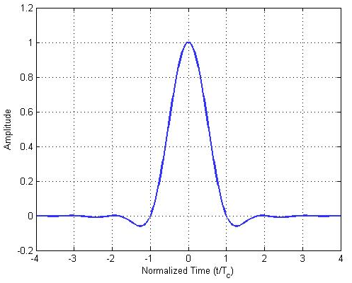

10.2.7 Chip transmission order

Change the first paragraph of 10.2.7 as shown:

During each symbol period, the least significant chip, c0, is transmitted first and the most significant chip, either c15 for DSSS (16,4) , or c8 for DSSS (8.4), for the 618 MHz, 416 MHz, and 195 MHz bands, is transmitted last.

10.3 O-QPSK PHY RF requirements

10.3.1 Operating frequency range

Change the dashed list in XXX as shown:

— 176 – 214 MHz
— 407-- 425 MHz
— 608 – 630 MHz

— 779–787 MHz
— 868.0–868.6 MHz
— 902–928 MHz
— 2400.0–2483.5 MHz

10.3.2 Transmit power spectral density (PSD) mask

Change the third paragraph of 10.3.2 as shown:

When operating in the 195, 416 MHz and 619 MHz bands, the transmitted spectral products shall be less than the limits specified in Table XX. For both relative and absolute limits, average spectral power shall be measured using a 100 kHz resolution bandwidth.

For the relative limit, the reference level shall be the highest average spectral power measured within ±1 MHz of the carrier frequency.

Change the title of Table XX as shown:

Table XX— 196, 416 MHz and 619 MHz bands O-QPSK transmit PSD limits as 250KB/s

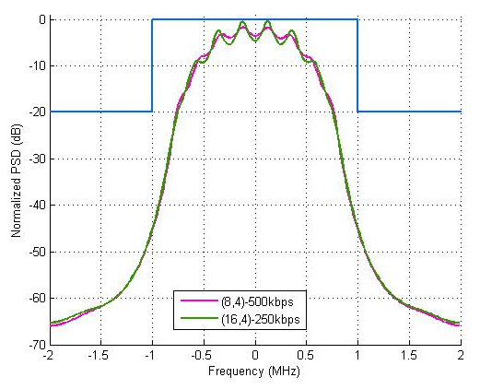

Table XX— 196, 416 MHz and 619 MHz bands O-QPSK transmit PSD limits

Bandwidth | Frequency | Relative limit | Absolute limit
2MHz | |f-f_{c}|>1.2MHz | -20dB | -20dBm

10.3.3 Symbol rate
Change the first paragraph of 10.3.3 as shown:

For 250 kb/s The O-QPSK PHY symbol rate shall be 62.5 ksymbol/s when operating in the 195 MHz, 416 MHz, and with an accuracy of ±40 ppm.

For 500 kb/s The O-QPSK PHY symbol rate shall be 125 ksymbol/s when operating in the 195 MHz, 416 MHz, and with an accuracy of ±40 ppm.

10. 3.5 Receiver interference rejection

There are the following major interferences on approved bands for medial signal transmission.

(There are more interference from TV and other microphone. One description how to reject them are neceaasry)

10. 3.5.1 Receiver interference sources on Chinese medical bands

- On 176-216 MHz band, the major interferences are sourced from: Digital TV, and Wireless Microphone
- On 407-425 MHz band, the major interference are sources from Interphone (Walkie-talkie)
- On 608-630 MHz band, the major interference are sources from Digital TV.

The details of Interferences on these bands are described in Annex ???

???

Insert the following new sub clause 10.4 after sub clause 10.3:

10.4 DCSS PHY
10.4.1 General

The DCSS PHY provides a method to determine the distance between an originator node and a recipient node. The general ranging procedure is shown in Figure XXX.

Figure XXX – General ranging procedure

A ranging procedure is initiated by the originator node by sending a ranging request frame on the communication channel containing initialization data to the recipient node. The recipient node responds on this communication channel with a data frame and either acknowledges or declines the ranging request depending on its abilities. During the ranging period, both nodes transmit and receive signals based on a DCSS modulation and perform phase measurements. At the end of this ranging procedure, the recipient sends a data frame containing its phase measurement results to the originator node using the initial communication channel.
Along with its own phase measurement results, the originator node is able to calculate the distance between both nodes. The communication channel used for initiating and configuring a distance measurement and exchanging measurement data uses one of the non-ranging PHYs defined in this standard. Both the DCSS PHY and the non-ranging PHY shall operate in the same frequency band.
10.4.1 DCSS ranging method

To start a ranging sequence, the originator transmits a start frame to the recipient. Based on this frame, both nodes wait phyPMSetupDuration before synchronizing their activities, so that TX mode and phase measurement always overlap. The originator sets its PLL to the phyPMStartFreq frequency while the recipient sets its PLL to the phyPMStartFreq + phyPMShiftFreq frequency. This frequency offset relates to the intermediate frequency of a low-IF receiver, where the originator receiver operates on an inverse IF position.

First, the recipient transmits a signal and the originator performs a phase measurement. The phase measurement duration at the originator is specified by phyPMSamplingDurationOrig. While both PLLs are running continuously, both devices switch their RX/TX direction and the recipient performs phase measurements on the signal transmitted by the originator.

As shown in Figure XXX, the inner loop is surrounded by an outer loop, while the frequencies of each PLL are stepped by phyPMStepFreq, starting from phyPMStartFreq to phyPMStopFreq on the originator and with an offset of phyPMShiftFreq on the recipient.

Figure XXX – Inner and outer loop of ranging sequence

Figure XXX shows receive and transmit activities of both nodes over time and the corresponding carrier frequencies. The start frame activates the ranging procedure in both nodes according to the PIB attributes that were exchanged previously. Both nodes set their PLLs to the carrier frequency, activate RX and TX mode accordingly, and wait phyPMFreqSettleDurationOrig/Rec. After the setup time of phyPMTxSetupDurationOrig/Rec, the receiver performs the phase measurement. Then both nodes exchange their roles regarding TX and RX. This sequence of transmitting once in both directions is designated as the inner loop and is repeated for each frequency defined by phyPMStartFreq, phyPMStopFreq, and phyPMStepFreq.
10.4.2 Phase measurement

Phase measurement is performed on the received carrier signal relative to a reference clock signal derived from the crystal oscillator having the same frequency as specified by phyPMShiftFreq. Therefore, the phase measurement represents the phase shift of two signals with nominally the same frequency.

Figure XXX – Ranging sequence

10.4.3 DCSS PHY RF requirements

10.4.3.1 Operating frequency bands

The DCSS PHY operates in the following bands:

— 176 – 216 MHz
— 407 – 425 MHz
— 608 – 630 MHz
— 902 – 928 MHz
— 2360 – 2400 MHz
— 2400 – 2483.5 MHz

10.4.3.2 Channel and frequency band assignments
The communication channel used for initiating and configuring a DCSS phase measurement and exchanging measurement data uses one of the non-ranging PHYs defined in this standard. The channel assignment of the communication channel follows definitions as described in 8.1.2.
The measurement bandwidth allocated for a DCSS phase measurement within a certain frequency band is selected with parameters phyPMStartFreq, phyPMStopFreq, and phyPMStepFreq.

10.4.3.3 Transmit center frequency tolerance
The transmit DCSS phase measurement frequency requirements are similar to the requirements of the communication channel of the non-ranging PHYs defined in this standard used for initiating and configuring a DCSS phase measurement and exchanging measurement data.

15 Filter FSK PHY

(Ken, Masahiro, please add the modification in this part)

Annex A: Interferences and their Models on 174-216, 407-425, and 608-630 MHz Bands

Table XXX, the interference on 174-216, 407-425 and 608-630 MHz Bands

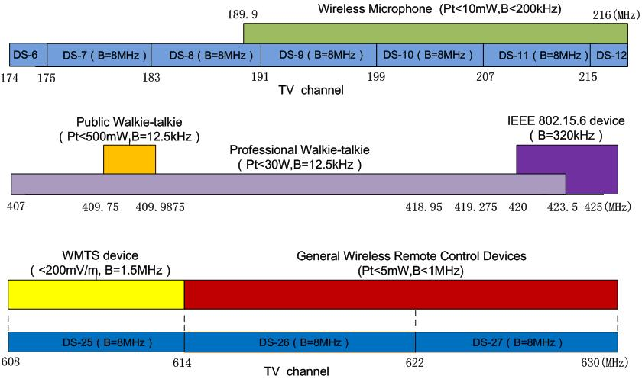

X.1 Inference on 176-214 MHZ Channel.

On this band, the major interference are sourced from
- VHF Radio and TV
- Wireless Microphone

The signal model and spectrum of VHF Radio and TV are:

 | Channel | Standard
Digital radio and TV | DS-6：174-175MHz  DS-7：175-183MHz  DS-8：183-191MHz  DS-9：191-199MHz  DS-10：199-207MHz  DS-11：207-215MHz  DS-12：215-216MHz | DTMB(OFDM) | CMMB(OFDM)
Analog radio and TV |  | GB/T 14433-93 Color Radio and TV Coverage Network Technical requirements
Remark: The analog radio and TV will stop in 2015.

DTMB (???) and CMMB (??? )are both of Chinese Digital TV standards

The model of microphone is copied as:
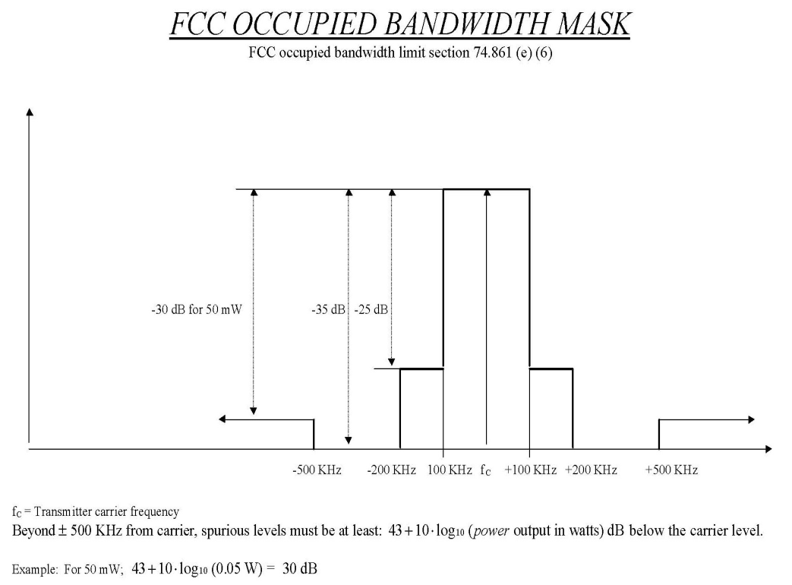

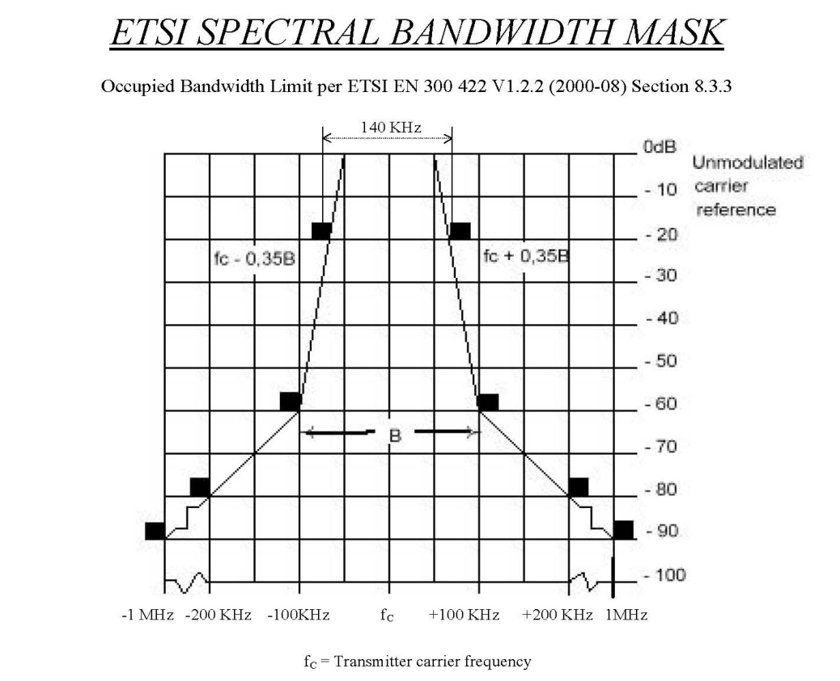

X.2 Inference on 407-425 MHZ Band

The major interference on this band are sourced from
- Interphone (Walkie-Talkie)

 |  | Public interphone  (Pt<500mW) | 409.7500-409.9875MHz | Analog | Channel number:20  Operation frequency:409.7500-409.9875MHz  Channel spacing:12.5kHz  Modulation:8K5F3E
 |  |  |  | Digital | Channel spacing:12.5kHz 6.25kHz  multi-access mode : FDMA/TDMA
 |  | Digital interphone  Standards: | DMR（base on TDMA）、DPMR（base on FDMA）、DSRR ,P25 standard

The model of interphone is described as:

- Operation Modes

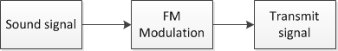

- Transmission Signal

: sound signal

: amplitude (0.3 in this modulation)

: carrier frequency (200MHz in this modulation)

: frequency deviation

X.3 Inferences on 608-630 MHZ Band

The major interferences on this band are sourced from:

  - UHF Radio and TV
  - General Wireless Remote Control Devices

The model of digital TV is described in the Table XXX

Table XX --- The model of TV Signals

 | Channel | Standard
Digital radio and TV | DS-25：608-614MHz  DS-26：614-622MHz  DS-27：622-630MHz | DTMB(OFDM) | CMMB(OFDM)
Analog radio and TV | DS-25：608-614MHz  DS-26：614-622MHz  DS-27：622-630MHz | GB/T 14433-93 Color TV Broadcast Coverage Network Technical Regulations
Remark: And China will stop the analog signal in 2015.

In 2012, the Analog TV is going to be stopped in China.

