IEEE P802.15
Wireless Personal Area Networks

Project | IEEE P802.15 Working Group for Wireless Personal Area Networks (WPANs)
Title | Proposed Resolution for TG4m TVWS-NB-OFDM: CIDs 76, 77, 78, 79, 80, 81, 82, 86, and 87
Date Submitted | April. 22, 2013
Source | [Keiichi Mizutani, Alina Lu Liru, Chin Sean Sum, Ming-Tuo Zhou, Fumihide Kojima, Hiroshi Harada(NICT)] | Voice: [[+81-46-847-5294]  Fax: [[+81-46-847-5440]  E-mail: [mizk@nict.go.jp]
Re: | Submission for comment resolution in LB88 of IEEE 802.15.4m draft
Abstract | Comment Resolution for the TVWS-NB-OFDM
Purpose | Resolve TVWS-NB-OFDM related comments in LB88
Notice | This document has been prepared to assist the IEEE P802.15. It is offered as a basis for discussion and is not binding on the contributing individual(s) or organization(s). The material in this document is subject to change in form and content after further study. The contributor(s) reserve(s) the right to add, amend or withdraw material contained herein.
Release | The contributor acknowledges and accepts that this contribution becomes the property of IEEE and may be made publicly available by P802.15.
- CID 76: The original texts: "The 88-bit sequence is spread as (d0, d0, d0, d0, d1, d1, d1, d1, d2, d2, d2, d2, …, d87, d87, d87, d87) with and the resulting sequence is XOR operated using with the scrambler output defined in TBD to generate a 352-bit sequence" is unclear and the spreading is not defined
- CID 79: what is the spreading sequence for this operation? [1 1 1 1] or something else?
- CID 80: TBD in the text.

Proposed Resolution
[1] Replace the following two sentences which are written in the end of paragraph of 20.3.1.3 (p.98, l.26-30):
The 88-bit sequence is spread as (d0, d0, d0, d0, d1, d1, d1, d1, d2, d2, d2, d2, …, d87, d87, d87, d87) with and the resulting sequence is XOR operated using with the scrambler output defined in TBD to generate a 352-bit sequence. The initial state of the scrambler for the 88-bit sequence shall be "all ones".
with a following sentence:
The 88-bit sequence is spread by using a spreading sequence [1 1 1 1] as (d0, d0, d0, d0, d1, d1, d1, d1, d2, d2, d2, d2, …, d87, d87, d87, d87) to generate a 352-bit sequence.

- CID 77: scramble seed is not defined
- CID 78: where is the "Scramble seed" field of the PHR defined?
- CID 81: what is the "scrambler output"?

Proposed Resolution
[1] Add a following sentence into between the definition of the Channel Aggregation field (p.98, l.17-18) and the definition of the Header Check Sequence (p.98, l.20-22):
The Scrambler field (S₈-S₀) specifies the scrambling seed defined by the manufacturer.

[2] Add a new sub-clause “20.3.3.2.4 Scrambler and scrambler seeds” as following:
20.3.3.2.4 Scrambler and scrambler seeds
The input to the scrambler is the data bits followed by tail bits and then pad bits. The scrambler uses a PN9 sequence that is shown in Figure 102. The PN9 scrambler is initialized by the scrambling seed specified by 9 bits in the PHR. The leftmost value of the scrambling seed is placed into the leftmost delay element in Figure 102.

- CID 82: Comment resolution for CID 491 is not reflected in Figure 188.

Proposed Resolution
[1] Divide Figure 188 into two parts with each caption as follows:
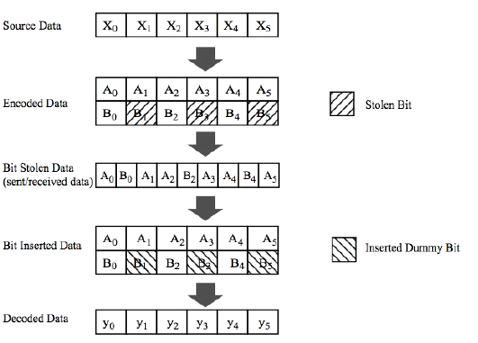
Figure 188 – R=2/3 puncturing pattern for TVWS-NB-OFDM
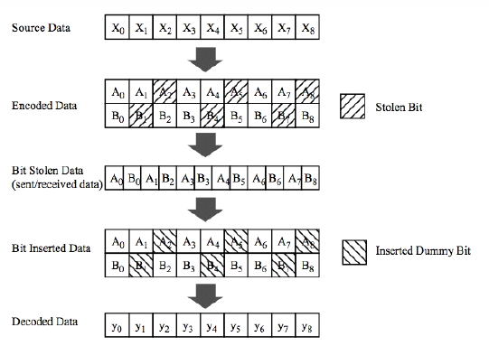
Figure 189 – R=3/4 puncturing pattern for TVWS-NB-OFDM

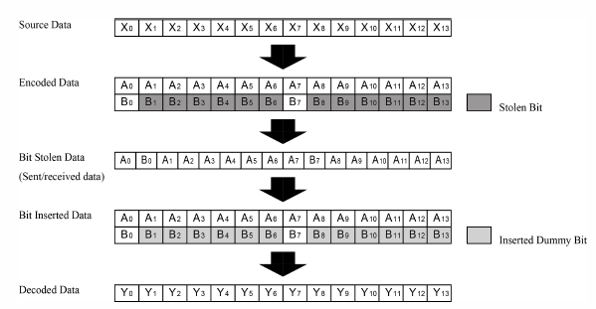
Figure 190 – R=7/8 puncturing pattern for TVWS-NB-OFDM

- CID 86: Comment resolution for CID 455 is not reflected in Equation.
- CID 87: Comment resolution for CID 455 is not reflected in Equation.

Proposed Resolution
[1] Replace the equation 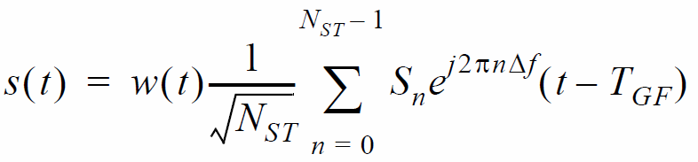 which is written in sub-clause 20.3.3.8 with the new equation 

