IEEE P802.15
Wireless Personal Area Networks

Project | IEEE P802.15 Working Group for Wireless Personal Area Networks (WPANs)
Title | The RF requirements for TVWS-OFDM
Date Submitted | [April 2013]
Source | [Cheolho SHIN(ETRI) ,Sangsung CHOI(ETRI) and Soo-Young Chang (SYCA)] | Voice: [ ]  Fax: [ ]  E-mail:  [chshin@etri.re.kr  sschoi@etri.re.kr, sychang@ecs.csus.edu]
Re:
Abstract | Working doc of TVWS-OFDM Comment Resolutions
Purpose | Comment Resolution
Notice | This document has been prepared to assist the IEEE P802.15. It is offered as a basis for discussion and is not binding on the contributing individual(s) or organization(s). The material in this document is subject to change in form and content after further study. The contributor(s) reserve(s) the right to add, amend or withdraw material contained herein.
Release | The contributor acknowledges and accepts that this contribution becomes the property of IEEE and may be made publicly available by P802.15.

20.2.4.4 Receiver sensitivity
The sensitivity requirements, as described in 8.1.7, for every Option and MCS modes are shown below in Table 209.

Table 209—TVWS-OFDM PHY sensitivity requirements
MCS Mode | Sensitivity
MCS Mode | Mandatory Modes | Optional Modes
0 | -97 dBm
1 | -94 dBm
2 | -88 dBm
3 |  | -91 dBm
4 |  | -88 dBm
5 |  | -82 dBm

20.2.4.5 Tx-to-Rx turnaround time
The TX-to-RX turnaround time shall be as given in 8.2.1.

20.2.4.6 Rx-to-Tx turnaround time
The RX-to-TX turnaround time shall be as given in 8.2.2.

20.2.4.7 Error-vector magnitude (EVM) definition
The relative constellation RMS error averaged over subcarriers, symbols, and packets shall not exceed the values shown in Table 210.

Table 210— TVWS-OFDM PHY EVM requirements
MCS mode | RMS error
MCS mode | Mandatory Modes | Optional Modes
0 | - 10
1 | -10
2 | -16
3 |  | - 10
4 |  | -10
5 |  | -16

The transmit modulation accuracy test shall be performed by instrumentation capable of converting the transmitted signal into a stream of complex samples. The sampled signal shall be processed in a manner similar to an actual receiver, according to the following steps, or an equivalent procedure:
a) Detect the start of packet.
b) Detect the transition from STF to LTF, and establish fine timing (with one sample resolution).
c) Estimate the coarse and fine frequency offsets.
d) De-rotate the packet according to estimated frequency offset.
e) Estimate the complex channel response coefficients for each of the subcarriers.
f) For each data OFDM symbol, transform the symbol into subcarrier received values and divide each subcarrier value with the estimated channel response coefficient.
g) For each data-carrying subcarrier, find the closest constellation point and compute the squared Euclidean distance from it.
h) Compute the RMS average of all errors in a packet. It is given by
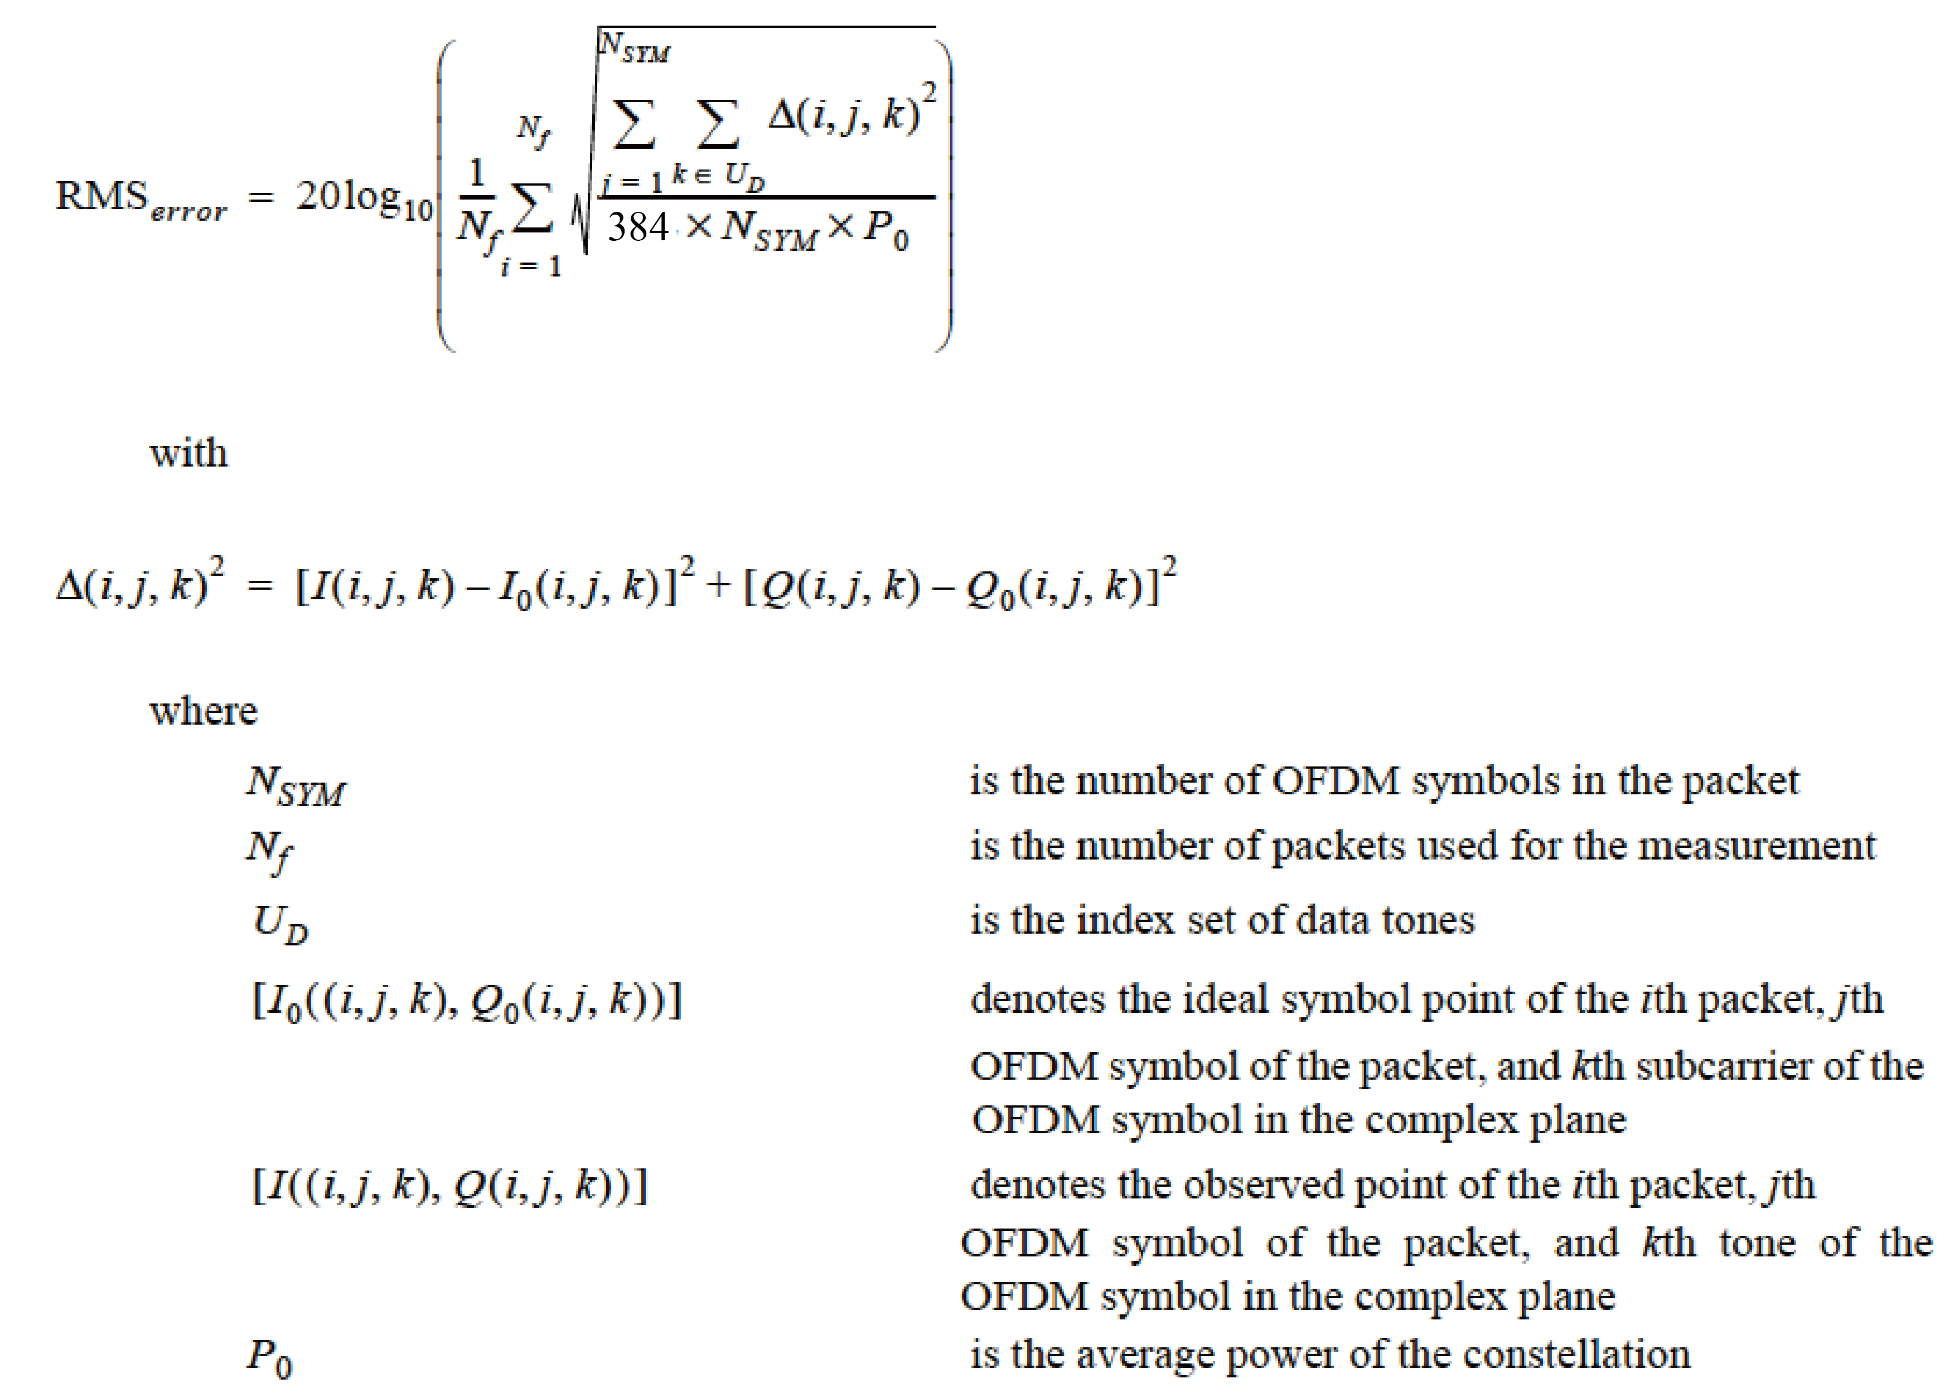
The test shall be performed over at least N_{f} = 20 packets. The payload of the packets under test shall contain N_{SYM} = 16 OFDM symbols. Random data shall be used for the payload.

20.2.4.8 Transmit center frequency and symbol tolerance
The transmit center frequency tolerance shall be ±20 ppm maximum. The symbol clock frequency tolerance shall also be ±20 ppm maximum. The transmit center frequency and the symbol clock frequency shall be derived from the same reference oscillator.

