IEEE P802.15
Wireless Personal Area Networks

Project | IEEE P802.15 Working Group for Wireless Personal Area Networks (WPANs)
Title | Coexistence Document for IEEE 802.15.4p
Date Submitted | [July 09, 2013]
Source | [Jon Adams]  [Lilee Systems, Ltd]  [Scottsdale, AZ] | Voice: [+1.480.628.6686]  Fax: [N/A]  E-mail: [jonadams@ieee.org]
Re: | [802.15 Plenary Meeting in Orlando, Florida]
Abstract | [IEEE 802.15.4 Coexistence Document]
Purpose | [Official minutes of the Working Group Session]
Notice | This document has been prepared to assist the IEEE P802.15. It is offered as a basis for discussion and is not binding on the contributing individual(s) or organization(s). The material in this document is subject to change in form and content after further study. The contributor(s) reserve(s) the right to add, amend or withdraw material contained herein.
Release | The contributor acknowledges and accepts that this contribution becomes the property of IEEE and may be made publicly available by P802.15.

Contributors of the CA document are sorted by alphabetical order of the last name:
M-C Doong
Jon Adams
Steve Jillings
Qing Li

Contents
1 Introduction 7
1.1 Bibliography 7
2 Overview 9
2.1 Regulatory Information 9
2.2 Overview of Coexistence Mechanisms in 802.15.4 and 802.15.4p 10
3 Dissimilar Systems Sharing the Same Frequency Bands with 802.15.4p 11
3.1 Coexisting Systems in 160.170 – 161.580 MHz Band 11
3.2 Coexisting Systems in 216 - 217 MHz Band 11
3.3 Coexisting Systems in 217 - 220 MHz Band 12
3.4 Coexisting Systems in 220 - 222 MHz Band 12
3.5 Coexisting Systems in 450 - 470 MHz Band 12
3.6 Coexisting Systems in 769 - 775 MHz Band 12
3.7 Coexisting Systems in 799 - 805 MHz Band 12
3.8 Coexisting Systems in 806 – 821 / 851 – 866 MHz Band 12
3.9 Coexisting Systems in 863 – 870 MHz Band 12
3.10 Coexisting Systems in 896 – 901 / 935 – 940 MHz Paired Bands 12
3.11 Coexisting Systems in 901 – 902 MHz Band 13
3.12 Coexisting Systems in 902 – 928 MHz Band 13
3.13 Coexisting Systems in 928 – 952 MHz Band 13
3.14 Coexisting Systems in 2400 – 2483.5 MHz Band 13
3.15 Coexisting Systems in 4940 - 4990 MHz Band 14
3.16 Coexisting Systems in 5250 - 5350 MHz Band 14
3.17 Coexisting Systems in 5470 - 5725 MHz Band 14
3.18 Coexisting Systems in 5650 - 5925 MHz Band 15
3.19 Coexisting Systems in 5725 - 5850 MHz Band 15
4 Coexistence Scenario and Analysis 16
4.1 PHY Modes in the 802.15.4p System 16
4.1.1 Parameters of the 802.15.4p PHY Modes 16
4.1.2 BER / FER Calculations for 802.15.4p PHY Modes 16
4.2 Interference Modeling 18
4.3 450 – 470 MHz Band Coexistence Performance 19
4.3.1 Parameters for Coexistence Quantification 19
4.3.1.1 PHY Mode Parameters of Coexisting Standards 19
4.3.1.2 BER / FER for PHY Modes of Coexisting 802 Standards 19
4.3.2 Coexistence Simulation Results 20
4.3.2.1 802.15.4p PHY Mode as Victim Receiver 20
4.3.2.2 802.15.4/4g PHY Modes as Victim Receiver 22
4.4 863 – 870 MHz Band Coexistence Performance 23
4.4.1 Parameters for Coexistence Quantification 23
4.4.1.1 PHY Mode Parameters of Coexisting Standards 23
4.4.1.2 BER / FER for PHY Modes of Coexisting 802 Standards 24
4.4.2 Coexistence Simulation Results 25
802.15.4p PHY Mode as Victim Receiver 25
4.4.2.1 25
4.4.2.2 802.15.4/4g PHY Modes as Victim Receiver 26
4.5 902 – 928 MHz Bands Coexistence Performance 28
4.5.1 Parameters for Coexistence Quantification 28
4.5.1.1 PHY Mode Parameters of Coexisting Standards 28
4.5.1.2 4.8.1.2 BER / FER for PHY Modes of Coexisting 802 Standards 28
4.5.2 Coexistence Simulation Results 29
4.5.2.1 802.15.4p PHY Mode as Victim Receiver 29
4.5.2.2 802.15.4PHY Modes as Victim Receiver 31
4.6 2400 – 2483.5 MHz Band Coexistence Performance 33
4.6.1 Parameters for Coexistence Quantification 33
4.6.1.1 PHY Mode Parameters of Coexisting Standards 33
4.6.1.2 BER / FER for PHY Modes of Coexisting 802 Standards 34
4.6.2 Coexistence Simulation Results 35
4.6.2.1 802.15.4p PHY Mode as Victim Receiver 35
4.6.2.2 802.11 PHY Modes as Victim Receiver 35
5 Interference Avoidance and Mitigation Techniques 37
6 Conclusions 38

Table of Figures
Figure 1: BER vs. SNR for 802.15.4p MSK, C4FM, QPSK, pi/4 DQPSK and DSSS DQPSK 17
Figure 2: FER vs. SNR for 802.15.4p MSK, C4FM, QPSK, pi/4 DQPSK and DSSS DQPSK 18
Figure 3: BER and FER vs. SNR for 802.15.4 Systems 20
Figure 4: Victim (802.15.4p 9.6Kbps C4FM) BER/FER vs. Distance from Interferer TX (802.15.4 4.8Kbps 2FSK) to Victim RX 21
Figure 5: Victim (802.15.4p 9.6Kbps C4FM) BER/FER vs. Distance from Interferer TX (802.15.4 9.6Kbps 4FSK) to Victim RX 22
Figure 6: Victim (802.15.4 4.8Kbps 2FSK) BER/FER vs. Distance from Interferer Tx (802.15.4p 9.6Kbps C4FM) to Victim Rx 22
Figure 7: Victim(802.15.4 9.6Kbps 4FSK) BER/FER vs. Distance from Interferer Tx (802.15.4p 9.6Kbps C4FM) to 802.15.4 Victim Rx 23
Figure 8: BER and FER vs. SNR for 802.15.4 Systems 25
Figure 9: Victim (802.15.4p DSSS DPSK) BER/FER vs. Distance from Interferer Tx(802.15.4 MR-FSK) to Victim Rx 25
Figure 10: Victim (802.15.4p DSSS DPSK) BER/FER vs. Distance from Interferer Tx (802.15.4 BPSK) to Victim Rx 26
Figure 11: Victim (802.15.4 MR-FSK) BER/FER vs. Distance from Interferer Tx (802.15.4p DSSS DPSK) to Victim Rx 27
Figure 12: Victim(802.15.4 BPSK) BER/FER vs. Distance from Interferer Tx (802.15.4p DSSS DPSK) to 802.15.4 Victim Rx 28
Figure 13: BER and FER vs. SINR for 802.15.4 Systems 29
Figure 14: Victim (802.15.4p DSSS DPSK) BER/FER vs. Distance from Interferer TX (802.15.4 MR-FSK) to Victim RX 30
Figure 15: Victim (802.15.4p DSSS DPSK) BER/FER vs. Distance from Interferer TX (802.15.4 BPSK) to Victim RX 31
Figure 16: Victim (802.15.4 MR-FSK) BER/FER vs. Distance from Interferer TX (802.15.4p DSSS DPSK) to Victim RX 32
Figure 17: Victim (802.15.4 BPSK) BER/FER vs. Distance from Interferer TX (802.15.4p DSSS DPSK) to Victim RX 33
Figure 18: BER and FER v.s. SNR for 802.11 Systems 34
Figure 19: Victim BER vs. Distance from Interferer Tx to Victim Rx 35
Figure 20: Victim BER vs. Distance from Interferer Tx to Victim Rx 36

Table of Tables
Table 1: Frequency Bands for 802.15.4p PHYs 10
Table 2: Dissimilar Systems Coexisting with 802.15.4p within 863 - 870 MHz Band 12
Table 3: Dissimilar Systems Coexisting with 802.15.4p in the 902 – 928 MHz Band 13
Table 4: Dissimilar Systems coexisting with 802.15.4p within 928 - 952 MHz band 13
Table 5: Dissimilar Systems coexisting with 802.15.4p within 2400 - 2483.5 MHz Band 14
Table 6: Dissimilar Systems coexisting with 802.15.4p within 5250 - 5350 MHz band 14
Table 7: Dissimilar Systems coexisting with 802.15.4p within 5470 - 5725 MHz band 14
Table 8: Dissimilar Systems coexisting with 802.15.4p within 5650 - 5925 MHz band 15
Table 9: Dissimilar Systems coexisting with 802.15.4p within 5725 - 5850 MHz band 15
Table 10: Major Parameters of 802.15.4p PHY Modes 16
Table 11: Major Parameters of Coexisting 802 Systems in the 450-470 MHz Band 19
Table 12: Major Parameters of Coexisting 802 Systems in the 863 - 870 MHz Band 24
Table 13: Major Parameters of Coexisting 802 Systems in the 902 - 928 MHz Band 28
Table 14: Major Parameters of Coexisting 802 Systems in the 2400 – 2483.5 MHz band 33

Introduction

Bibliography
(B1) IEEE Std. 802.15.1 – 2005, IEEE Standard for Information Technology – Telecommunications and Information exchange between systems – Local and metropolitan area networks – Specific requirements – Part 15.1: Wireless Medium Access Control (MAC) and Physical Layer (PHY) Specifications for Wireless Personal Area Networks (WPANs).
(B2) IEEE Std. 802.15.2 – 2003, IEEE Recommended Practice for Information Technology – Telecommunications and Information exchange between systems – Local and metropolitan area networks – Specific requirements – Part 15.2: Coexistence of Wireless Personal Area Networks with Other Wireless Devices Operating in Unlicensed Frequency Bands.
(B3) IEEE Std. 802.15.3 – 2003, IEEE Standard for Information Technology – Telecommunications and Information exchange between systems – Local and metropolitan area networks – Specific requirements – Part 15.3: Wireless Medium Access Control (MAC) and Physical Layer (PHY) Specifications for High Rate Wireless Personal Area Networks (WPANs).
(B4) IEEE Std. 802.15.4 – 2011, IEEE Standard for Information Technology – Telecommunications and Information exchange between systems – Local and metropolitan area networks – Specific requirements – Part 15.4: Wireless Medium Access Control (MAC) and Physical Layer (PHY) Specifications for Low-Rate Wireless Personal Area Networks (WPANs).
(B5) IEEE Std. 802.15.4e – 2012, IEEE Standard for Information Technology – Telecommunications and Information exchange between systems – Local and metropolitan area networks – Specific requirements – Part 15.4: Low-Rate Wireless Personal Area Networks (LRWPANs) Amendment to the MAC sub-layer.
(B6) IEEE Std. 802.15.4p/D6 – 2012, IEEE Draft Standard for Information Technology –Telecommunications and Information exchange between systems – Local and metropolitan area networks – Specific requirements – Part 15.4: Wireless Medium Access Control (MAC) and Physical Layer (PHY) Specifications for Low-Rate Wireless Personal Area Networks (WPANs) – Amendment x: Physical Layer Specifications for Low Energy, Critical Infrastructure
Monitoring Networks
(B7) IEEE Std. 802.15.4g - 2012, IEEE Standard for Information Technology – Telecommunications and Information exchange between systems – Local and metropolitan area networks – Specific requirements – Part 15.4: Wireless Medium Access Control (MAC) and Physical Layer (PHY) Specifications for Low-Rate Wireless Personal Area Networks (WPANs) – Amendment 3: Physical Layer Specifications for Low Data Rate Wireless Smart Metering
Utility Network
(B8) IEEE Std. 802.15.4f – 2012, IEEE Standard for Information Technology – Telecommunications and Information exchange between systems – Local and metropolitan area networks – Specific requirements – Part 15.4: Wireless Medium Access Control (MAC) and Physical Layer (PHY) Specifications for Low-Rate Wireless Personal Area Networks (WPANs) – Amendment 2: Active Radio Frequency Identification (RFID) System Physical Layer (PHY)
(B9) IEEE Std. 802.11 – 2011 IEEE Standard for Information Technology – Telecommunications and Information exchange between systems – Local and metropolitan area networks – Specific requirements – Part 11: Wireless LAN Medium Access Control (MAC) and Physical Layer (PHY) Specifications.
(B10) IEEE Std. 802.15.4g TG4 Coexistence Assurance Document (IEEE 802.15-10-00668-05-004g)
(B11) IEEE Std. 802.15.4 Coexistence analysis of IEEE Std. 802.15.4 with other IEEE standards and proposed standards (IEEE 802.15.10-0808-00)
(B12) IEEE Std. 802.15.4p TG4p PAR (IEEE 802.15.12-0nnn-nn-0SGp)

Overview
The overview of 802.15.4p is summarized in Section 5.2 Scope of TG4p PAR (Bnn).

Regulatory Information
The available US and European frequency bands for 802.15.4p are given as below:
(a) 160.170 – 161.580 MHz
(b) 216 - 217 MHz
(c) 217 - 220 MHz
(d) 220 - 222 MHz
(e) 450 – 470 MHz
(f) 769 - 775 MHz
(g) 799 - 805 MHz
(h) 806 – 821 / 851 - 866 MHz
(i) 863 – 870 MHz (Europe)
(j) 896 – 901 / 935 – 940 MHz
(k) 901 – 902 MHz
(l) 902 – 928 MHz
(m) 928 - 952 MHz
(n) 2400 – 2483.5 MHz
(o) 4940 – 4990 MHz
(p) 5250 – 5350 MHz
(q) 5470 – 5725 MHz
(r) 5650 – 5925 MHz
(o) 5725 – 5850 MHz
From the above list, bands (e) and (j) – (n) may be occupied by different 802.15.4p PHYs. These are listed in Table 1, below.

Table 1: Frequency Bands for 802.15.4p PHYs
Frequency Band (MHz) | IEEE 802.15.4p PHYs
Frequency Band (MHz) | RCC LMR | RCC DSSS BPSK | RCC Ranging
160.170 – 161.580 | X
216 – 217 | X
217 – 220 | X
220 – 222 | X
450 – 470 | X
769 – 775 | X
799 – 805 | X
806 – 821 / 851 – 866 | X
863 – 870 | X
896 – 901 / 935 – 940 | X
901 – 902 | X
902 – 928 | X | X | X
928 – 952 | X
4940 – 4990 | X | X
5250 – 5350 | X | X | X
5470 – 5725 | X | X | X
5650 – 5925 | X | X | X
5725 - 5850 | X | X | X

Overview of Coexistence Mechanisms in 802.15.4 and 802.15.4p
The importance of a coexistence mechanism in 15.4p is manifold. 15.4p specifies three alternative PHYs that shall be able to coexist with each other if operating co-located in the same frequency band. 15.4p also has to share multiple frequency bands and coexist with dissimilar 802 systems.

The coexistence mechanisms specified in 802.15.4 and subsequent amendments are applicable to both homogeneous (among different 15.4p PHYs) and heterogeneous (across other 802 systems) coexistence.

Dissimilar Systems Sharing the Same Frequency Bands with 802.15.4p
This clause presents an overview on other 802 systems which are specified to operate in some of the same frequency bands that are also specified for 802.15.4p. The following sub-clauses present collocated dissimilar systems with reference to respective frequency bands which are shared by dissimilar 802.15.4 systems.
The frequency bands of interest are the 160.170 – 161.580 MHz band, 216 - 217 MHz band, 217 – 220 MHz band, 220 – 222 MHz band, 450 - 470 MHz band, 769 – 775 MHz band, 799 – 805 MHz band, 806 – 821 / 851 – 866 MHz band (paired), 863 – 870 MHz band, 896 – 901 / 935 – 940 MHz band (paired), 902 – 902 MHz band, 902 – 928 MHz band, 938 – 952 MHz band, 2400 – 2483.5 MHz band, 4940 – 4990 MHz band, 5250 – 5350 MHz band, 5470 – 5725 MHz band, 5650 – 5925 MHz band, and 5725 – 2825 MHz band.
In this and following clauses, each frequency band is discussed referring to a table listing all the coexisting systems from other standard specifications. The contents of the tables are formatted as below:
- Standard specification: the name of the 802 system with which 802.15.4p system is coexisting.
- PHY specification: the PHY design of the above 802 system specification
- Receiver bandwidth: the receiver bandwidth of the above 802 system specification
- Transmit power: the transmit power of the above 802 system specification
- Receiver sensitivity: the receiver sensitivity of the above 802 system specification.
- Involved 802.15.4p system: the particular PHY in 802.15.4p that is coexisting with the above 802 system specification
Note: The data rate modes, including receiver bandwidth, transmit power and receiver sensitivity listed in the columns of the following tables, are only a part of the complete list from the respective standard specifications. These data rate modes are chosen for the purpose of coexistence analysis in this document.

Coexisting Systems in 160.170 – 161.580 MHz Band
No existing 802 systems share the 160.170 - 161.580 MHz band with 802.15.4p PHYs.

Coexisting Systems in 216 - 217 MHz Band
No existing 802 systems share the 216 – 217 MHz band with 802.15.4p PHYs.

Coexisting Systems in 217 - 220 MHz Band
No existing 802 systems share the 217 – 220 MHz band with 802.15.4p PHYs.

Coexisting Systems in 220 - 222 MHz Band
No existing 802 systems share the 220 – 222 MHz band with 802.15.4p PHYs.

Coexisting Systems in 450 - 470 MHz Band
At this time, there is one approved standard for operation in this band: IEEE 802.15.4-2012 (specifically the 15.4g amendment). However, in the US this is a licensed band under CFR 47 (US FCC) Part 90 rules, and so any usages shall be controlled by the licensee and the frequency coordinator for that band segment. Therefore, it is highly improbable that the licensee shall choose to put to mutually interfering systems on the same channel.

Coexisting Systems in 769 - 775 MHz Band
No existing 802 systems share the 769 – 775 MHz band with 802.15.4p PHYs.

Coexisting Systems in 799 - 805 MHz Band
No existing 802 systems share the 799 – 805 MHz band with 802.15.4p PHYs.

Coexisting Systems in 806 – 821 / 851 – 866 MHz Band
No existing 802 systems share the 806 – 821 / 851 – 866 MHz band with 802.15.4p PHYs.

Coexisting Systems in 863 – 870 MHz Band
Table 2 shows other 802 systems that share the 863 – 870 MHz band with 802.15.4p PHYs.
Table 2: Dissimilar Systems Coexisting with 802.15.4p within 863 - 870 MHz Band
Standard | Standard PHY | Involved 802.15.4p PHY
Standard | Standard PHY | RCC LMR | RCC DSSS BPSK | RCC Ranging
802.15.4 | BPSK | X | X | X
802.15.4 | ASK | X | X | X
802.15.4 | O-QPSK | X | X | X
802.15.4 | MR-FSK | X | X | X
802.15.4 | MR-OFDM | X | X | X
802.15.4 | MR-O-QPSK | X | X | X

Coexisting Systems in 896 – 901 / 935 – 940 MHz Paired Bands
At this time, there is one approved standard for operation in this band: IEEE 802.15.4-2012 (specifically the 15.4g amendment). However, in the US this is a licensed band under CFR 47 (US FCC) Part 90 rules, and so any usages shall be controlled by the licensee. Therefore, it is highly improbable that the licensee shall choose to put to mutually interfering systems on the same channel.

Coexisting Systems in 901 – 902 MHz Band
At this time, there is one approved standard for operation in this band: IEEE 802.15.4-2012 (specifically the 15.4g amendment). However, in the US this is a licensed band under CFR 47 (US FCC) Part 24 rules, and so any usages shall be controlled by the licensee. Therefore, it is highly improbable that the licensee shall choose to put to mutually interfering systems on the same channel.

Coexisting Systems in 902 – 928 MHz Band
Table 3 shows other 802 systems that share the 902 – 928 MHz band with 802.15.4p PHYs.
Table 3: Dissimilar Systems Coexisting with 802.15.4p in the 902 – 928 MHz Band
Standard | Standard PHY | Involved 802.15.4p PHY
Standard | Standard PHY | RCC LMR | RCC DSSS BPSK | RCC Ranging
802.15.4 | BPSK | X | X | X
802.15.4 | ASK | X | X | X
802.15.4 | O-QPSK | X | X | X
802.15.4 | MR-FSK | X | X | X
802.15.4 | MR-OFDM | X | X | X
802.15.4 | MR-O-QPSK | X | X | X

Coexisting Systems in 928 – 952 MHz Band
Table 4 shows other 802 systems that share the 928 - 952 MHz band with 802.15.4p PHYs.
Table 4: Dissimilar Systems coexisting with 802.15.4p within 928 - 952 MHz band
Standard | Standard PHY | Involved 802.15.4p PHY
Standard | Standard PHY | RCC LMR | RCC DSSS BPSK | RCC Ranging
802.15.4 | BPSK | X | X | X
802.15.4 | ASK | X | X | X
802.15.4 | O-QPSK | X | X | X
802.15.4 | MR-FSK | X | X | X
802.15.4 | MR-OFDM | X | X | X
802.15.4 | MR-O-QPSK | X | X | X

Coexisting Systems in 2400 – 2483.5 MHz Band
Table 5 shows other 802 systems that share the 2400 – 2483.5 MHz band with 802.15.4p PHYs.

Table 5: Dissimilar Systems coexisting with 802.15.4p within 2400 - 2483.5 MHz Band
Standard | Standard PHY | Involved 802.15.4p PHY
Standard | Standard PHY | RCC LMR | RCC DSSS BPSK | RCC Ranging
802.15.1 | FHSS GFSK | X | X | X
802.15.3 | SC D-QPSK | X | X | X
802.15.4 | O-QPSK | X | X | X
802.15.4 | CSSS | X | X | X
802.11b | DSSS | X | X | X
802.11g | DSSS | X | X | X
802.11g | OFDM | X | X | X
802.11n | OFDM | X | X | X

Coexisting Systems in 4940 - 4990 MHz Band
At this time, there is one approved standard for operation in this band: IEEE 802.15.11-2011. However, this band is separated into 1 MHz wide channels that are not comingled with the aggregatable 5 MHz channels. The 802.15.4p usage is restricted to the 1 MHz wide channels that are at both band edges. Thus, there is no potential for co-channel interference.

Coexisting Systems in 5250 - 5350 MHz Band
In the 5250 - 5350 MHz band, IEEE 802.11-2011 is the only other 802 system sharing this band with the proposed 802.15.4p PHYs. In the US under 47 CFR 15 UNII band rules, all subject users are required to meet the same TX power output rules. The primary difference between 802.11 and 802.15.4p systems in this band is occupied bandwidth. As the proposed 802.15.4p systems have a significantly narrower bandwidth than most of the 802.11 systems used in this band, the primary impact with co-channel use will be interference to the 802.11 system.
Table 6: Dissimilar Systems coexisting with 802.15.4p within 5250 - 5350 MHz band
Standard | Standard PHY | Involved 802.15.4p PHY
Standard | Standard PHY | RCC LMR | RCC DSSS BPSK | RCC Ranging
802.11a | OFDM | X | X | X
802.11n | OFDM | X | X | X

Coexisting Systems in 5470 - 5725 MHz Band
Table 7 shows other 802 systems that share 5470 - 5725 MHz band with 802.15.4p PHYs
Table 7: Dissimilar Systems coexisting with 802.15.4p within 5470 - 5725 MHz band
Standard | Standard PHY | Involved 802.15.4p PHY
Standard | Standard PHY | RCC LMR | RCC DSSS BPSK | RCC Ranging
802.11a | OFDM | X | X | X
802.11n | OFDM | X | X | X

Coexisting Systems in 5650 - 5925 MHz Band
Table 8 shows other 802 systems that share the 5650 - 5925 MHz band with 802.15.4p PHYs
Table 8: Dissimilar Systems coexisting with 802.15.4p within 5650 - 5925 MHz band
Standard | Standard PHY | Involved 802.15.4p PHY
Standard | Standard PHY | RCC LMR | RCC DSSS BPSK | RCC Ranging
802.11a | OFDM | X | X | X
802.11n | OFDM | X | X | X

Coexisting Systems in 5725 - 5850 MHz Band
Table 9 shows other 802 systems that share the 5725 - 5850 MHz band with 802.15.4p PHYs
Table 9: Dissimilar Systems coexisting with 802.15.4p within 5725 - 5850 MHz band
Standard | Standard PHY | Involved 802.15.4p PHY
Standard | Standard PHY | RCC LMR | RCC DSSS BPSK | RCC Ranging
802.11a | OFDM | X | X | X
802.11n | OFDM | X | X | X

Coexistence Scenario and Analysis

PHY Modes in the 802.15.4p System

Parameters of the 802.15.4p PHY Modes
The PHY modes selected from both the FSK and DSSS DPSK PHYs, along with their corresponding parameters are tabulated in Table 10.
Table 10: Major Parameters of 802.15.4p PHY Modes
Parameters and values | 802.15.4p LMR PHY | 802.15.4p LMR PHY | 802.15.4p LMR PHY | 802.15.4p LMR PHY | 802.15.4p LMR PHY
Operation mode | MSK | C4FM | QPSK | Pi/4 DQPSK | DSSS DQPSK
Data Rate (Kbps) | 9.6 / 19.2 | 9.6 / 19.2 / 38.4 | 16 / 32 | 16 / 32 / 36 | various
Chip Rate (Mcps) | n.a. | n.a. | n.a. | n.a. | 1
Spreading factor | n.a. | n.a. | n.a. | n.a. | 11
FEC | disabled | disabled | disabled | disabled | disabled

BER / FER Calculations for 802.15.4p PHY Modes
As defined in TG4g Coexistence Assurance Document section 4.1.2 (B10), the BER and FER are modeled in Matlab with uncoded AWGN channel without interference for 802.15.4p PHY modes. The receiver bandwidth is assumed to be equal to the equivalent noise bandwidth of the PHY mode. The BER and FER plots of the 802.15.4p PHY modes are illustrated in Figure 1 and Figure 2. The BER and FER plots are simulated with matched filter receiver and coherent demodulator for all modulation modes except that frequency discriminator is used for C4FM. The FEC is disabled for the simulations. The frame length is set to 125 octets.
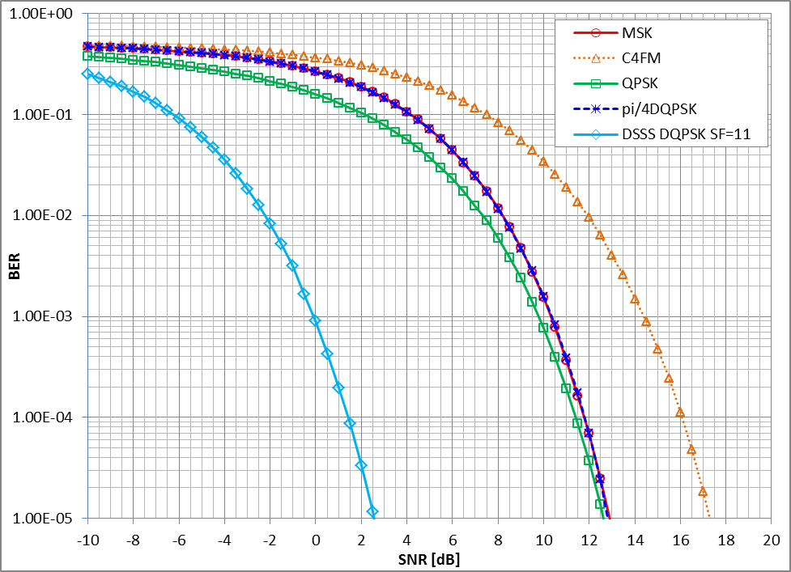
Figure 1: BER vs. SNR for 802.15.4p MSK, C4FM, QPSK, pi/4 DQPSK and DSSS DQPSK
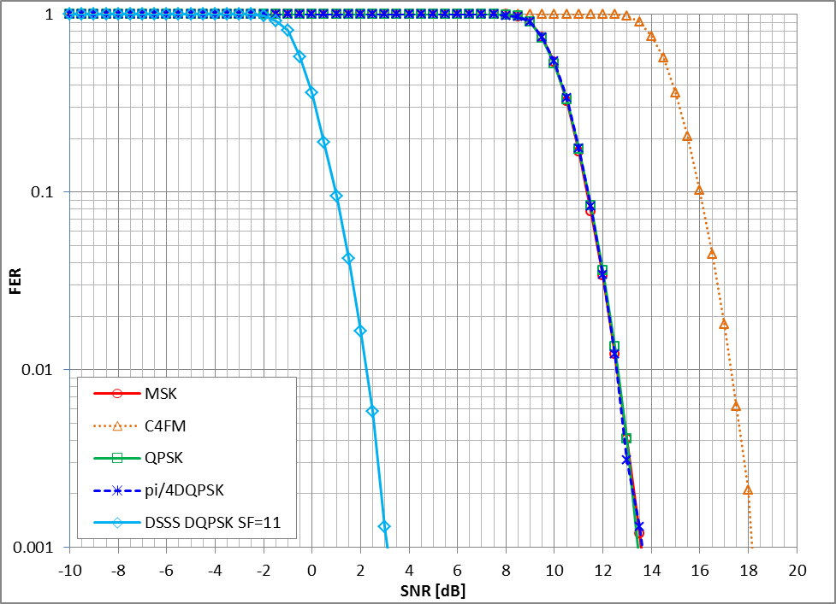
Figure 2: FER vs. SNR for 802.15.4p MSK, C4FM, QPSK, pi/4 DQPSK and DSSS DQPSK

Interference Modeling
802.15.4g’s interference model, described in section 4.2 of TG4g Coexistence Assurance Document (B10), is adopted for 802.15.4p’s coexistence simulation modeling.
- In the coexistence model, the transmitting power and distance between the victim’s transmitter and receiver are fixed, thus the received signal strength is fixed. The interference at the victim’s receiver is injected accordingly vs. the distance from the interferer’s transmitter to the victim’s receiver.
- Hata channel model (large scale urban) is used for the interference calculation. No AWGN noise is included in the channel to limit the factors affecting the system’s performance to interference only. Therefore the coexistence performance analysis herein is mainly focused on the interference caused by the interferer’s transmitter.
- There is no frequency offset between the interferer’s center frequency and the victim’s center frequency in the spectrum. This assumes the worst case.
- Antenna gain is assumed 0dBi.

450 – 470 MHz Band Coexistence Performance
This sub-clause presents the coexistence performance of the systems coexisting in the 450 - 470 MHz frequency band. In order to understand the impact of the generated interference, 802.15.4p systems and other coexisting 802 systems in this frequency band are set as both the victim and interferer source.

Parameters for Coexistence Quantification
The following sub-clauses present the parameters involved in quantification of coexistence analysis amongst the participating systems.

PHY Mode Parameters of Coexisting Standards
Table 11 shows the PHY mode parameters of coexisting standards within the frequency band
Table 11: Major Parameters of Coexisting 802 Systems in the 450-470 MHz Band
Parameters and values | 802.15.4 PHY | 802.15.4 PHY | 802.15.4p LMR PHY
Operation mode | Filtered 2FSK | Filtered 4FSK | C4FM
Data Rate (Kbps) | 4.8 | 9.6 | 9.6
Chip Rate (Mcps) | n.a. | n.a. | n.a.
Spreading factor | n.a. | n.a. | n.a.
FEC | disabled | disabled | disabled

BER / FER for PHY Modes of Coexisting 802 Standards
In this sub-clause, the BER / FER performance corresponding to SNR for the 802 standards within the frequency band are presented. The BER and FER curves are illustrated in Figure 3.
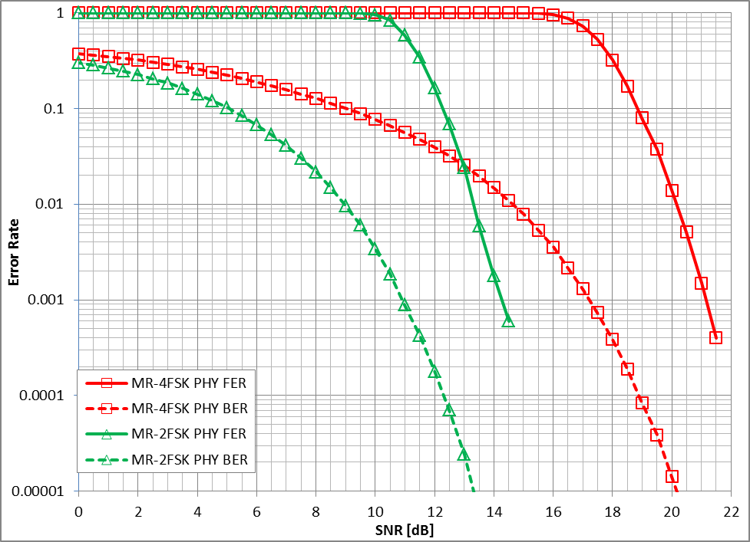

Figure 3: BER and FER vs. SNR for 802.15.4 Systems

Coexistence Simulation Results

802.15.4p PHY Mode as Victim Receiver
and show the BER/FER performances of the 802.15.4p PHY mode victim receiver corresponding to the distance from the interferer to the 802.15.4p victim receiver.

Figure 4: Victim (802.15.4p 9.6Kbps C4FM) BER/FER vs. Distance from Interferer TX (802.15.4 4.8Kbps 2FSK) to Victim RX
Figure 5: Victim (802.15.4p 9.6Kbps C4FM) BER/FER vs. Distance from Interferer TX (802.15.4 9.6Kbps 4FSK) to Victim RX

802.15.4/4g PHY Modes as Victim Receiver
show the BER/FER performances of the 802.15.4 victim receivers corresponding to the distance from the 802.15.4p interferer to the TX 802.15.4/4g victim receivers.

Figure 6: Victim (802.15.4 4.8Kbps 2FSK) BER/FER vs. Distance from Interferer Tx (802.15.4p 9.6Kbps C4FM) to Victim Rx

Figure 7: Victim(802.15.4 9.6Kbps 4FSK) BER/FER vs. Distance from Interferer Tx (802.15.4p 9.6Kbps C4FM) to 802.15.4 Victim Rx

863 – 870 MHz Band Coexistence Performance
This sub-clause presents the coexistence performance of the systems coexisting in the 863 - 870 MHz frequency band. In order to understand the impact of the generated interference, 802.15.4p systems and other coexisting 802 systems in this frequency band are set as both the victim and interferer source.

Parameters for Coexistence Quantification
The following sub-clauses present the parameters involved in quantification of coexistence analysis amongst the participating systems.

PHY Mode Parameters of Coexisting Standards
Table 12 shows the PHY mode parameters of coexisting standards within the frequency band

Table 12: Major Parameters of Coexisting 802 Systems in the 863 - 870 MHz Band
Parameters and values | 802.15.4 PHY | 802.15.4 PHY | 802.15.4p LMR PHY
Operation mode | MR-FSK | BPSK | DSSS DQPSK
Data Rate (Kbps) | 200 | 40 | 181
Chip Rate (Mcps) | n.a. | 0.6 | 1
Spreading factor | n.a. | 15 | 11
FEC | disabled | disabled | disabled

BER / FER for PHY Modes of Coexisting 802 Standards
In this sub-clause, the BER / FER performance corresponding to SNR for the 802 standards within the frequency band are presented. The BER and FER curves are illustrated in Figure 8.

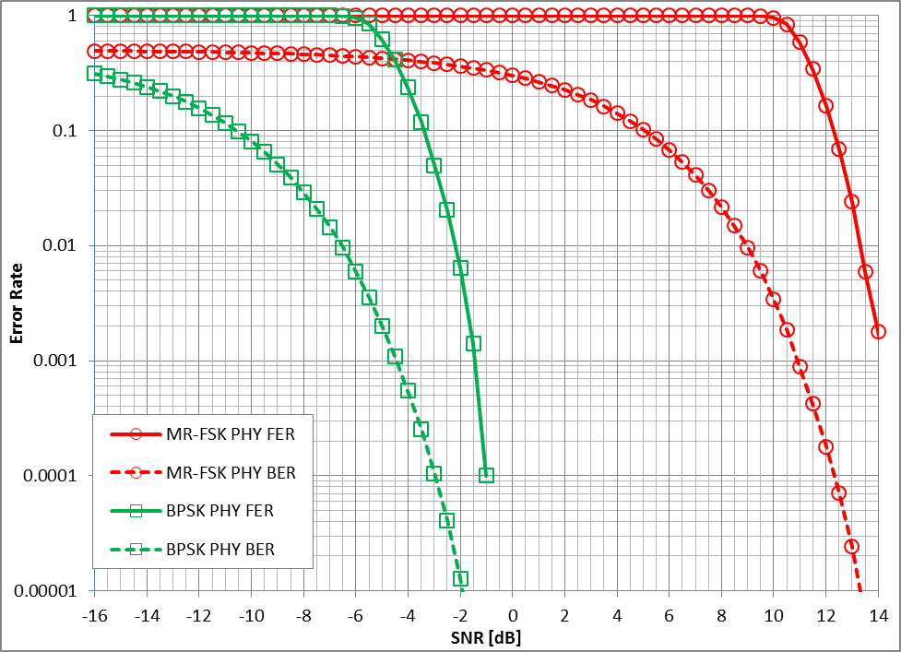

Figure 8: BER and FER vs. SNR for 802.15.4 Systems

Coexistence Simulation Results
802.15.4p PHY Mode as Victim Receiver show the BER/FER performances of the 802.15.4p PHY mode victim receiver corresponding to the distance from the interferer to the 802.15.4p victim receiver.

Figure 9: Victim (802.15.4p DSSS DPSK) BER/FER vs. Distance from Interferer Tx(802.15.4 MR-FSK) to Victim Rx
Figure 10: Victim (802.15.4p DSSS DPSK) BER/FER vs. Distance from Interferer Tx (802.15.4 BPSK) to Victim Rx

802.15.4/4g PHY Modes as Victim Receiver
show the BER/FER performances of the 802.15.4 victim receivers corresponding to the distance from the 802.15.4p interferer to the TX 802.15.4/4g victim receivers.
Figure 11: Victim (802.15.4 MR-FSK) BER/FER vs. Distance from Interferer Tx (802.15.4p DSSS DPSK) to Victim Rx
Figure 12: Victim(802.15.4 BPSK) BER/FER vs. Distance from Interferer Tx (802.15.4p DSSS DPSK) to 802.15.4 Victim Rx

902 – 928 MHz Bands Coexistence Performance
This sub-clause presents the coexistence performance of the systems coexisting in the 902 - 928 MHz frequency bands. In order to understand the impact of the generated interference, 802.15.4p systems and other coexisting 802 systems in this frequency band are set as both the victim and interferer source.

Parameters for Coexistence Quantification
The following sub-clauses present the parameters involved in quantification of coexistence analysis amongst the participating systems.

PHY Mode Parameters of Coexisting Standards
Table 13 shows the PHY mode parameters of coexisting standards within the frequency band.
Since spreading factor of 11 is the minimum number specified on 802.15.4p LMR PHY DSSS DQPSK, it provides minimum spreading and protection, hence it is selected for this simulation.
The 40Kbps with 0.6Mcps is the low data rate family which has the narrowest bandwidth just wide enough to meet the spectrum density requirement specified by FCC part 15.247, hence it is selected for this simulation.
The 200Kbps of MR-FSK has data rate close to the LMR PHY DSSS DQPSK in this simulation, for a close comparison.

Table 13: Major Parameters of Coexisting 802 Systems in the 902 - 928 MHz Band
Parameters and values | 802.15.4 PHY | 802.15.4 PHY | 802.15.4p LMR PHY
Operation mode | MR-FSK | BPSK | DSSS DQPSK
Data Rate (Kbps) | 200 | 40 | 181
Chip Rate (Mcps) | n.a. | 0.6 | 1
Spreading factor | n.a. | 15 | 11
FEC | disabled | disabled | disabled

4.8.1.2 BER / FER for PHY Modes of Coexisting 802 Standards
In this sub-clause, the BER / FER performances corresponding to SNR for the 802 standards within the frequency band are presented. The BER and FER curves are illustrated in Figure 13.
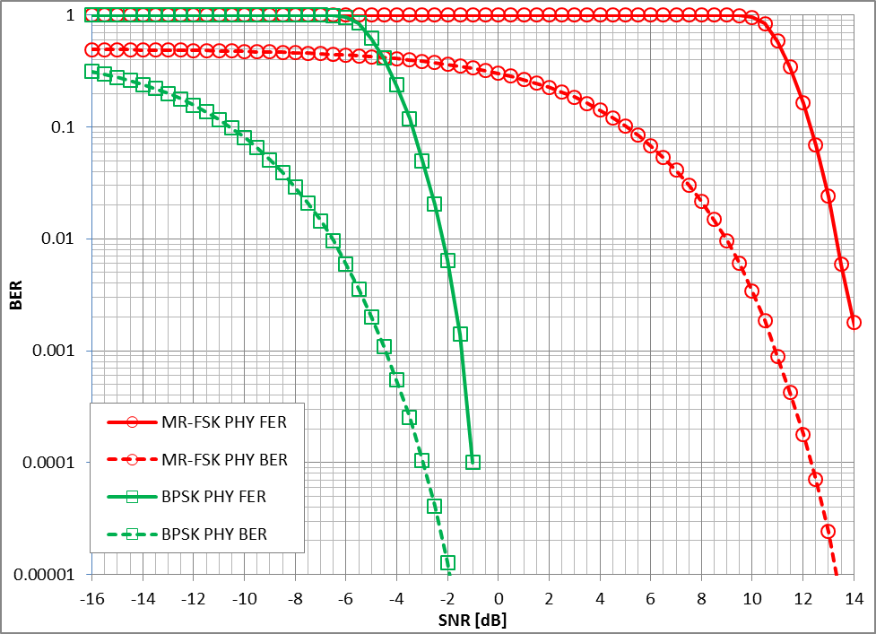
Figure 13: BER and FER vs. SINR for 802.15.4 Systems

Coexistence Simulation Results

802.15.4p PHY Mode as Victim Receiver
Figure 14 and Figure 15 show the BER/FER performances of the 802.15.4p PHY mode victim receivers corresponding to the distance from the interferer to 802.15.4p victim receivers.

Figure 14: Victim (802.15.4p DSSS DPSK) BER/FER vs. Distance from Interferer TX (802.15.4 MR-FSK) to Victim RX
Figure 15: Victim (802.15.4p DSSS DPSK) BER/FER vs. Distance from Interferer TX (802.15.4 BPSK) to Victim RX

802.15.4PHY Modes as Victim Receiver
Figure 16 and Figure 17 show the BER/FER performances of the 802.15.4victim receivers corresponding to the distance from the 802.15.4p interferer TX to the 802.15.4/4g victim receiver.
Figure 16: Victim (802.15.4 MR-FSK) BER/FER vs. Distance from Interferer TX (802.15.4p DSSS DPSK) to Victim RX

Figure 17: Victim (802.15.4 BPSK) BER/FER vs. Distance from Interferer TX (802.15.4p DSSS DPSK) to Victim RX

2400 – 2483.5 MHz Band Coexistence Performance
This sub-clause presents the coexistence performance of the systems coexisting in the 2400 – 2483.5 MHz frequency band. In order to understand the impact of the generated interference, 802.15.4p systems and other coexisting 802 systems in this frequency band MHz band are set as both the victim and interferer source.

Parameters for Coexistence Quantification
The following sub-clauses present the parameters involved in quantification of coexistence analysis amongst the participating systems.

PHY Mode Parameters of Coexisting Standards
Table 14 shows the PHY mode parameters of coexisting standards within the frequency band

Table 14: Major Parameters of Coexisting 802 Systems in the 2400 – 2483.5 MHz band

Parameters and values | 802.11g PHY | 802.15.4p LMR PHY
Operation mode | OFDM | DSSS DQPSK
Data Rate (Kbps) | 6000 | 181
Chip Rate (Mcps) | n.a. | 1
Spreading factor | n.a. | 11
FEC | Rate ½ convolutional code | disabled

BER / FER for PHY Modes of Coexisting 802 Standards
In this sub-clause, the BER / FER performance corresponding to SNR for the all the 802 standards within the frequency band are presented. The BER and FER curves are illustrated in Figure 18.
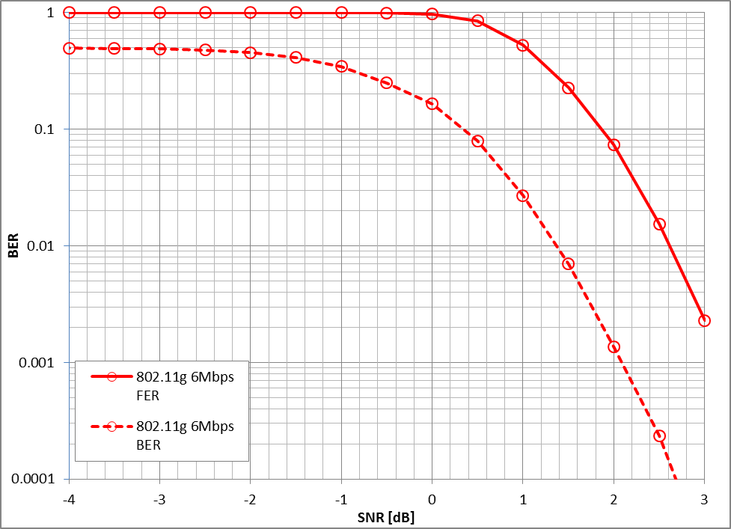
Figure 18: BER and FER v.s. SNR for 802.11 Systems

Coexistence Simulation Results

802.15.4p PHY Mode as Victim Receiver
Figure 19 shows the BER/FER performances of the 802.15.4p PHY mode victim receivers corresponding to the distance from the 802.11 interferers to the 802.15.4p victim receiver.
Figure 19: Victim BER vs. Distance from Interferer Tx to Victim Rx

802.11 PHY Modes as Victim Receiver
Figure 20 show the BER/FER performances of the 802.11 victim receivers corresponding to the distance from the 802.15.4p interferer to the 802.11 victim receiver at different interferer’s transmitting power levels.

Figure 20: Victim BER vs. Distance from Interferer Tx to Victim Rx

Interference Avoidance and Mitigation Techniques
802.15.4p adopts the interference avoidance and mitigation techniques outlined in 802.15.4g coexistence document (B10).

Conclusions
As a victim, 802.15.4p FSK has comparable BER performance with the other 802 FSK systems; 802.15.4p DSSS has much better BER performance than the other 802 DSSS systems due to option of the high spreading factor values.
As an interferer, either 802.15.4p FSK or 802.15.4p DSSS has similar performance impact to the other 802 systems at the same transmitting power level. However the performance degradation to the other systems can become significant as the transmitting power is increased up to the possible maximum 30dBm. This requires more physical distance from other 802 systems if an 802.15.4p system is designed to operate at a high transmitting power level.

