IEEE P802.15
Wireless Personal Area Networks

Project | IEEE P802.15 Working Group for Wireless Personal Area Networks (WPANs)
Title | Comment Resolution for TG4m TVWS-NB-OFDM
Date Submitted | March. 19, 2013
Source | [Keiichi Mizutani, Ryuhei Funada, Alina Lu Liru, Chin Sean Sum, Ming-Tuo Zhou, Fumihide Kojima, Hiroshi Harada(NICT)] | Voice: [[+81-46-847-5294]  Fax: [[+81-46-847-5440]  E-mail: [mizk@nict.go.jp]
Re: | Submission for comment resolution in LB87 of IEEE 802.15.4m draft
Abstract | Comment Resolution for the TVWS-NB-OFDM
Purpose | Resolve TVWS-NB-OFDM related comments in LB87
Notice | This document has been prepared to assist the IEEE P802.15. It is offered as a basis for discussion and is not binding on the contributing individual(s) or organization(s). The material in this document is subject to change in form and content after further study. The contributor(s) reserve(s) the right to add, amend or withdraw material contained herein.
Release | The contributor acknowledges and accepts that this contribution becomes the property of IEEE and may be made publicly available by P802.15.
- CID 420: Figure 124 should be consistent with Fig. 115.

Proposed Resolution; Modify Figure 124 as follow,
Number of OFDM symbols
1 | 1 | 1 | Variable
STF | LTF | As defined in 20.3.1.3 | PSDU
SHR |  | PHR | PHY payload
Figure 124 – Format of the TVWS-NB-OFDM PPDU

- CID 441: PHR must be re-designed to be accommodated in one OFDM symbol with some further protection.
- CID 442: FEC type field in PHR is of no use.
- CID 443: Data scrambling shall be used in TVWE-NB-OFDM and scramble seed needs to be inserted in PHR.

Proposed Resolution; Modify Figure 127 as follow,
Bit string index | 0 | 1 | 2-5 | 6-16 | 17-20 | 21-29 | 30-37 | 38-43
Bit mapping | R₀ | RNG | M₃-M₀ | L₁₀-L₀ | A₃-A₀ | S₈-S₀ | H₇-H₀ | T₅-T₀
Field name | Reserved | Ranging | Rate | Frame Length | Channel Aggregation | Scramble Seed | HCS | Tail
Figure 127 – PHY header fields for TVWS-NB-OFDM

Furthermore, add the following sentences after the end of 20.3.1.3.
The PHR is conveyed using a single OFDM symbol as follows: The 44 PHR bits are encoded using the rate-1/2 recursive convolutional code as described in 20.3.3.2.2 to create 88-bit sequence (d0, d1, d2, … d87). The 88-bit sequence is spread as (d0, d0, d0, d0, d1, d1, d1, d1, d2, d2, d2, d2, …, d87, d87, d87, d87) with and the resulting sequence is XOR operated using with the scrambler output defined in TBD to generate a 352-bit sequence. The initial state of the scrambler for the 88-bit sequence shall be “all ones”. The 352-bit sequence is then interleaved as described in 20.3.3.1 and mapped as BPSK as described in 20.3.3.3.2. The resulting value are interleaved as described in 20.3.3.4, pilots are inserted as described in 21.5.3.2.5, and then modulated as an OFDM symbol.
- CID 460: Need definition of phySymbolsPerOctet for NB-OFDM-PHY. Subsequently, update description of this attribute in base standard.

Proposed Resolution; Add subclause “20.3.3.7 PIB attribute values for phySymbolsPerOctet” as follows,

20.3.3.7 PIB attribute values for phySymbolsPerOctet
The number of symbols per octet depends on MCS and is computed as follows:
phySymbolsPerOctet = 8 * n/k * 1/N_{dbps}

- CID 469: Figure 128 should include data scrambler.
- CID 470: IFFT should be changed with IDFT in Figure 128.
- CID 478: This figure doesn’t make appear the PHR generation.
- CID 479: This figure doesn’t make appear the PHR generation.

Proposed Resolution; Modify Figure 128 as follow.
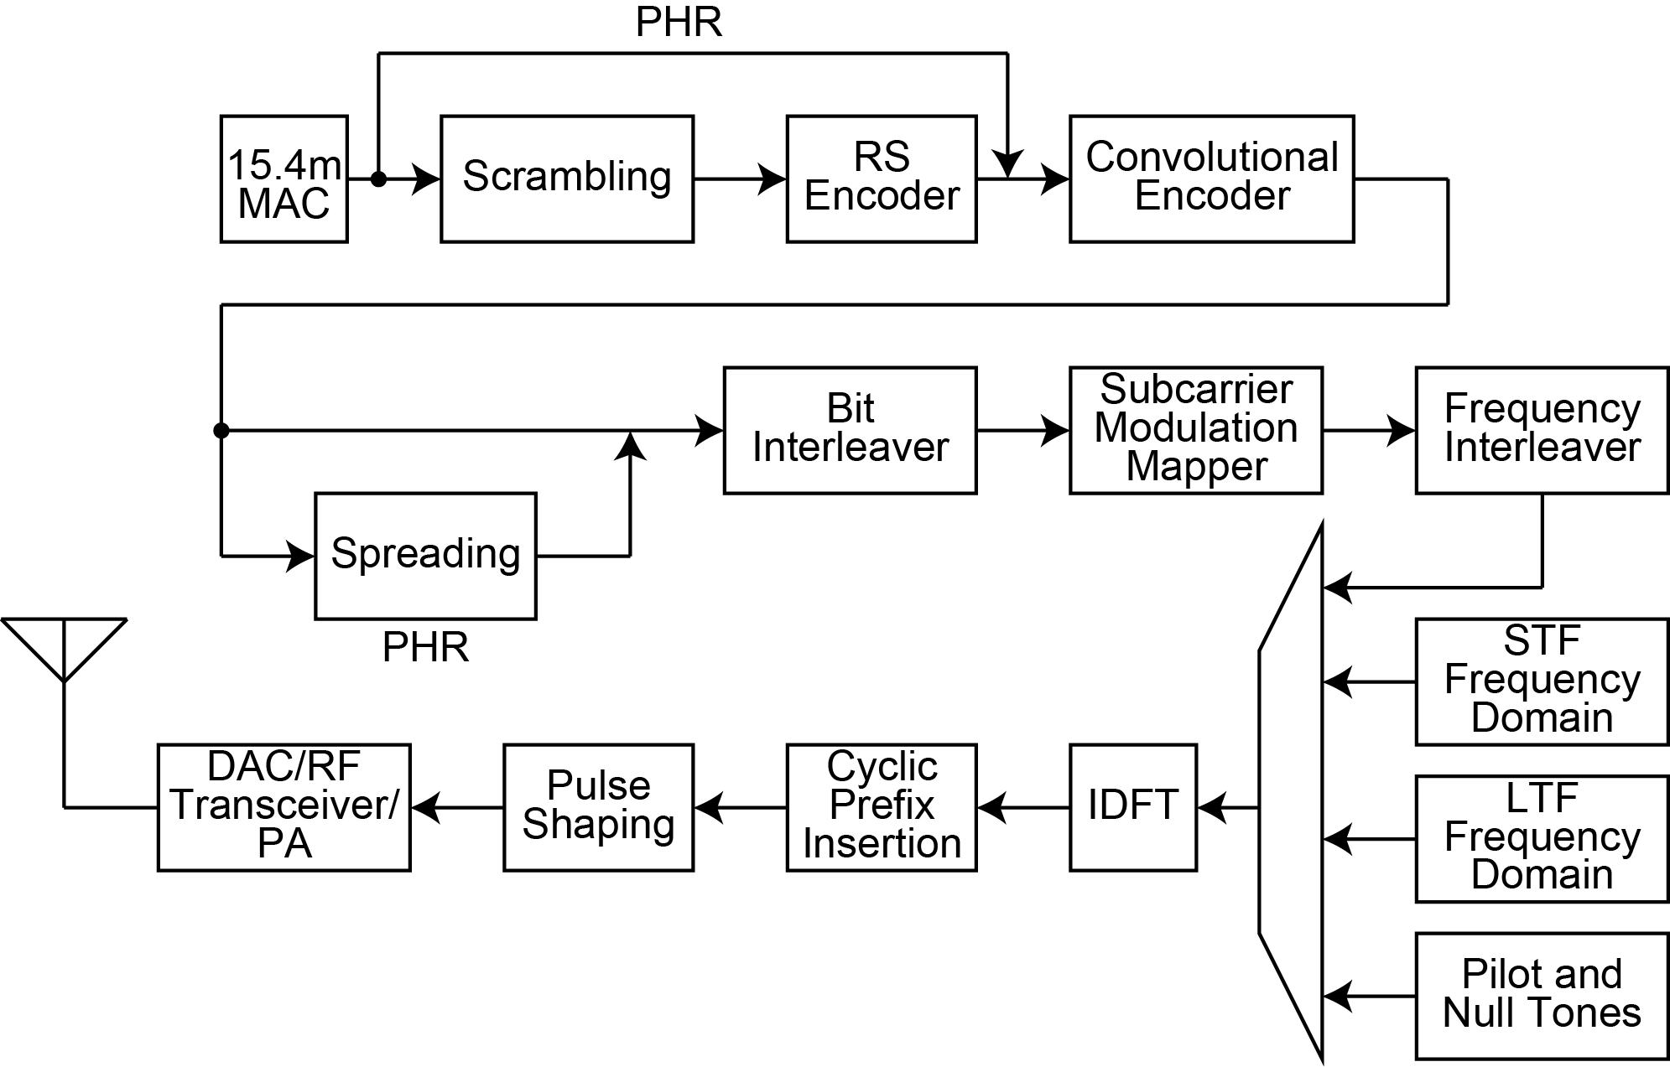
Figure 128 – Reference modulator diagram for TVWS-NB-OFDM

- CID 490: R=7/8 puncturing pattern for TVWS-NB-OFDM is missing.

Proposed Resolution; Add the R=7/8 puncturing pattern for TVWS-NB-OFDM in Figure 130 as follows.

Punctured Coding (r=7/8)
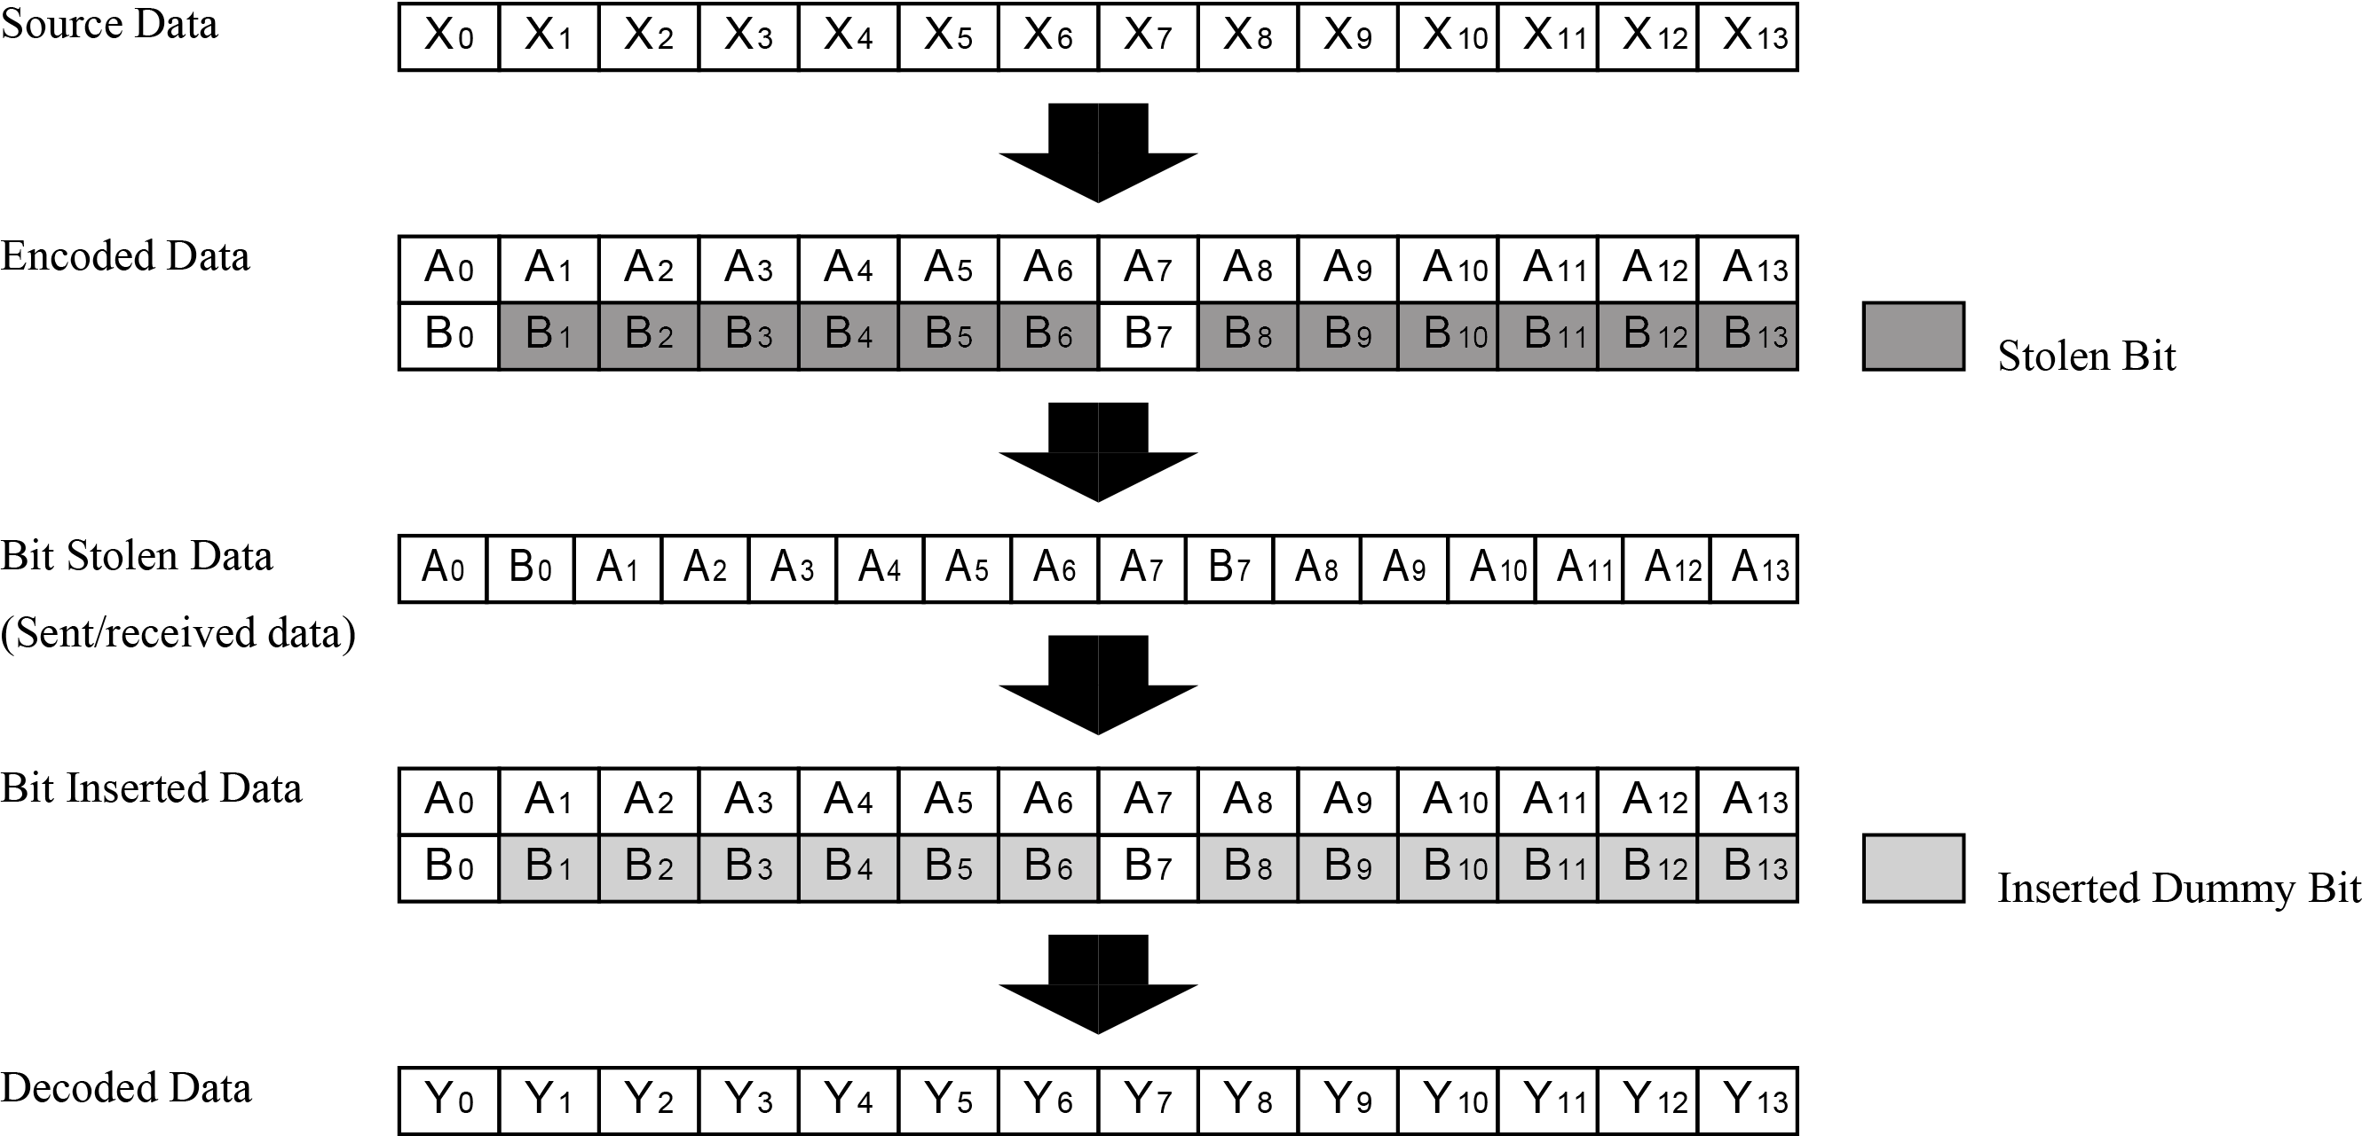
Figure 130 – Puncturing pattern for TVWS-NB-OFDM

- CID 505: Channel spacing shown needs to be changed so that subcarrier intervals are aligned in aggregated channels. Guard band for each side of channel also needs to be modified to satisfy the modified channel spacing.

Proposed Resolution; Change the value of channel spacing and guard band for each side of channel as follows. The proposed channel spacing is equal to the integral multiple of subcarrier spacing to realize easy implementation of channel aggregation.

Table 146 – Channel aggregation parameters for TVWS-NB-OFDM
Maximal bandwidth on channel aggregation use | 6 MHz | 8 MHz
Number of maximal aggregated channels | 11 | 16
Channel spacing | 400.79365 kHz
Guard band for each side of channel | 795.63495 kHz | 793.6508 kHz

- CID 512: One can assume that these requirements would be worked into the draft over time. Please include a list of the specifications that would be specified by the standard. Include RF requirements that are known.

Proposed Resolution;
Add the subclause “20.3.5.3 Receiver sensitivity”, “20.3.5.4 Tx-to-Rx turnaround time”, “20.3.5.5 Rx-to-Tx turnaround time”, “20.3.5.6 Error-vector magnitude (EVM) definition”, “20.3.5.7 Transmit center frequency and symbol tolerance“ as follows. Furthermore, the subclause “20.3.5.3 Pulse shaping” is moved to subclause 20.3.3.8 since the pulse shaping is not RF requirement.

20.3.5.3 Receiver sensitivity
The sensitivity requirements, as described in 8.1.7, for every MCS level are shown in Table 147.

Table 147—Sensitivity requirements for MCS levels
MCS level | Sensitivity
0 | -97 dBm
1 | -96 dBm
2 | -94 dBm
3 | -92 dBm
4 | -89 dBm
5 | -85 dBm
6 | -81 dBm
7 | -80 dBm
8 | -78 dBm

20.3.5.4 Tx-to-Rx turnaround time
The TVWS-NB-OFDM PHY shall meet the requirements for TX-to-RX turnaround time as defined in 8.2.1.

20.3.5.5 Rx-to-Tx turnaround time
The TVWS-NB-OFDM PHY shall meet the requirements for RX-to-TX turnaround time as defined in 8.2.2.

20.3.5.6 Error-vector magnitude (EVM) definition
The relative constellation RMS error averaged over subcarriers, symbols, and packets shall not exceed the values shown in Table 148.

Table 148—EVM requirements for TVWS-NB-OFDM PHY
MCS level | RMS error
0 | -3 dB
1 | -5 dB
2 | -8 dB
3 | -11 dB
4 | -14 dB
5 | -17 dB
6 | -20 dB
7 | -23 dB
8 | -26 dB

The transmit modulation accuracy test shall be performed by instrumentation capable of converting the transmitted signal into a stream of complex samples. The sampled signal shall be processed in a manner similar to an actual receiver, according to the following steps, or an equivalent procedure:
a) Detect the start of packet.
b) Detect the transition from STF to LTF, and establish fine timing (with one sample resolution).
c) Estimate the coarse and fine frequency offsets.
d) De-rotate the packet according to estimated frequency offset.
e) Estimate the complex channel response coefficients for each of the subcarriers.
f) For each data OFDM symbol, transform the symbol into subcarrier received values and divide each subcarrier value with the estimated channel response coefficient.
g) For each data-carrying subcarrier, find the closest constellation point and compute the squared Euclidean distance from it.
h) Compute the RMS average of all errors in a packet. It is given by
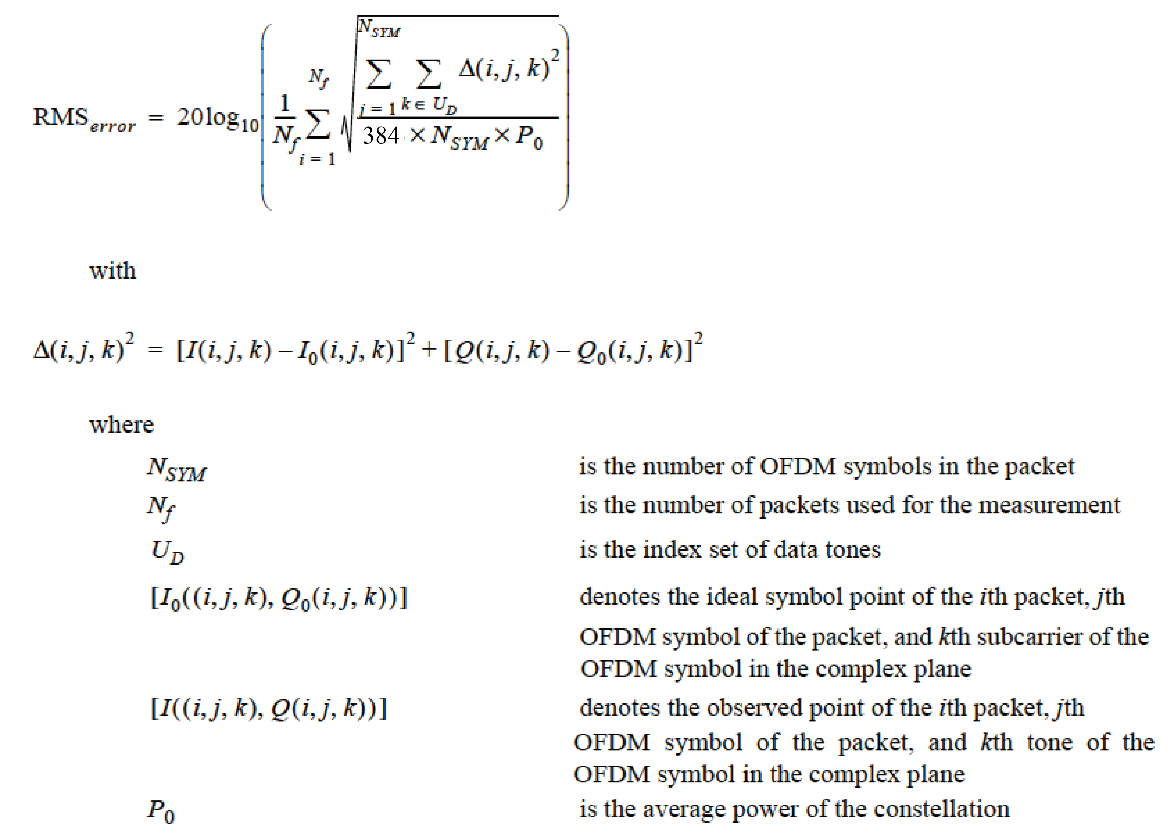
The test shall be performed over at least N_{f} = 20 packets. The payload of the packets under test shall contain N_{SYM} = 16 OFDM symbols. Random data shall be used for the payload.

20.3.5.7 Transmit center frequency and symbol tolerance
The transmit center frequency tolerance shall be ±20 ppm maximum. The symbol clock frequency tolerance shall also be ±20 ppm maximum. The transmit center frequency and the symbol clock frequency shall be derived from the same reference oscillator.

