IEEE P802.15
Wireless Personal Area Networks

Project | IEEE P802.15 Working Group for Wireless Personal Area Networks (WPANs)
Title | TG4j Coexistence Assurance Document
Date Submitted | April 2012
Source | David Evans (Philips),  Raymond Krasinski (Philips),  Anuj Batra (TI),  Mark Dawkins (Toumaz),  Srinath Hosur (TI),  Dong Wang (Philips)
Re: | IEEE 802.15.4j
Abstract | Analysis on coexistence of IEEE 802.15.4j with other IEEE 802 systems within the same frequency band
Purpose | To address the coexistence capability of IEEE 802.15.4j to satisfy requirements of the IEEE 802.19 Task Group and IEEE 802 Executive Committee to determine if a proposed IEEE 802 standard has made a reasonable effort to be able to coexist with devices compliant to other IEEE 802 standards in their operating band.
Notice | This document has been prepared to assist IEEE P802.15 coexistence. It is offered as a basis for discussion and is not binding on the contributing individual(s) or organization(s). The material in this document is subject to change in form and content after further study. The contributor(s) reserve(s) the right to add, amend or withdraw material contained herein.
Release | The contributor acknowledges and accepts that this contribution becomes the property of IEEE and may be made publicly available by P802.15.

Table of Contents
1 Scope 1
2 References 1
3 Acronyms and abbreviations 2
4 IEEE 802.15.4j amendment overview 2
4.1 Operating frequency bands 2
4.2 Modulation parameters 2
4.3 Coexistence mechanisms 2
5 Other IEEE 802 standards occupying same frequency bands as IEEE 802.15.4j MBANS band 3
5.1 2360-2400 MHz band (US only) 3
6 Coexistence scenarios and analysis 3
6.1 Methodology 3
6.1.1 Path loss model 4
6.1.2 PER for IEEE 802.15.4j 4
6.2 Coexistence with IEEE 802.15.6 5
6.2.1 IEEE 802.15.6 narrow-band PHY parameters 5
6.2.2 Assumptions in coexistence performance 6
6.2.3 Coexistence performance 8
6.3 Coexistence with devices above 2400 MHz 11
7 Discussions and conclusion 11

Scope
The IEEE 802.19 TAG has mandated that new wireless standards developed under IEEE 802 be accompanied by a Coexistence Assurance document. In [1], guidelines are provided for how coexistence can be quantified based on predicted packet error rates among IEEE 802 wireless devices. A detailed discussion of coexistence and coexistence methods can be found in IEEE Std 802.15.2-2003 [2]. Hence, this coexistence assurance document is provided by the IEEE 802.15.4j Task Group to satisfy the requirements of the IEEE 802.19 Task Group and IEEE 802 Executive Committee.
The IEEE 802.15 Task Group 4j defines an amendment to the IEEE Std 802.15.4 [3], including changes to the Medium Access Control (MAC) layer and additions to the PHY layer to support the 2360-2400 MHz FCC Medical Body Area Network Systems (MBANS) band. This amendment will enable devices to be used on or near a body in compliance with the FCC MBANS Rules [4]. The IEEE 802.15.4j Amendment is only valid for the United States (US) and therefore this document will only address coexistence within the US. At the time of writing of this document, this band cannot be used by MBANS devices outside of the US.
The lower part of the MBANS band from 2360-2390 MHz can only be used in healthcare facilities and the use of the band will be controlled by an MBANS coordinator [4]. The upper part of the MBANS band from 2390-2400 MHz can be used both within healthcare facilities and outside those facilities such as in ambulances and for home healthcare applications. Devices using this band will be under the supervision of healthcare professionals.
This document addresses the coexistence of the IEEE 802.15.4j MBANS band systems with other IEEE 802 standards operating in the same frequency bands. It addresses the interference caused by IEEE 802.15.4j devices to these existing systems, and the interference from these existing standards with IEEE 802.15.4j.

References
[1] S. Shellhammer, “Writing a Coexistence Assurance Document,” IEEE 802.19-09/0001r0, 2009.
[2] “Coexistence of Wireless Personal Area Networks with Other Wireless Devices Operating in Unlicensed Frequency Band,” IEEE Std 802.15.2TM-2003.
[3] IEEE Std 802.15.4TM-2011.
[4] FCC MBANS Rules, xxx
[5] S. Shellhammer, “Estimating of Packet Error Rate Caused by Interference – A Coexistence Assurance Methodology,” IEEE 802.19-05/0028r2, 2005.
[6] IEEE Std. 802.15.4TM-2006, Annex E.4.1.
[7] IEEE Std. 802.15.6TM-2012.
[8] J .G. Proakis, Digital Communications 4th edition, 2000.
[9] A. Batra et al, “TG6 Coexistence Assurance Document,” IEEE 802.15-11-0296-00-006, March 2011.
[10] FCC CFR47 Part 95—Personal Radio Services.

Acronyms and abbreviations

AWN Affected Wireless Network
BAN Body Area Network
BCH Bose, Ray-Chaudhuri, Hocquenghem Code
BER Bit Error Rate
CCA Clear Channel Assessment
D-MPSK Differential M-ary Phase Shift Keying
DSSS Direct Sequence Spread Spectrum
ED Energy Detection
IWN Interfering Wireless Network
LQI Link Quality Indicator
MBANS Medical Body Area Network Service
OOB Out-of-band
O-QPSK Offset Quadrature Phase Shift Keying
PER Packet Error Rate
SINR Signal to Interference plus Noise Ratio
SIR Signal to Interference Ratio

IEEE 802.15.4j amendment overview

Operating frequency bands
The allocated frequency band for the IEEE 802.15.4j Amendment is:
- 2360-2400MHz (MBANS)

Modulation parameters
The IEEE 802.15.4j MBANS device modulation parameters in the frequency band as shown in Table 1.

Frequency band | Data Rate | Symbol rate | Modulation | Spreading factor | Channel spacing
2360-2400 MHz | 250 kbps | 62.5 ksps | DSSS O-QPSK | 8 | 5 MHz
Table 1 – IEEE 802.15.4j modulation parameters
It should be noted that MBANS devices use the same modulation scheme as used by IEEE 802.15.4 devices in the 2400-2483 MHz band.

Coexistence mechanisms
The coexistence mechanisms for the MBANS band specified in the IEEE 802.15.4j standard are:
- Clear Channel Assessment (CCA)
  - Energy detection and/or carrier sense
- Dynamic channel selection
- Low Duty cycle
- Limited transmission power
- Modulation
  - Direct sequence spread spectrum (DSSS) with half-sine pulse shaping
- ED and LQI
- Channelization Scheme
  - Channel alignment between IEEE 802.15.6 and IEEE 802.15.4j
  - Configurable channelization scheme to minimize co-channel operations with IEEE 802.15.6

Other IEEE 802 standards occupying same frequency bands as IEEE 802.15.4j MBANS band
This clause lists the IEEE 802 standards that occupy the same frequency band as the IEEE 802.15.4j MBANS band. The common frequency band is 2360-2400 MHz. There are no other frequency bands used by the IEEE 802.15.4j Amendment.

2360-2400 MHz band (US only)
Table 2 shows the list of other IEEE 802 standards that share the 2360-2400 MHz band with the IEEE 802.15.4j Amendment.

Standard | PHY specification
IEEE 802.15.6 | D-MPSK
Table 2 – Other IEEE 802 standards in the 2360-2400 MHz band

Coexistence scenarios and analysis
This clause presents the analysis of the interference caused by IEEE 802.15.4j MBANS devices to the IEEE 802 standard devices identified in section 5, and vice versa. Note that the interferer parameters chosen in the following sub-clauses are chosen for the purpose of coexistence analysis in this CA document and are a sub-set of the available modes.

Methodology
In order to quantify the coexistence performance, the techniques described in Shellhammer [1] and [2] have been adopted. The coexistence assurance methodology predicts the PER of an affected wireless network (AWN), in the presence of an interfering wireless network (IWN). In its simplest form, the methodology assumes an AWN and an IWN, each composed of a single transmitter and a receiver. The methodology takes as input a path loss model, a BER function for the AWN, and in some case predicted temporal models for packets generated by the AWN and for packets generated by the IWN. Based on these inputs, the methodology predicts the PER of the AWN as a function of the physical separation between the IWN transmitter and the AWN receiver.
The appeal of the coexistence assurance methodology is that multiple networking standards can be characterized and compared with just a few parameters, notably:
- Bandwidth of AWN and IWN devices
- Path loss model for the networks
- PER as a function of SIR of AWN devices

Path loss model
The coexistence methodology uses the path loss model described in IEEE 802.15.2-2003 [2], which stipulates a two-segment function with a path loss exponent of 2.0 for the first 8 meters and then a path loss exponent of 3.3 thereafter. The equations for determining the path loss are given in Table 3. The model does not apply below about 0.5 meters due to near-field and implementation effects [2].

Equation | Condition
Path loss = 40.2 + 20 log₁₀(d) | 0.5 m ≤ d ≤ 8 m
Path loss = 58.2 + 33log₁₀(d/8) | d > 8 m
Table 3 – Equations for path loss (dB) at 2.4 GHz versus distance (m)
The path loss versus distance is shown in Figure 1 [5].
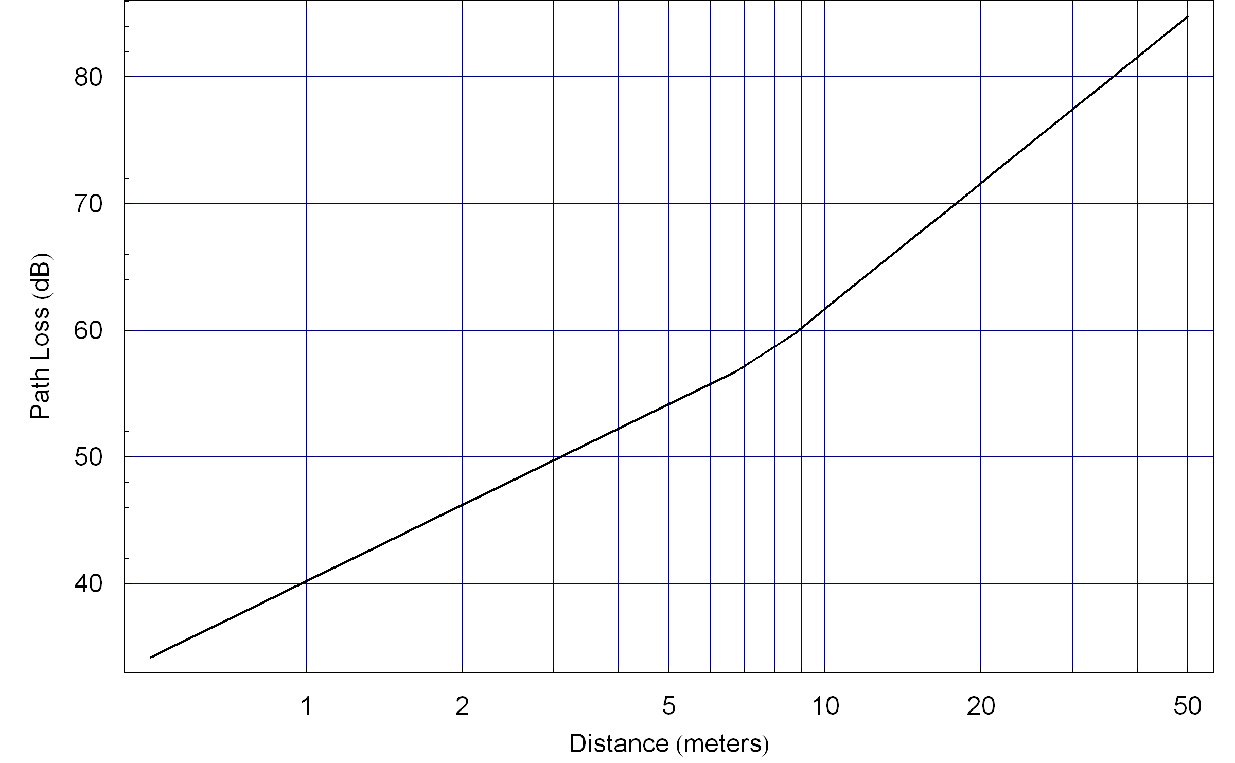
Figure 1 – Path loss curve for 2.4 GHz band

PER for IEEE 802.15.4j
The PER for the 2450 MHz O-QPSK PHY in IEEE 802.15.4 is calculated from a BER model. The BER (P_{b}) is given as a function of SIR as follows [6]:

$P_{b}=\left(\frac{8}{\text{15}}\right)\left(\frac{1}{\text{16}}\right)\sum_{j=2}^{\text{16}}{{\left(−1\right)}^{j}\left(\begin{matrix}\text{16} \\ j\end{matrix}\right)\text{exp}\left(\text{20}\text{SIR}\left(\frac{1}{j}−1\right)\right)}$ (1)
From the computed BER, the PER is obtained as shown in the Equation (2).
$\text{PER}=1−{\left(1−P_{b}\right)}^{L}$ (2)
where L is the number of bits in a packet and the typical length of an IEEE 802.15.4j packet is 22 octets [6].
The PER curve as a function of SIR for the IEEE 802.15.4j O-QPSK PHY is plotted in Figure 2.
Figure 2 – PER as a function of SIR for IEEE 802.15.4j PHYs

Coexistence with IEEE 802.15.6
This section considers issues regarding coexistence between IEEE 802.15.4j devices with IEEE 802.15.6 devices.

IEEE 802.15.6 narrow-band PHY parameters
The IEEE 802.15.6 narrow-band (NB) PHY has modulation parameters are shown in Table 3 [7].

Bit rate | Symbol Rate | Modulation | Code rate (k/n) | Spreading factor | Channel bandwidth
121.4 kbps | 600 ksps | π/2 DBPSK | 51/63 | 4 | 1000 kHz
971.4 kbps | 600 ksps | π/4 DQPSK | 51/63 | 1 | 1000 kHz
Table 3 – Specifications of IEEE 802.15.6 NB PHY (2360-2400 MHz band)

Assumptions in coexistence performance

Bandwidth
In the 2360-2400 MHz band the IEEE 802.15.6 channel is 1 MHz wide. The IEEE 802.15.4j has a receiver bandwidth that is approximately 2 MHz wide [6].

Path loss model
The path loss model used in this section is given in section 6.1.1

PER model
To calculate the PER for the IEEE 802.15.6 NB PHY, first of all the error probability of one BCH codeword is derived. According to Proakis [8], the codeword error probability of a perfect code for hard-decision decoding is given by a simple closed form, i.e.
$P_{w}=1−\sum_{m=0}^{t}{\left(\begin{matrix}N \\ m\end{matrix}\right)P_{b^{m}}{\left(1−P_{b}\right)}^{N−m}}$ (3)
Where N is the number of symbols in a codeword, P_{b} is the bit error probability, and t = 2 is the number of symbol error symbols that can be corrected. Although the (63, 51)-BCH code itself is not a perfect code, as shown in Figure 3, the error probability shows good agreement with BER obtained by simulations. This closed form given in Equation (3) is used to compute the PER. The BER for the IEEE 802.15.6 PHY, π/2-DBPSK, in the 2400-2483.5 MHz band is given by
$P_{b}=0\text{.}5\text{exp}\left(−2\text{.}\text{42}\text{SIR}\right)$ (4)
These equations are based on the bit error probability of BPSK with differentially coherent detection [8]. The difference of the coefficients multiplied to SIR comes from the difference of the spreading factors. Then, PER for IEEE 802.15.6 NB-PHY is computed as shown in the Equation (5).
$\text{PER}=1−{\left(1−P_{w}\right)}^{N_{c}}$ (5)
where N_{c} is the number of BCH codewords in one IEEE 802.15.6 payload. For example, if the number of payload bits is 255*8 bits, the number of codewords N_{c} becomes ceil(255*8/51) = 40. The PER curve for the IEEE 802.15.6 NB-PHY in the 2400-2483.5 MHz band is displayed in Figure 3.

Figure 3 – PER as a function of SINR for IEEE 802.15.6 PHY (2400-2483.5 MHz)
The PER curve for IEEE 802.15.4j is given in 6.1.2

Computation of SIR
In this coexistence test, the receive signal power at a receiver in an AWN is assumed to be 10 dB higher than the receiver sensitivity S_{AWN}. The physical separation d, between the AWN’s receiver and a transmitter in an IWN, determines the path loss pl(d) as given in Table 3. Assuming antenna gains for both devices are 0 dBi, SIR at the AWN’s receiver is simply given by
$\text{SIR}=(S_{\text{AWN}}+\text{10})−(P_{\text{tx},\text{IWN}}−\text{pl}\left(d\right))$ (6)
Where P_{tx,IWN} is the transmit signal power from the IWN’s transmitter. The P_{tx,IWN} is assumed to be 0 dBm for the IEEE 802.15.4j transmitters, and -10 dBm for the IEEE 802.15.6 transmitters. According to [2], if its receiver bandwidth of an AWN’s device, B_{AWN}, is narrower than the IWN’s signal bandwidth B_{IWN}, the SIR is scaled by the ratio between these bandwidths:
$\text{SIR}=(S_{\text{AWN}}+\text{10})−(P_{\text{tx},\text{IWN}}−\text{pl}\left(d\right))+{B_{\text{AWN}}}/B$ (7)

Temporal model
Neither the IEEE 802.15.4j devices nor the IEEE 802.15.6 NB-PHY devices operate with 100% duty cycle. By taking into account the duty cycle, a temporal model given in [2] is introduced. In this temporal model, interference packets are uniformly generated in a given duty cycle. The time duration and idle duration is given by the bit rate, length of the payload, and duty ratio. Typical numbers for these parameters are listed in Table 5. The length of typical payload is set to 22 octets for IEEE 802.15.4 [6]. Assuming that IEEE 802.15.6 device has 255-octet payload, which is the maximum length of the payload. On the duty ratio, since IEEE 802.15.6 covers wide variety of applications, it is reasonable to assume the duty cycle at 10 % worst case.

Modulation | Data rate | Length | Duration | Duty cycle
π/2-shift D-BPSK (802.15.6) | 121.4 kbps | 255 octets | 16.80 ms | 10 %
O-QPSK (802.15.4) | 250 kbps | 22 octets | 0.70 ms | 10 %
Table 5 – Specifications related to set a temporal model

Coexistence performance
This clause shows the results of the coexistence assurance methodology [9]. Figure 4 shows the PER of the IEEE 802.15.4 O-QPSK receiver in the presence of interference from an IEEE 802.15.6 signal. The results show that the required physical separation between the IEEE 802.15.4 receiver and an IEEE 802.15.6 transmitter is 12 meters to maintain PER of 10⁻². Note that the PER that is shown in the figures is for the 2400-2483.5 MHz band. It is assumed that the same PER will be observed in the 2360-2400 MHz band.
Figure 4 – PER for coexistence assurance results for AWN IEEE 802.15.4, IWN IEEE 802.15.6
The different IEEE 802.15.6 data rate modes use different modulation schemes (pi/2-DBPSK, pi/4-DQPSK) and spreading factors (1~4) and have different minimum SNR requirements and receive sensitivities. For example, the minimum required SNR (and the receive sensitivity) of the 971.4 kbps highest rate mode is about 9 dB higher than that of the 121.4 kbps lowest rate mode in the model.
However this does not affect significantly the required IEEE 802.15.6 to IEEE 802.15.4j separation distance based on the SIR computation model that is used in this coexistence document. In the model, the receive signal power at a receiver of an AWN (affected wireless network, e.g. IEEE 802.15.6) is assumed to be 10 dB higher than the receiver sensitivity S_{AWN}, which means the AWN received signal power is not fixed and will change when we change the data rate mode. The following calculations will make show this.
• The AWN receiver sensitivity S_{AWN =} SNR_m+N, where SNR_m is the minimum required SNR for the AWN receiver to work properly (e.g. to achieve PER <0.01) and N is the noise power (constant).
• The SIR at the AWN receiver with the SIR computational model used in the IEEE 802.15.6 is SIR = S_{AWN} + 10 – (P_{tx,IWN} – pl(d)) = SNR_m + N +10 – (P_{tx,IWN} – pl(d)).
• To make the AWN receiver work properly even with interference, SIR > SNR_m => pl(d) > P_{tx,IWN} - (N +10).
• From the above calculation, it can seen that the required separation distance is independent to the data rate mode (e.g. SNR_m, S_{AWN}), but only depends on P_{tx,IWN} and N which are two constants in analysis.
Therefore the 121kbps and 971kbps modes require the comparable separation distances under the SIR computation model used in IEEE 802.15.6 and this is shown in Figure 5.
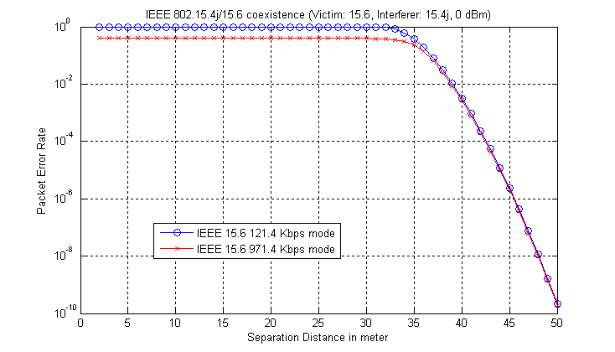
Figure 5 – PER for coexistence assurance results for AWN IEEE 802.15.6, IWN IEEE 802.15.4

Higher transmit power operation of IEEE 802.15.4j
IEEE 802.15.4j can utilize a transmit power of 20 mW (+13 dBm) in the 2390-2400 MHz band and this would require 13 dB extra propagation attenuation (or path loss) to help the IEE 802.15.4j to IEEE 802.15.6 co-channel coexistence. With the channel model used in this coexistence document this means that the separation distance needs to increase by 10^(13/33) = 2.4 times and this translates into an actual increase from about 40 meters to about 96 meters (for PER<=0.01). The simulation results are shown in Figure 6.
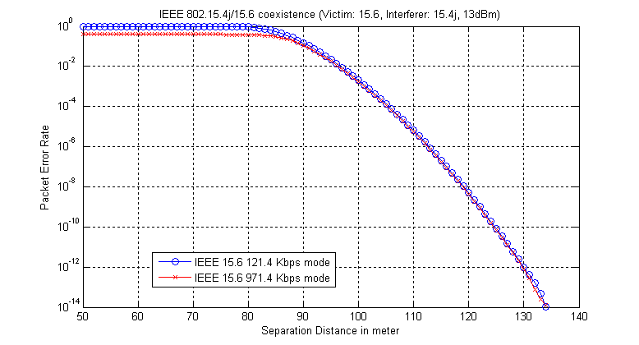
Figure 6 - PER for coexistence assurance results for AWN IEEE 802.15.6, IWN IEEE 802.15.4 transmitting +13 dBm
So far in this document the coexistence scenarios have considered the co-channel situation. There is also a case where the adjacent channel coexistence needs to be considered. In this situation an IEEE 802.15.6 device is considered to be operating on the channel at 2389 MHz and an IEEE 802.15.4j device is operating in the 2390-2400 MHz band using the maximum allowed power of 13 dBm.
The FCC rules [4] for MBANS devices specify that transmitter out-of-band (OOB) emissions are attenuated in accordance with § 95.635 [10]. This requires that the emissions 500 kHz outside the MBANS band is to be less than 500 µV/m measured at 3m and this is equivalent to a power of -41 dBm/MHz. To assist MBANS devices to be able to use the full 20 mW (13 dBm) transmit power that is allowed in the 2390-2400 MHz band, the IEEE 802.15.4j Amendment has specified a channel that is centered on 2395 MHz for this purpose (see 6.3). This also implies that in this situation the OOB emissions from IEEE 802.15.4j into the IEEE 802.15.6 channel at 2389 MHz will also be less than -41.3 dBm/MHz. The coexistence model requires that the separation distance is around 1.7 meter as shown in Figure 7.
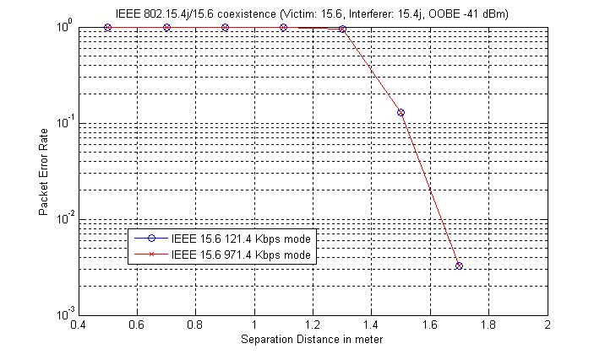
Figure 7 - PER for coexistence assurance results for OOB impact of IEEE 802.15.4 transmitting +13 dBm

Coexistence with devices above 2400 MHz
The top edge of the MBANS band at 2400 MHz lies adjacent to the 2400-2483.5 MHz band. This band is used by several IEEE standards such as IEEE 802.11, IEEE 802.15.1 and IEEE 802.15.4. It is therefore important to consider the likely impact of MBANS devices that are operating adjacent to other IEEE 802 wireless systems.
The FCC rules [4] for MBANS devices specify that transmitter out-of-band (OOB) emissions are attenuated in accordance with § 95.635 [10]. This requires that the emissions at 500 kHz above 2400 MHz are to be less than 500 µV/m measured at 3m and this is equivalent to a power of -41.3 dBm/MHz. Note that this limit is lower than the OOB emissions limits for devices that operate in the 2400-2483.5 MHz band.
To ensure that MBANS devices will meet this OOB emission limit a guard band is placed between the upper MBANS channel and the edge of the band at 2400 MHz. Furthermore, to assist MBANS devices to be able to use the full 20 mW (13 dBm) transmit power that is allowed in the 2390-2400 MHz band, the IEEE 802.15.4j Amendment has specified a channel that is centered on 2395 MHz for this purpose.

Discussions and conclusion
This document has presented an analysis of the coexistence between the IEEE 802.15.4j Amendment and IEEE 802.15.6 systems. The results of the analysis as presented in figure 4 indicate that distances of over 12m and 40m are required to protect IEEE 802.15.4j and IEEE 802.15.6 systems respectively. This is somewhat alarming since it is expected that these two systems may be used together in close proximity around the human body. However it would appear that the separation distance to protect IEE 802.15.6 is unaffected by the data rate that is used.
The analysis has focused on the worst case “on-channel” situation where both systems are operating on the same center frequency with 100% duty cycle. The dynamic channel selection feature of IEEE 802.15.4j would minimize the probability of such worst case in practice. When devices are not operated on the same center frequency it is the adjacent and alternate channel performance of the receiver of the device that becomes important.
For IEEE 802.15.6 devices the adjacent channel rejection is 17 dB at a 121.4 kbps data rate [7]. No figure is defined for the alternate channel. This would suggest that once IEEE 802.15.4j devices are operated in the adjacent channel of IEEE 802.15.6 and beyond, safe operating distances of a few meters and below may be possible. It should be noted that the channel plan for the IEEE 802.15.4j Amendment was developed to be in alignment with the channel raster of IEEE 802.15.6. There is therefore the potential for an IEEE 802.15.6 device to operate between two IEEE 802.15.4j channels.
For IEEE 802.15.4j devices the adjacent channel rejection is 0dB and for the alternate channel the rejection figure is 30 dB [3]. The alternate channel figure indicates with suitable channel separation, IEEE 802.15.6 devices can be operated at distances well below 1m.
IEEE 802.15.4j devices can be operated at a transmit power of 13 dBm in the 2390-2400 MHz band and this requires an increase in the distance to over 96 m to protect IEEE 802.15.6 devices. In this situation the OOB emission limits on IEEE 802.15.4j devices will however allow IEEE 802.15.6 devices in the 2360-2390 MHz to operate at 1.7m separation.
Concerning the operation of MBANS devices on the band edge at 2400 MHz and adjacent to other IEEE 802 wireless systems, good protection of the IEEE 802 wireless systems operating in the 2400-2483.5 MHz band is ensured by both the FCC MBANS rules and IEEE 802.15.4j Amendment specification.

