IEEE P802.15
Wireless Personal Area Networks

Project | IEEE P802.15 Working Group for Wireless Personal Area Networks (WPANs)
Title | Draft TG4j Amendment Text for Coordinator Switching commands
Date Submitted | [12 March, 2012]
Source | [Dave Evans¹]  [Philips¹] | Voice: [+44 1293 886490]  Fax: [ ]  E-mail: [david.evans@philips.com]
Re: | [If this is a proposed revision, cite the original document.]  [If this is a response to a Call for Contributions, cite the name and date of the Call for Contributions to which this document responds, as well as the relevant item number in the Call for Contributions.]  [Note: Contributions that are not responsive to this section of the template, and contributions which do not address the topic under which they are submitted, may be refused or consigned to the “General Contributions” area.]
Abstract | [Draft TG4j amendment text for the 802.15.4 MAC layer clauses 5 and 6. This describes the coordinator switching commands.]
Purpose | [For consideration by TG4j as text suitable for inclusion in the 802.15.4j draft amendment.]
Notice | This document has been prepared to assist the IEEE P802.15. It is offered as a basis for discussion and is not binding on the contributing individual(s) or organization(s). The material in this document is subject to change in form and content after further study. The contributor(s) reserve(s) the right to add, amend or withdraw material contained herein.
Release | The contributor acknowledges and accepts that this contribution becomes the property of IEEE and may be made publicly available by P802.15.
Insert:

5.1.2.6 Coordinator Switch

A PAN coordinator can switch the devices that are associated to its PAN to another coordinator by using the coordinator switch and device re-alignment commands. The PAN coordinator shall first broadcast a coordinator switch request on a channel using coordinator switch request command described in 5.3.15 indicating the number of devices that its wishes to switch. The number of devices defines the devices that are associated with its PAN. If another coordinator has the resources and is able to accept the number of devices it may respond to the broadcast coordinator switch request by sending a coordinator switch response command to the PAN coordinator confirming that it is able to accept the defined number of devices. The time for which the PAN coordinator listens for responses after transmitting the coordinator request command is beyond the scope of this standard. The PAN coordinator shall repeat broadcast of the coordinator switch request on all of the available channels. The sequence of coordinator switch broadcast request and coordinator switch response messages are shown in Figure 16b.

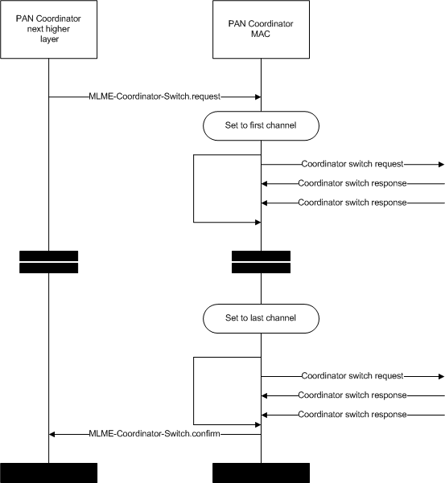

Figure 16b – Coordinator switch broadcast and response

The PAN coordinator shall then select another coordinator and confirm to that coordinator using the coordinator switch request command that it shall accept the association of the number of device defined in the command. The process for the selection of another coordinator is beyond the scope of this standard. Once the PAN coordinator has received a successful confirmation of the coordinator switching request command from the new coordinator, it shall send a channel switch notification command containing the PAN ID and the extended address of the new coordinator and the channel number and channel page that it is operating on. On receiving the channel switch command, the devices shall attempt to associate with the new coordinator whose details are provided in this command and shall do so without performing a channel scan. The sequence of coordinator switch selection and channel switch notification messages are shown in Figure 16c.

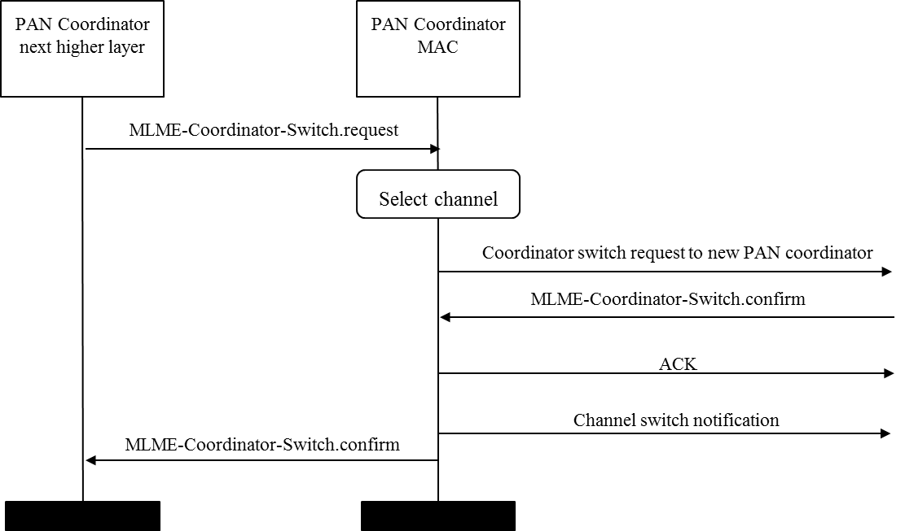

Figure 16c – Coordinator switch selection and channel switch notification

5.3 MAC command frames

Insert the following and change Table 5:

Table 5—MAC command frames

Command frame identifier | Command frame | RFD |  | Subclause
Command frame identifier | Command frame | Tx | Rx | Subclause
0x0f | Coordinator switch request |  |  | 5.3.15.1
0x1a | Coordinator switch response |  |  | 5.3.15.1
0x1b-0xff | Reserved |  |  | -

Insert:

5.3.15 Coordinator switch

5.3.15.1 Coordinator switch request

The coordinator switch request command allows a PAN coordinator to determine whether there are any other coordinators that have the resources to accept the devices that are associated with the PAN coordinator. The coordinator switch request command also allows a PAN coordinator to confirm to another coordinator that it has selected that coordinator to accept the devices that are associated with its PAN.

Only FFDs shall be capable of transmitting and receiving this command.

This command is optional.

The coordinator switch request command shall be formatted as illustrated in Figure 59h.

Octets: variable | 1 | 1
MHR fields | Command Frame Identifier | Number of Devices

Figure 59h – Coordinator switch request command format

5.3.15.1.1 MHR fields

The Destination Addressing Mode field shall be set to indicate short addressing when the coordinator switch request is broadcast in a channel otherwise the Destination Addressing Mode field shall be set to indicate extended addressing. The Source Addressing Mode field shall be set to indicate long addressing.

The Frame Pending field shall be set to zero and ignored upon reception and the AR field shall be set to zero.

The Destination PAN Identifier field shall contain the broadcast PAN identifier and the Destination Address field shall contain the broadcast short address when the coordinator switch request is broadcast in a channel otherwise the Destination PAN Identifier field shall contain the macPANID of new PAN coordinator and the Destination Address field shall contain the macExtendedAddress of the new PAN coordinator when the coordinator switch request is transmitted to a new PAN coordinator.

The Source PAN Identifier field shall contain the value of the macPANID of the source PAN coordinator. The Source Address field shall contain the value of macExtendedAddress of the source PAN coordinator.

5.3.15.1.2 Number of devices field

The number of device field shall be formatted as illustrated in Figure 59i.

Bits: 0-7
Number of Devices

Figure 59i – Number of devices field format

The Number of Devices shall be used to indicate the total number of devices that are associated with the source PAN coordinator.

5.3.15.2 Coordinator switch response

The coordinator switch response command allows another coordinator to communicate the results of a coordinator switch request attempt back to the source PAN coordinator requesting a coordinator switch.

This command shall only be sent by FFDs to the source PAN coordinator that is currently trying to request a coordinator switch.

Only FFDs shall be capable of receiving this command.

The coordinator switch response command shall be formatted as illustrated in Figure 59j.

Octets: variable | 1 | 1
MHR fields | Command Frame Identifier | Switch status

Figure 59j – Coordinator switch response command format

5.3.15.2.1 MHR fields

The Destination Addressing Mode and the Source Addressing Mode fields shall each be set to indicate extended addressing.

The Frame Pending field shall be set to zero and ignored upon reception. If the coordinator switch response command is sent in response to a coordinator switch request command that was broadcast to the channel the AR field shall be set to zero otherwise if the coordinator switch request command was sent directly to the new coordinator the AR field shall be set to one.

The PAN ID Compression field shall be set to zero. In accordance with this value of the PAN ID Compression field, the Destination PAN ID field shall contain the value of macPANId of the source PAN coordinator while the Source PAN ID field shall contain the macPANID of the new coordinator that is responding to the coordinator switch request. The Destination Address field shall contain the extended address of the source PAN coordinator that sent the coordinator switch request command. The Source Address field shall contain the value of macExtendedAddress of the new coordinator that is responding to the PAN coordinator switch request.

5.3.15.2.2 Switch status field

If the new coordinator is able to associate a number of devices to its PAN, this field shall contain the value of the Number of Devices field that was received on reception of the broadcast coordinator switch request command.

If the coordinator switch request command was sent directly to the new coordinator, it shall confirm that it is able to associate a number of devices to its PAN and this field shall contain the value of the Number of Devices field that was received on reception of the coordinator switch request command otherwise if the new coordinator was not able to associate a number of devices to its PAN, this field shall contain 0x00.

6.2 MAC management service

Insert in Table 8 as indicated:

Table 8—Summary of the primitives accessed through the MLME-SAP

Name | Request | Indication | Response | Confirm
MLME-COORDINATOR-SWITCH | 6.2.22.1* | 6.2.22.2* | 6.2.22.3* | 6.2.22.4*

Insert:

6.2.22 Coordinator switch notification primitives

These primitives are used when a device requests a coordinator switch.

6.2.22.1 MLME-COOORDINATOR-SWITCH.request

The MLME-COORDINATOR-SWITCH.request primitive is used by a PAN coordinator to request a coordinator switch from other coordinators.

The semantics of this primitive are:

MLME-COORDINATOR-SWITCH.request (
ChannelNumber,
ChannelPage,
SrcAddrMode,
DstAddrMode,
NumberOfDevices,
SecurityLevel,
KeyIdMode,
KeySource,
KeyIndex
)

The primitive parameters are defined in Table 44o.

Table 44o— MLME-COORDINATOR-SWITCH.request parameters

Name | Type | Valid range | Description
ChannelNumber | Integer | Any valid channel number | The channel number on which to attempt a coordinator switch.
ChannelPage | Integer | Any valid channel page | The channel page on which to attempt a coordinator switch.
SrcAddrMode | Enumeration | SHORT_ADDRESS, EXTENDED_ADDRESS | The source addressing mode for this MPDU.
DstAddrMode | Enumeration | SHORT_ADDRESS, EXTENDED_ADDRESS | The destination addressing mode for this MPDU.
NumberOfDevices | Integer | 0x00-0xff | Specifies the number of devices that the coordinator wishes to switch to another coordinator.
SecurityLevel | Integer | As defined in Table 46 | As defined in Table 46.
KeyIdMode | Integer | As defined in Table 46 | As defined in Table 46.
KeySource | Set of octets | As defined in Table 46 | As defined in Table 46.
KeyIndex | Integer | As defined in Table 46 | As defined in Table 46.

On receipt of the MLME-COORDINATOR-SWITCH.request primitive, the MLME of a coordinator shall first update the appropriate PHY and MAC PIB attributes, and then generates a coordinator switch command as defined in 5.3.15.

6.2.22.2 MLME-COORDINATOR-SWITCH.indication

The MLME-COORDINATOR-SWITCH.indication primitive is used to indicate the reception of a coordinator switch request command.

The semantics of this primitive are as follows:

MLME-COORDINATOR-SWITCH.indication (
CoordPANId,
DeviceAddress,
NumberOfDevices,
SecurityLevel,
KeyIdMode,
KeySource,
KeyIndex
)

The primitive parameters are defined in Table 44p

Table 44p—MLME-COORDINATOR-SWITCH.indication parameters

Name | Type | Valid range | Description
CoordPANId | Integer | 0x0000–0xfffe | The PAN identifier of the coordinator requesting a coordinator switch.
DeviceAddress | Device address | An extended IEEE address | The address of the coordinator requesting a coordinator switch
NumberOfDevices | Integer | 0x00-0xff | Specifies the number of devices for which a coordinator switch is being requested.
SecurityLevel | Integer | As defined in Table 46 | As defined in Table 46.
KeyIdMode | Integer | As defined in Table 46 | As defined in Table 46.
KeySource | Set of octets | As defined in Table 46 | As defined in Table 46.
KeyIndex | Integer | As defined in Table 46 | As defined in Table 46.

When the next higher layer of a coordinator receives the MLME-COORDINATOR-SWITCH.indication primitive, the next higher layer shall determine whether it has the resources to be able accept the association of additional devices using an algorithm outside the scope of this standard.

6.2.22.3 MLME-COORDINATOR-SWITCH.response

The MLME-COORDINATOR-SWITCH.response primitive reports the results of an MLME-COORDINATOR-SWITCH.request primitive.

The semantics of this primitive are as follows:

MLME-COORDINATOR-SWITCH.response (
CoordPANId,
DeviceAddress,
NumberOfDevices,
SecurityLevel,
KeyIdMode,
KeySource,
KeyIndex
)

The primitive parameters are defined in Table 44q.

Table 44q—MLME-COORDINATOR-SWITCH.response parameters

Name | Type | Valid range | Description
CoordPANId | Integer | 0x0000–0xfffe | The PAN identifier of the coordinator requesting a coordinator switch.
DeviceAddress | Device address | An extended 64 bit IEEE address | The address of the coordinator requesting a coordinator switch.
NumberOfDevice | Integer | 0x00–0xff | Confirms the number of devices for which a coordinator switch is being requested.  If this value is 0x00 then the coordinator switch request was unsuccessful.
SecurityLevel | Integer | As defined in Table 46 | As defined in Table 46.
KeyIdMode | Integer | As defined in Table 46 | As defined in Table 46.
KeySource | Set of octets | As defined in Table 46 | As defined in Table 46.
KeyIndex | Integer | As defined in Table 46 | As defined in Table 46.

When the MLME of a coordinator receives the MLME-COORDINATOR-SWITCH.response primitive, it shall generate a coordinator response command as described in 5.3.16 in response to a broadcast coordinator switch request and in response to a unicast coordinator switch request command as described in 5.1.2.6.

6.2.22.4 MLME-COORDINATOR-SWITCH.confirm

The MLME-COORDINATOR-SWITCH.confirm primitive is used to inform the next higher layer of the initiating device whether its request for coordinator switch was successful or unsuccessful.

The semantics of this primitive are as follows:

MLME-COORDINATOR-SWITCH.confirm (
CoordPANId,
DeviceAddress,
NumberOfDevices,
status,
SecurityLevel,
KeyIdMode,
KeySource,
KeyIndex
)

The primitive parameters are defined in Table 44r.

Table 44r-MLME-COORDINATOR-SWITCH.confirm parameters

Name | Type | Valid range | Description
CoordPANId | Integer | 0x0000–0xfffe | The PAN identifier of the new coordinator.
DeviceAddress | Device address | An extended 64 bit IEEE address | The address of the new coordinator.
NumberOfDevices | Integer | 0x00–0xff | Confirms the number of devices for which a coordinator switch is being requested.  If this value is 0x00 then the coordinator switch request was unsuccessful.
status | Enumeration | SUCCESS,  CHANNEL_ACCESS_FAILURE,  NO_ACK,  NO_DATA,  COUNTER_ERROR,  FRAME_TOO_LONG,  IMPROPER_KEY_TYPE,  IMPROPER_SECURITY_LEVEL,  SECURITY_ERROR,  UNAVAILABLE_KEY,  UNSUPPORTED_LEGACY,  UNSUPPORTED_SECURITY,  INVALID_PARAMETER | The status of the association attempt.
SecurityLevel | Integer | As defined in Table 46 | As defined in Table 46.
KeyIdMode | Integer | As defined in Table 46 | As defined in Table 46.
KeySource | Set of octets | As defined in Table 46 | As defined in Table 46.
KeyIndex | Integer | As defined in Table 46 | As defined in Table 46.

If the coordinator switch request was successful, then the status parameter will be set to SUCCESS. Otherwise, the status parameter will be set to indicate the type of failure.

