IEEE P802.15
Wireless Personal Area Networks

Project | IEEE P802.15 Working Group for Wireless Personal Area Networks (WPANs)
Title | Comments Regarding FCC RM-11651 Petition
Date Submitted | [January 18, 2012]
Source | [Dalibor Pokrajac,  GuardRFID] | Voice: [604-282-7584]  Fax: [604-998-4018]  E-mail: [dalibor.pokrajac@guardrfid.com]
Re: | [802.15 Interim Meeting in Jacksonville, Florida]
Abstract | [Comments regarding FCC RM-11651 a Lockheed Martin Corporation petition to FCC to enable more flexible use of 433 MHz band]
Purpose | [Provide comments to the IEEE 802.18 Radio Regulatory Technical Advisory Group (RR-TAG) regarding FCC RM-11651]
Notice | This document has been prepared to assist the IEEE P802.15. It is offered as a basis for discussion and is not binding on the contributing individual(s) or organization(s). The material in this document is subject to change in form and content after further study. The contributor(s) reserve(s) the right to add, amend or withdraw material contained herein.
Release | The contributor acknowledges and accepts that this contribution becomes the property of IEEE and may be made publicly available by P802.15.
The following are comments relevant to “Petition for Rulemaking by Lockheed Martin Corporation regarding Amendment of Part 15 to Enable More Flexible RFID Use in the 433 MHz Band”.

These comments are written in addition to document “15-12-00450004f-draft-comments-fcc-rm-11651-433mhz-petition.doc”

- Frequency band ranging from 433.05 MHz – 434.79 MHz (“433 MHz Band”) in most of the world is considered a license free band in which coexistence of low power RF devices is assured through:
  - Limit in transmit power
  - Limit in duty cycle of transmissions
  - Listen Before Talk mechanism

The following table provides a snapshot of some of radio regulations in this band:

Region | Regulation | Transmit Power (ERP) | Max Signal Bandwidth
USA  Canada | FCC 15.231(5)(b) / RSS-210  FCC 15.231(e) / RSS-210  FCC15.240 / RS-210 | 23 uW  4 uW  0.57 mW | 1,000 kHz
Europe, Africa | EN 300 220 | 10 mW  (10% duty cycle) | 500 kHz
China | SRRC Regulation Oct 2005 | 2.2 mW | 200 kHz
Japan | ARIB T92 | 1 mW | 200 kHz
Korea | MIC Notice No. 2005-29 | 3.6 mW | 500 kHz
Australia, New Zealand | AS/NZS 4268:2003 | 15 mW | 1,740 kHz

It is visible that USA and Canadian regulations (which are more or less identical) severely restrict transmit power and duty cycle in this band when compared with the rest of the world.
- 433 MHz Band is presently used by many companies to provide active RFID and RTLS systems throughout the world and especially in North America where most of the companies certify their products under Section 15.231 and some under Section 15.240. However, both Sections have severe limitations which, if mitigated, would open the door for wider proliferation of RFID and RTLS devices in 433 MHz Band.
- Due to its physical properties, 433 MHz Band is in many ways preferred choice for RFID and RTLS devices, but also for applications involving wireless sensor networks where low power consumption combined with decent communication range, low signal pathloss and world-wide regulatory compliance are the key technological advantages.
- 2.4 GHz Band is the only other frequency band which can be used world wide for these kind of applications. Diagram below illustrates advantages of using 433 MHz band instead of 2.4 GHz
15 dB
15 dB

Industrial LOS Environment Office LOS/NLOS Environment

As predicted by theory of RF propagation, experimental results show 15 dB advantage in signal attenuation over 2.4 GHz band.

- In order to provide appropriate utilization of 433 MHz Band, IEEE 802.15.4f standard divides available 1.74 GHz band into multiple channels and data rates:
  - 250 kb/s (3 channels, 580 kHz channel width)
  - 100 kb/s (5 channels, 348 kHz channel width)
  - 31.25 kb/s (15 channels, 108 kHz channel width)

- Graphical illustration of this data rate and frequency allocation is shown in diagram below:

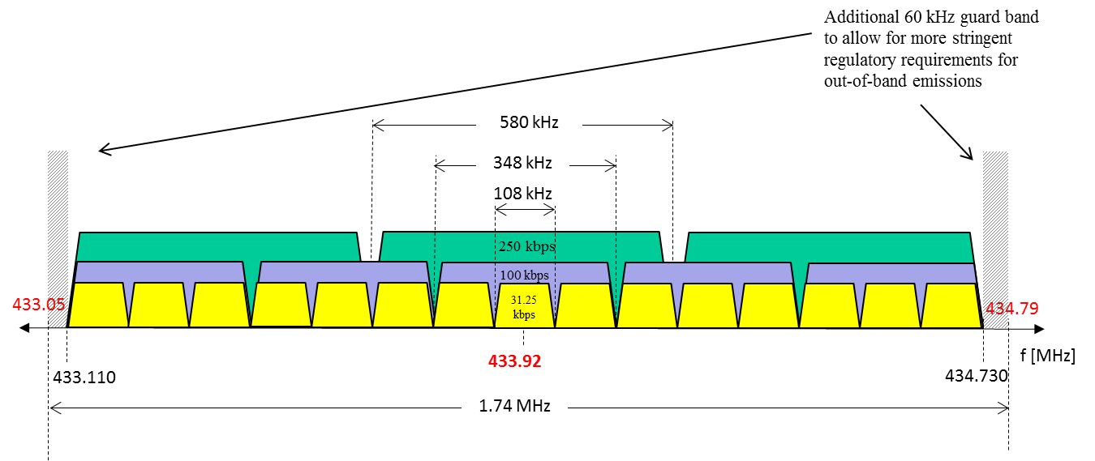

- 802.15.4 provides mechanisms needed to assure coexistence within the band, primarily through CSMA mechanism, also known as “Listen Before Talk”.
- MSK modulation assures appropriate adjacent channel attenuation as well as out of band attenuation to protect other devices, which are not compliant with 802.15.4f PHY.
- Even though 802.15.4f is intended for RFID and RTLS applications, inclusion of this PHY within IEEE 802.15.4 allows future usage for any wireless sensor networks which would benefit from advantages listed above. However, current FCC regulations severely restrict this potential which could be unlocked by allowing higher transmit power and higher duty cycle than currently specified in Section 15.231.
- Accepting Lockheed Martin Petition RM-11651 as is, or even with small modifications, would open this potential with little impact on existing devices which operate in this band.

