IEEE P802.15
Wireless Personal Area Networks

Project | IEEE P802.15 Working Group for Wireless Personal Area Networks (WPANs)
Title | 100 Gbps Study Group Technical Expectations Document (TED)
Date Submitted | [Nov, 2011]
Source | Rick Roberts | E-mail: richard.d.roberts@intel.com
Re:
Abstract
Purpose
Notice | This document has been prepared to assist the IEEE P802.15. It is offered as a basis for discussion and is not binding on the contributing individual(s) or organization(s). The material in this document is subject to change in form and content after further study. The contributor(s) reserve(s) the right to add, amend or withdraw material contained herein.
Release | The contributor acknowledges and accepts that this contribution becomes the property of IEEE and may be made publicly available by P802.15.

Document Overview

This document treats THz communications and related network applications operating in the THz frequency bands between 275 – 3000GHz. Such THz communications applications would include; component to component, board to board, machine to machine, human to machine and human to human, (indoor and outdoor) wireless communications. THz communication applications cover multiple categories with varying requirements. As envisioned, THz communications would overall employ wireless modulation methods of limited complexity, omni and/or directional antenna systems, and would typically offer very high data transfer rates in multiples of 10 Gbps, and up to possibly 1 Tbps, for parity with future fiber optic capacities.

List of contributors
Ralf-Peter Braun | Deutsche Telekom
Michael Grigat | Deutsche Telekom
Thomas Schneider | Deutsche Telekom
Stefan Preußler | Deutsche Telekom
Cai Yunlong | Huawei
Thomas Kürner | TU Braunschweig
Sebastian Priebe | TU Braunschweig
Sebastian Rey | TU Braunschweig
Ho-Jin Song | NTT Microsystem Integration Labs
Katsuhiro Ajito | NTT Microsystem Integration Labs
Makoto Yaita | NTT Microsystem Integration Labs
Rick Roberts | Intel Labs
Juthika Basak | Intel Labs
Mial Warren | TriLumina Corporation
Alan Willner | University of Southern California
Ed. Note: need to add additional names

Table of Contents
1. Definitions: 9
2. General Guidelines 10
3. Protocol Reference Model 11
4. Use case summary 12
4.1 Outdoor Fixed Wireless Links 12
4.2 Indoor Fixed Wireless Links 12
4.3 Nano Cells 12
4.4 WLAN Types of Applications 12
4.5 WPAN Types of Applications 13
4.6 Connecting devices on short ranges 13
4.7 Kiosk Downloading 13
4.8 Board-to-Board Communications 13
4.9 Data Center/Server Farm Wireless Data Distribution 13
5. TED Summary 14
6. Topology 15
6.1 Outdoor Fixed Wireless Topology 15
6.1.1 Wireless Bckhauling/Fronthauling 15
6.2 Indoor Fixed Wireless Topology 16
6.3 Nano Cell Topology 16
6.4 WLAN Topology 16
6.5 WPAN Topology 16
6.6 Connecting devices on short range Topology 16
6.7 Kiosk Download Topology 16
6.8 Board-to-Board Communications Topology 16
6.9 Data Center/Server Farm Wireless Data Distribution 17
6.9.1 Data center infrastructure [29] 19
6.9.2 3-Tier Data center Infrastructure [29] 19
7. Data Rates 21
7.1 Outdoor Fixed Wireless Rates 21
7.1.1 Required data rates for backhauling of small cells 21
7.1.2 Required data rates for backhauling and fronthauling of macro cells: 21
7.2 Indoor Fixed Wireless Rates 21
7.3 Nano Cell Rates 21
7.4 WLAN Rates 21
7.5 WPAN Rates 22
7.6 Connecting devices on short range Rates 22
7.7 Kiosk Download Rates 22
7.8 Board-to-Board Communications Rates 22
7.9 Data Center/Server Farm Wireless Data Distribution Rates 22
8. Operational frequency bands 23
8.1 Outdoor Fixed Wireless Frequencies 23
8.1.1 Outdoor attenuation profile 23
8.1.2 Attenuation in THz transmission windows 26
8.2 Indoor Fixed Wireless Frequencies 27
8.3 Nano Cell Frequencies 27
8.4 WLAN Frequencies 27
8.5 WPAN Frequencies 27
8.6 Connecting devices on short range Frequencies 27
8.7 Kiosk Download Frequencies 27
8.8 Board-to-Board Communications Frequencies 27
8.9 Data Center/Server Farm Wireless Data Distribution Frequencies 27
9. Coexistence/protection existing services and other use cases 28
9.1 Potentially Critical Interference Scenarios 28
9.1.1 Nomadic devices operated outdoors in rural environment 28
9.1.2 Nomadic devices operated outdoors in urban environment 29
9.1.3 Fixed links with scattering objects close to direct ray path 29
9.1.4 Relevant emission from antenna sidelobes 30
9.1.5 Airborne operated transmitters 30
9.1.6 Satellite in limb scanning mode 31
9.2 Spectral Masks between Active Services and Earth Exploration Services (EESS) 31
9.2.1 Maximum equivalent isotropically radiated power (EIRP) 31
9.2.2 Definition of transmit power spectrum masks 32
10. Regulatory requirements 34
11. Transmission range 35
11.1. Outdoor Fixed Wireless Range 35
11.2. Indoor Fixed Wireless Range 35
11.3. Nano Cell Range 35
11.4. WLAN Range 35
11.5. WPAN Range 35
11.6. Connecting devices on short range Range 35
11.7. Kiosk Download Range 35
11.8 Board-to-Board Communications Range 35
11.9 Data Center/Server Farm Wireless Data Distribution Range 35
12. Antenna gain and required alignment accuracy 36
12.1. Outdoor Fixed Wireless Gain and Accuracy 36
12.2. Indoor Fixed Wireless Gain and Accuracy 37
12.3. Nano Cell Gain and Accuracy 37
12.4. WLAN Gain and Accuracy 38
12.5. WPAN Gain and Accuracy 39
12.6. Connecting devices on short range Gain and Accuracy 39
12.7. Kiosk Download Gain and Accuracy 39
12.8. Board-to-Board Communications Gain and Accuracy 39
12.9. Data Center/Server Farm Wireless Data Distribution Gain and Accuracy 39
13. Channel models 40
13.1 Outdoor Fixed Wireless 40
13.1.1 Co-channel interference 40
13.1.2 Fading mechanisms 40
13.1.3 Spatial/temporal properties 40
13.2. Indoor Fixed Wireless 40
13.2.1 Co-channel interference 40
13.2.2 Fading mechanisms 40
13.2.3 Spatial/temporal properties 40
13.3. Nano Cells 41
13.3.1 Co-channel interference 41
13.3.2 Fading mechanisms 41
13.3.3 Spatial/temporal properties 41
13.4. WLAN Types of Applications 41
13.5. WPAN Types of Applications 42
13.5.1 Co-channel interference 42
13.5.2 Fading mechanisms 42
13.5.3 Spatial/temporal properties 42
13.6. Connecting devices on short ranges 42
13.6.1 Co-channel interference 42
13.6.2 Fading mechanisms 42
13.6.3 Spatial/temporal properties 42
13.7. Kiosk Downloading 42
13.7.1 Co-channel interference 42
13.7.2 Fading mechanisms 42
13.7.3 Spatial/temporal properties 43
13.8. Board-to-Board Communications 43
13.8.1 Co-channel interference 43
13.8.2 Fading mechanisms 43
13.8.3 Spatial/temporal properties 43
13.9 Data Center/Server Farm Wireless Data Distribution Gain and Accuracy 43
13.9.1 Co-channel interference 43
13.9.2 Fading mechanisms 43
13.9.3 Spatial/temporal properties 44
14. Link budget and SNR analysis 45
14.1 Example Link Budget 45
14.2. Outdoor Fixed Wireless Link Budget 45
14.3. Indoor Fixed Wireless Link Budget 45
14.4. Nano Cell Link Budget 45
14.5. WLAN Link Budget 45
14.6. WPAN Link Budget 45
14.7. Connecting devices on short range Link Budget 45
14.8. Kiosk Download Link Budget 46
14.9. Board-to-Board Communications Link Budget 46
14.10 Data Center/Server Farm Wireless Data Distribution Gain and Accuracy 46
15. Size, Weight and Power 47
15.1. Outdoor Fixed Wireless SWaP 47
15.2. Indoor Fixed Wireless SWaP 47
15.3. Nano Cell SWaP 47
15.4. WLAN SWaP 47
15.5. WPAN SWaP 47
15.6. Connecting devices on short range SWaP 47
15.7. Kiosk Download SWaP 47
15.8. Board-to-Board Communications SWaP 47
15.9 Data Center/Server Farm Wireless Data Distribution SWaP 47
16. Mobility and Link switching 48
16.1. Outdoor Fixed Wireless Link Switching 48
16.2. Indoor Fixed Wireless Link Switching 48
16.3. Nano Cell Link Switching 48
16.4. WLAN Link Switching 48
16.5. WPAN Link Switching 48
16.6. Connecting devices on short range Link Switching 48
16.7. Kiosk Download Link Switching 48
16.8. Board-to-Board Communications Link Switching 48
16.9. Data Center/Server Farm Wireless Data Distribution Link Switching 48
17. Beam steered or control channel assisted device discovery 49
17.1. Outdoor Fixed Wireless Device Discovery 49
17.2. Indoor Fixed Wireless Device Discovery 49
17.3. Nano Cell Device Discovery 49
17.4. WLAN Device Discovery 49
17.5. WPAN Device Discovery 49
17.6. Connecting devices on short range Device Discovery 49
17.7. Kiosk Download Device Discovery 49
17.8. Board-to-Board Communications Device Discovery 49
17.9. Data Center/Server Farm Wireless Data Distribution Device Discovery 49
18. Media access mechanism and superframe expectations 50
18.1 Multiband operation 51
18.2 Full-duplex Operation 51
19. Security mechanisms 52
20. I/O Interfaces and Memory Buffer Considerations 53
21. References 54

Definitions:

General Guidelines

This technical expectations document (TED) describes the technical expectations for a THz standard, such as performance-related issues, reliability issues and availability issues. These types of issues are often called quality of service (QoS). Technical expectations are documented in the same manner as any specifications, including a description, an example, a source or references to related technical documents.

Difference between Expectations and Requirements (TED vs. TRD)

The THz IG group decided to use the term “expectations” instead of “requirements” in order to adopt a less rigid, informal process with the intention to be able to quickly develop actual requirements when the transition to a task group occurs. This document serves to provide guidance for development of IEEE802 THz technical contributions.

Protocol Reference Model

The communication protocol reference model used for this document is shown in Figure 1.

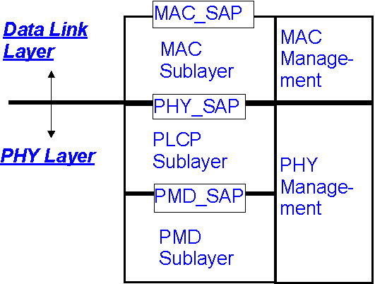
PHY_SAP: PHY Service Access Point
PLCP: PHY Layer Convergence Protocol
MAC_SAP: MAC Service Access Point
PMD: Physical Medium Dependent (radio)
Figure 1: Reference partitioning

Use case summary

The following six use case summaries were extracted from document 802.15-11-0749-00-0thz.

Outdoor Fixed Wireless Links
- Operational environment: Links of backbone network; static use
- Typical range: A few hundred meters up to several kilometers
- Specific propagation conditions: LOS; Atmospheric attenuation becomes important
- Requirements for the antenna alignment: Highly directive antennas; alignment during the installation process by radio engineers

Indoor Fixed Wireless Links
- Operational environment: Links of backbone network; static use
- Typical range: Up to a few hundred meters or more
- Specific propagation conditions: LOS/Obstructed LOS; Atmospheric attenuation becomes important
- Requirements for the antenna alignment: Highly directive antennas; alignment during the installation process by radio engineers

Nano Cells
- Operational environment: Part of a hierarchical cellular network; potentially mobile users; indoor as well as outdoor
- Typical range: < 200m
- Specific propagation conditions: LOS/NLOS; dynamically changing conditions
- Requirements for the antenna alignment: automatic beamsteering required

WLAN Types of Applications
- Operational environment: Connection to access points; nomadic users; mainly indoor
- Typical range: < 100m
- Specific propagation conditions: LOS/NLOS; heavily dynamically changing
- Requirements for the antenna alignment: automatic beamsteering required

WPAN Types of Applications
- Operational environment: Adhoc networks; nomadic users; mainly indoor
- Typical range: < 10m
- Specific propagation conditions: LOS/NLOS; static to moderately dynamically changing
- Requirements for the antenna alignment: automatic beamsteering required

Connecting devices on short ranges
- Operational environment: indoor (typically on a desktop), nomadic use
- Typical range: a few cm
- Specific propagation conditions: LOS, multi paths from nearby objects and multiple reflections from Tx and Rx
- Requirements for the antenna alignment: ideally by automatic beamsteering but with Gbps-Link, manual alignment may be possible

Kiosk Downloading
- Operational environment: indoor, nomadic use
- Typical range: a few cm
- Specific propagation conditions: LOS, multiple reflections from Tx and Rx
- Requirements for the antenna alignment: automatic beamsteering (manual alignment may be very difficult)

Board-to-Board Communications
- Operational environment: inside computers and inside devices, fixed use
- Typical range: a few cm
- Specific propagation conditions: LOS/NLOS, potentially strong multi paths
- Requirements for the antenna alignment: fixed alignment during design process possible (automatic beamsteering as an option)

Data Center/Server Farm Wireless Data Distribution
- Enterprise type environment, less sensitivity to complexity issues
- Typical range: up to 100 meters
- Specific propagation conditions: LOS, Obstructed-LOS
- Requirements for the antenna alignment: switched beam, spatial separation for frequency reuse
- Network is self-organizing, fixed node

TED Summary

This clause contains an overall summary of the rest of the document, mentioning the highlights such as PHY types (assuming multiple options), data rates, topology options (e.g. star, point-to-point, etc.), and MAC frame formats.

Topology

This clause identifies operational topologies such as point-to-point, star, uni-cast, multi-cast, etc. This clause also includes topologies that require packet forwarding between nodes. These operational topologies are use case driven and reference should be included to the pivotal use case documents.

Outdoor Fixed Wireless Topology
e.g. point-to-point access connections (could include hub-and-spoke (star) topologies), relay connections, repeater connections

Wireless Bckhauling/Fronthauling

Wireless backhauling/fronthauling is one of the potential applications for a standard on 100G (100 Gbit/s over beam switchable wireless point-to-point links). In the following the terms wireless backhauling and fronthauling are explained.

A backhaul link is a connection between the base station and a more centralized network element.

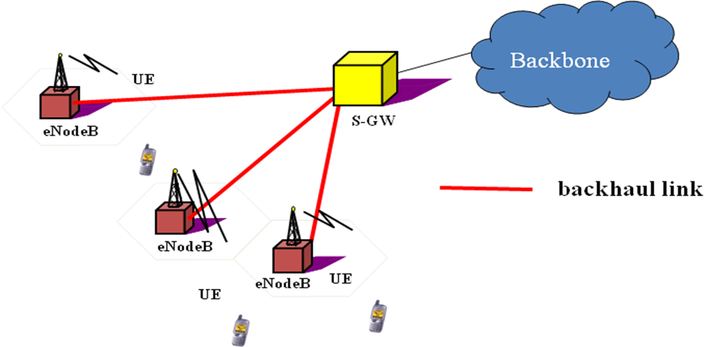
Topology for the backhauling of base stations [39]

The fronthaul link is the link between the radio equipment controller of a base station and the remote radio head (radio unit). Currently the Common Public Radio Interface (CPRI) is used to connect these two entities.
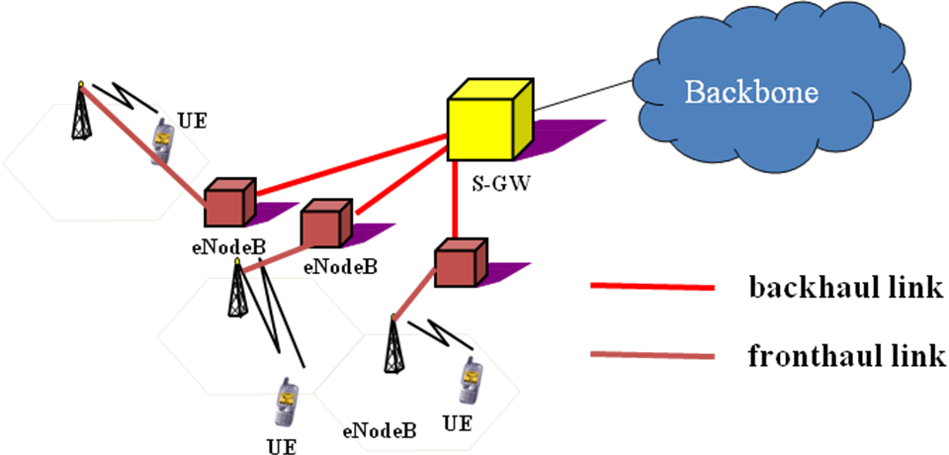
Topology for the fornthauling of base stations [39]

Future developments like massive deployment of small cells, the implementation of cooperative multipoint transmission (CoMP) and/or Cloud Radio Access Networks (C-RAN) may increase the required data rates for either fronthauling or backhauling or both [39], [40].

Indoor Fixed Wireless Topology

Nano Cell Topology

WLAN Topology

WPAN Topology

Connecting devices on short range Topology

Kiosk Download Topology

Board-to-Board Communications Topology

Data Center/Server Farm Wireless Data Distribution

The following information is taken from [31].

In order to apply wireless links in data centers beamforming capabilities are required, see Fig. 6-1 inclusding the following feature:

- Beamforming capabilities both in azimuth and elevation
- Ceiling reflectors (aluminium plates or other good reflecting materials)
- Electromagnetic absorbers on top of the racks to prevent local reflection/scattering around the antenna

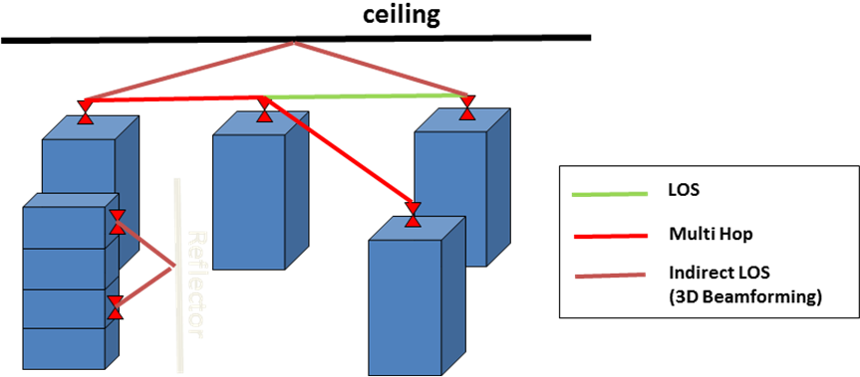

Fig. 6-1 LOS and Indirect LOS Paths [33,34]

Traditional DCN architectures are based on layered 2-tier (3tier-) architectures with core, (aggregation) and access layers [32] A couple of specific arrangements of the servers racks exploring the possibilities to introduce wireless links are proposed as well.

In Fig. 6-2 to 6-4 some of these proposals are presented.

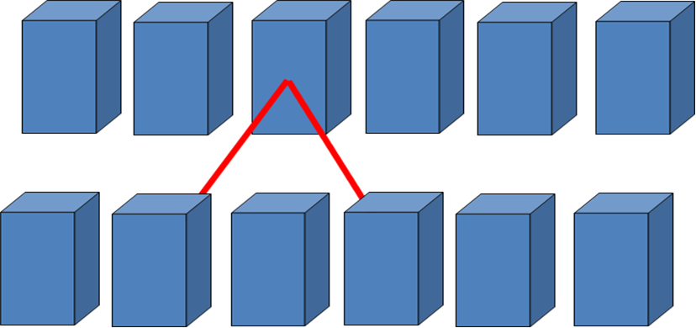

Fig. 6-2 Node Arrangements – Two Parallel Rows [32]

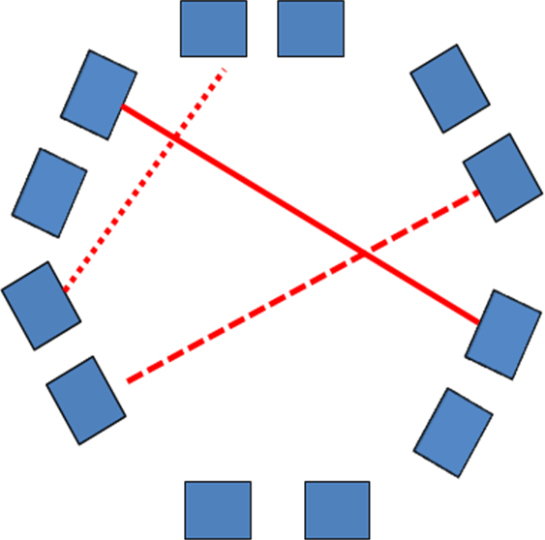

Fig. 6-3: Node Arrangements – Hexagonal Shape [32]
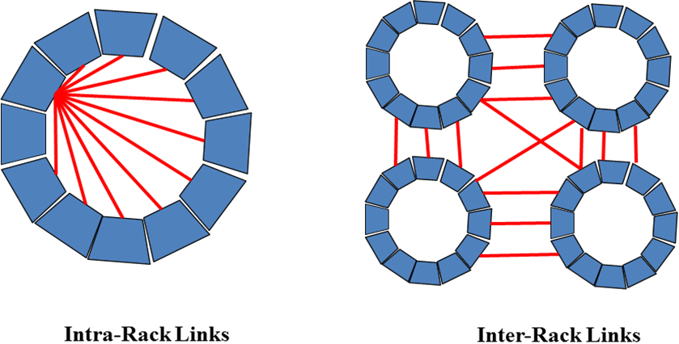
Fig. 6-4: Node Arrangements in a Cayley Data Center [35]

Data center infrastructure [29]
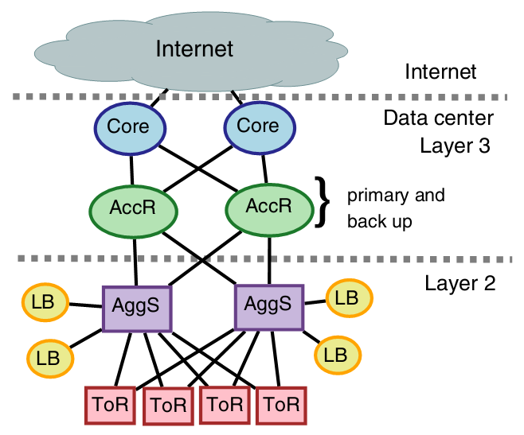

3-Tier Data center Infrastructure [29]

Core Layer
The data center core is a Layer 3 domain built with high-bandwidth links (10 GE or a bunch of 10GE)

Aggregation Layer
Supports Layer 2 and Layer 3 functionality; using 10 Gbps links.

Access Layer/ToR
A Layer 2 domain
ToR using 1Gbps links

Topology is tradeoffs
Emerging 40G Ethernet , performance bottlenecks
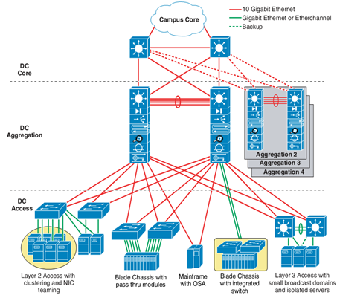

Data Rates

The data rates should be sufficient to support the proposed use cases in conjunction with the operational frequency plan and channel model. This section discusses the data rates, which usually is the bases for different PHY type classes. The data rates are use case driven.

Outdoor Fixed Wireless Rates

Outdoor fixed wireless links may be used for backhauling or fornthauling in cellular networks.

Required data rates for backhauling of small cells
- In the literature the following indications for required data rates are given:
  - A 2.4 Gb/s GPON (Gigabit enabled Passive Optical Network) is shared among 16 small cells [41].
  - In [42] a range of 10 – 500 Mbps for the required backhaul capacity per small cell is given
- The above numbers are given for current cellular standards.
  - Future standards will provide higher data rates
  - Small cells may become more popular, which may yield the requirement of aggregated backhauling for more than 16 small cells

Required data rates for backhauling and fronthauling of macro cells:
- [42] gives also some indications on the required capacity for macro cell backhaul and fronthaul.
- The highest numbers are given for the C-RAN case:
  - Backhaul: > 10 Gbps
  - Fronthaul: 1-10 Gbps

Indoor Fixed Wireless Rates

Nano Cell Rates

WLAN Rates

In reference [30] some first thoughts about modulation schemes and forward error corrections are presented based on link level simulations with realistic devices. In particular phase noise will probably only allow for easy modulation schemes like BPSK or QPSK in the THz range. Nevertheless, with a bandwidth of 50 GHz and QPSK, a gross data rate of 100 Gbit/s can be reached. The forward error correction schemes will reduce the throughput significantly since the most advanced and efficient techniques may be too power (thermal problem) and chip area consuming. Some simple examples can also be found in reference [30], achieving a bit error rate of 10^-9 for a reasonable SNR in the order of 10dB.

WPAN Rates

Connecting devices on short range Rates

Kiosk Download Rates

Board-to-Board Communications Rates

Data Center/Server Farm Wireless Data Distribution Rates

The intended target data rate is 10 Gbps, 40 Gbps, and 100 Gbps [30]. The expected BER for data center applications is 10^-12.

Operational frequency bands

The THz frequency range is quite large, with some frequencies exhibiting better propagation qualities than others. Also influencing this issue are practical limits on implementation physics. In this section the operational frequency bands are discussed. Each use case may operate in a different band.

Outdoor Fixed Wireless Frequencies

The atmospheric attenuation related to the different frequencies is shown in Figure 2 with respect to reference [22]

Outdoor attenuation profile

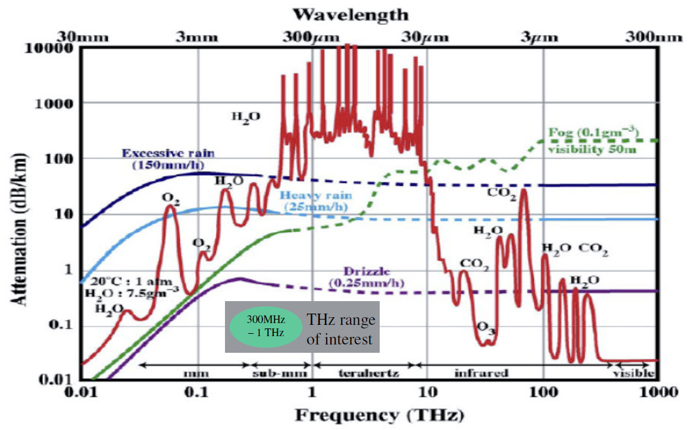

Figure 2: Atmospheric attenuation of electromagnetic waves in dB/km versus the Frequency in THz for different atmospheric parameters

The attenuation of electromagnetic waves in the atmosphere occurs due to interactions and resonances with the molecules of the atmosphere[22, 23]. Especially the water vapour has an important influence on THz-waves.

The specific attenuation can be calculated with the ITU-R [24] and am [25] models. The result up to a frequency of 1 THz at sea level, for an air pressure of 1013 hPa, a temperature of 15°C and a water vapor density of 7.5 g/m³ can be seen in Figure 3.

Figure 3: Atten. Specific attenuation of the earths atmosphere at sea level

However, fog and especially rain can lead to a scattering of the THz-waves at the water droplets, which reduces the power at the receiver [26, 27].

The additional attenuation due to fog, for water vapor densities of 0.05 g/m³ (vision range 300 m) and 0.5 g/m³ (vision range 50 m) is shown in Figure 4 .

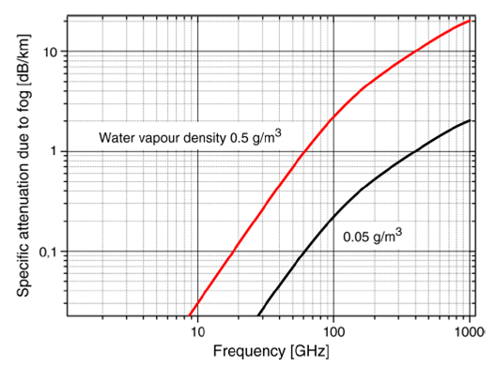
Figure 4 – Additional attenuation due to fog

The additional attenuation due to rain depends on the frequency of the wave and the rain rate. As shown in Figure 5, the maximum attenuation is not in the THz band, but between 100 GHz and 200 GHz.

Figure 4: Specific attenuation of electromagnetic waves due to rain

Attenuation in THz transmission windows

In most cases the atmospheric attenuation adds to the attenuation of either the fog or the rain, but not both together. The over all attenuation can be seen in Figure 6 [ 22,23]

Figure 5: Attenuation in a clear atmosphere at sea level (blue), fog with a vision range of 50 m (red) and rain with a rain rate of 50 mm/h (black)

If it is assumed that the maximum allowed attenuation for a given application amounts to 100 dB/km, 5 different transmission windows (shaded regions in Figure 6) can be allocated in the frequency range between 300 and 900 GHz. The center frequencies and bandwidths of these transmission windows are given in Table 1 [22, 23].

Table 1 Bandwidths and center frequencies of the transmission windows in the frequency range of 330 GHz and 900 GHz with an overall attenuation below 100 dB/km in the worst case

Indoor Fixed Wireless Frequencies

Nano Cell Frequencies

WLAN Frequencies

WPAN Frequencies

Connecting devices on short range Frequencies

Kiosk Download Frequencies

Board-to-Board Communications Frequencies

Data Center/Server Farm Wireless Data Distribution Frequencies

Millimeter wavelength and shorter.

Coexistence/protection existing services and other use cases

The THz bands are currently used for earth science research (mainly passive) and coexistence/protection of these users is necessary to enable the broad acceptance of the technology. This section discusses coexistence and protection issues [20], [21].

Also, each use case outlined in clause 4.0 must coexist with all other clause 4.0 use cases. In some instances this coexistence will be explicit (i.e. different operation bands), but in other instances the coexistence mechanism might be more implicit.

Potentially Critical Interference Scenarios

This is an ideal estimation of maximum occurring interference powers using worst case assumptions throughout all scenarios with no additional attenuation due to the impact of weather.

Nomadic devices operated outdoors in rural environment

The assumptions are that the nomadic TX is accidentally pointed in immediate skyward direction as a satellite is passing overhead, directly looking at the ground (0° zenith angle, shortest path). Also it is assumed that a ground reflection may superimpose constructively with the direct path towards the satellite

Nomadic devices operated outdoors in urban environment

In this scenario we assume that no objects shadow the direct ray path and that additionally the reflections from buildings around the TX coherently combine at the satellite.

Indoor-operated devices are not relevant due to transmission losses; therefore, indoor setups are implicitly covered by the outdoor scenario.

Fixed links with scattering objects close to direct ray path

In this scenario, objects close to the direct ray path may scatter/reflect power in a skyward direction towards the satellite. This scenario is possible despite highly directive antennas.

Relevant emission from antenna sidelobes

High sidelobe levels may cause non-negligible radiation in a skyward direction with fixed links become especially critical because of potentially high output powers.

Airborne operated transmitters

In this scenario, radiation through the fuselage or windows is possible, and the transmitted rays may not be attenuated due to the use of composite fuselages. At higher altitudes we can hardly expect any atmospheric absorption.

Satellite in limb scanning mode

THz waves may be radiated in the immediate direction of the limb scanner. Ground-based transmitters do not become relevant due to the long horizontal path.

Spectral Masks between Active Services and Earth Exploration Services (EESS)

Maximum equivalent isotropically radiated power (EIRP)

The clause shows how to calculate the maximum equivalent isotropically radiated power (EIRP), which is scenario path loss specific, and includes the satellite antenna gain. If the TX radiated signal does not exceed the maximum allowed interference power mask, then there will be no interference.

Definition of transmit power spectrum masks

This clause provides the definition of transmit power spectrum masks and constraints for the isotropically radiated power spectral density. A simple approximation with line segments (line parameter sets given in [1]) is used to calculate the effective limitation to several 10 dBm EIRP for bandwidths of several 10 GHz.

Nomadic devices in rural and urban areas

Fixed links and sidelobes

Fixed links are far less critical than nomadic transmitters and can support higher output powers and longer distances with no significant sidelobe limitations. These relevant constraints are only applicable below 500 GHz.

Airborne TX and limb scanning

Airborne transmitters are most critical with constraints in almost the entire THz range resulting in restrictions requiring lower power and shorter ranges.

Regulatory requirements

Devices will need to comply with the regulatory requirements specified for THz devices. Unique to THz is that these regulatory requirements will be evolving over the next few years. In this section these issues can be discussed. All regulatory assumptions should be clearly stated.

Active THz systems will have to comply with the ITU Radio Regulations footnote 5.565.

Transmission range

The transmission range is driven by use cases in conjunction with the operational frequency plan and channel model. This section discusses the transmission range, which often is the justification for different PHY types.

Outdoor Fixed Wireless Range

For antenna gains of 70 dBi and an adaptive antenna alignment the range for fixed wireless links with carrier frequencies in the first THz window can be up to 1 km even under worst environmental conditions of a rain rate of 50 mm/h. Even for higher carrier frequencies such link distances are possible, but than the maximum transmissible data rates decrease (see clause 12.1).

Indoor Fixed Wireless Range

Nano Cell Range

WLAN Range

WPAN Range

Connecting devices on short range Range

Kiosk Download Range

Board-to-Board Communications Range

Data Center/Server Farm Wireless Data Distribution Range

Antenna gain and required alignment accuracy

The antenna gain and required alignment accuracy is driven by use cases. This section discusses the antenna gain and required alignment accuracy, which may be part of the justification for different PHY types.

Outdoor Fixed Wireless Gain and Accuracy

Due to the very high path loss accompanied with THz transmission, for outdoor applications high antenna gains are required. The antenna gain depends on the distance, transmitted data rate, carrier frequency and application. However, an example for a fixed wireless link with a distance of 1 km under worst environmental conditions of a rain rate of 50 mm/h is given in Figure 7. For shorter distances, or better atmospheric conditions, antennas with lower gain can be used. If a transmit power of 10 dBm, a noise figure of 10 dB, and an ambient temperature of 300 K is assumed, the maximum transmittable data rates per GHz bandwidth in a 1 km link are shown in Figure 7 [23].

From Figure 7, very high data rates can only be transmitted if the antenna gains are respectively high. For an antenna gain of 50 dBi for the transmitter and receiver antennas a maximum data rate of 25 Gbps can be transmitted in the 76 GHz bandwidth available in the first window. However, if the antenna gain is increased to 70 dBi, the maximum data rate can be increased to about 860 Gbps in the first transmission window.

Figure 6: Ideal antenna diameter (left and blue) and diameter of the radiated area (right and red) in dependence of the antenna gain for the first THz window and a distance of 1 km

For 70 dBi antenna gain the angle for loss of connectivity due to fluctuation of the pole and the pole twist is just 0.13°. The requirement for adaptive antenna alignments or control mechanisms to compensate for pole sway/twist depends on the grade of sway/twist impairments, given by the antenna installations, e.g. type of pole or building.

Indoor Fixed Wireless Gain and Accuracy

Nano Cell Gain and Accuracy

WLAN Gain and Accuracy

Simple Link Budget based on realistic components for a direct path only in a wireless lan setup:

Transmitter power (baseband) | 10 dBm
Conversion loss | -7.4 dB
Antenna gain (transmitter) | + Gtx [dBi]
Free space loss | - Lfsl [dB]
Antenna gain (receiver) | + Grx [dBi]
Noise figure | - 7.6 dB
Thermal noise | Pn [dBm]
Signal to Noise Ratio | = SNR [dB]

Using a bandwidth of 50 GHz at a center frequency of 325 GHz and a direct path length of aprox. 6m, this leads to a free space loss (Lfsl) of 98.2dB. In order to achieve a reasonable SNR of 10dB a total antenna gain of 46.4 dBi is required.

The following simulations were performed for a very simple empty room (6m x 4m x 2.5m) wireless LAN scenario, c.f. [30]. Assuming antennas with a Gaussian beam shape in the transmitter and the receiver with identical Half Power Beam Widths (HPBWs in azimuth and elevation), a gain suitable gain of 51.2 dBi can be realized.

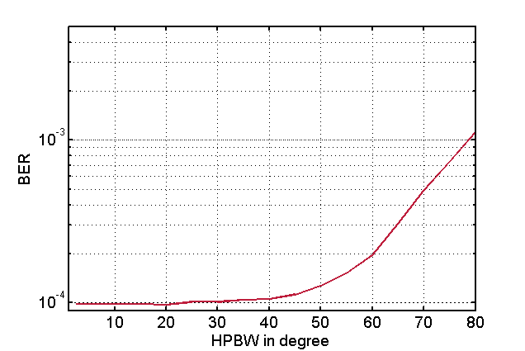

As shown in the above figure, a directive antenna can also cancel out the Inter Symbol Interference (ISI) form multipath propagation. A Bit Error Rate (BER) of 10^-4 is defined as Quasi Error Free (QEF) for simulations without Forward Error Correction. Please note that the channel impulse response was normalized, therefore a HPBW of 20° is sufficient to supress ISI for a 16 QAM. Still a HPBW of only 10° is required taking the absolute gain into account.

The perfect alignment of directive antennas is practically impossible. If the HPBW is assumed to be 15° then the next figure shows the impact of an increasing misalignment of the receiver’s antenna. Significant ISI only occurs for a a misaglinment of more than 30° with a 16 QAM. Again the absolute antenna gain is not represented in the simulations. A misalignment of 7.5° (half of the HPBW) means that the SNR will decrease by 3 dB. In a future system design, this will have to be considered in a safety margin for misaglinment in the link budget.

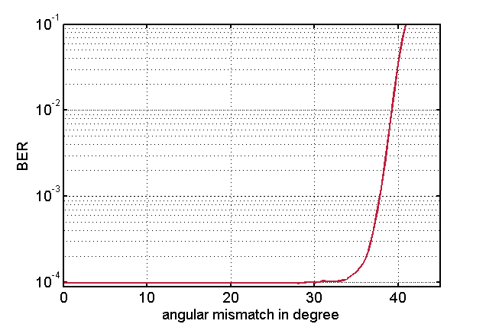

WPAN Gain and Accuracy

Connecting devices on short range Gain and Accuracy

Kiosk Download Gain and Accuracy

Board-to-Board Communications Gain and Accuracy

Data Center/Server Farm Wireless Data Distribution Gain and Accuracy

Channel models

Usually the channel model per sec is a stand-alone document. This clause contains relevant highlights from the channel model along with a link to the more comprehensive document. All models must be broadband inasmuch as the required operational bandwidth must be taken into consideration.

Outdoor Fixed Wireless

Co-channel interference

Fading mechanisms

Scintillation

Molecular attenuation

Doppler

Spatial/temporal properties

Angle of arrival/departure

Time of arrival

Delay spread

Coherence time/bandwidth

Indoor Fixed Wireless

Co-channel interference

Fading mechanisms

Scintillation

Molecular attenuation

Doppler

Spatial/temporal properties

Angle of arrival/departure

Time of arrival

Delay spread

Coherence time/bandwidth

Nano Cells

Co-channel interference

Fading mechanisms

Scintillation

Molecular attenuation

Doppler

Spatial/temporal properties

Angle of arrival/departure

Time of arrival

Delay spread

Coherence time/bandwidth

WLAN Types of Applications

In [36, 37] a stochastic channel model for WLAN/WPAN applications in indoor scenarios is proposed based on a deterministic ray tracing propagation simulator building upon the experimental understanding of the THz indoor radio channel. The model, based upon measurements and calibration described in [38], features broadband channel realizations with 50 GHz bandwidth and is fully polarimetric, includes spatial channel information and allows for the fast generation of channel realizations. The software for generation of channel model realizations is available on request form the authors, see [36].

WPAN Types of Applications

Co-channel interference

Fading mechanisms

Scintillation

Molecular attenuation

Doppler

Spatial/temporal properties

See section 13.4.3

Connecting devices on short ranges

Co-channel interference

Fading mechanisms

Scintillation

Molecular attenuation

Doppler

Spatial/temporal properties

Angle of arrival/departure

Time of arrival

Delay spread

Coherence time/bandwidth

Kiosk Downloading

Co-channel interference

Fading mechanisms

Scintillation

Molecular attenuation

Doppler

Spatial/temporal properties

Angle of arrival/departure

Time of arrival

Delay spread

Coherence time/bandwidth

Board-to-Board Communications

Co-channel interference

Fading mechanisms

Scintillation

Molecular attenuation

Doppler

Spatial/temporal properties

Angle of arrival/departure

Time of arrival

Delay spread

Coherence time/bandwidth

Data Center/Server Farm Wireless Data Distribution Gain and Accuracy

Co-channel interference

Fading mechanisms

Scintillation

Molecular attenuation

Doppler

Spatial/temporal properties

Angle of arrival/departure

Time of arrival

Delay spread

Coherence time/bandwidth

Link budget and SNR analysis

It is likely that each use case will have a unique link budget analysis due to differences in required performance and complexity of modulation formats. Reference [22] contains useful information in regards to link budget calculations.

Example Link Budget

Outdoor Fixed Wireless Link Budget

Indoor Fixed Wireless Link Budget

Nano Cell Link Budget

WLAN Link Budget

WPAN Link Budget

Connecting devices on short range Link Budget

Kiosk Download Link Budget

Simple AWGN Link Budget (Kiosk Downloading)
Bit Rate (Gbps) | 20
Avg TX Power (dBm) | 10
TX Antenna Gain (dBi) | 30
EIRP dBm (+40 dBm max) | 40
Center Freq (GHz) | 300
Aperature Loss @ 1 meter | 81.98419728
Standoff Distance (meters) | 1
Path Loss at Distance (dB) | 0
Obstacle Loss (dB) | 0
RX Antenna Gain (dBi) | 15
RX Ingested Power (dBm) | -26.98419728
Eb (energy / bit) | -129.9944972
RX Noise Figure (dB) | 15
No (noise power / Hz) | -159
Required Eb/No (dB) | 16
Implementation Loss (dB) | 10
At Distance Link Margin (dB) | 3.005502763
Zero Margin Distance (meters) | 1.413432712

Board-to-Board Communications Link Budget

Data Center/Server Farm Wireless Data Distribution Gain and Accuracy

Size, Weight and Power

Size, weight and power (SWaP) concerns arise from use case expectations and influences range and data rate. The antenna is included in the SWaP estimate. Of primary concern is mobile operation battery life. This section discusses these issues.

Outdoor Fixed Wireless SWaP

Indoor Fixed Wireless SWaP

Nano Cell SWaP

WLAN SWaP

WPAN SWaP

Connecting devices on short range SWaP

Kiosk Download SWaP

Board-to-Board Communications SWaP

Data Center/Server Farm Wireless Data Distribution SWaP

Mobility and Link switching

There may be a need to support link switching due to physical movement or interference. This section discusses these issues. Obviously this is use case dependent since for some use cases link switching may not be appropriate.

Outdoor Fixed Wireless Link Switching

Indoor Fixed Wireless Link Switching

Nano Cell Link Switching

WLAN Link Switching

WPAN Link Switching

Connecting devices on short range Link Switching

Kiosk Download Link Switching

Board-to-Board Communications Link Switching

Data Center/Server Farm Wireless Data Distribution Link Switching

Beam steered or control channel assisted device discovery

There may be a need to support device discovery, which includes aligning the antenna to close the link. This section discusses these issues. These parameters may be use case dependent.

Outdoor Fixed Wireless Device Discovery

Indoor Fixed Wireless Device Discovery

Nano Cell Device Discovery

WLAN Device Discovery

WPAN Device Discovery

Connecting devices on short range Device Discovery

Kiosk Download Device Discovery

Board-to-Board Communications Device Discovery

Data Center/Server Farm Wireless Data Distribution Device Discovery

Media access mechanism and superframe expectations

The following two figures are from [28] and are the basis for much of the MAC section material.

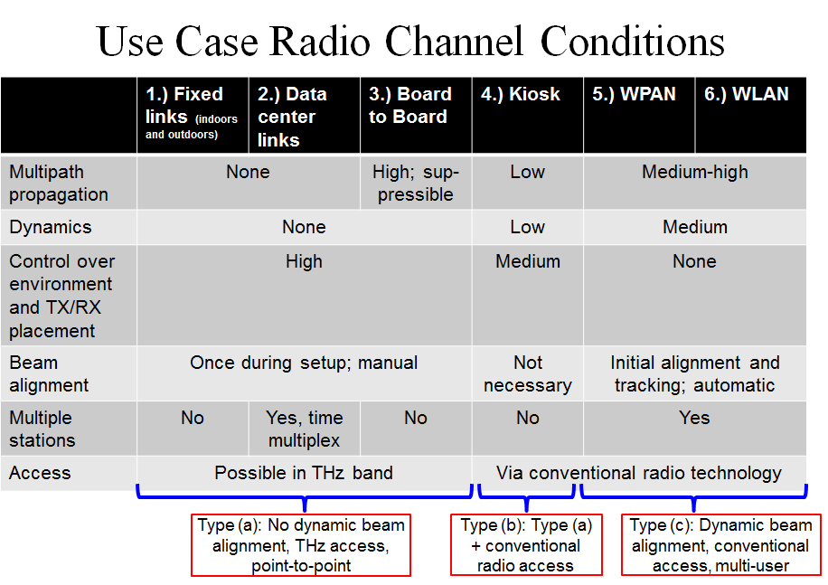
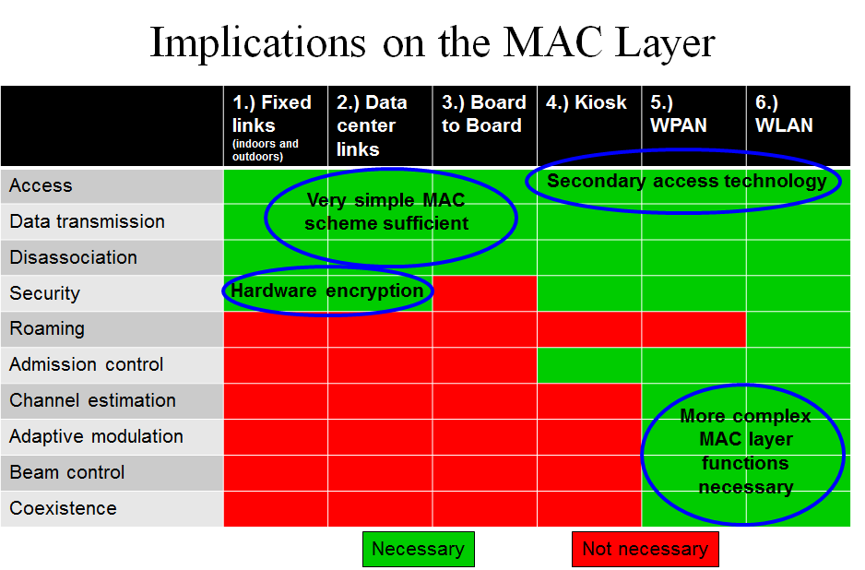

Multiband operation
- Antenna alignment
- Fast session transfer, for example from 60 GHz to THz

Full-duplex Operation
Methods for a full-duplex MAC were discussed in [43]. These include features such as
- Superframe configuration (i.e. CAP only)
- Beaconing methods
- PNC designation
- PMD modifications to accommodate full-duplex
- Link establishment beaconing protocol
- Asynchronous vs. synchronous full-duplex superframes
- PHY/MAC header fields and preamble definitions

Security mechanisms

I/O Interfaces and Memory Buffer Considerations

References

[1] S. Priebe, C. Jastrow, M. Jacob, T. Kleine-Ostmann, T. Schrader, T. Kürner: Channel and Propagation Measurements at 300 GHz, IEEE Transactions on Antennas and Propagation, vol. 59, no. 5, pp. 1688–1698, 2011.

[2] C. Jansen, S. Priebe, C. Möller, M. Jacob, H. Dierke, M. Koch, T. Kürner: Diffuse Scattering from Rough Surfaces in THz Communication Channels, IEEE Transactions on Terahertz Science and Technology, vol.1, no. 2, pp.1688–1698, 2011.

[3] M. Jacob, S. Priebe, R. Dickhoff, T. Kleine-Ostmann, T. Schrader, T. Kürner: Diffraction in mm and Sub-mm Wave Indoor Propagation Channels, IEEE Transactions on Microwave Theory and Techniques, vol. 60, no. 3, pp. 833–844, 2011.

[4] S. Priebe, M. Jacob, C. Jastrow, T. Kleine-Ostmann, T. Schrader, T. Kürner: A Comparison of Indoor Channel Measurements and Ray Tracing Simulations at 300 GHz, Proc. 35th International Conference on Infrared, Millimeter and THz Waves (IRMMW-THz), 2 pages (electronic), Rome, September 2010.

[5] S. Priebe, M. Jacob, T. Kürner: Angular and RMS Delay Spread Modeling in View off THz Indoor Communication Systems, Accepted for publication in Proc. 12th URSI Commission F Triennial Open Symposium on Radio Wave Propagation and Remote Sensing, 8 pages, Garmisch Partenkirchen, March 2011.

[6] S. Priebe, M. Jacob, C. Jansen, T. Kürner: Non-Specular Scattering Modeling for THz Propagation Simulations, Proc. 5th European Conference on Antennas and Propagation (EuCAP), 5 pages (electronic), Rome, April 2011.

[7] S. Priebe, M. Jacob, T. Kürner: Polarization Investigation of Rough Surface Scattering for THz Propagation Modeling, Proc. 5th European Conference on Antennas and Propagation (EuCAP), 5 pages (electronic), Rome, April 2011.

[8] S. Priebe, M. Jacob, T. Kürner: AoA, AoD and ToA Characteristics of Scattered Multipath Clusters for THz Indoor Channel Modeling, Proc. 17th European Wireless Conference (EW), 9 pages (electronic), Vienna, April 2011.

[9] S. Priebe, M. Jacob, T. Kürner: The Impact of Antenna Directivities on THz Indoor Channel Characteristics, Accepted for publication in Proc. European Conference on Antennas and Propagation (EuCAP), Prague, 5 pages (electronic), March 2012.

[10] S. Priebe, M. Jacob, T. Kürner: Affection of THz Indoor Communication Links by Antenna Misalignment, Accepted for publication in Proc. European Conference on Antennas and Propagation (EuCAP), Prague, 5 pages (electronic), March 2012.

[11] T. Kürner, S. Priebe, M. Jacob, C. Jastrow, T. Kleine-Ostmann, T. Schrader: Measuring the Channel Characteristics at 300 GHz - Preliminary Results, IEEE 802.15-09-0496-01-0thz, San Francisco, July 2009.

[12] T. Kürner, S. Priebe, M. Jacob, C. Jastrow, T. Kleine-Ostmann, T. Schrader: Measurements of the Channel Characteristics at 300 GHz, IEEE 802.15-09-0756-00-0thz, Atlanta, November 2009.

[13] S. Priebe, M. Jacob, C. Jastrow, T. Kleine-Ostmann, T. Schrader, T. Kürner: Towards a 300 GHz Channel Model, IEEE 802.15-10-0436-01-0thz, San Diego, July 2010.

[14] S. Priebe, M. Jacob, C. Jastrow, T. Kleine-Ostmann, T. Schrader, T. Kürner: Digital Data Transmission at 300 GHz, IEEE 802.15-10-0437-01-0thz, San Diego, July 2010.

[15] S. Priebe, M. Jacob, T. Kürner: Diffuse Rough Surface Scattering Analysis for THz Communication Systems, IEEE 802.15-11-0146-01-0thz, Singapore, March 2011.

[16] S. Priebe, M. Jacob, T. Kürner: Spatial and Temporal Dispersion in THz Propagation Channels, IEEE 802.15-11-0180-02-0thz, Singapore, March 2011.

[17] S. Priebe, M. Jacob, T. Kürner: Stochastic Modeling of Scattered Multipath Clusters in THz Indoor Communication Channels, IEEE 802.15-11-0474-01-0thz, San Francisco, July 2011.

[18] S. Priebe, M. Jacob, T. Kürner: Will THz Communication Interfere with Passive Remote Sensing?, IEEE 802.15-12-0101-00-0thz, Hawaii, March 2012.

[19] S. Priebe, M. Jacob, T. Kürner: Performance of Antennas in THz Indoor Communication Channels, IEEE 802.15-12-0102-01-0thz, Hawaii, March 2012.

[20] S. Priebe, D. M. Britz, M. Jacob, S. Sarkozy, K. M. K. H. Leong, J. E. Logan, B. S. Gorospe, T. Kürner: Interference Investigations of Active Communications and Passive Earth Exploration Services in the THz Frequency Range“, accepted for publication in IEEE Transactions on THz Science and Technology, 14 pages, 2012

[21] S. Priebe: Interference between THz Communications and Spaceborne Earth Exploration Services, IEEE 802.15-12-0324-00-0thz, San Diego, July 2012

[22] M. Grigat, T. Schneider, S. Preußler, R. P. Braun: Link Budget Considerations for THz Fixed Wireless Links, IEEE 802.15-12-0582-01-0thz, San Antonio, November 2012

[23] T. Schneider, A. Wiatrek, S. Preußler, M. Grigat, R. P. Braun: Link Budget Analysis for Terahertz Fixed Wireless Links, IEEE Transactions on THz Science and Technology 2, 250 – 256 (2012)

[24] Attenuation by Atmospheric Gases, ITU Rec. ITU-R P.676-8, ITU, Oct. 2009

[25] “The am atmospheric model, submillimeter array,” Tech. Memo #152 https://www.cfa.harvard.edu/~spaine/am/

[26] “Attenuation due to clouds and fog”, ITU Rec. ITU-R P.840-4, ITU, Oct. 2009

[27] “Specific attenuation model for rain, for use in prediction methods”, ITU Rec. ITU-R P.838-3, ITU, 2005

[28] S. Priebe: MAC Layer Concepts for THz Communications, IEEE 802.15-13-0119-00-0thz, Orlando, March 2013

[29] Cai Yunlong: Data Center Traffic Characteristics and 100Gb/s Demand, IEEE 802.15-13-0519-00-0thz, Nanjing, September 2013

[30] S. Rey, S. Priebe, Thomas Kürner: Link Level Simulations of THz-Communications, IEEE 802.15-13-0406-00thz, Geneva, July 2013

[31] T. Kürner, Literature Review on Requirements for Wireless Data Centers, IEEE 802.15-13-0411-00-0thz, Geneva, July 2013

[32] H. Vardhan, Wireless Data Center with Millimeter Wave Network, Proc. IEEE Globecom 2010

[33] Zhang W et. al, “3D beamforming for wireless data centers”, in Proceedings of the 10th ACM Workshop on Hot Topics in Networks. 2011

[34] K. Ramchadran, “60 GHz Data-Center Networking: Wireless Worryless?“, 2008

[35] “On the feasibility of Completely Wireless Data Centers“, http://www.cs.cornell.edu/courses/cs6452/2012sp/papers/cayley.pdf

[36] S. Priebe, Thomas Kürner: A Stochastic Indoor Radio Channel Model for THz WPANs/WLANs, IEEE 802.15-13-0358-00thz, Geneva, July 2013

[37] S. Priebe, T. Kürner: “Stochastic Modeling of THz Indoor Radio Channels“, accepted for publication in IEEE Transactions on Wireless Communications, 12 pages, 2013.

[38] Sebastian Priebe, Martin Jacob, Marius Kannicht, Thomas Kürner: Ultra Broadband Indoor Channel Measurements and Calibrated Ray Tracing Propagation Modeling at THz Frequencies, IEEE 802.15-13-0637-00thz, Dallas, Texas, November 2013

[39] Thomas Kürner: Requirments on Wireless Backhauling/Fronthauling, IEEE 802.15-13-0636-01thz, Dallas, Texas, November 2013

[40] Thomas Kürner, Information on Backhauling/Fronthauling, IEEE 802.15-15-0625-01thz, Los Angeles, CA, January 2014

[41] C. Ranaweera et. al, „Design and Optimization of Fiber Opic Small-Cell Backhaul Based on an Existing Fiber-to-the-Node Residential Access Network

[42] http://backhaulforum.com/cloud-ran-fronthaul-perspective/ (visited on 17.1.14). IEEE Comunicatiosn Magazine, September 2013, pp. 62-69

[43] Rick Roberts, et. al., 100 Gbps Optical Wireless Tutorial,
http://griffin.meeting.verilan.com/docs/802.15/14/15-14-0016-00-0thz-100-gbps-optical-wireless-tutorial.pdf

