IEEE P802.15
Wireless Personal Area Networks

Project | IEEE P802.15 Working Group for Wireless Personal Area Networks (WPANs)
Title | THz IG Technical Expectations Document (TED)
Date Submitted | [Nov, 2011]
Source | Rick Roberts | E-mail: richard.d.roberts@intel.com
Re:
Abstract | [THz Technical Expectations]
Purpose
Notice | This document has been prepared to assist the IEEE P802.15. It is offered as a basis for discussion and is not binding on the contributing individual(s) or organization(s). The material in this document is subject to change in form and content after further study. The contributor(s) reserve(s) the right to add, amend or withdraw material contained herein.
Release | The contributor acknowledges and accepts that this contribution becomes the property of IEEE and may be made publicly available by P802.15.

Document Overview

This document treats THz communications and related network applications operating in the THz frequency bands between 275 – 3000GHz. Such THz communications applications would include; component to component, board to board, machine to machine, human to machine and human to human, (indoor and outdoor) wireless communications. THz communication applications cover multiple categories with varying requirements. As envisioned, THz communications would overall employ wireless modulation methods of limited complexity, omni and/or directional antenna systems, and would typically offer very high data transfer rates in multiples of 10 Gbps, and up to possibly 1 Tbps, for parity with future fiber optic capacities.

List of contributors

Table of Contents
1. Definitions: 9
2. General Guidelines 10
3. Protocol Reference Model 11
4. Use case summary 12
4.1 Outdoor Fixed Wireless Links 12
4.2 Indoor Fixed Wireless Links 12
4.3 Nano Cells 12
4.4 WLAN/WPAN Types of Applications 12
4.5 Connecting devices on short ranges 13
4.6 Kiosk Downloading 13
4.7 Board-to-Board Communications 13
4.8 Data Center/Server Farm Wireless Data Distribution 13
5. TED Summary 14
6. Topology 15
6.1 Outdoor Fixed Wireless Topology 15
6.2 Indoor Fixed Wireless Topology 15
6.3 Nano Cell Topology 15
6.4 WLAN/WPAN Topology 15
6.5 Connecting devices on short range Topology 15
6.6 Kiosk Download Topology 15
6.7 Board-to-Board Communications Topology 15
6.8 Data Center/Server Farm Wireless Data Distribution 15
7. Data Rates 16
7.1 Outdoor Fixed Wireless Rates 16
7.2 Indoor Fixed Wireless Rates 16
7.3 Nano Cell Rates 16
7.4 WLAN/WPAN Rates 16
7.5 Connecting devices on short range Rates 16
7.6 Kiosk Download Rates 16
7.7 Board-to-Board Communications Rates 16
7.8 Data Center/Server Farm Wireless Data Distribution Rates 16
8. Operational frequency bands 17
8.1 Outdoor Fixed Wireless Frequencies 17
8.1.1 Outdoor attenuation profile 17
8.1.2 Attenuation due to Fog / Rain 18
8.1.3 Attenuation in THz transmission windows 18
8.2 Indoor Fixed Wireless Frequencies 18
8.3 Nano Cell Frequencies 18
8.4 WLAN/WPAN Frequencies 19
8.5 Connecting devices on short range Frequencies 19
8.6 Kiosk Download Frequencies 19
8.7 Board-to-Board Communications Frequencies 19
8.8 Data Center/Server Farm Wireless Data Distribution Frequencies 19
9. Coexistence/protection existing services and other use cases 20
9.1 Potentially Critical Interference Scenarios 20
9.1.1 Nomadic devices operated outdoors in rural environment 20
9.1.2 Nomadic devices operated outdoors in urban environment 21
9.1.3 Fixed links with scattering objects close to direct ray path 21
9.1.4 Relevant emission from antenna sidelobes 22
9.1.5 Airborne operated transmitters 22
9.1.6 Satellite in limb scanning mode 23
9.2 Spectral Masks between Active Services and Earth Exploration Services (EESS) 23
9.2.1 Maximum equivalent isotropically radiated power (EIRP) 23
9.2.2 Definition of transmit power spectrum masks 24
10. Regulatory requirements 26
11. Transmission range 27
11.1. Outdoor Fixed Wireless Range 27
11.2. Indoor Fixed Wireless Range 27
11.3. Nano Cell Range 27
11.4. WLAN/WPAN Range 27
11.5. Connecting devices on short range Range 27
11.6. Kiosk Download Range 27
11.7 Board-to-Board Communications Range 27
11.8 Data Center/Server Farm Wireless Data Distribution Range 27
12. Antenna gain and required alignment accuracy 28
12.1. Outdoor Fixed Wireless Gain and Accuracy 28
12.2. Indoor Fixed Wireless Gain and Accuracy 28
12.3. Nano Cell Gain and Accuracy 28
12.4. WLAN/WPAN Gain and Accuracy 28
12.5. Connecting devices on short range Gain and Accuracy 28
12.6. Kiosk Download Gain and Accuracy 28
12.7. Board-to-Board Communications Gain and Accuracy 28
12.8. Data Center/Server Farm Wireless Data Distribution Gain and Accuracy 28
13. Channel models 29
13.1 Outdoor Fixed Wireless 29
13.1.1 Co-channel interference 29
13.1.2 Fading mechanisms 29
13.1.3 Spatial/temporal properties 29
13.2. Indoor Fixed Wireless 29

13.2.1 Co-channel interference 29
13.2.2 Fading mechanisms 29
13.2.3 Spatial/temporal properties 29
13.3. Nano Cells 30
13.3.1 Co-channel interference 30
13.3.2 Fading mechanisms 30
13.3.3 Spatial/temporal properties 30
13.4. WLAN/WPAN Types of Applications 30
13.4.1 Co-channel interference 30
13.4.2 Fading mechanisms 30
13.4.3 Spatial/temporal properties 30
13.5. Connecting devices on short ranges 31
13.5.1 Co-channel interference 31
13.5.2 Fading mechanisms 31
13.5.3 Spatial/temporal properties 31
13.6. Kiosk Downloading 31
13.6.1 Co-channel interference 31
13.6.2 Fading mechanisms 31
13.6.3 Spatial/temporal properties 31
13.7. Board-to-Board Communications 32
13.7.1 Co-channel interference 32
13.7.2 Fading mechanisms 32
13.7.3 Spatial/temporal properties 32
13.8 Data Center/Server Farm Wireless Data Distribution Gain and Accuracy 32
13.9.1 Co-channel interference 32
13.9.2 Fading mechanisms 32
13.9.3 Spatial/temporal properties 32
14. Link budget and SNR analysis 34
14.1 Example Link Budget 34
14.3. Outdoor Fixed Wireless Link Budget 34
14.4. Indoor Fixed Wireless Link Budget 34
14.5. Nano Cell Link Budget 34
14.6. WLAN/WPAN Link Budget 34
14.7. Connecting devices on short range Link Budget 34
14.8. Kiosk Download Link Budget 35
14.9. Board-to-Board Communications Link Budget 35
14.9 Data Center/Server Farm Wireless Data Distribution Gain and Accuracy 35
15. Size, Weight and Power 36
15.1. Outdoor Fixed Wireless SWaP 36
15.2. Indoor Fixed Wireless SWaP 36
15.3. Nano Cell SWaP 36
15.4. WLAN/WPAN SWaP 36
15.5. Connecting devices on short range SWaP 36
15.6. Kiosk Download SWaP 36
15.7. Board-to-Board Communications SWaP 36
15.8 Data Center/Server Farm Wireless Data Distribution SWaP 36
16. Mobility and Link switching 37
16.1. Outdoor Fixed Wireless Link Switching 37
16.2. Indoor Fixed Wireless Link Switching 37
16.3. Nano Cell Link Switching 37
16.4. WLAN/WPAN Link Switching 37
16.5. Connecting devices on short range Link Switching 37
16.6. Kiosk Download Link Switching 37
16.7. Board-to-Board Communications Link Switching 37
16.8. Data Center/Server Farm Wireless Data Distribution Link Switching 37
17. Beam steered or control channel assisted device discovery 38
17.1. Outdoor Fixed Wireless Device Discovery 38
17.2. Indoor Fixed Wireless Device Discovery 38
17.3. Nano Cell Device Discovery 38
17.4. WLAN/WPAN Device Discovery 38
17.5. Connecting devices on short range Device Discovery 38
17.6. Kiosk Download Device Discovery 38
17.7. Board-to-Board Communications Device Discovery 38
17.8. Data Center/Server Farm Wireless Data Distribution Device Discovery 38
18. Media access mechanism and superframe expectations 39
18.1 Multiband operation 39
19. Security mechanisms 40
20. I/O Interfaces and Memory Buffer Considerations 41
21. References 42

Definitions:

General Guidelines

This technical expectations document (TED) describes the technical expectations for a THz standard, such as performance-related issues, reliability issues and availability issues. These types of issues are often called quality of service (QoS). Technical expectations are documented in the same manner as any specifications, including a description, an example, a source or references to related technical documents.

Difference between Expectations and Requirements (TED vs. TRD)

The THz IG group decided to use the term “expectations” instead of “requirements” in order to adopt a less rigid, informal process with the intention to be able to quickly develop actual requirements when the transition to a task group occurs. This document serves to provide guidance for development of IEEE802 THz technical contributions.

Protocol Reference Model

The communication protocol reference model used for this document is shown in Figure 1.

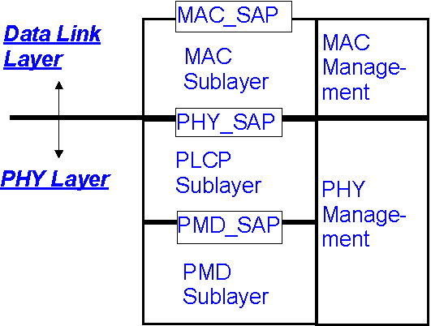
PHY_SAP: PHY Service Access Point
PLCP: PHY Layer Convergence Protocol
MAC_SAP: MAC Service Access Point
PMD: Physical Medium Dependent (radio)
Figure 1: Reference partitioning

Use case summary

The following six use case summaries were extracted from document 802.15-11-0749-00-0thz.

Outdoor Fixed Wireless Links
- Operational environment: Links of backbone network; static use
- Typical range: A few hundred meters up to several kilometers
- Specific propagation conditions: LOS; Atmospheric attenuation becomes important
- Requirements for the antenna alignment: Highly directive antennas; alignment during the installation process by radio engineers

Indoor Fixed Wireless Links
- Operational environment: Links of backbone network; static use
- Typical range: Up to a few hundred meters or more
- Specific propagation conditions: LOS/Obstructed LOS; Atmospheric attenuation becomes important
- Requirements for the antenna alignment: Highly directive antennas; alignment during the installation process by radio engineers

Nano Cells
- Operational environment: Part of a hierarchical cellular network; potentially mobile users; indoor as well as outdoor
- Typical range: < 200m
- Specific propagation conditions: LOS/NLOS; dynamically changing conditions
- Requirements for the antenna alignment: automatic beamsteering required

WLAN/WPAN Types of Applications
- Operational environment: Connection to access points; nomadic users; mainly indoor
- Typical range: < 100m (mostly < 10m)
- Specific propagation conditions: LOS/NLOS; dynamically changing conditions
- Requirements for the antenna alignment: automatic beamsteering required

Connecting devices on short ranges
- Operational environment: indoor (typically on a desktop), nomadic use
- Typical range: a few cm
- Specific propagation conditions: LOS, multi paths from nearby objects and multiple reflections from Tx and Rx
- Requirements for the antenna alignment: ideally by automatic beamsteering but with Gbps-Link, manual alignment may be possible

Kiosk Downloading
- Operational environment: indoor, nomadic use
- Typical range: a few cm
- Specific propagation conditions: LOS, multiple reflections from Tx and Rx
- Requirements for the antenna alignment: automatic beamsteering (manual alignment may be very difficult)

Board-to-Board Communications
- Operational environment: inside computers and inside devices, fixed use
- Typical range: a few cm
- Specific propagation conditions: LOS/NLOS, potentially strong multi paths
- Requirements for the antenna alignment: fixed alignment during design process possible (automatic beamsteering as an option)

Data Center/Server Farm Wireless Data Distribution
- Enterprise type environment, less sensitivity to complexity issues
- Typical range: up to 100 meters
- Specific propagation conditions: LOS, Obstructed-LOS
- Requirements for the antenna alignment: switched beam, spatial separation for frequency reuse
- Network is self-organizing, fixed node

TED Summary

This clause contains an overall summary of the rest of the document, mentioning the highlights such as PHY types (assuming multiple options), data rates, topology options (e.g. star, point-to-point, etc.), and MAC frame formats.

Topology

This clause identifies operational topologies such as point-to-point, star, uni-cast, multi-cast, etc. This clause also includes topologies that require packet forwarding between nodes. These operational topologies are use case driven and reference should be included to the pivotal use case documents.

Outdoor Fixed Wireless Topology

Indoor Fixed Wireless Topology

Nano Cell Topology

WLAN/WPAN Topology

Connecting devices on short range Topology

Kiosk Download Topology

Board-to-Board Communications Topology

Data Center/Server Farm Wireless Data Distribution

Data Rates

The data rates should be sufficient to support the proposed use cases in conjunction with the operational frequency plan and channel model. This section discusses the data rates, which usually is the bases for different PHY type classes. The data rates are use case driven.

Outdoor Fixed Wireless Rates

Indoor Fixed Wireless Rates

Nano Cell Rates

WLAN/WPAN Rates

Connecting devices on short range Rates

Kiosk Download Rates

Board-to-Board Communications Rates

Data Center/Server Farm Wireless Data Distribution Rates

Operational frequency bands

The THz frequency range is quite large, with some frequencies exhibiting better propagation qualities than others. Also influencing this issue are practical limits on implementation physics. In this section the operational frequency bands are discussed. Each use case may operate in a different band.

Outdoor Fixed Wireless Frequencies
reference [22]

Outdoor attenuation profile

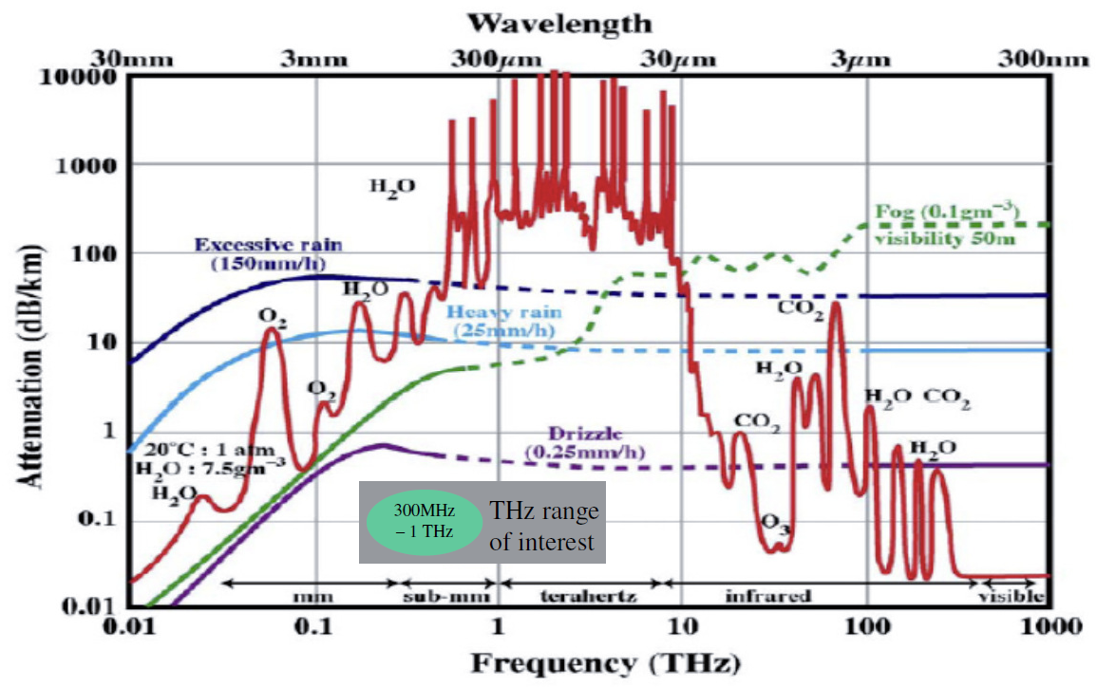

Attenuation due to Fog / Rain

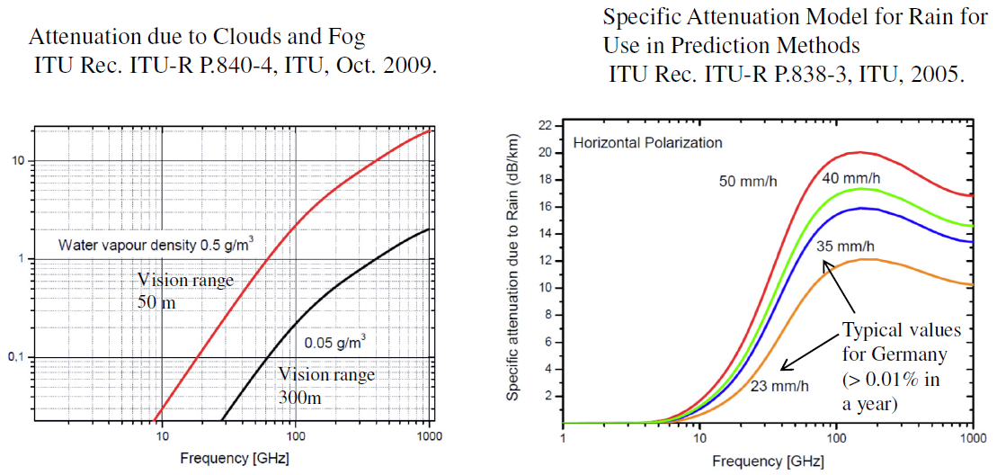

Attenuation in THz transmission windows

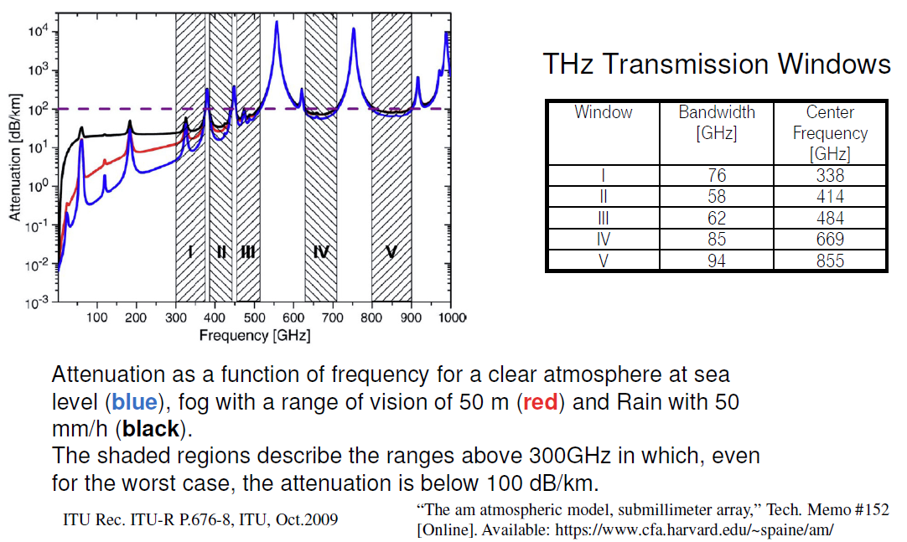

Indoor Fixed Wireless Frequencies

Nano Cell Frequencies

WLAN/WPAN Frequencies

Connecting devices on short range Frequencies

Kiosk Download Frequencies

Board-to-Board Communications Frequencies

Data Center/Server Farm Wireless Data Distribution Frequencies

Coexistence/protection existing services and other use cases

The THz bands are currently used for earth science research (mainly passive) and coexistence/protection of these users is necessary to enable the broad acceptance of the technology. This section discusses coexistence and protection issues [20], [21].

Also, each use case outlined in clause 4.0 must coexist with all other clause 4.0 use cases. In some instances this coexistence will be explicit (i.e. different operation bands), but in other instances the coexistence mechanism might be more implicit.

Potentially Critical Interference Scenarios

This is an ideal estimation of maximum occurring interference powers using worst case assumptions throughout all scenarios with no additional attenuation due to the impact of weather.

Nomadic devices operated outdoors in rural environment

The assumptions are that the nomadic TX is accidentally pointed in immediate skyward direction as a satellite is passing overhead, directly looking at the ground (0° zenith angle, shortest path). Also it is assumed that a ground reflection may superimpose constructively with the direct path towards the satellite

Nomadic devices operated outdoors in urban environment

In this scenario we assume that no objects shadow the direct ray path and that additionally the reflections from buildings around the TX coherently combine at the satellite.

Indoor-operated devices are not relevant due to transmission losses; therefore, indoor setups are implicitly covered by the outdoor scenario.

Fixed links with scattering objects close to direct ray path

In this scenario, objects close to the direct ray path may scatter/reflect power in a skyward direction towards the satellite. This scenario is possible despite highly directive antennas.

Relevant emission from antenna sidelobes

High sidelobe levels may cause non-negligible radiation in a skyward direction with fixed links become especially critical because of potentially high output powers.

Airborne operated transmitters

In this scenario, radiation through the fuselage or windows is possible, and the transmitted rays may not be attenuated due to the use of composite fuselages. At higher altitudes we can hardly expect any atmospheric absorption.

Satellite in limb scanning mode

THz waves may be radiated in the immediate direction of the limb scanner. Ground-based transmitters do not become relevant due to the long horizontal path.

Spectral Masks between Active Services and Earth Exploration Services (EESS)

Maximum equivalent isotropically radiated power (EIRP)

The clause shows how to calculate the maximum equivalent isotropically radiated power (EIRP), which is scenario path loss specific, and includes the satellite antenna gain. If the TX radiated signal does not exceed the maximum allowed interference power mask, then there will be no interference.

Definition of transmit power spectrum masks

This clause provides the definition of transmit power spectrum masks and constraints for the isotropically radiated power spectral density. A simple approximation with line segments (line parameter sets given in [1]) is used to calculate the effective limitation to several 10 dBm EIRP for bandwidths of several 10 GHz.

Nomadic devices in rural and urban areas

Fixed links and sidelobes

Fixed links are far less critical than nomadic transmitters and can support higher output powers and longer distances with no significant sidelobe limitations. These relevant constraints are only applicable below 500 GHz.

Airborne TX and limb scanning

Airborne transmitters are most critical with constraints in almost the entire THz range resulting in restrictions requiring lower power and shorter ranges.

Editors Note (July meeting): should we translate these graphics and associated calculations into numeric tables? These masks are difficult to work use in their present form (ref. 9.2.1).

Regulatory requirements

Devices will need to comply with the regulatory requirements specified for THz devices. Unique to THz is that these regulatory requirements will be evolving over the next few years. In this section these issues can be discussed. All regulatory assumptions should be clearly stated.

Active THz systems will have to comply with the ITU Radio Regulations footnote 5.565.

Transmission range

The transmission range is driven by use cases in conjunction with the operational frequency plan and channel model. This section discusses the transmission range, which often is the justification for different PHY types.

Outdoor Fixed Wireless Range

Indoor Fixed Wireless Range

Nano Cell Range

WLAN/WPAN Range

Connecting devices on short range Range

Kiosk Download Range

Board-to-Board Communications Range

Data Center/Server Farm Wireless Data Distribution Range

Antenna gain and required alignment accuracy

The antenna gain and required alignment accuracy is driven by use cases. This section discusses the antenna gain and required alignment accuracy, which may be part of the justification for different PHY types.

Outdoor Fixed Wireless Gain and Accuracy

Indoor Fixed Wireless Gain and Accuracy

Nano Cell Gain and Accuracy

WLAN/WPAN Gain and Accuracy

Connecting devices on short range Gain and Accuracy

Kiosk Download Gain and Accuracy

Board-to-Board Communications Gain and Accuracy

Data Center/Server Farm Wireless Data Distribution Gain and Accuracy

Channel models

Usually the channel model per sec is a stand-alone document. This clause contains relevant highlights from the channel model along with a link to the more comprehensive document. All models must be broadband inasmuch as the required operational bandwidth must be taken into consideration.

Outdoor Fixed Wireless

Co-channel interference

Fading mechanisms

Scintillation

Molecular attenuation

Doppler

Spatial/temporal properties

Angle of arrival/departure

Time of arrival

Delay spread

Coherence time/bandwidth

Indoor Fixed Wireless

Co-channel interference

Fading mechanisms

Scintillation

Molecular attenuation

Doppler

Spatial/temporal properties

Angle of arrival/departure

Time of arrival

Delay spread

Coherence time/bandwidth

Nano Cells

Co-channel interference

Fading mechanisms

Scintillation

Molecular attenuation

Doppler

Spatial/temporal properties

Angle of arrival/departure

Time of arrival

Delay spread

Coherence time/bandwidth

WLAN/WPAN Types of Applications

Co-channel interference

Fading mechanisms

Scintillation

Molecular attenuation

Doppler

Spatial/temporal properties

Angle of arrival/departure

Time of arrival

Delay spread

Coherence time/bandwidth

Connecting devices on short ranges

Co-channel interference

Fading mechanisms

Scintillation

Molecular attenuation

Doppler

Spatial/temporal properties

Angle of arrival/departure

Time of arrival

Delay spread

Coherence time/bandwidth

Kiosk Downloading

Co-channel interference

Fading mechanisms

Scintillation

Molecular attenuation

Doppler

Spatial/temporal properties

Angle of arrival/departure

Time of arrival

Delay spread

Coherence time/bandwidth

Board-to-Board Communications

Co-channel interference

Fading mechanisms

Scintillation

Molecular attenuation

Doppler

Spatial/temporal properties

Angle of arrival/departure

Time of arrival

Delay spread

Coherence time/bandwidth

Data Center/Server Farm Wireless Data Distribution Gain and Accuracy

Co-channel interference

Fading mechanisms

Scintillation

Molecular attenuation

Doppler

Spatial/temporal properties

Angle of arrival/departure

Time of arrival

Delay spread

Coherence time/bandwidth

Link budget and SNR analysis

It is likely that each use case will have a unique link budget analysis due to differences in required performance and complexity of modulation formats. Reference [22] contains useful information in regards to link budget calculations.

Example Link Budget

Outdoor Fixed Wireless Link Budget

Indoor Fixed Wireless Link Budget

Nano Cell Link Budget

WLAN/WPAN Link Budget

Connecting devices on short range Link Budget

Kiosk Download Link Budget

Simple AWGN Link Budget (Kiosk Downloading)
Bit Rate (Gbps) | 20
Avg TX Power (dBm) | 10
TX Antenna Gain (dBi) | 30
EIRP dBm (+40 dBm max) | 40
Center Freq (GHz) | 300
Aperature Loss @ 1 meter | 81.98419728
Standoff Distance (meters) | 1
Path Loss at Distance (dB) | 0
Obstacle Loss (dB) | 0
RX Antenna Gain (dBi) | 15
RX Ingested Power (dBm) | -26.98419728
Eb (energy / bit) | -129.9944972
RX Noise Figure (dB) | 15
No (noise power / Hz) | -159
Required Eb/No (dB) | 16
Implementation Loss (dB) | 10
At Distance Link Margin (dB) | 3.005502763
Zero Margin Distance (meters) | 1.413432712

Board-to-Board Communications Link Budget

Data Center/Server Farm Wireless Data Distribution Gain and Accuracy

Size, Weight and Power

Size, weight and power concerns arise from use case expectations and influences range and data rate. Of primary concern is mobile operation battery life. This section discusses these issues.

- March 2012 meeting note: Is the antenna included in the SWaP estimates?

Outdoor Fixed Wireless SWaP

Indoor Fixed Wireless SWaP

Nano Cell SWaP

WLAN/WPAN SWaP

Connecting devices on short range SWaP

Kiosk Download SWaP

Board-to-Board Communications SWaP

Data Center/Server Farm Wireless Data Distribution SWaP

Mobility and Link switching

There may be a need to support link switching due to physical movement or interference. This section discusses these issues. Obviously this is use case dependent since for some use cases link switching may not be appropriate.

Outdoor Fixed Wireless Link Switching

Indoor Fixed Wireless Link Switching

Nano Cell Link Switching

WLAN/WPAN Link Switching

Connecting devices on short range Link Switching

Kiosk Download Link Switching

Board-to-Board Communications Link Switching

Data Center/Server Farm Wireless Data Distribution Link Switching

Beam steered or control channel assisted device discovery

There may be a need to support device discovery, which includes aligning the antenna to close the link. This section discusses these issues. These parameters may be use case dependent.

Outdoor Fixed Wireless Device Discovery

Indoor Fixed Wireless Device Discovery

Nano Cell Device Discovery

WLAN/WPAN Device Discovery

Connecting devices on short range Device Discovery

Kiosk Download Device Discovery

Board-to-Board Communications Device Discovery

Data Center/Server Farm Wireless Data Distribution Device Discovery

Media access mechanism and superframe expectations

Multiband operation
- Antenna alignment
- Fast session transfer, for example from 60 GHz to THz

Security mechanisms

I/O Interfaces and Memory Buffer Considerations

References

[1] S. Priebe, C. Jastrow, M. Jacob, T. Kleine-Ostmann, T. Schrader, T. Kürner: Channel and Propagation Measurements at 300 GHz, IEEE Transactions on Antennas and Propagation, vol. 59, no. 5, pp. 1688–1698, 2011.

[2] C. Jansen, S. Priebe, C. Möller, M. Jacob, H. Dierke, M. Koch, T. Kürner: Diffuse Scattering from Rough Surfaces in THz Communication Channels, IEEE Transactions on Terahertz Science and Technology, vol.1, no. 2, pp.1688–1698, 2011.

[3] M. Jacob, S. Priebe, R. Dickhoff, T. Kleine-Ostmann, T. Schrader, T. Kürner: Diffraction in mm and Sub-mm Wave Indoor Propagation Channels, IEEE Transactions on Microwave Theory and Techniques, vol. 60, no. 3, pp. 833–844, 2011.

[4] S. Priebe, M. Jacob, C. Jastrow, T. Kleine-Ostmann, T. Schrader, T. Kürner: A Comparison of Indoor Channel Measurements and Ray Tracing Simulations at 300 GHz, Proc. 35th International Conference on Infrared, Millimeter and THz Waves (IRMMW-THz), 2 pages (electronic), Rome, September 2010.

[5] S. Priebe, M. Jacob, T. Kürner: Angular and RMS Delay Spread Modeling in View off THz Indoor Communication Systems, Accepted for publication in Proc. 12th URSI Commission F Triennial Open Symposium on Radio Wave Propagation and Remote Sensing, 8 pages, Garmisch Partenkirchen, March 2011.

[6] S. Priebe, M. Jacob, C. Jansen, T. Kürner: Non-Specular Scattering Modeling for THz Propagation Simulations, Proc. 5th European Conference on Antennas and Propagation (EuCAP), 5 pages (electronic), Rome, April 2011.

[7] S. Priebe, M. Jacob, T. Kürner: Polarization Investigation of Rough Surface Scattering for THz Propagation Modeling, Proc. 5th European Conference on Antennas and Propagation (EuCAP), 5 pages (electronic), Rome, April 2011.

[8] S. Priebe, M. Jacob, T. Kürner: AoA, AoD and ToA Characteristics of Scattered Multipath Clusters for THz Indoor Channel Modeling, Proc. 17th European Wireless Conference (EW), 9 pages (electronic), Vienna, April 2011.

[9] S. Priebe, M. Jacob, T. Kürner: The Impact of Antenna Directivities on THz Indoor Channel Characteristics, Accepted for publication in Proc. European Conference on Antennas and Propagation (EuCAP), Prague, 5 pages (electronic), March 2012.

[10] S. Priebe, M. Jacob, T. Kürner: Affection of THz Indoor Communication Links by Antenna Misalignment, Accepted for publication in Proc. European Conference on Antennas and Propagation (EuCAP), Prague, 5 pages (electronic), March 2012.

[11] T. Kürner, S. Priebe, M. Jacob, C. Jastrow, T. Kleine-Ostmann, T. Schrader: Measuring the Channel Characteristics at 300 GHz - Preliminary Results, IEEE 802.15-09-0496-01-0thz, San Francisco, July 2009.

[12] T. Kürner, S. Priebe, M. Jacob, C. Jastrow, T. Kleine-Ostmann, T. Schrader: Measurements of the Channel Characteristics at 300 GHz, IEEE 802.15-09-0756-00-0thz, Atlanta, November 2009.

[13] S. Priebe, M. Jacob, C. Jastrow, T. Kleine-Ostmann, T. Schrader, T. Kürner: Towards a 300 GHz Channel Model, IEEE 802.15-10-0436-01-0thz, San Diego, July 2010.

[14] S. Priebe, M. Jacob, C. Jastrow, T. Kleine-Ostmann, T. Schrader, T. Kürner: Digital Data Transmission at 300 GHz, IEEE 802.15-10-0437-01-0thz, San Diego, July 2010.

[15] S. Priebe, M. Jacob, T. Kürner: Diffuse Rough Surface Scattering Analysis for THz Communication Systems, IEEE 802.15-11-0146-01-0thz, Singapore, March 2011.

[16] S. Priebe, M. Jacob, T. Kürner: Spatial and Temporal Dispersion in THz Propagation Channels, IEEE 802.15-11-0180-01-0thz, Singapore, March 2011.

[17] S. Priebe, M. Jacob, T. Kürner: Stochastic Modeling of Scattered Multipath Clusters in THz Indoor Communication Channels, IEEE 802.15-11-0474-01-0thz, San Francisco, July 2011.

[18] S. Priebe, M. Jacob, T. Kürner: Will THz Communication Interfere with Passive Remote Sensing?, IEEE 802.15-12-0101-00-0thz, Hawaii, March 2011.

[19] S. Priebe, M. Jacob, T. Kürner: Performance of Antennas in THz Indoor Communication Channels, IEEE 802.15-12-0102-01-0thz, Hawaii, March 2011.

[20] S. Priebe, D. M. Britz, M. Jacob, S. Sarkozy, K. M. K. H. Leong, J. E. Logan, B. S. Gorospe, T. Kürner: Interference Investigations of Active Communications and Passive Earth Exploration Services in the THz Frequency Range“, accepted for publication in IEEE Transactions on THz Science and Technology, 14 pages, 2012

[21] S. Priebe: Interference between THz Communications and Spaceborne Earth Exploration Services, IEEE 802.15-12-0324-00-0thz, San Diego, July 2012

[22] M. Grigat, T. Schneider, S. Preußler, R. P. Braun: Link Budget Considerations for THz Fixed Wireless Links, IEEE IEEE 802.15-12-0582-01-0thz, San Antonio, November 2012

