IEEE P802.15
Wireless Personal Area Networks

Project | IEEE P802.15 Working Group for Wireless Personal Area Networks (WPANs)
Title | THz IG Technical Expectations Document (TED)
Date Submitted | [Nov, 2011]
Source | Rick Roberts | E-mail: richard.d.roberts@intel.com
Re:
Abstract | [THz Technical Expectations]
Purpose
Notice | This document has been prepared to assist the IEEE P802.15. It is offered as a basis for discussion and is not binding on the contributing individual(s) or organization(s). The material in this document is subject to change in form and content after further study. The contributor(s) reserve(s) the right to add, amend or withdraw material contained herein.
Release | The contributor acknowledges and accepts that this contribution becomes the property of IEEE and may be made publicly available by P802.15.

List of contributors

Table of Contents

1. Definitions: 4
2. General Guidelines 5
3. Protocol Reference Model 6
4. Use case summary 7
5. TED Summary 8
6. Channel models 9
7. Topology 10
8. Data Rates 11
9. Transmission range 12
10. Operational frequency bands 13
11. Power Consumption 14
12. Coexistence with, and protection of, existing services 15
13. Form Factor 16
14. Mobility and Link switching 17
15. Regulatory requirements 18
16. References 19

Definitions:

General Guidelines

This technical expectations document (TED) describes the technical expectations for a THz standard, such as performance-related issues, reliability issues and availability issues. These types of issues are often called quality of service (QoS). Technical expectations are documented in the same manner as any specifications, including a description, an example, a source or references to related technical documents.

Difference between Expectations and Requirements (TED vs. TRD)

The THz IG group decided to use the term “expectations” instead of “requirements” in order to adopt a less rigid, informal process with the intention to be able to quickly develop actual requirements when the transition to a task group occurs. This document serves to provide guidance for development of IEEE802 THz technical contributions.

Protocol Reference Model

The communication protocol reference model used for this document is shown in Figure 1.

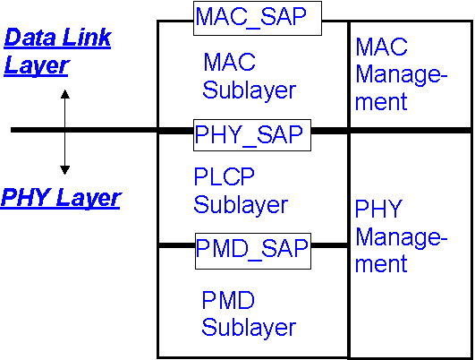
PHY_SAP: PHY Service Access Point
PLCP: PHY Layer Convergence Protocol
MAC_SAP: MAC Service Access Point
PMD: Physical Medium Dependent (radio)
Figure 1: Reference partitioning

Use case summary

This clause summarizes the operational use cases which will heavily influence all sequential work in this committee and the text in this document. Reference should be included to the pivotal use case documents.

TED Summary

This clause contains an overall summary of the rest of the document, mentioning the highlights such as PHY types (assuming multiple options), data rates, topology options (e.g. star, point-to-point, etc.) and MAC frame formats.

Channel models

Usually the channel model per sec is a stand-alone document. This clause contains relevant highlights from the channel model along with a link to the more comprehensive document.

Topology

This clause identifies operational topologies such as point-to-point, star, uni-cast, multi-cast, etc. These operational topologies are use case driven and reference should be included to the pivotal use case documents.

Data Rates

The data rates should be sufficient to support the proposed use cases in conjunction with the operational frequency plan and channel model. This section discusses the data rates, which usually is the bases for different PHY type classes.

Transmission range

The transmission range is driven by use cases in conjunction with the operational frequency plan and channel model. This section discusses the transmission range, which often is the justification for different PHY types.

Operational frequency bands

The THz frequency range is quite large, with some frequencies exhibiting better propagation qualities than others. Also influencing this issue are practical limits on implementation physics. In this section the operational frequency bands are discussed.

Power Consumption

Power consumption concerns arise from use case expectations and influences range and data rate. Of primary concern is mobile operation battery life. This section discusses these issues.

Coexistence with, and protection of, existing services

The THz bands are currently used for earth science research (mainly passive) and coexistence/protection of these users is necessary to enable the broad acceptance of the technology. This section discusses coexistence and protection issues.

Form Factor

Form factor is an important consideration, especially for mobile devices, and is driven by use case considerations. This section discusses form factor issues, which can include physical issues such as antenna placement.

Mobility and Link switching

There may be a need to support link switching due to physical movement or interference. This section discusses these issues.

Regulatory requirements

Devices will need to comply with the regulatory requirements specified for THz devices. Unique to THz is that these regulatory requirements will be evolving over the next few years. In this section these issues can be discussed. All regulatory assumptions should be clearly stated.

References

