IEEE P802.15
Wireless Personal Area Networks

Project | TG6 Body Area Networks
Title | Response to Action for HBC(EFC) Conference Call
Date Submitted | 3 May 2011
Source | [Seung-Hoon Park][Samsung Electronics]  [Jung-hwan Hwang][ETRI] | Voice: [+82-31-279-4579]  Fax: [+82-31-279-2441]  E-mail: [shannon.park@samsung.com]  [jhhwang@etri.re.kr]
Re: | AdvaMed/IEEE 802.15 TG6 Conference Call Report uploaded on 12 April 2011
Abstract | Minutes of AdvaMed and IEEE 802.15 TG6 HBC Conference Call including response from Samsung & ETRI.
Purpose | Minutes of TG6 session including response from Samsung & ETRI
Notice | This document has been prepared to assist the IEEE P802.15. It is offered as a basis for discussion and is not binding on the contributing individual(s) or organization(s). The material in this document is subject to change in form and content after further study. The contributor(s) reserve(s) the right to add, amend or withdraw material contained herein.
Release | The contributor acknowledges and accepts that this contribution becomes the property of IEEE and may be made publicly available by P802.15.

Conference Call Report 2011 March 8
AdvaMed/IEEE 802.15 TG6
Human Body Communications

Participants

Art Astrin IEEE
Tushar Dharampal St. Jude Medical
Dennis Digby Biotronik
Barbara Gibb Neuropace
Charles Farlow Medtronic
Jim Henke Medtronic
Jim Kippola Boston Scientific
Bernie Liebler AdvaMed (report author)
Ashok Nedungadi Biotronik
Joel Peltier Medtronic
Seung-Hoon Park Samsung
Sung-Min Park Medtronic
Ron Reitan Boston Scientific
Paul Stadnik Biotronik
Brian Sutton Biotronik

The call covered Samsung’s responses to a set of questions (attached) that industry had provided after the first conference call on March 1. The following discussion tracks the call responses and additional questions.

1. We have been provided the PSD and center frequencies for the proposed application. However, we would like to know if the plots provided were results of a simulation or whether measurements were made on an actual system implementation.

Samsung Pre-Conference Call Response: Both of simulation and measurement were made. You can see the simulation and measurement on TX spectrum on the page 17 of the document # 318.

Discussion and Actions: Charles Farlow (Medtronic) said document 318 is out of date for two reasons; 1) Measurement results did not include a system with the transmitter filter and 2) HBC center frequencies were changed in the latest draft standard. Samsung replied there is no measured data available for the system with the transmitter filter or planned center frequencies.

2. Samsung's presentation on radio standards (IEEE 802.15-10-0318-00-0006) covers transmitter-radiated emissions. Since HBC involves conducted currents on the human body, how does their presentation relate to conducted signal levels appearing on or inside the body that might cause disturbances to implants?

Samsung Pre-Conference Call Response: You are right. The document #318 is covering regulatory issues on frequency spectrum that can be applied to HBC. Regarding safety issues of HBC, you can refer to the document # IEEE 802.15-10-0055-00-0006. In the document, we showed that HBC satisfied a safety regulation for the human body. Also, we showed measurement results on coexistence of HBC with medical devices. Regarding disturbances to implant devices, Medtronic recommended that HBC should satisfy ANSI/AAMI PC 69 Annex M. We will respond to this recommendation through a comment resolution.

Discussion and Actions: The industry requested that document #55 and the comment resolution be distributed at least several days in advance of the next conference call. Charles Farlow (Medtronic) accepted an action to forward document #55 to industry participants in the conference call. Representatives from St. Jude Medical and Biotronik asked if any testing had been performed as specified in AAMI/ANSI PC69. Samsung replied they have not measured the system according to PC69.
Action: Charles Farlow (Medtronic) to forward document #55 to industry representatives.
Action: Samsung will try to show compliance [to PC69] with previous measurement data.
⇒ Refer to the reference for action item #2 which includes comparison results of EMFs exposure by HBC with ANSI/AAMI PC69 standard.
Action: Samsung to distribute comment resolution at least three days prior to the next conference call.

3. Can you provide the proposed path length (application/simulated) be provided along with the dimensions of the electrodes (ref: Page 4 of doc # IEEE 802. 15-09-0689-00-0006)?

Samsung Pre-Conference Call Response: The path length depends on application, but it is usually about 150 cm that is approximate length between the two hands along the body. Also, the dimension of the electrode is usually under 1 cm².

Discussion and Actions: Was this value (150 cm) used in simulations? Samsung replied “Yes, in calculation of link budget.” Several members of industry inquired about the HBC channel model (#780-2008). Action: Charles Farlow (Medtronic) to forward document #780 to industry representatives.

4. Looking at slide 4 of IEEE 802.15-09-0689-00-0006, HBC uses electric field propagating through human body. This means that there will be propagating EM field in the tissues. This field will couple to implantable medical devices like pacemakers and coupled energy can interact with the device causing such issues as false sensing, etc. This is why the radiating power can be crucial. So, the question will be what is the field intensity in the area of implantation that can potentially interfere with devices?

Samsung Pre-Conference Call Response: Other wireless technologies as well as HBC can interfere with implant devices because a radiated field from a wireless antenna is absorbed inside the human body and the absorbed field can interfere with the implant devices. Therefore, there is no reason to strictly apply the interference issue only to HBC. The device industry should treat this issue equally with other wireless technologies by making the corresponding technology satisfy existing regulations about interference.

Discussion and Actions: Samsung does not have any measurement or simulation data in the area of implantation. Sung-Min Park (Medtronic) brought up the difference between radiation and conduction. Samsung tried to defend HBC as being the same as any other wireless technology. Ron Reitan (Boston Scientific) said large amplitude RF signal would be demodulated by a medical device due to nonlinearities. Ron Reitan asked if the standard could produce random bursts of data at rates similar to similar to heartbeat rates. In vitro testing of implantable devices is required. He suggested performing in vitro tests with a variety of implantable devices, perhaps testing with an HBC transmitter programmed for a higher level (than specified in the standard) – to validate a 20 dB or 30 dB margin of safety. Sung-Min Park suggested Samsung consider simulation with the Hugo human body model. Samsung replied they do not have a human body model. Sung-Min replied the US FDA provides a free version of the model for FEM or FDTD simulation. One member of industry said implantable devices can resolve microvolt-level signal levels.
Action: Samsung will consider both proposals (simulation and in vitro testing).
⇒ Both of simulation and in vitro testing will take much time, but the reference for action item #4 can be referred until having results from simulation and in vitro testing.

Follow-up Questions from Biotronik: Regarding the human body model mentioned in item 4, Doc 55 p.5 appears to have a human body model. Samsung reports they simulated EF/EM density values, presumably throughout the body. This was generated from Remcom xFDTD. Is Samsung willing to share these data? Does the graphic on p.5 represent spatial temperature (SAR) variation through the body, or rather field distribution through the body? It does not show much variation, perhaps because it is simply a low-resolution output. Does this indicate most signal is transmitted along the body's surface rather than capacitively coupled through the body? A detailed analysis of the simulation output could answer this question.
⇒ Remcom xFDTD data cannot be shared. The graphic on p.5 in Doc 55 is the field distribution. The simulation is performed as that the signal is transmitted from Tx electrode at one side of body to Rx electrode at opposite side of body through body surface by capacity coupling.

5. We do not understand the methodology for the measurement of transmitter power. Is this measured with a human subject? If it is, then variability of transmitted power will be large. What is the measurement configuration for parameters (e.g., Average Tx Power) listed on page 15, IEEE 802.15-09-0689-00-0006.

Samsung Pre-Conference Call Response:
- The radiated power is measured by only electrode without body at 3 meters anechoic chamber.
- Average transmit power of link budget table at 15 page is conduction power according to high impedance load.

Discussion and Actions: How much power is delivered to the body? Samsung has no information on changes of impedance within the human population. Joel Peltier (Medtronic) stated concerns about near-field magnetic coupling also sense amps are peak sensing devices. Samsung replied that for magnetic field intensity, document #55 (see question #2) provides information about this parameter (magnetic-field intensity in near field).
Action: Charles Farlow (Medtronic) accepted an action to distribute document #689 to the industry for further review.

6. The phrase "The transmit power to the human body ..." preceding the numerical value (-39 dBm) in draft standard D02 (paragraph 11.8.2) is ambiguous. This value (including measurement methodology) must be fully explained and understood, so members of the medical device industry can make the conversions required to evaluate compliance to ANSI/AAMI PC69 Annex M (Correlation between levels of test voltages used in the standard and radiated field strengths).

Samsung Pre-Conference Call Response: The phrase means that an electric field whose total power is -39 dBm is coupled with the human body. PC69 Annex M regulates EM field strength by intentional or inadvertent emitters that is permitted to implantable pacemakers and ICDs, so the value to be considered is intensity of a magnetic field.

Discussion and Actions: Samsung asked the group to review document #55. Charles Farlow (Medtronic) asked for clarification about the -39 dBm figure in the draft standard. Samsung could not provide the requested clarification since the appropriate engineer was not participating in the conference call.
Action: Samsung to clarify HBC transmit power limits at least three days before the next conference call.
⇒ Refer to the reference for action item #6 which includes calculation of transmitting power.

7. The low frequency spectral mask (i.e., below the intended band of operation for HBC) is not defined in draft standard D02 (figures 162 and 163). The graphical representation should be accompanied by specific values of attenuation or attenuation slope.

Samsung Pre-Conference Call Response: Related information will be provided through a comment resolution.

Discussion and Actions:
Action: Samsung to provide this information to industry at least three days before the next conference call.
⇒ The figures are updated into BAN D03 document according to comment resolution spread sheet as follows. However, I think that the attenuation value for lower band can be reduced more than current one.

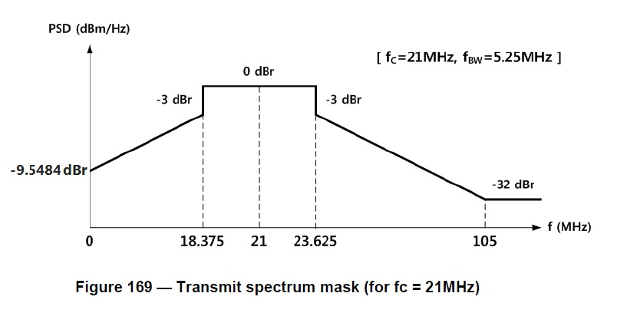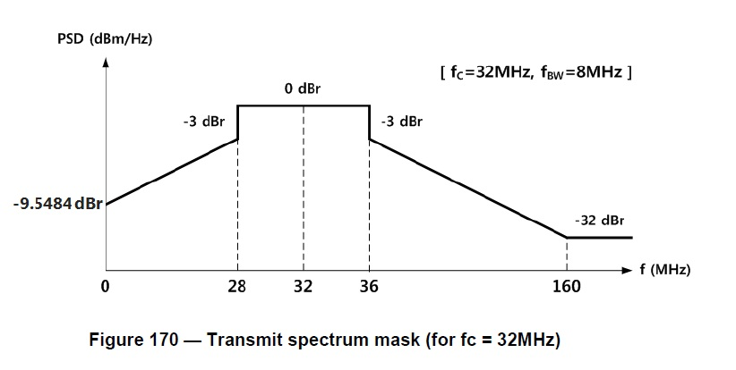

8. Is the model in PC-69 Annex M (Radiated emissions translated into in-body potentials valid for the conducted emissions of HBC? Does Samsung believe their devices using HBC will ensure that pacemakers and ICDs will not observe sensing signals within zone 1 and remain within zone 2 limits (defined in Figure M.3)?

Samsung Pre-Conference Call Response: Refer to the answer for the Question #2

Discussion and Actions: The group will revisit during the next conference call.
Action: Industry to review document #55.

9. Can you provide a worst-case (max transmit power and coupling) power spectrum (including frequencies down to 1 Hz.). What is the peak transmit power allowed by the standard?

Samsung Pre-Conference Call Response:
- According to international SAR regulations, the limits of Tx power are 1.6 mW in US (ANSI C95.1) and 20 mW in EU (ICNIRP Guidelines 1998).
- from 15-10-0318-… document, -55dBm at about 1Hz (50 Ohm) or -69 dBm (50 kOhm)

Radiated power is calculated by adding antenna gain (-27dBi), so power is -96dBm. This value equals to 2.51E-10 mW.

Discussion and Actions: The group will revisit during the next conference call.
Action: Samsung to provide spectrum plot from 1 Hz to 50 kHz with new center frequency, modulation scheme, and transmit filter. Also, clarification of peak transmit power (preliminary answer is -39 dBm.)
⇒ For the clarification of transmit power, refer to the reference for action item #6 which includes calculation of transmitting power.
⇒ Only under 10MHz spectrum plots for 16MHz (from original proposal) are obtained due to simulation limitation. And this is floating-point simulation as I understand. I guess that the level of emission for 21MHz & 32MHz will be lower than the case of 16MHz.
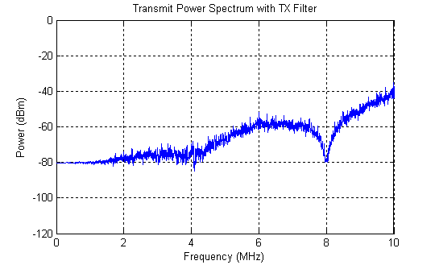

10. Have you considered low frequency amplitude modulation due to intermittent electrode-skin contact that could be within the sensing passband (1 – 1000 Hz)?

Samsung Pre-Conference Call Response:
- We have not considered the low frequency amplitude modulation.

Discussion and Actions: Samsung has not considered low-frequency amplitude modulation. The concern is similar to amplitude modulation: intermittent quality of electrode/skin interface. Ron Reitan agreed; perhaps even greater modulation depth than constant skin contact.

Follow-up Clarification from Biotronik: Biotronik's Question 10 simply identified another mechanism (intermittent electrode contact) that could generate low frequency amplitude modulation components that could be demodulated by medical device sensors. Samsung replied that they had not considered this mechanism.

11. What is the maximum field strength (V/m) within the body during HBC communication? Have you done simulation or testing to determine this value?

Samsung Pre-Conference Call Response:
- Refer to page 10 of IEEE doc # IEEE 802. 15-10-0055-00-0006

Discussion and Actions: The group will revisit during the next conference call. Action: Industry to review document #55.

The group concluded the call by agreeing to reconvene by conference call on April 5 (April 6, Korea).
[Other Q&A]
- Please provide a representative worst case signal (or group of signals) into the body.
We need definition of worst case signal, but you can refer to p. 18 of DOC#318 for a spectrum pattern of a transmitting signal.
- What low frequency components in the signal are expected (including demodulation by implantable devices and/or step signals)?
⇒ Low frequency components may be induced from the pattern of data source. However, scrambler can mitigate the pattern effect. And there may be just a little effect to low frequency (under 1 kHz) caused by lower frequency component relative to source pattern, even though there is without scrambler.
- What is the output stage of the Transmit filter? Is it a direct digital output? What is the power supply of the output stage?
⇒ A digital signal is inputted into the transmitter filter and transformed into an analog signal. The power supply of the output stage is 3 V.
- Was the electrode-body interface modeled or implemented as an impedance network? If so, please provide the details of the same.
⇒ The electrode-body interface was not separately modeled but the HBC channel model includes effects of the electrode-body interface.
- What are the maximum currents seen from arm to arm (ref: Page 4 of doc # IEEE 802. 15-09-0689-00-0006)?
⇒ The current from arm to arm was not measured because its level is too low. Instead, we measured field intensity (Page 6, DOC#55).

