IEEE P802.15
Wireless Personal Area Networks
Project | IEEE P802.15 Working Group for Wireless Personal Area Networks (WPANs)
Title | IEEE P802
Date Submitted | [17 March, 2011]
Source | [Sang-Kyu Lim, Il Soon Jang, Dae Ho Kim, You Jin Kim, Tae-Gyu Kang]  [ETRI, 218 Gajeongno, Yuseong-Gu, Daejeon, Korea] | Voice: [ +82-42-860-1573]  Fax: [+82-42-860-5218]  E-mail: [sklim@etri.re.kr]
Re: | [Response to the SB 1st recirculation for the IEEE 802.15.7 standard]
Abstract | [This document describes the modified text in Annex F for the comment resolution of the SB 1st recirculation.]
Purpose | [Description of what the authors wants P802.15 to do with the contents in the document.]
Notice | This document has been prepared to assist the IEEE P802.15. It is offered as a basis for discussion and is not binding on the contributing individual(s) or organization(s). The material in this document is subject to change in form and content after further study. The contributor(s) reserve(s) the right to add, amend or withdraw material contained herein.
Release | The contributor acknowledges and accepts that this contribution becomes the property of IEEE and may be made publicly available by P802.15.

Blue: text deleted from D6
Red: modified or inserted text
+++++++++++++++++++++++++++++++++++++++++++++++++++++++++++
8.5.2.3 VPPM-mode dimming
The VPPM-mode dimming is described in 4.4.3.1.5. The VPPM PHY shall have basic dimming level support at 10% duty cycle resolution. To support higher resolution for dimming from 0 to 100% in steps of 0.1%, the VPPM PHY shall use the algorithm as provided in Figure 113 Figure xxx. For example, for supporting 25% dimming, the PHY shall alternately send 20% and 30% duty cycle VPPM symbols groups. It is recommended that the receiver change the matched filtering in step with the change in the transmitter symbol shape to enable optimum detection.
By default, a 50% duty cycle shall be used for VPPM. If dimming is supported using VPPM modulation in PHY I or PHY II, a dimming notification command shall be sent by the MAC to the receiver. Both the TX and RX shall use the algorithm in Figure 113 Figure xxx for VPPM dimming. The transmitter shall honor all dimming requests from the upper layer. It is recommended that the transmitter use the receiver’s capabilities information as provided in 5.3.19.1.1 for VPPM dimming support. This information is obtained during the device discovery process provided in 5.1.2.4.

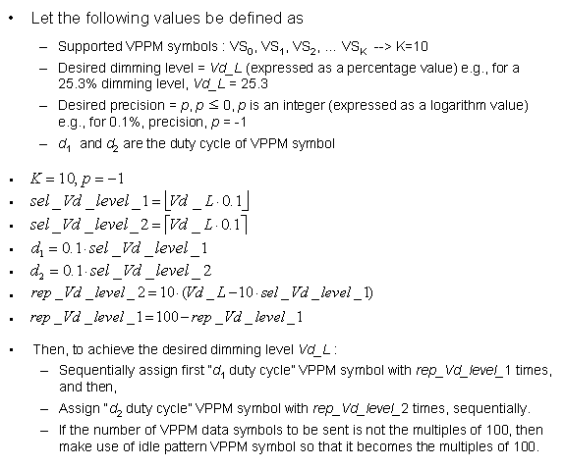
Figure xxx— Algorithm for high resolution dimming level in VPPM-mode

10.6 Data mapping for VPPM
The data mapping for VPPM shall be defined as in Table103. The physical value mapped from the logical data '0' has a transition from 'high' to 'low', and the physical value mapped from the logical data '1' has a transition from 'low' to 'high', as shown in Table103. 'Low' and 'high' values are defined in 8.3.2. The variable d in Table103 is the VPPM duty cycle, and it is assigned by the VPPM-mode dimming mechanism described in 8.5.2.3.
