IEEE P802.15
Wireless Personal Area Networks

Project | IEEE P802.15 Working Group for Wireless Personal Area Networks (WPANs)
Title | LB63 MSK Comment Resolution
Date Submitted | [January 19, 2011]
Source | [Dalibor Pokrajac,  GuardRFID] | Voice: [604-282-7584]  Fax: [604-998-4018]  E-mail: [dalibor.pokrajac@guardrfid.com]
Re: | []
Abstract | [This document contains proposed changes to the IEEE P802.15.4f Draft d1 to address comment resolution of various CIDs relevant to 433 MHz PHY and 2450 MHz PHY]
Purpose | []
Notice | This document has been prepared to assist the IEEE P802.15. It is offered as a basis for discussion and is not binding on the contributing individual(s) or organization(s). The material in this document is subject to change in form and content after further study. The contributor(s) reserve(s) the right to add, amend or withdraw material contained herein.
Release | The contributor acknowledges and accepts that this contribution becomes the property of IEEE and may be made publicly available by P802.15.
Overview
The following text addresses some of the comments from Letter Ballot LB63 (first letter ballot for 802.15.4f Draft Standard). All comments addressed in this document are related to 4 main categories of comments on MSK PHYs (433 MHz and 2450 MHz):
- Forward Error Correction (including Interleaving)
- Definition of Transmitter / Receiver
- Definition of Preamble and associated SFD
- Definition of Data Whitening

Forward Error Correction
CID: 8, 10, 63, 98, 105, 106, 121, 134, 221, 264, 267, 270, 272, 273, 301, 303

Draft D1 of 802.15.4f Draft standard specifies Forward Error Correction to be used optionally for 433 MHz PHY and 2450 MHz PHY. For this purpose, ½ rate convolutional coding is specified, the same coding as it is currently proposed to be used for FSK PHY in 802.15.4g.
After careful review of proposed coding and comments, the proposal is to remove Forward Error Correction from 802.15.4f Draft standard altogether. The reasoning for this proposal is as follows:
- 802.15.4f PHYs (including MSK PHYs) are intended to be used for active RFID and RTLS applications which are extremely sensitive to power consumption and battery size. These devices usually operate in environment with many nodes (hundreds, thousands and tens of thousands) occupying the same channel and same physical space (e.g. a warehouse).
- Frame size is critical to be as short as possible to minimize power consumption and channel occupancy time.
- RFID /RTLS Tags are usually very small devices with low efficiency antenna with uneven transmit pattern. A change in Tag orientation or change in a surface to which Tag is attached can easily produce 10-30dB change in link budget.
- Under these circumstances, gain of 3-6 dB that potentially could be achieved with FEC, Interleaving and Whitening is not good trade-off, given that is increases frame length substantially, therefore degrading power consumption and channel occupancy time.
Resolution:
Based on above the following is proposed:
- Remove section 6.8b.2.4. Forward Error Correction
- Remove section 6.8b.2.5. Code-symbol Interleaving
- On Page 14, remove lines 17 – 23 which specify usage of FEC
- In Table 20b remove reference to coded SFD.

Definition of Transmitter and Receiver for 433 MHz PHY and 2450 MHz PHY
CID: 11, 65, 150, 151, 222, 271,
Resolution:
- Add the following text after “6.8b.2.3 MSK Modulation”:

6.8b.2.4. Operating frequency range

The 433 MHz PHY operates in the 433.05 – 434.79 MHz frequency band.

The 2450 MHz PHY operates in 2400 – 2483 MHz frequency band.

6.8b.2.5 Transmit PSD mask

The PSD mask for the 433 MHz PHY is specified as:
The transmitted spectral products shall be less than the limits specified in Table 39ad. For both relative and absolute limits, average spectral power shall be measured using a 100 kHz resolution bandwidth. For the relative limit, the reference level shall be the highest average spectral power measured within +/- 600 kHz or +/- 100 kHz of the carrier frequency (respective to datarate).

Table 39ad 433 MHz band MSK transmit PSD limit
PHY | Data Rate | Frequency | Relative Limit | Absolute Limit
433 MHz | 250 ksymbols/s | |f – fc| > 1.2 MHz | -20 dB | -20 dB
433 MHz | 31.25 ksymbols/s | |f – fc| > 200 kHz | -20 dB | -20 dB

The PSD mask for the 2450 MHz PHY is specified as:
The transmitted spectral products shall be less than the limits specified in Table 39ae. For both relative and absolute limits, average spectral power shall be measured using a 100 kHz resolution bandwidth. For the relative limit, the reference level shall be the highest average spectral power measured within +/- 600 kHz of the carrier frequency.

Table 39ae 2450 MHz band MSK transmit PSD limit
PHY | Data Rate | Frequency | Relative Limit | Absolute Limit
2450 MHz | 250 ksymbols/s | |f – fc| > 1.2 MHz | -20 dB | -20 dB

6.8b.2.6 Symbol rate
The 433 MHz PHY symbol rate shall be either 250 ksymbol/s or 31.25 ksymbol/s with an accuracy of ±40 ppm.
2450 MHz PHY symbol rate shall be 250 ksymbol/s with an accuracy of ±40 ppm.

6.8b.2.7. Transmit center frequency tolerance

The 433 MHz PHY shall have a transmit center frequency tolerance as defined in 8.2.4. of IEEE 802.15.4i RevD3 (-40 ppm).

The 2450 MHz shall have a transmit center frequency tolerance as defined in 8.2.4. of IEEE 802.15.4i RevD3 (-40 ppm).

6.8b.2.8. Transmit power

The 433 MHz PHY shall have a minimum transmit power as described in 8.2.5. of IEEE 802.15.4i RevD3 (minimum of -3 dBm and maximum as per local regulations).

The 2450 MHz PHY shall have a minimum transmit power as described in 8.2.5. of IEEE 802.15.4i RevD3 (minimum of -3 dBm and maximum as per local regulations).

6.8b.2.9 Receiver maximum input level of desired signal

The 433 MHz PHY shall have a receiver maximum input level as described in 8.2.6. of IEEE 802.15.4i RevD3 (greater than or equal to -20 dBm).

The 2450 MHz PHY shall have a receiver maximum input level as described in 8.2.6. of IEEE 802.15.4i RevD3 (greater than or equal to -20 dBm).

6.8b.2.10 Modulation Frequency Deviation Tolerance
Modulation frequency tolerance is measured as a percentage of maximum frequency deviation ∆f.
Modulation frequency deviation shall be constrained within +/- 30% of maximum frequency deviation ∆f as defined in 6.8b.2.2.

6.8b.2.11 Zero Crossing Tolerance
All zero crossing shall be constrained within +/- 12.5% of symbol time (+/- 1/8th of the symbol).

Data Scrambling (Whitening)
CID: 7, 64, 263
Insert the following section:

6.8b.2.12 Data Whitening

Data whitening shall be the exclusive or of the PPDU data (without SHR) with the PN9 sequence. This shall be performed by the transmitter and is given by:
where:
En is the whitened bit
Rn is the data bit being whitened
PN9n is the PN9 sequence bit

Index n starts after the SFD from 0 and is increased by one every symbol. For each packet transmitted, R0 is the PHR first raw data bit after the SFD. Conversely, the decoding process, as performed at the receiver, can be described by:
where:
REn is the PSDU bit at the output of the MSK demodulator
Rn is the PSDU bit after de-whitening
For each packet received, R0 is the PHR first raw data bit.
The PN generator is defined by the schematic in Figure 27r
Figure 27r Schematic of PN Generator
The seed in the PN9 shall be all ones: "111111111." The PN9 shall be reinitialized to the seed after each packet (either transmit or receive).

The preamble and the SFD are not whitened. The PN9 generator is clocked starting from the seed. For example, the first 30 bits out of the PN9, once it is enabled, would be as follows:

PN9n = 00, 01, 02, 03, 14, 15, 16, 17, 08, 19, 110, 111, 012, 013, 014, 015, 116, 017, 118, 119, 020, 021, 122, 123, 024, 125, 126, 027, 128, 129

Preamble and SFD
CID: 117
Preamble proposed in 802.15.4f D1 is “101010…..1010” (32-bit Preamble). This Preamble is in contrast with Preamble “010101….0101” as it is already defined in 802.15.4-2006 and proposed in 802.15.4g for constant envelope modulation. It would be desirable to have the same Preamble for all PHYs that use similar or the same modulation.
Change in Preamble must be accompanied with change of SFD in order to maximize energy peak obtained through correlation. The following SFD is proposed:
0100 1001 1000 1111
Correlation properties of proposed SFD are shown in diagram below:
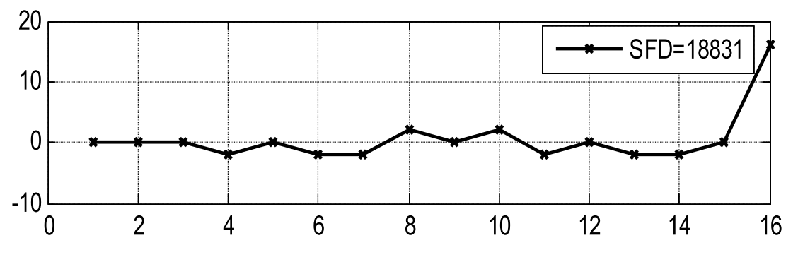
Note: 18831 is decimal value. The same SFD expressed in BCD is 0x498F

Resolution:
- Change line 19 on Page 13 (Paragraph 6.3 PPDU Format) as follows:

18 The Preamble field for the 433 MHz PHY and 2450 MHz PHY is shown below:
19 1 0 1 0 1 0 1 0 [leftmost bit b0 transmitted first in time]
20 b0.............................b7

- Change Table 20b to include new SFD as follows:

 | SFD (b0 – b15)
SFD Value | 0100 1001 1000 1111

