IEEE P802.15
Wireless Personal Area Networks
Project | IEEE P802.15 Working Group for Wireless Personal Area Networks (WPANs)
Title | IEEE P802
Date Submitted | [14th September, 2010]
Source | [Sang-Kyu Lim, Dae Ho Kim, Il Soon Jang, You Jin Kim, Tae-Gyu Kang]  [ETRI]  [Daejeon, Korea] | Voice: [ +82-42-860-1573]  Fax: [+82-42-860-5218]  E-mail: [sklim@etri.re.kr]
Re: | [Response to LB #57 comments]
Abstract | [This document describes the text for the merger clause 4.4.3.1.5 "VPPM dimming" and Annex B "VPPM principles" in D2 draft.]
Purpose | [To resolve the LB #57 comments]
Notice | This document has been prepared to assist the IEEE P802.15. It is offered as a basis for discussion and is not binding on the contributing individual(s) or organization(s). The material in this document is subject to change in form and content after further study. The contributor(s) reserve(s) the right to add, amend or withdraw material contained herein.
Release | The contributor acknowledges and accepts that this contribution becomes the property of IEEE and may be made publicly available by P802.15.

Blue: text modification as per the suggested remedy of T-CID 395
Related CIDs: T-CIDs 395, and 413

4.4.3.1.5 VPPM dimming
VPPM is a modulation scheme adapted for pulse width based light dimming and offers protection from intra-frame flicker. It does not create a color-shift in the light source which can arise from amplitude dimming because the pulse amplitude in VPPM is always constant and the dimming control is performed by the pulse width, not the amplitude. Similarly, VPPM scheme can protect the light source from the damages by over-driving of the signal amplitude for full brightness.
VPPM makes use of the characteristics of 2-PPM (Pulse Position Modulation) for non-flicker and PWM (Pulse Width Modulation) for dimming control and full brightness. Bits "1" and "0" in VPPM are distinguished by the pulse position in a unit period and have the same pulse width in unit period. Therefore, the non-flicker characteristic in VPPM is obtained from the property that the average brightness on bits "1" and "0" is constant. The VPPM signal with 50 % pulse width shows the same waveform as 2-PPM signal.
Dimming and full brightness in VPPM is achieved by controlling the “ON” time pulse width. Figure xx describes the dimming control mechanism by VPPM. It is possible to adjust the pulse width for VPPM based on the dimming requirements. Therefore, a user can achieve the full brightness which the light source can provide.
As shown in Figure yy, the light intensity for the payload can be adjusted by adapting the pulse width of VPPM symbols. The light intensity for the preamble and header can be adjusted by inserting compensation symbols of the appropriate length and intensity before the frame. The details on high resolution dimming using VPPM are described in 5.9.6.2.3.

Figure xx – Schematic mechanism of VPPM dimming

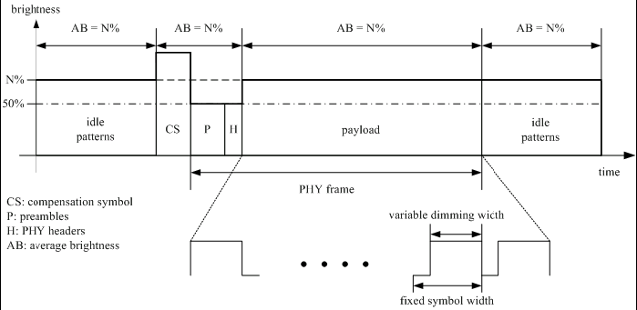
Figure yy – Example of VPPM dimming

