IEEE P802.15
Wireless Personal Area Networks

Project | IEEE P802.15 Working Group for Wireless Personal Area Networks (WPANs)
Title | HBC(EFC) – Proposed Replacement Text
Date Submitted | September, 2010
Source | Samsung [Jahng Sun Park, HyunKuk Choi, SangYun Hwang, Seong-Jun Song, , SeokYong Lee, JongRim Lee, Chul-Jin Kim, Seung-Hoon Park, Eun Tae Won], ETRI [Junghwan Hwang, Hyung-il Park, Tae-Young Kang, Sung-Weon Kang]
Re: | Letter ballot comments on the clause 9 of d01P802-15-6_Draft_Standard[1].pdf.  Comments to Clause 11 HBC(EFC)
Abstract | This submission provides the proposed replacement text based on the corresponding comment resolution discussed earlier at TG6.
Purpose | To improve subclause 7.9 of d01P802-15-6_Draft_Standard[1] and hence resolve letter ballot comments on the subclause.
Notice | This document has been prepared to assist the IEEE P802.15. It is offered as a basis for discussion and is not binding on the contributing individual(s) or organization(s). The material in this document is subject to change in form and content after further study. The contributor(s) reserve(s) the right to add, amend or withdraw material contained herein.
Release | The contributor acknowledges and accepts that this contribution becomes the property of IEEE and may be made publicly available by P802.15.

- Human Body Communications (HBC) PHY specification
  - General
This is specification for HBC PHY which uses the EFC technology. It covers the entire Physical Layer (PHY) protocol for Body Area Networks, such as packet structure, modulation, preamble/SFD, etc. This standard is intended to conform to established regulations in the United States, Japan and Korea.
HBC transmitter is implemented with only digital circuits and needs one electrode (instead of antenna), and HBC receiver can be implemented without any blocks related to RF carrier signals (mixer, VCO, ADC/DAC, etc.). These allows HBC device to have very low implementation complexity and low power consumption.
There are two bands of operation centered at 21MHz and 32MHz. More information regarding the regulation conformation is given in Error: Reference source not found.
  - HBC packet structure
The HBC packet is composed of Preamble, SFD (Start Frame Delimiter), Header, and PHY Payload (PSDU) as shown in Figure 139. The PHY Payload is composed of MAC Header, MAC Frame Body, and FCS (Frame Check Sequence). The PLCP Header fields are shown in Figure 139. The description of each header field is given in Table 353 of .

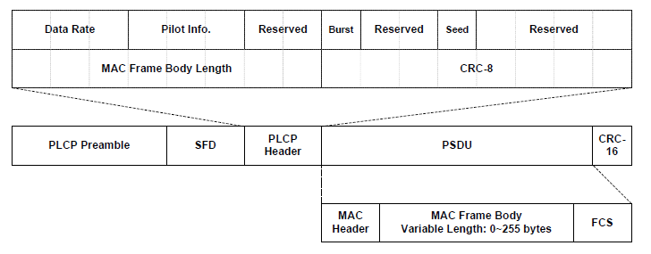
- — HBC Packet Structure
  - HBC Transmitter
HBC transmitter uses frequency selective digital transmission (FSDT) scheme; data is spread in frequency domain using frequency selective spread codes before transmission. The center frequency for the transmission is selected by using the specific frequency selective spread code. The HBC transmitter is composed of following blocks as shown in Figure 140.
- Preamble Generator
- SFD/RI Generator
- Header Generator
- Serial-to-Parallel (S2P)
- FS-Spreader [FS = Frequency Selective]
- Pilot Generator
- MUX

The generated Preamble, SFD/RI, Header, PSDU, and Pilot signals are sent to an electrode via a MUX. Since the preamble and SFD are fixed data patterns, they are pre-generated and sent ahead of the packet header and payload. These different signals are transmitted in sequence via a MUX and the electrode.

- — HBC Transmitter Block Diagram

  - PHY Preamble
A preamble sequence is transmitted four times (PR1 to PR4) to ensure packet synchronization by the receiver (see Figure 141).
- — Preamble Field

Each preamble sequence is created by spreading a 64-bit gold code sequence via frequency shift code (FSC). FSC uses a repeated [0, 1] code and the spreading factor (SF) is decided by the number of time FSC is repeated. If the SF is 2, 4, and 8, the FSC is [0, 1], [0, 1, 0, 1], and [0, 1, 0, 1, 0, 1, 0, 1], respectively. The SF is 8 for HBC packet preamble. Figure 142 shows a block diagram for the preamble generation. f_{CK} denotes operating clock frequency. The center frequency shall be 21MHz or 32MHzcenter, for the cases of f_{CK} equal to 42MHz and 64MHz, respectively.

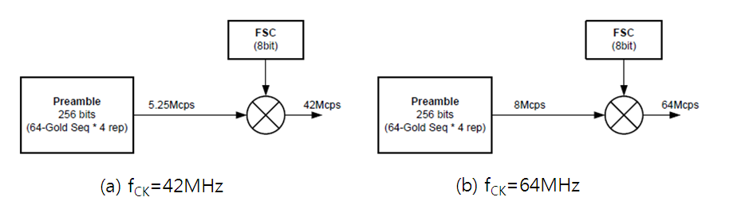

- — Preamble Generation Block Diagram (f_{CK} = 42 MHz or 64 MHz)

- — Code Set for Preamble

- — FSC Bit Mapping for Preamble (@16 MHz)

Table 68 shows polynomials for the Gold CodeGgeneration and Figure 143 showsea gold code generaton. As shown in 1, two polynomials are used for the preamble generation.Table 2 showhea code set used for generating preambce. The code set is a kind of truncated sequence, which is selected in the gold code sequence generated by-1 Table 3 Table 69 shows the FSC bit mapping used for preambce generation. In the code set, the bit 0 code shall be firstly transmitted and each FSC bit mapped signal shall be transmitted or received least significant bit (LSB) first.

- — Polynomials for Gold Code Generation
 | Polynomial 1 | Polynomial 2
Polynomial | x¹⁰ + x³ + 1 | x¹⁰ + x⁸ + x³ + x² +1
Initial value  [x1 x2 … x10] | [1:10] (0010010001) | [1:10] (0011111010)

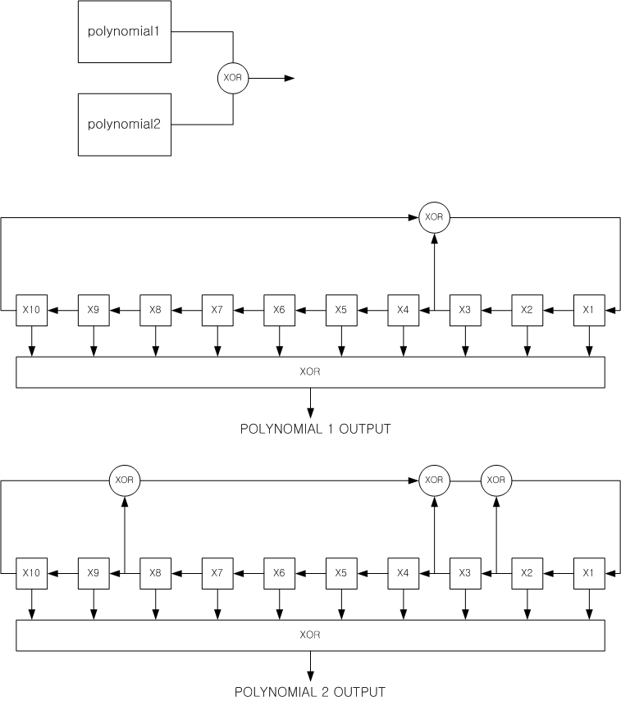

- — Gold Code Generator

— Code Set for Preamble
Bit | 0 | 1 | 2 | 3 | 4 | 5 | 6 | 7 | 8 | 9 | 10 | 11 | 12 | 13 | 14 | 15
Code | 1 | 1 | 0 | 0 | 0 | 1 | 0 | 0 | 1 | 1 | 0 | 0 | 1 | 0 | 1 | 0
Bit | 16 | 17 | 18 | 19 | 20 | 21 | 22 | 23 | 24 | 25 | 26 | 27 | 28 | 29 | 30 | 31
Code | 0 | 1 | 0 | 1 | 0 | 0 | 0 | 0 | 0 | 0 | 0 | 1 | 1 | 0 | 0 | 0
Bit | 32 | 33 | 34 | 35 | 36 | 37 | 38 | 39 | 40 | 41 | 42 | 43 | 44 | 45 | 46 | 47
Code | 1 | 1 | 1 | 1 | 1 | 0 | 1 | 0 | 1 | 1 | 1 | 0 | 0 | 1 | 0 | 0
Bit | 48 | 49 | 50 | 51 | 52 | 53 | 54 | 55 | 56 | 57 | 58 | 59 | 60 | 61 | 62 | 63
Code | 1 | 0 | 1 | 1 | 1 | 0 | 0 | 1 | 1 | 0 | 0 | 0 | 0 | 0 | 1 | 0

- — FSC Bit Mapping for Preamble
Gold code value | FSC bit mapping result (Preamble output)
0 | [1 0 1 0 1 0 1 0]
1 | [0 1 0 1 0 1 0 1]

  - Start Frame Delimiter (SFD) and Rate Indicator (RI)
    - SFD
During packet reception, the receiver finds the start of the packet by detecting preamble sequence, and then it finds the starting point of the frame by detecting Start Frame Delimiter (SFD). Unlike preamble sequence, SFD sequence is sent only once. The SFD sequence is generated by applying FSC with SF of 8 to a 64-bit gold code sequence. shows the SFD signal generation block.
- — SFD/RI Signal Generation Block Diagram (f_{CK} = 42 MHz or 64 MHz)
Table 70 shows the Gold Code Generation Polynomials, and Table 71 shows the code set used for generating SFD sequence. Table 72 shows the FSC bit mapping used for SFD sequence generation.
- — Gold Code Generation Polynomials for SFD
 | Polynomial 1 | Polynomial 2
Polynomial | x10 + x3 + 1 | x10 + x8 + x3 + x2 +1
Initial Values  [x1 x2 … x10] | [1:10] (0101100000) | [1:10] (0000100010)

- — Code Set for SFD
Bit | 0 | 1 | 2 | 3 | 4 | 5 | 6 | 7 | 8 | 9 | 10 | 11 | 12 | 13 | 14 | 15
Code | 0 | 1 | 0 | 1 | 0 | 1 | 1 | 0 | 0 | 1 | 0 | 1 | 1 | 1 | 0 | 1
Bit | 16 | 17 | 18 | 19 | 20 | 21 | 22 | 23 | 24 | 25 | 26 | 27 | 28 | 29 | 30 | 31
Code | 1 | 1 | 0 | 1 | 1 | 0 | 1 | 1 | 1 | 1 | 0 | 0 | 1 | 0 | 1 | 0
Bit | 32 | 33 | 34 | 35 | 36 | 37 | 38 | 39 | 40 | 41 | 42 | 43 | 44 | 45 | 46 | 47
Code | 0 | 1 | 0 | 1 | 1 | 0 | 0 | 0 | 0 | 0 | 1 | 0 | 0 | 1 | 1 | 0
Bit | 48 | 49 | 50 | 51 | 52 | 53 | 54 | 55 | 56 | 57 | 58 | 59 | 60 | 61 | 62 | 63
Code | 0 | 1 | 1 | 1 | 1 | 0 | 1 | 0 | 1 | 1 | 0 | 0 | 1 | 1 | 0 | 1

- — FSC Bit Mapping for SFD
Preamble code value | FSC bit mapping result (Preamble output)
0 | [1 0 1 0 1 0 1 0]
1 | [0 1 0 1 0 1 0 1]

    - Rate Indicator using SFD
By using “time offset,” the SFD field shall also indicate the transmitted packet data rate if RI is used. With this “Rate Indicator” (RI), the receiver does not need to refer to the PHY header to detect the incoming packet’s data rate. This allows the header along with the payload be transmitted at the same high data rate increasing transmission efficiency.
Besides the default traditional method using Data Rate Field (DRF) in PHY header, the SFD sequence can be used to indicate the data rate of the whole incoming packet, both header and payload. This concept is called “Rate Indicator” (RI).
With RI, as shown in Figure 146, the transmitter can introduce varying time offset when sending the SFD sequence to indicate a fixed set of information as described in Table 73. By detecting this time offset, the receiver can figure out what particular information is being sent. With RI, the information delivered is the whole packet’s data rate.

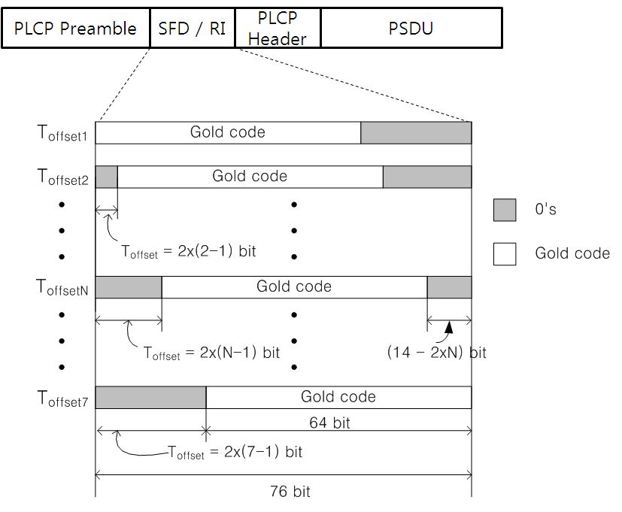
- — Zero Padding Method for RI Signal Generation
A total of 12 bits (all zeros) is introduced to allow time offset in addition to 64 bit Gold code for SFD. This sums to a total of 76 bits. FSC with SF of 8 is applied to give the final SFD field length of 608 chips.
SFD Length = (64-bit gold code + 12 bits for time offset) × 8 = 608 chips
RI can indicate seven (7) different data rates as shown in Table 73. RI allows both PLCP header and PSDU to be transmitted at the same data rate which provides throughput efficiency, especially for high data rates. To use RI, the sender should indicate to the receiver by setting Always Active field to one in MAC capability format. A hub may initiate RI mode for only one RI enabled device and transmits a stream of frames. After finishing the traffic session to a device, a hub should indicate to the device by setting Always Active field to zero.
- — SFD Time Offset and Data Rate Mapping for RI
RI | Data Rate ( f_{CK} = 42MHz ) | Data Rate ( f_{CK} = 64MHz )
Toffset1 | 164 kbps | 250 kbps
Toffset2 | 328 kbps | 500 kbps
Toffset3 | 656 kbps | 1 Mbps
Toffset4 | 1.3125 Mbps | 2 Mbps
Toffset5 | Reserved | Reserved
Toffset6 | Reserved | Reserved
Toffset7 | Reserved | Reserved

  - PHY Header
When Data Rate Field (DRF) mode (instead of RI) is used, the Header signal is generated as shown in Figure 147. If RI method is used, the header signal is generated as specified in Figure 150. For the operation of S2P and orthogonal modulation, please refer 11.7.2 and Table 427. As shown in Error: Reference source not found, the data rate for the header is fixed in the DRF mode. Table 421 shows the description of each PHY header field.

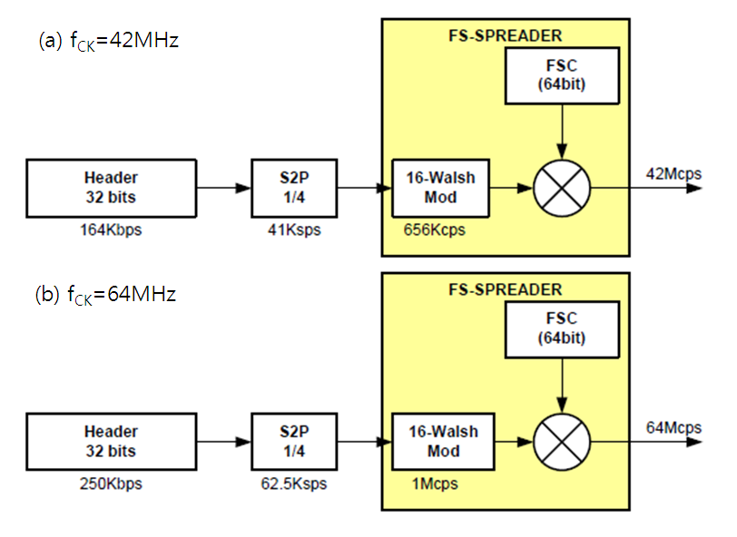
- — Header Generation Block Diagram (f_{CK} = 42MHz or 64MHz)

- — PHY Header Field Description

Bit Position | Field | Length (bit) | Values | Description
0 ~ 2 | Data Rate | 3 | fc=21MHz  000: 164 Kbps  001: 328 Kbps  010: 656 Kbps  011: 1.3125 Mbps  100: Reserved  101: Reserved  110: Reserved  111: Reserved | PSDU data rate  (RI can also be used.  See 11.5.2.)
0 ~ 2 | Data Rate | 3 | fc=32MHz  000: 250kbps  001: 500kbps  010: 1Mbps  011: 2Mbps  100: Reserved  101: Reserved  110: Reserved  111: Reserved | PSDU data rate  (RI can also be used.  See 11.5.2.)
3 ~ 4 | Pilot Info  (Pilot insertion period) | 2 | 000: Reserved  001: Reserved  010: 64 octets  011: 128 octets  100: Reserved  101: Reserved  110: no insertion | Pilot Insertion Interval  (Section Error: Reference source not found)
6 ~ 7 | Reserved | 2 | Reserved | -
8 | Burst mode | 1 | 0: Next packet is not part of burst  1: Next packet is part of burst | information about the next packet – whether it is being sent in a burst mode.
9~10 | Reserved | 2 | Reserved | -
11 | Scrambler Seed | 1 | See Table 424 | -
12~15 | Reserved | 4 | Reserved | PSDU length extension
16 ~ 23 | PSDU Length | 8 | 0 ~ 255 | PSDU Length in octets
24 ~ 31 | CRC8 | 8 | - | CRC value of PLCP Header

    - CRC8
CRC8 is calculated over the PHY header. Figure 148 shows the CRC8 implementation block diagram and its generator polynomial. The CRC8 operation is as follows. The remainder register (r0 through r7) is initialized to zero. The bits of the PHY header except for the CRC8 field is delivered into the CRC generator in the order of transmission (LSB first). After the last bit of the PHY header is shifted into the CRC generator, the remainder register becomes the CRC8 field. In Figure 148, r0 is transmitted first.
- — CRC8 Implementation

  - PSDU

    - Scrambler
A scrambler with polynomial$P(z)=z^{\text{32}}+z^{\text{31}}+z^{\text{11}}+1$ shall be used to whiten the PSDU. Error: Reference source not foundFigure 149 shows a typical implementation of the scrambler. The output of the scrambler is generated as:

$z[n]=z[n−\text{11}]⊕z[n−\text{31}]⊕z[n−\text{32}]$
where “⊕” denotes modulo-2 addition. Table 424Error: Reference source not found defines the initialization vector, z_{init}.

- — Block diagram of scrambler

- — Scrambler Seed Selection
Scrambler Seed  (SS) | Initialization Vector  z_{init} = z[-1] z[-2] … z[-32]
0 | 0110 1001 0101 0100 0000 0001 0101 0010
1 | 1000 1010 0101 1111 0110 0010 0001 1111
The MAC shall set the scrambler seed to 0 when the PHY is initialized and the scrambler seed shall be incremented, using a 1-bit rollover counter, for each frame sent by the PHY.

    - S2P and FS-spreader
Serial to Parallel (S2P) and FS-Spreader generates PHY Header (for RI method) and PSDU. FS-Spreader is composed of Orthogonal coding and FSC as shown in .
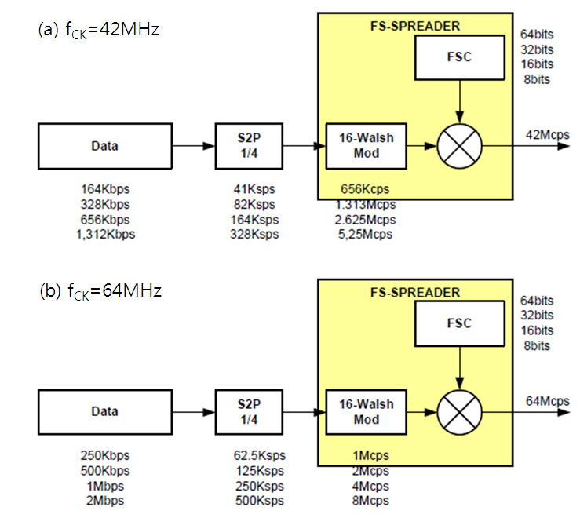
- — S2P and FS-Spreader Block Diagram (f_{CK} = 42MHz or 64MHz)

The data to be transmitted is created by mapping 4 bits (a symbol) from S2P converter to a 16-bit chip. Table 427 shows the symbol-to-chip mapping. The 16-bit chip is then spread by applying FSC. Thus, the final chip rate is the same regardless of input data rate. Table 425 and Table 426 shows data rate, symbol rate, spreading factor (SF) class according to f_{CK}.
- Modulation parameters for PLCP Header and PSDU (f_{CK}=42MHz)
Packet Component | Modulation | Symbol Rate  (ksps) | Spreading Factor  (S) | Information Data Rate | f_{CK}  (MHz) | Support
PLCP Header | FS-Spreader | 41 | 128 | 164 kbps | 42 | Mandatory
PSDU | FS-Spreader | 41 | 128 | 164 kbps | 42 | Mandatory
PSDU | FS-Spreader | 82 | 64 | 328 kbps | 42 | Optional
PSDU | FS-Spreader | 164 | 32 | 656 kbps | 42 | Optional
PSDU | FS-Spreader | 328 | 16 | 1.3125 Mbps | 42 | Optional
- Modulation parameters for PLCP Header and PSDU (f_{CK}=64MHz)
Packet Component | Modulation | Symbol Rate  (ksps) | Spreading Factor  (S) | Information Data Rate | f_{CK}  (MHz) | Support
PLCP Header | FS-Spreader | 62.5 | 128 | 250 kbps | 64 | Mandatory
PSDU | FS-Spreader | 62.5 | 128 | 250 kbps | 64 | Mandatory
PSDU | FS-Spreader | 125 | 64 | 500 kbps | 64 | Optional
PSDU | FS-Spreader | 250 | 32 | 1 Mbps | 64 | Optional
PSDU | FS-Spreader | 500 | 16 | 2 Mbps | 64 | Optional

- — Orthogonal Code Mapping
S2P Output Bits | Orthogonal Code | S2P Output Bits | Orthogonal Code
0000 | 1111 1111 1111 1111 | 1000 | 1111 1111 0000 0000
0001 | 1010 1010 1010 1010 | 1001 | 1010 1010 0101 0101
0010 | 1100 1100 1100 1100 | 1010 | 1100 1100 0011 0011
0011 | 1001 1001 1001 1001 | 1011 | 1001 1001 0110 0110
0100 | 1111 0000 1111 0000 | 1100 | 1111 0000 0000 1111
0101 | 1010 0101 1010 0101 | 1101 | 1010 0101 0101 1010
0110 | 1100 0011 1100 0011 | 1110 | 1100 0011 0011 1100
0111 | 1001 0110 1001 0110 | 1111 | 1001 0110 0110 1001

    - Pilot Signal
To prevent loosing synchronization due to clock drift, optional “Pilot” sequence can be inserted in PSDU as shown in Figure 151. The same sequence used for SFD, which is used for the DRF mode with no timing offset, is used for pilot, and the pilot insertion interval is indicated in the “Pilot Info” field in PHY header. There are three pilot insertion intervals (Table 428). If total PSDU length is less than pilot insertion period, packets do not contain any pilot symbols. Pilot signal is inserted between a block of data which size is same as the value of Insertion Period as specified in Table 428 and Figure 151.

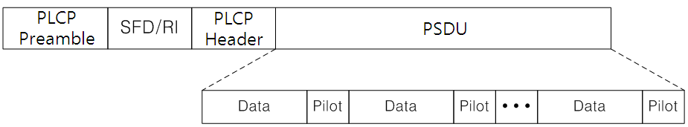
- — Pilot Insertion in PSDU

- — Pilot Insertion Periods
Pilot Info Field | Insertion Period
000 | Reserved
001 | Reserved
010 | 64 octets
011 | 128 octets
100 | Reserved
101 | Reserved
110 | Reserved
111 | No pilot insertion

- — Pilot Insertion Mechanism
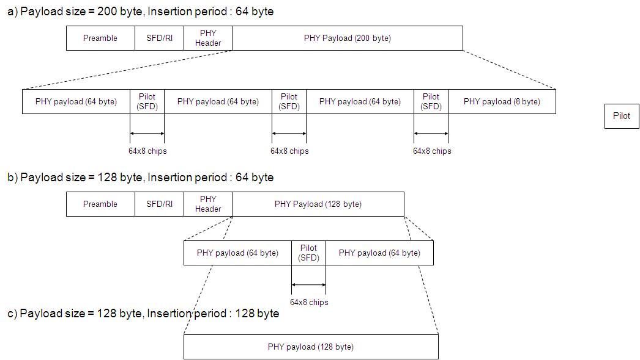

    - CRC16
CRC16 is calculated over the PSDU. Figure 12 shows the CRC16 implementation block diagram and its generator polynomial. The CRC16 operation is as follows. The remainder register (r0 through r15) is initialized to zero. The bits of the PSDU, which is packet data transmitted after the PHY header, is delivered into the CRC generator in the order of transmission (LSB first). After the last bit of the PSDU is shifted into the CRC generator, the remainder register becomes the CRC16 field. In Figure 12, r0 is transmitted first.
- — CRC16 Implentation
  - Transmitter Specifications
    - Transmit Mask
A transmit spectrum mask shall be used to remove harmonics and possible interference in other bands, especially with 400MHz medical band. The transmit power spectrum shall be less than 0 dBr (dB relative to the maximum spectral density of the signal) within f_{BW}. In case that f_{C} is 21MHz and 32MHz, f_{BW} is 5.25MH and 8MHz, respectively, where f_{c} is channel center frequency and f_{BW} is channel bandwidth. The required transmit spectrum masks are shown in the Figure 154A and Figure 155 for 21MHz and 32MHz channel center frequencies respectively$\left|f−f_{c}\right|<{f_{\text{BW}}}/2$$\left|f−f_{c}\right|={f_{\text{BW}}}/2$${f_{\text{BW}}}/2<\left|f−f_{c}\right|<4f_{c}$$\left|f−f_{c}\right|>4f_{c}$.

$$\left|f−f_{c}\right|<{f_{\text{BW}}}/2$$
$$\left|f−f_{c}\right|={f_{\text{BW}}}/2$$
$${f_{\text{BW}}}/2<\left|f−f_{c}\right|<4f_{c}$$
$$\left|f−f_{c}\right|>4f_{c}$$

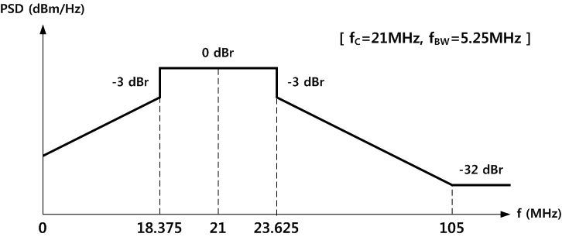
- — Transmit Spectrum Mask (for fc = 21MHz)

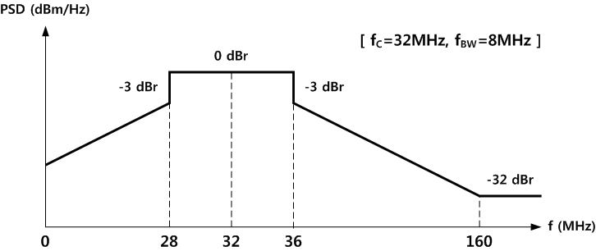
- — Transmit Spectrum Mask (for fc = 32MHz)

    - Transmit Power
The transmit power to the human body is -39 dBm and it shal be less than -36 dBm
as the overall power in the frequency band. Devices shall limit their transmit power to mitigate against interference to other devices and systems, and to meet the regulatory policies.
    - Clock Frequency Tolerance
The symbol clock frequency tolerance shall be ± 20 ppm maximum. In the case that the performance of PSDU detection is degraded due to clock drift, 11.8.4 provides the related protocol.

    - Transmit Timing Requirements
The timing information of the transmit signal is shown in Figure 156. It has two timing requirements: duty cycle and rising/falling time. Table 431 and Figure 156 show these requirements under the condition of 15pF capacitive load.

- — Transmit Timing Requirements
Parameter | Conditions (C_{L}=15pF) | Min | Max | Unit
Output Duty Cycle | Ratio of t_{wh} over (t_{wh}+t_{wl}) | 48 | 52 | %
Rising/Falling Time | 10% to 90% of V_{DDTX} | 2 | 4 | ns

- —Transmit Timing information

  - Receiver Specifications
    - Receiver Sensitivity
The minimum receiver sensitivity levels shall be the levels listed in Table 432. The levels are obtained for a packet error rate (PER) of less than 1 % with a payload of 128 octets. The sensitivity values assume a receiver with a noise figure of 10dB and implementation loss of 6dB.

- — Minimum Receiver Sensitivity Level
Data Rate (kbps) | Minimum Receiver Sensitivity (dBm)
125 | -112
250 | -106
500 | -100
1000 | -94
2000 | -88

  - General Requirements
    - Operating Frequency Bands
A compliant device shall be able to support transmissions and reception in one of the following frequency bands:
- 21 MHz
- 32 MHz
    - Channel Numbering
The system uses only one frequency band among bands described in 11.11.1
  - PHY layer timing
The values for the PHY layer timing parameters are defined in Table 433.
- — Physical layer timing parameters
PHY Parameter | Value
pSIFS | 50 μs
pMIFS | 20 μs

    - Inter-frame spacing
The inter-frame spacing parameters are given in Table 434.
- — Inter-frame spacing parameters
MAC Parameter | Value
SIFS | pSIFS
MIFS | pMIFS

    - Receive-to-Transmit Turnaround Time
The RX-to-TX turnaround time shall not be greater than pSIFS. The turnaround is defined as time elapsed from when the last sample of the last received symbol is present on the air interface, to the time when first sample of the first transmitted symbol of the PLCP preamble for the next frame is present on the air interface.
    - Transmit-to-Receive Turnaround Time
The TX-to-RX turnaround time shall not be greater than pSIFS. The turnaround is defined as the time elapsed from when the last sample of the last transmitted symbol is present on the air interface until the time when the receiver is ready to begin the reception of first sample for the next PHY frame.
    - Time between Successive Transmissions
For burst mode transmissions, the inter-frame spacing between uninterrupted successive transmissions by a device shall be fixed to exactly pMIFS. The inter-frame spacing is defined as the time elapsed from when the last sample of the last transmitted symbol is present on the air interface, to the time when the first sample of the first transmitted symbol of the PLCP preamble for the following packet is present on the air interface.

The following terms will be added to Clause 4. Abbreviations and acronyms.

* EFC - Electro Field Communication
* HBC - Human Body Communication
* SFD - Start Frame Delimiter
* FSDT - Frequency Selective Digital Transmission
* RI - Rate Indicator
* S2P - Serial to Parallel
* FS-Spreader - Frequency Selective Spreader
* MUX - Multiplxer
* MCU - Micro Controller Unit
* SF - Spreading Factor
* DRF - Data Rate Field

The following table will be added to MAC clause.
PHY-dependent MAC sublayer parameters pertaining to EFCHBC PHY
Parameter | Value
pAllocationSlotMin | 1 ms
pAllocationSlotResolution | 1 ms
pAlohaSlotLength | (200 us + pSIFS)(800usec+pSIFS) x 1.1
pHybridARQ | FalseTrue
pMaxFrameBodyLength | 255 octets
pRandomAccess | Slotted Aloha
pSynchResolution | 1 / (Symbol Rate x 8)
pSIFS | 50 μs
pUnconnectedPolledAllocationMin | 67.25 μs (Preamble time+SFD/RI time + Header time  fCK=42MHz : 48.7619 us + 12.1905 us + 97.5238 us = 158.4762 us  fCK=64MHz : 32 us + 8 us + 64 us = 104 us

This method is not approved by medical authorities in many countries, at the time of publication.

