IEEE P802.15
Wireless Personal Area Networks
Project | TG6 Body Area Networks
Title | Resolution of TG6 Draft D0 coexistence comments S7-210, S7-307, S7-484, S7-485, S7-487, (and S7-303, S7-290, S7-360, S7-300, S7-219, S7-211, S7-38, S7-46, S7-30, S7-483, S7-491, S7-504)
Date Submitted | 10 September 2010
Source | Ranjeet Kumar Patro, Sridhar Rajagopal and Seung-Hoon Park | Address: [66/1, Bagmane Tech Park, Byrasandra, C.V.Raman Nagar, Bangalore, India]  Voice: :[+91-80- 41819999]  Fax: [+91-80- 41819999]  Email:[rkp.atd@samsung.com]
Re: | Proposed Resolution of D0 Comment S7-49
Abstract
Purpose
Notice | This document has been prepared to assist the IEEE P802.15. It is offered as a basis for discussion and is not binding on the contributing individual(s) or organization(s). The material in this document is subject to change in form and content after further study. The contributor(s) reserve(s) the right to add, amend or withdraw material contained herein.
Release | The contributor acknowledges and accepts that this contribution becomes the property of IEEE and November be made publicly available by P802.15.

Resolution of TG6 Draft D0 comments S7-210, S7-307, S7-484, S7-485, S7-487, (and S7-303, S7-290, S7-360, S7-300, S7-219, S7-211, S7-38, S7-46, S7-30, S7-483, S7-491, S7-504)

S7-210: Section 7.12.3, Page 111, Line 15
- Comment: Much of this subclause is either tangential to coexistence or implementation specific. It does not prescribe testable normative behaviors pertaining to coexistence.
- Commentators proposed resolution: Rewrite the whole subclause to specify how a hub is supposed to do for coexistence between its BAN and neighbor BANs. Only specify actions that are relevant to interoperability and testable.
- Must be satisfied: Yes
- Resolution: Accept in principle
- Proposed change: Entire 7.12.3 has been rewritten to address the comment and other comments to the section.

S7-307: Section 7.12.3.3, Page 113, Line 32
- Comment: Interference mitigation mode needs clarifications
- Commentators proposed resolution: The explanation related to the interference mitigation co-existence modes is insufficient. The text needs figures and message sequence charts for detailed explanation of co-existence modes. Develop and use flowcharts for co-existence similar to those defined for beacon shifting illustration. Refer to contribution for co-existence modes doc DCN 314r1 and DCN 344 Section 8
- Must be satisfied: Yes
- Resolution: Accept in principle
- Proposed change: See below

S7-484: Section 7.12.3, Page 112, Line 11
- Comment: what is a BAN enquiry frame? I don’t see it defined anywhere.
- Commentators proposed resolution: "BAN enquiry" should be changed to "Coexistence request".
- Must be satisfied: Yes
- Resolution: Accept
- Proposed change: Done

S7-485: Section 7.12.3, Page 112, Line 13
- Comment: what is a BAN enquiry response frame? I don’t see it defined anywhere.
- Commentators proposed resolution: "BAN enquiry response" should be changed to "Coexistence response"
- Must be satisfied: Yes
- Resolution: Accept
- Proposed change: Done

S7-487: Section 7.12.4, Page 114, Line 15
- Comment: This entire section is also dislocated from the rest of the text. What is the definition of severe interference? How would load control work in congested channel conditions if connection assignements do not get through? Isnt this best managed by higher layers?
- Commentators proposed resolution: I am not sure this clause is useful other than for information. So I suggest that it should be taken out or completely rewritten to reference existing frames and terminology and well defined behavior that can be implemented without ambiguity.
- Must be satisfied: Yes
- Resolution: Reject
- Proposed change: Severe inter-piconet interference is recognized by increase in packet error rate, sever drop in the signal strength for a sufficient long duration or overflow in the total capacity. It is an internal trigger. Channel condition is time varying in nature, and some packets are in error not necessarily mean that connection request frame shall also be in error.

7.12.3 Time sharing, Offset Piconet Synchronization and Interference mitigation coexistence modes

Figure 1: Hub Behavior - Time sharing, offset synchronization and interference mitigation modes

A prospective BAN hub shall select a default channel to operate prior to starting a new BAN. A hub shall try to select an unoccupied channel for network operation. Hub may select an occupied channel when no unoccupied channel is available for network operation and may operate in Time Sharing or Offset Piconet Synchronization or Interference mitigation mode. This is shown in Figure 1. The time sharing and offset piconet synchronization modes are non-interference (NI) modes that try to schedule the transmissions across piconets to avoid interference while the co-existence interference mitigation mode tries to minimize the interference when scheduling transmissions across piconets is not possible. The details on the time sharing, offset synchronization and interference mitigation for co-existence modes are provided in 7.12.3.1, 7..12.3.2 and 7.12.3.3 respectively. Hub may initiate ED (energy detection) scan, active scan or passive scan to perform channel scan over a given list of channels in a given frequency band to select an unoccupied channel for network operation.

In energy detection (ED) based scanning method; hub shall repeatedly perform energy detection based measurement in a channel for nEDScanDuration duration specified by the next higher layer. The maximum energy measurement obtained during this duration shall be noted by the hub before moving on to the next channel in the channel list. A hub shall be able to store between one and an implementation-specified maximum number of channel energy measurements. The ED scan shall terminate when either the number of channel energy measurements stored equals the implementation-specified maximum or peak energy detected in a channel is lesser than the energy detection threshold. Hub may select an unoccupied channel for network operation, at the termination of ED scan.

In active scan based method, the hub shall select a channel, and send a coexistence request frame with coexistence mode field set to Piconet Enquiry. Upon successful transmission of the coexistence request frame, hub shall enable its receiver for at least nActiveScanDuration duration specified by the next higher layer and wait for coexistence response frame from an existing BAN hub. If no coexistence response messages received in response to the coexistence request frame from the hub, the hub shall monitor the network activity for nNetworkActivityDuration duration specified by the next higher layer in the same channel. During nActiveScanDuration duration, hub shall reject all frames and record the information contained in the command data field of the coexistence response frame, when received, before moving on to the next channel in the channel list. A hub shall be able to store between one and an implementation-specified maximum number of command data field information received from coexistence response frames. Active scan shall terminate either when the number of active channel scan equals the implementation specified maximum or when no coexistence response frame is received in nActiveScanDuration duration and followed by no network activity is detected for nNetworkActivityDuration duration in a channel. Hub may select an unoccupied channel for network operation, at the termination of active scan.

In passive channel scan, hub shall try to locate beacon or B2 message in a channel for nPassiveScanDuration duration specified by the next higher layer. The inactive duration field indicated in the beacon and the frame payload of B2 frame may be used for BANs coexistence when applicable. The hub shall record frame payload of B2 frame before moving on to the next channel in the channel list to repeat passive scan procedure. A hub shall be able to store between one and an implementation specified maximum number of frame payload in the B2 frames. The passive scan shall terminate when the number of B2 frame payloads stored equals the implementation specified maximum. Hub may select an unoccupied channel for network operation, at the termination of passive scan.

Hub shall select an occupied channel when no unoccupied channel is selected at the termination of ED scan or Active scan or Passive scan or combination thereof. Hub shall utilize the information gathered during the ED scan and active scan and passive scan to select an occupied channel and operate in Time Sharing or Offset Synchronization or Interference Mitigation mode.

7.12.3.1 Time sharing mode

Figure 2 Time sharing mode (may need modification to precise superframe structure in BAN)

Figure 2 shows the operation of the time sharing mode between two piconets C1 and C2. To operate in the time sharing mode, hub shall perform passive scan if not performed and record frame payload information in the B2 frame received in all channels, and select an occupied channel for network operation. Upon selecting an occupied channel and finding an existing BAN hub, hub shall send coexistence request command frame to the existing BAN hub, using CAP/RAP1/RAP2 access mechanism, with recipient ID as existing hub address, sender ID as its own address and with “Coexistence Mode” field set to Time Sharing and “Allocation Time” field specifying allocation requirement in slots. The prospective hub shall utilize the information contained in the B2 frame payload or the Beacon frame received from the existing hub to arrive at its allocation requirement.

Upon receiving coexistence request frame, existing hub shall respond with coexistence response frame, by providing exclusive allocation time when coexistence request accepted or rejecting the coexistence request, to the prospective hub. Hub shall indicate the acceptance or rejection of coexistence request with the status field in the coexistence response frame. Existing hub may adjust allocation of its connected device for allocation of exclusive time duration to the new hub. Existing hub shall utilize the priority information of prospective hub while responding with the coexistence response frame. Hub with only medical device should have priority over hub with medical and non-medical devices; hub with medical and non-medical devices should have priority over hub with only non-medical devices.

When coexistence request is granted, the prospective hub shall utilize the Beacon Period Length, Allocation Slot Length, CAP Length, Offset to start time and Reserved Slots fields in the B2 frame of existing hub to obtain its Beacon Period length and other Superframe related parameters and commence its network operation such that both hub shall have mutual exclusive active beacon periods.

The message sequence chart (MSC) for the time sharing mode is shown in Figure 3.
Figure 3 MSC for the time sharing mode (check with current understanding in TG6)

7.12.3.2 Offset BAN synchronization mode

Figure 4 Offset synchronization mode for low duty cycle PHY

The offset synchronization mode is as shown in Figure 4. This mode is only applicable for BAN devices that support low duty cycle (<= 50%) at the PHY layer. In this mode of operation, the devices can overlap even within their transmissions by accounting for the free time available between the symbols transmitted at the PHY layer. Thus, it is different from the time sharing mode, where there is no overlap allowed during the entire transmission of the frame. When existing hub refuses to allow releasing its time resource to other hub, due to limited time resources being available on existing BAN or due to existing hub having an equal or higher priority than the prospective hub, the prospective hub shall choose to operate in offset BAN synchronization mode. The offset synchronization mode will appear in the PHY layer as shown in Figure 5. A small gap may be allowed between the end of the symbol of first piconet and the start of the symbol of the second piconet in order to account for delay spread and multipath as shown in Figure 5.

Figure 5 offset synchronization for low duty cycle PHY

Hub shall send coexistence request command frame to the existing BAN hub, using CAP/RAP1/RAP2 access mechanism, with recipient ID as existing hub address, sender ID as its own address and with “Coexistence Mode” field set to Offset Piconet Synchronization and with “Duty Cycle” requirement. The prospective hub shall utilize the information contained in the B2 frame payload or the Beacon frame received from the existing hub to arrive at its duty cycle requirement.

Upon receiving coexistence request frame, existing hub shall respond with coexistence response frame, by providing allowed duty cycling value when coexistence request accepted or rejecting the coexistence request, to the prospective hub. Hub shall indicate the acceptance or rejection of coexistence request with the status field in the coexistence response frame. Existing hub shall utilize the priority information of prospective hub and may adjust its duty cycle and data rate to allow the coexistence of prospective hub. Hub with only medical device should have priority over hub with medical and non-medical devices; hub with medical and non-medical devices should have priority over hub with only non-medical devices.

When coexistence request is granted, the prospective hub shall follow the existing hub and ensure that symbols within the packet are not overlapping (with help of low duty cycle and offset synchronization) even when the packets are overlapping. The MSC for the offset synchronization mode is as shown in Figure 6.

Figure 6 MSC for offset synchronization mode (check with TG6 for understanding)

7.12.3.3 Interference co-existence mitigation (CM) mode for unsynchronized BANs

Figure 7 Co-existence mitigation (CM) mode operation (check with TG6 for understanding)

The prospective hub can use this mode, when coexistence request is rejected for time sharing mode and offset synchronization mode. This is as shown in Figure 7. In this mode, BANs cannot or do not wish to interact, hence no message exchange is required in this mode. A hub shall start in an unsynchronized manner and may receive transmissions from other BANs and may have overlapping transmissions with other BANs. When possible, the hub shall select a logical channel for network operation while minimizing the impact on the existing BANs. When possible, hub shall perform passive scan on all logical channels in all frequency bands. Once a particular piconet is found to already exist, the hub will estimate piconet information such as the number of devices on that piconet to obtain a traffic estimate, the received signal strength indication to figure out how far away the devices on that piconet, existing data rate used by devices in the piconet and priority information related to the existing piconet. The prospective hub may obtain this information either by listening to the beacon message or B2 message in logical channels. This process is as shown in Figure 8. At the end of the passive scan, the device trying to establish a new piconet will look at the collected information from the scan and make a decision about selecting a new logical channel and frequency band.

Figure 8 Co-existence mitigation (CM) mode operational process

7.12.4 Using a relay for co-existence support

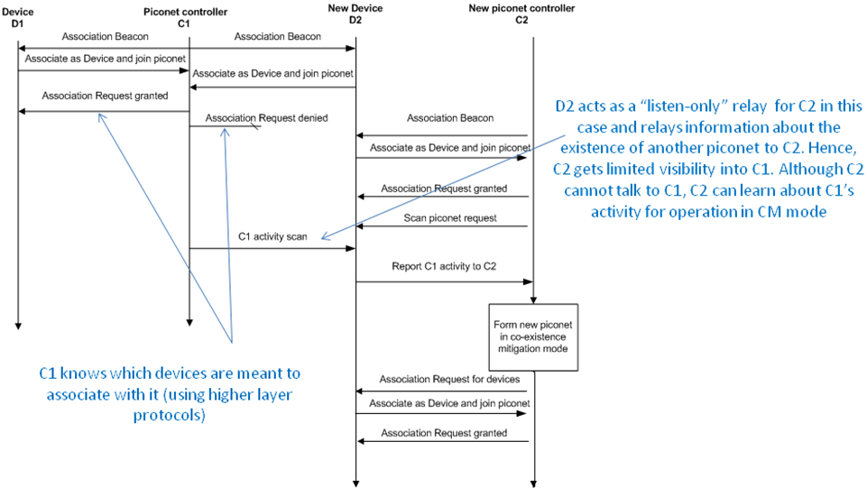
Figure 9 - need to check with TG6 committee if this concept is supported in TG6 since relay nodes are supported in TG6. This figure needs to be modified to show relay node support and use for co-existence.

7.12.5 BAN dissolution

Figure 10 BAN termination for co-existence (check understanding in TG6)

7.12.6 Load control for short-term coexistence

For dynamic or semi-dynamic network scenario, hub may reduce or remove the allocations at short term to the services of its body area network, when any of other coexistence mechanism is running with or without. In dynamic or semi-dynamic network scenario, a hub may trigger load control, when inter-piconet interference is severe, and where severe inter-piconet interference is recognized by increase in packet error rate, severe drop in the signal to noise ratio for a sufficient long duration or overflow in the total capacity. Total capacity which is occupied time resource for nearby BANs can be calculated by using coexistence information contained in the B2 frame. Hub may perform load control by reducing traffic load from connected nodes or by disconnecting connected nodes or combination of reducing traffic from connected nodes and disconnecting connected nodes. Hub performs Additive Increase and Multiplicative Decrease slot assignment/node connection to change and restore the traffic load with different rate according to traffic class. The rule should be designed for piconets to be operated fairly. See Table 22.

Table 22— Load control rate according to traffic priority
Traffic Priority | Traffic designation | Decreasing rate [%]  (according to # of assigned slots) | Increasing slot
0 | Background (BK) | 100 | + 1
1 | Best effort (BE) | 100 | + 2
2 | Excellent effort (EE) | 75 | + 1
3 | Controlled load (CL) | 75 | + 2
4 | Video (VI) | 50 | X 2 (from 1)
5 | Voice (VO) | 50 | X 2 (from 2)
6 | Medical data or network control | 10 | X 2 (from 2)
7 | Emergency or medical event report | 0 | -

