IEEE P802.15
Wireless Personal Area Networks
Project | IEEE P802.15 Working Group for Wireless Personal Area Networks (WPANs)
Title | IEEE P802
Date Submitted | [15th July, 2010]
Source | [Il Soon Jang , Sang-Kyu Lim, Dae Ho Kim, You Jin Kim, Tae-Gyu Kang]  [ETRI]  [Daejeon, Korea] | Voice: [ +82-42-860-5424]  Fax: [+82-42-860-5218]  E-mail: [isjang@etri.re.kr]
Re: | [Response to LB #50 comments]
Abstract | [The text for MLME Primitives on color frame is described as per the results of comment resolution]
Purpose | [To reflect the results of the comment resolution]
Notice | This document has been prepared to assist the IEEE P802.15. It is offered as a basis for discussion and is not binding on the contributing individual(s) or organization(s). The material in this document is subject to change in form and content after further study. The contributor(s) reserve(s) the right to add, amend or withdraw material contained herein.
Release | The contributor acknowledges and accepts that this contribution becomes the property of IEEE and may be made publicly available by P802.15.

Blue: new text
Black: deleted text
Pink: Editorial instructions
Orange: modified text on AM 2 meeting, 16th July, 2010.
This document is based on DCN 10/348/r0 which describes the comment resolution on CIDs 177, 247, 635, 645, 660, 798, 799, 800, 792, 793, 794, 796, 797, 785, 786, 787, 788, 790, and 791.

6.2.1.1 has been modified as per DCN 10/348/r0. This subclause connects with the resolution of the CID 247.
6.2.1.1 PD-DATA.request
The PD-DATA.request primitive requests the transfer of an MPDU (i.e. PSDU) from the MAC sublayer to the local PHY entity.
The semantics of the PD-DATA.request primitive is are as follows:
PD-DATA.request (
psduLength,
psdu,
bandplanID
)
Table 7 specifies the parameters for the PD-DATA.request primitive.
Table 7 - PD-DATA.request parameters
Name | Type | Valid range | Description
psduLength | Unsigned  Integer | <=aMaxPHYPacketSize | The number of octets in the PSDU to be transmitted by the PHY entity.
psdu | Set of octets |  | The set of octets forming the PSDU to be transmitted by the PHY entity.
bandplanID | integer | bandplanID | The color band of psdu

The new subclause of 7.1.17 has been added as per DCN 10/348/r0. This subclause connects with the resolution of the CID 635.
7.1.17 Primitives for requesting color frame settings from DME
Figure <xx> shows the message sequence chart for color packet function. The Originator higher layer uses the MLME-COLOR primitives for color packet frame function.
Figure <xx> Message sequence chart for color packet frame function
7.1.17.1 MLME-COLOR.request
The MLME-COLOR.request primitive requests that the MLME performs the color packet frame function as defined in 7.6.10.
7.1.17.1.1 Semantics of the service primitive
The semantics of the MLME-COLOR.request primitive are as follows;
MLME-COLOR.request (
macCFType macCFConfig,
macCFColor,
macCFEnable,
macCFMsg
)
Table <xx1>, Table <xx2>, and Table <xx3> specify the parameters for the MLME-COLOR.request primitive, the parameters of color packet configuration message format for MAC procedures, and the parameters of color packet configuration message format for ACK frame, respectively.
Table <xx1> MLME-COLOR.request parameters
Name | Type | Valid range | Description
macCFType macCFConfig | Integer | 0-2 | 0 : Configuration for MAC procedures  1: Configuration for channel quality  2: Configuration for upper layer
macCFColor | Integer | bandplanID | bandplanID
macCFEnable | BOOL | TRUE, FALSE | Color frame enable/disable
macCFMsg | CF MSG Format |  | When macCFType is 2, this field is not used.

Table <xx2> Color packet configuration message format for MAC procedures
Name | Type | Valid range | Description
macDuringASSOCColor | Integer | bandplanID | Color frame is transmitted using macDuringASSOCColor bandplanID between MLME‐ASSOCIATE.request and MLME‐ASSOCIATE.confirm.
macDuringDISASSOCColor | Integer | bandplanID | Color frame is transmitted using macDuringDISASSOCColor bandplanID between MLME‐DISASSOCIATE.request and MLME‐DISASSOCIATE.confirm,.
macDuringSYNCColor | Integer | bandplanID | Color frame is transmitted using macDuringSYNCColor bandplanID between MLME‐SYNC.request and MLME‐SYNC.confirm.
macDuringSCANColor | Integer | bandplanID | Color frame is transmitted using macDuringSCANColor bandplanID between MLME‐SCAN.request and MLME‐SCAN.confirm.

Table <xx3> Color packet configuration message format for ACK Frame
Name | Type | Valid range | Description
macACKFrameColor | Integer | bandplanID | Use macACKFrameColor for ACK Frame which denotes ACK
macNACKFrameColor | Integer | bandplanID | Use macNACKFrameColor for ACK Frame which denotes NACK

7.1.17.1.2 Appropriate Usage
The MLME-COLOR.request primitive is generated by the MLME and issued to its MLME whenever the color packet usage algorithm requires the required color packet value.
The MLME-COLOR.request primitive is received by the MLME whenever color frame function is desired.
7.1.17.1.3 Effect on receipt
If the transmitter is enabled on the receipt of the MLME-COLOR.request primitive, MLME will cause the MAC to perform the required color packet function. MLME will issue MLME-COLOR.confirm primitive with the status of SUCCESS after a color frame is transmitted.
If color frame transmission is supported upon the receipt of the MLME-COLOR. request primitive, a color frame shall be transmitted and the MAC will issue a MLME-COLOR.confirm primitive and the status of SUCCESS, UNSUPPORTED_ATTRIBUTE or INVALID_PARAMETER will be returned.
7.1.17.2 MLME-COLOR.confirm
MLME-COLOR.confirm primitive reports the results of a color frame request.
7.1.17.2.1 Semantics of the service primitive
The semantics of the MLME-COLOR.confirm primitive are as follows;
MLME-COLOR.confirm (
status
)
Table <xx> specifies the parameters for the MLME-COLOR.confirm primitive.
Table <xx> MLME-COLOR.confirm parameters
Name | Type | Valid range | Description
status | Enumeration | SUCCESS,  UNSUPPORTED_ATTRIBUTE, or  INVALID_PARAMETER | The result of the request to perform a MLME-COLOR.request.

7.1.17.2.2 When generated
The MLME-COLOR.confirm primitive is generated by the MLME and issued to its MLME in response to a MLME-COLOR.request primitive. The MLME-COLOR.confirm primitive will return a status of SUCCESS, indicating a successful color packet transmission. If the PIBAttribute parameter specifies an attribute that is not found in the database, as shown in Table <xx>, the MLME will issue the MLME-COLOR.confirm primitive with a status of UNSUPPORTED_ATTRIBUTE. If the PIBAttibuteValue parameter specifies a value that is out of the valid range for the given attribute, the MLME will issue the MLME-SET.confirm primitive with a status of INVALID_PARAMETER.
The MLME-COLOR.confirm primitive is issued to its MLME in response to a MLME-COLOR.request primitive. The MLME-COLOR.confirm primitive shall return a status of SUCCESS either indicating a successful color frame transmission, or a status of UNSUPPORTED_ATTRIBUTE if color frame is not supported, or a status of INVALID_PARAMETER.
7.1.17.2.3 Appropriate Usage
On receipt of the MLME-COLOR.confirm primitive, the Originator next higher layer is notified of the results of the color frame transmission from originator of MAC
The new subclause of 5.6.4.6 has been added as per DCN 10/348/r0. This subclause connects with the resolution of the CID 177.
5.6.4.6 Color packet frame
Figure <XX> shows the structure of the color frame, which originates from the MAC sublayer. MAC payload contains the color frame payload. MAC payload is prefixed with an MHR. The MHR contains the MAC Frame Control field and a 16-bit FCS. The MHR and MAC payload together form the color frame, (i.e., MPDU).
The MPDU is then passed to the PHY as the PSDU, which becomes the PHY payload. The PHY payload is prefixed with an SHR, containing the Preamble Sequence field, and a PHR containing the length of the PHY payload in octets. The preamble sequence enables the receiver to achieve symbol synchronization. The SHR, PHR, and PHY payload together form the PHY packet, (i.e., PPDU).
The color frame is used for the color packet function.
A user can perceive intuitively some information (such as the current step of communication procedure, the data transmission quality, the transferred file size or remained file size).
Figure <XX>—Schematic view of the Color frame
The subclause 5.6.3 has been modified as per DCN 10/348/r0. This subclause connects with the resolution of the CID 177.
5.6.3 Frame structure
The frame structures have been designed to keep the complexity to a minimum while at the same time making them sufficiently robust for transmission on a noisy channel. Each successive protocol layer adds to the structure with layer-specific headers and footers. This standard defines five six frame structures, which are introduced in 5.6.3.1 through 5.6.3.5 5.6.3.6:
- A beacon frame, used by a coordinator to transmit beacons
- A data frame, used for all transfers of data
- An acknowledgment frame, used for confirming successful frame reception
- A MAC command frame, used for handling all MAC peer entity control transfers
- A visibility/dimming frame, available to maintain the proper light intensity between data packets
- A color frame, used for providing information such as device status and channel quality to users intuitively

The subclause 7.2.1.1.1 has been modified as per DCN 10/348/r0. This subclause connects with the resolution of the CID 645.
7.2.1.1.1 Frame type subfield
The Frame Type subfield is 3 bits in length and shall be set to one of the nonreserved values listed in Table 67.
Table 67-Values of the Frame Type subfield
Frame type value  b₂ b₁ b₀ | Description
000 | Beacon
001 | Data
010 | Acknowledgment
011 | MAC command
100 | Visibility
101 | Color
101110–111 | Reserved

The subclause 7.2.2.4 has been added as per DCN 10/348/r0. This subclause connects with the resolution of the CID 660.
7.2.2.4 Color frame format
The MAC color frame shall be formatted as illustrated in Figure <XX1>. The MHR for a color packet frame shall contain the Frame Control field.

Figure <XX1> -MAC Color frame format
In the Frame Control field, the Frame Type subfield shall contain the value that indicates a color frame as shown in Figure <XX2>.
The Color Packet Indicator field(CPI) shall contain whether this frame include color frame payload.
The Peer Device Information Indicator(PDDI) field shall contain the information for transferring to the peer device such as channel quality.
Figure <XX2> Frame Control Field
The subclause 7.3.18 has been added as per DCN 10/348/r0. This subclause connects with the resolution of the CID 660.
7.3.18 Color frame command
Color frame command is used to enable or disable the color frame of peer device. Color frame command format is shown in Figure <XX2>.
Octets: 7 | 1 | N
MHR fields | Command Frame Identifier (see Table 79) | Color frame transmission
Figure <XX2> Color frame command format
The clause 7.3 has been modified as per DCN 10/348/r0. This clause connects with the resolution of the CID 660.
7.3 MAC command frames
The command frames defined by the MAC sublayer are listed in Table 79. A coordinator shall be capable of transmitting and receiving all command frame types, with the exception of the GTS request command, while the requirements for a device are indicated by an “X” in the table. MAC commands shall only be transmitted in the CAP for beacon-enabled WPANs or at any time for nonbeacon-enabled WPANs.
How the MLME shall construct the individual commands for transmission is detailed in 7.3.1 through 7.3.13. MAC command reception shall abide by the procedure described in 7.6.6.2.
- MAC command frames
Command frame identifier | Command name | device |  | Subclause
Command frame identifier | Command name | Tx | Rx | Subclause
0x01 | Association request | X |  | Error: Reference source not found
0x02 | Association response |  | X | Error: Reference source not found
0x03 | Disassociation notification | X | X | Error: Reference source not found
0x04 | Data request | X |  | Error: Reference source not found
0x05 | WPAN ID conflict notification | X |  | Error: Reference source not found
0x06 | Beacon request |  |  | Error: Reference source not found
0x07 | Coordinator realignment |  | X | Error: Reference source not found
0x08 | GTS request |  |  | Error: Reference source not found
0x09 | Blinking notification |  |  | Error: Reference source not found
0x0a | Dimming notification |  |  | Error: Reference source not found
0x0b | Fast link recovery |  |  | Error: Reference source not found
0x0c | Mobility notification |  |  | Error: Reference source not found
0x0d | Information element exchange |  |  | Error: Reference source not found
0x0e | GTS Response |  |  | Error: Reference source not found
0x0f | Clock rate change notification |  |  | Error: Reference source not found
0x10 | Multiple channel assignment |  |  | Error: Reference source not found
0x11 | Channel hopping |  |  | Error: Reference source not found
0x12 | VLC cell and mobility |  |  | Error: Reference source not found
0x13 | Visible frame transmission |  |  | Error: Reference source not found
0x14 | Color frame transmission |  |  | 7.3.18
0x140x15–0xff | Reserved |  |  | —

The subclause 7.6.10 has been modified as per DCN 10/348/r0. This subclause connects with the resolutions of CIDs 785, 786, 787, 788, 790, 791, 792, 793, 794, 795, 796, 797, 798, 799, and 800.
7.6.10 Supplemental color packet scheme information The title has been changed as per the resolution of CID 786.
A color packet is a packet that intutively provides information such as device status and channel quality to the user, via the various colors used in the VLC application. A VLC device can use the color packet to transfer the status information messages to a peer device via the MAC service access point.
When the color packet is used, the device needs to check the current state and then display the corresponding color packet state information to the user. In addition, messages can be transferred to a peer device. Various states of a device and the corresponding colors are described in Table 88(CID 785) and the colors mapped for each state of devices are based on the bandplan ID.
Table 88-Connection State and Color Band Choice for Indication
State | Color band ID chosen
Connection request | Color “A”
Device information exchange | Color “B”
Data transfer | Color “C”~Color”E”
Disconnection | Color “F”
Misalignment | Color “G”

The basic communication procedures for color packet usage in VLC consists of three MAC states: idle state, connection state, and data exchange state. In the basic communication procedures, the first step begins when device 1 transmits the "Connection Request Packet" to device 2. It finishes when device 1 receives the "Connection Response Packet" from device 2. Device 1 can transmit color 'A' packet to device 2 while device 1 sends "Connection Request Packet" to device 2 and device 1 receives "Connection Response Packet" from device 2. The user can know intuitively the current communication state of device 1 through color 'A'.
The second step is device 1 shifts from the connection state to the data exchange state. Device 1 can transmit the color 'B' packet to device 2 during the state transition so that the user can intuitively know the current communication state through the use of color 'B'.
The third step has device 2 receiving data packets from device 1. Device 1 continues in the data exchange state while device 2 receives a data packet from device 1. Device 1 can transmit the color 'C' packet to device 2 during the data exchange state. Likewise, device 1 can receive a data packet from device 2 and device 2 continues in the data exchange state while device 1 receives this data packet. Device 2 can transmit color 'C' or another color packet to device 1 during the data exchange state. In other words, color packet can be applied in both directions. The color packet will be applied only to path on which the application data is not transferred because the other path, the one on which the application data is transferred, is too busy to send the color packet.
In the last step, device 1 shifts from the data exchange state to the idle state. Device 1 can transmit a color 'F' packet to device 2 during the state transition. The user can know the current step of the communication procedure through the color packet during these communication procedures.
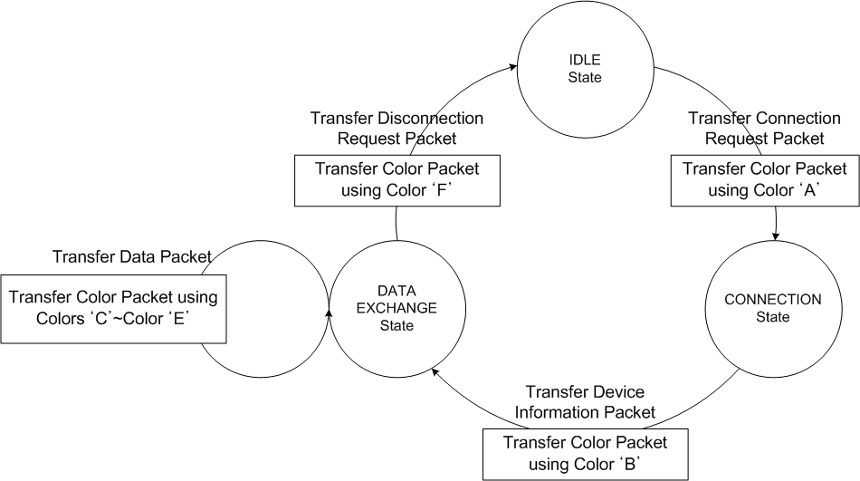
Figure 122 Color packet in device state diagram (CID 787)

This slide Figure 122(CID 788, 790) shows the device 1 state diagram in previous basic communication MAC state transition(CID 791) procedures . Each color packet is transferred during each state transition.
Error: Reference source not found and Error: Reference source not found show the communication state diagrams describing the previous basic communication procedures. Each color packet, according to the bandplan, can be transmitted during each state transition in Error: Reference source not found and Error: Reference source not found. In the case of an asymmetric data transfer, device 2 may not transmit color packets to device 1 during the transmission of the data packet.
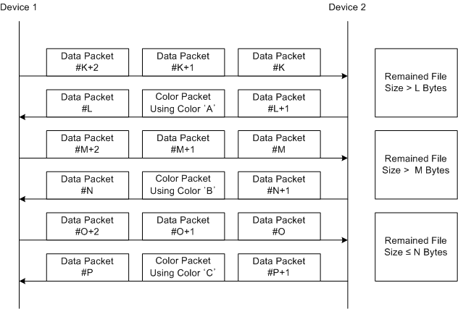
Figure 124 Color packet usage in file transfer application(CID 792, 793, 794, 796, 797)

Figure 124 and Figure 125 show other usages for color packets in VLC applications. Error: Reference source not found describes how the user can know the remaining or transferred file size through the color packet in VLC file transfer applications. Device 1 transfers some files to Device 2. When the remained file size, which is not transferred to Device 2, is more than L bytes, Device 2 transfers the color packet with color ‘A’. When remained file size, which is not transferred to Device 2, is less than L bytes and more than M bytes, it transfers the color packet with color ‘B’. When remained file sizes is less than N bytes, it transfers color packet with color ‘C’ (CID 792, 793, 794, 796, 797). Figure 125 describes how the user can know the quality of the data transmission or the communication quality, such as packet error rate (PER), through the color packet. The PER statistics need to be averaged over a long frame in order to choose the color packet. This information can help provide misalignment indication to the user. Different colors can be used to indicate different states of misalignment. For example, green, blue, and red color packets can be used to visualize low, middle, and high PER values, respectively.
- An example of a Color Status Table in Coarse Link Adaptation
Color of Color Packet | Data Transmission Quality | Action Item
Color “A” | Current PER < PER #1 | Increase the data rate
Color “B” | PER #1<= PER <= PER #2 | Hold the current data rate
Color “C” | Current PER => PER #2 | Decrease the data rate

Error: Reference source not found describes an example of color packet usage scheme (CID 795) to visualize the link adaptation status between two devices. A device can transmit the link adaptation information to a peer device through the color packet. User can also know the PER status based on Error: Reference source not found. The device receiving the color packet can change the data rate based on a color packet table, such as Error: Reference source not found because the device, as well as the user, can also detect the transmitted color packet. In table 89, color ‘A’ means the increase of data rate, color ‘B’ means that keep the current data rate, and color ‘C’ means the decrease of the data rate for peer device.(CID 795).
7.6.10.1 Color packet structure(CID 798, 799, 800)
The color packet header can include the indicators as follows. There can be an indicator indicating that the transmitted packet is just a color packet; that is, there is no data messages. It is also possible to have an indicator indicating whether the color packet include some messages for a peer device or not.
The Color Packet is defined in Color packet
Color Packet Header | Color Packet Pattern
- Color packet
.

