CID 20

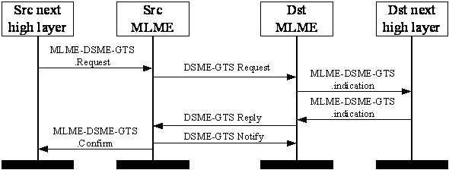
Figure 39.a ―Message sequence chart for DSME-GTS allocation/deallocation/reallocation

CID 79

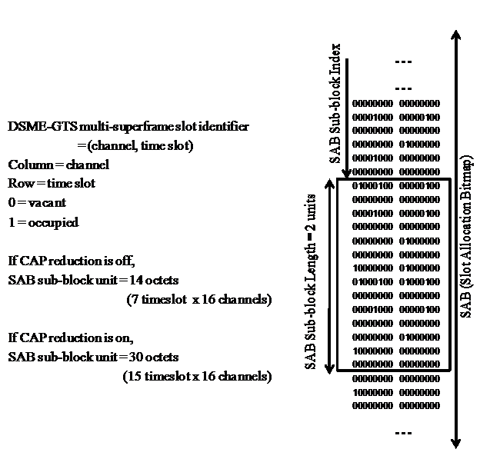

Figure 65.aa―SAB sub-block in Channel Adaptation Mode

CID 99

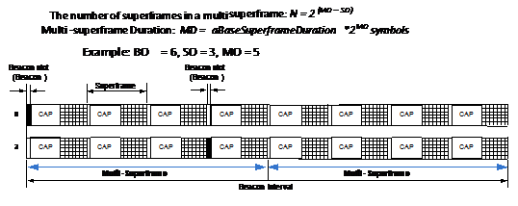
Figure 73.f—DSME-based multi-superframe structure

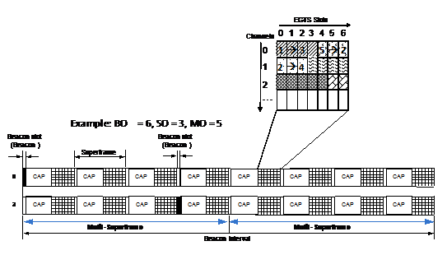
Figure 73.g—DSME-based multi-superframe structure

CID 111

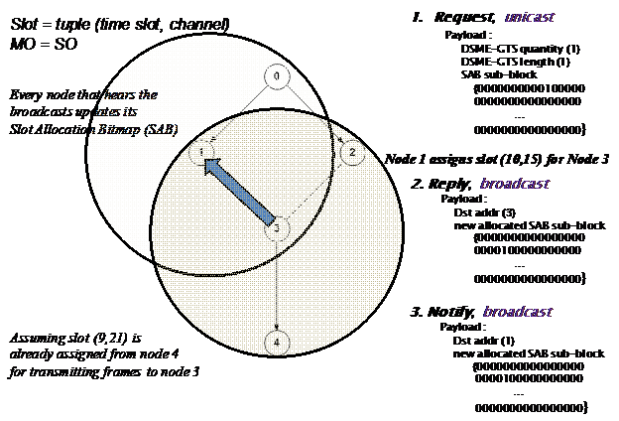

CID 1610 and CID 984

There are 5 modifications in the draft which need to be done to resolve comment CID 984 and 1610.

1. Replace the whole section of 7.1.20.4.4 with the following text:

7.1.20.4.4 MLME-DSME-INFO.indication
7.1.20.4.4.1 General
The MLME-DSME-INFO.indication primitive is used to indicate the reception of a DSME-GTS information request.
7.1.20.4.4.2 Semantics
The semantics of the MLME-DSME-INFO.indication primitive are as follows:
MLME-DSME-INFO.indication (
DeviceAddress,
SecurityLevel,
KeyIdMode,
KeySource,
KeyIndex
)
Table 78.?? specifies the parameters for the MLME-DSME-INFO.indication primitive.
Table 78.?? – MLME-DSME-INFO.indication parameters
Name | Type | Valid range | Description
DeviceAddress | Device address | An extended 64-bit IEEE address. | The address of the device requesting DSME-GTS information.

7.1.20.4.4.3 When generated
The MLME-DSME-INFO.indication primitive is generated by the MLME of the Destination device and issued to its next higher layer to indicate the reception of a DSME-GTS information request command.
7.1.20.4.4.4 Appropriate usage
When the next higher layer of a Destination device receives the MLME-DSME-INFO.indication primitive, the Destination device issues the MLME-DSME-INFO.response primitive to its MLME.

7.1.20.4.5 MLME-DSME-INFO.response
7.1.20.4.5.1 General
The MLME-DSME-INFO.response primitive is used to initiate a response to a MLME-DSME-INFO.indication primitive.
7.1.20.4.5.2 Semantics
The semantics of the MLME-DSME-INFO.response primitive are as follows:
MLME-DSME-INFO.response (
DeviceAddress,
Timestamp,
DSMECharacteristics,
SecurityLevel,
KeyIdMode,
KeySource,
KeyIndex
)
Table 78.?? specifies the parameters for the MLME-DSME-INFO.response primitive.
Table 78.?? — MLME-DSME-INFO.response parameters
Name | Type | Valid range | Description
DeviceAddress | Device address | An extended 64-bit IEEE address. | The address of the device requesting DSME-GTS information.
Timestamp | Integer | 0x000000–0xffffff | The time, in symbols, at which the DSME information reply command (see7.3.12.6) was transmitted.  The symbol boundary is described by macSyncSymbolOffset (see Table 86 in 7.4.1).  This is a 24-bit value, and the precision of this value shall be a minimum of 20 bits, with the lowest 4 bits being the least significant.
DSMECharacteristics | DSME Characteristics | See 7.3.12.4.3 | The characteristics of the DSME-GTS between Source device and Destination device. This value is correct only when DSME Characteristics Type subfield is 110. Otherwise, it indicates that Source device’s request for DSME-GTS information is fail.

7.1.20.4.5.3 Appropriate usage
The MLME-DSME-INFO.response primitive is generated by the next higher layer of a Destination device and issued to its MLME in order to respond to the MLME-DSME-INFO.indication primitive.
7.1.20.4.5.4 Effect on receipt
When the MLME of a Destination device receives the MLME-DSME-INFO.response primitive, it generates a DSME-GTS information reply command.

7.1.20.4.6 DSME information sequence chart
Figure 39.c illustrates the sequence of messages necessary for successful DSME-GTS information request. Figure 39.c depicts the messages flow for the case in which the Source device requests the timestamp and the DSME-GTS parameters from the Destination device.

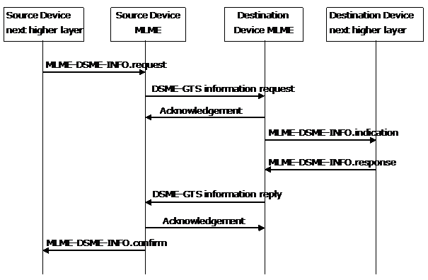

Figure 39.c - Message sequence chart for DSME-GTS information request

2.
Insert ‘SecurityLevel, KeyIdMode, KeySource, KeyIndex’ between Line 33 and 34 in Page 57 Section 7.1.20.4.3.2.

3.
Change ‘two (e.g., 16-bit short addressing)’ (L4&L19 P112) to ‘three (i.e., 64-bit extended addressing)’.

4.
Insert ‘DSME Characteristics field is correct only when DSME Characteristics Type subfield is 110. Otherwise, it indicates that Source device’s request for DSME-GTS information is fail.’ at the end of ‘7.3.12.6 DSME information reply command’ (P112).

5.
Delete ‘the DSME information reply command frame indicating a failure or’ (L34 P168).

CID 1612
Insert a new subclause “7.1.20.x MLME-DSME-SUPERFRAME” in the clause “7.1.20 DSME-specific MAC sublayer service specification”:
7.1.20.x.1 General
These primitives define how a device is instructed to request the parameters of superframe structure stored by Connection Device and notified of those parameters.
7.1.20.x.2 MLME-DSME-SUPERFRAME.request
7.1.20.x.2.1 General
The MLME-DSME-SUPERFRAME.request primitive allows the device to request the parameters of superframe structure stored by Connection Device.
7.1.20.x.2.2 Semantics
The semantics of the MLME-DSME-SUPERFRAME.request primitive are as follows:
MLME- DSME-SUPERFRAME.request (
DstAddrMode
DstAddr,
SecurityLevel,
KeyIdMode,
KeySource,
KeyIndex
)
Table x.1 specifies the parameters for the MLME-DSME-SUPERFRAME.request primitive.
Table x.1 – MLME-DSME-SUPERFRAME.request parameters
Name | Type | Valid Range | Description
DstAddrMode | Integer | 0x02–0x03 | The addressing mode of the Connection Device to which the request is intended. This parameter can take one of the following values:  0x02 = 16-bit short address,  0x03 = 64-bit extended address.
DstAddr | Device  address | As specified by the DstAddrMode parameter | The address of the Connection Device to which the request is intended.
7.1.20.x.2.3 Appropriate usage
The MLME-DSME-SUPERFRAME.request primitive is generated by the next higher layer of a device and issued to its MLME to request the parameters of superframe structure stored by Connection Device.
7.1.20.x.2.4 Effect on receipt
On receipt of the MLME-DSME-SUPERFRAME.request primitive, the MLME of the device generates a DSME superframe request command.
7.1.20.x.3 MLME-DSME-SUPERFRAME.indication
7.1.20.x.3.1 General
The MLME-DSME-SUPERFRAME.indication primitive is used to indicate the reception of a DSME superframe request command.
7.1.20.x.3.2 Semantics
The semantics of the MLME-DSME-SUPERFRAME.indication primitive are as follows:
MLME- DSME-SUPERFRAME.indication (
DeviceAddress,
SecurityLevel,
KeyIdMode,
KeySource,
KeyIndex
)
Table x.2 specifies the parameters for the MLME-DSME-SUPERFRAME.indication primitive.
Table x.2 – MLME-DSME-SUPERFRAME.indication parameters
Name | Type | Valid Range | Description
DeviceAddress | Device  address | An extended 64-bit IEEE address. | The address of the device requesting the parameters of superframe structure stored by Connection Device.
7.1.20.x.3.3 When generated
The MLME-DSME-SUPERFRAME.indication primitive is generated by the MLME of the Connection Device and issued to its next higher layer to indicate the reception of a DSME superframe request command.
7.1.20.x.3.4 Appropriate usage
When the next higher layer of the Connection Device receives the MLME-DSME-SUPERFRAME.indication primitive, the Connection Device determines whether it has the parameters. The next higher layer of the Connection Device then issues the MLME-DSME-SUPERFRAME.response primitive to its MLME.
7.1.20.x.4 MLME-DSME-SUPERFRAME.response
7.1.20.x.4.1 General
The MLME-DSME-SUPERFRAME.response primitive is used to initiate a response to an MLME-DSME-SUPERFRAME.indication primitive.
7.1.20.x.4.2 Semantics
The semantics of the MLME-DSME-SUPERFRAME.response primitive are as follows:
MLME- DSME-SUPERFRAME.response (
DeviceAddress,
BeaconOrder,
SuperframeOrder,
Multi-superframeOrder,
status,
SecurityLevel,
KeyIdMode,
KeySource,
KeyIndex
)
Table x.3 specifies the parameters for the MLME-DSME-SUPERFRAME.response primitive.
Table x.3 – MLME-DSME-SUPERFRAME.response parameters
Name | Type | Valid Range | Description
DeviceAddress | Device  address | An extended 64 bit IEEE address. | The address of the device requesting the parameters of superframe structure stored by Connection Device.
BeaconOrder | Integer | 0-15 | The parameters of superframe structure stored by Connection Device. Also see 7.5.10.1.1 for the explanation.
SuperframeOrder | Integer | 0-15
Multi-superframeOrder | Integer | 0-15
7.1.20.x.4.3 Appropriate usage
The MLME-DSME-SUPERFRAME.response primitive is generated by the next higher layer of the Connection Device and issued to its MLME in order to respond to the MLME-DSME-SUPERFRAME.indication primitive.
7.1.20.x.4.4 Effect on receipt
On receipt of the MLME-DSME-SUPERFRAME.response primitive, the MLME of the Connection Device generates a DSME superframe response command.
7.1.20.x.5 MLME-DSME-SUPERFRAME.confirm
7.1.20.x.5.1 General
The MLME-DSME-SUPERFRAME.confirm primitive is used to inform the next higher layer of the initiating device whether its request is successful.
7.1.20.x.5.2 Semantics
The semantics of the MLME-DSME-SUPERFRAME.confirm primitive are as follows:
MLME- DSME-SUPERFRAME.confirm (
BeaconOrder,
SuperframeOrder,
Multi-superframeOrder,
status,
SecurityLevel,
KeyIdMode,
KeySource,
KeyIndex
)
Table x.4 specifies the parameters for the MLME-DSME-SUPERFRAME.confirm primitive.
Table x.4 – MLME-DSME-SUPERFRAME.confirm parameters
Name | Type | Valid Range | Description
BeaconOrder | Integer | 0-15 | The parameters of superframe structure stored by Connection Device. Also see 7.5.10.1.1 for the explanation.
SuperframeOrder | Integer | 0-15
Multi-superframeOrder | Integer | 0-15
7.1.20.x.5.3 When generated
The MLME-DSME-SUPERFRAME.confirm primitive is generated by the initiating MLME and issued to its next higher layer in response to MLME-DSME-SUPERFRAME.request primitive.
7.1.20.x.5.4 Appropriate usage
On receipt of the MLME-DSME-SUPERFRAME.confirm primitive, the next higher layer of the initiating device is notified of the result of its request of the parameters of superframe structure stored by Connection Device.

Insert a new subclause “7.3.12.x DSME-Superframe request command” in the clause “7.3.12 DSME-commands”:
The superframe request command allows a device to request the parameters of superframe structure stored by Connection Device.
The superframe request command shall be formatted as illustrated in Figure x.1.
octets: | 1
MHR fields | Command Frame Identifier (see Table 82)
Figure x.1 – Superframe request command format
Both the Destination Addressing Mode subfield and the Source Addressing Mode subfield of the Frame Control field shall each be set to three (i.e., 64-bit extended addressing). The Destination Address field shall be the address of the Connection Device.

Insert a new subclause “7.3.12.y DSME-Superframe response command” in the clause “7.3.12 DSME-commands”:
The superframe response command allows the Connection Device to reply the results of the request for the parameters of superframe structure.
The superframe response command shall be formatted as illustrated in Figure y.1.
bits: | 8 | 4 | 4 | 4
MHR fields | Command Frame Identifier (see Table 82) | Beacon Order | Superframe Order | Multi-superframe Order
Figure y.1 – Superframe response command format
The Destination Addressing Mode and Source Addressing Mode subfields of the Frame Control field shall each be set to three (i.e., 64-bit extended addressing). The Destination Address field shall contain the extended address of the requesting device.
The Beacon Order field shall contain the value of BO stored by the Connection Device. The Superframe Order field shall contain the value of SO stored by the Connection Device. The Multi-superframe Order field shall contain the value of MO stored by the Connection Device. If Beacon Order field value equal to 15, Superframe Order field and Multi-superframe Order field shall be ignored.

(Please also update Table 82 for command frame identifiers of DSME-Superframe request command and ‘DSME-Superframe response command’.)

CID 1604 and CID 1473

Insert ‘7.1.20.8 MLME-DSME-ABTUPDATE’ after ‘7.1.20.7 DSME-Primitives for channel scanning’:
7.1.20.8 MLME-DSME-ABTUPDATE
7.1.20.8.1 DSME-Primitives for updating ABT
MLME-DSME-ABTUPDATE defines how a device can update its ABT. All DSME-devices shall provide an interface for these ABT update primitives.
7.1.20.8.2 MLME-DSME-ABTUPDATE.request
7.1.20.8.2.1 General
The MLME-DSME-ABTUPDATE.request primitive allows a device to inquiry the availability of a certain part of ABT in its neighbors.
7.1.20.8.2.2 Semantics
The semantics of the MLME-DSME-ABTUPDATE.request primitive are as follows:
MLME-DSME-ABTUPDATE.request (
DSMEABTSpecification,
SecurityLevel,
KeyIdMode,
KeySource,
KeyIndex
)
Table 78.x1 specifies the parameters for the MLME-DSME-ABTUPDATE.request primitive.
Table 78.x1 - MLME-DSME-ABTUPDATE.request parameters
Name | Type | Valid range | Description
DSMEABTSpecification | Bitmap | See 7.3.12.4.5 | The allocation bitmap table of the DSME-GTS slots which are marked as unavailable but may have the incorrect status. The selection criteria of the DSME-GTS slots are out of the scope of this standard.

7.1.20.8.2.3 Appropriate usage
The MLME-DSME-ABTUPDATE.request primitive is generated by the next higher layer of a device and issued to its MLME when the device wants to update its ABT with its neighbors.

7.1.20.8.2.4 Effect on receipt
On receipt of the MLME-DSME-ABTUPDATE.request primitive by a device, the MLME of the device generates and sends a DSME-ABT update request command. The DSME-ABT update request command is generated with the DSME ABT Specification in the DSMEABTSpecification parameter.

7.1.20.8.3 MLME-DSME-ABTUPDATE.indication
7.1.20.8.3.1 General
The MLME-DSME-ABTUPDATE.indication primitive is used to indicate the reception of a DSME-ABT update request.
7.1.20.8.3.2 Semantics
The semantics of the MLME-DSME-ABTUPDATE.indication primitive are as follows:
MLME-DSME-ABTUPDATE.indication (
DeviceAddress,
DSMEABTSpecification,
SecurityLevel,
KeyIdMode,
KeySource,
KeyIndex
)
Table 78.x2 specifies the parameters for the MLME-DSME-ABTUPDATE.indication primitive.
Table 78.x2 – MLME-DSME-ABTUPDATE.indication parameters
Name | Type | Valid range | Description
DeviceAddress | Device address | An extended 64-bit IEEE address. | The address of the device requesting the ABT status in its neighbors.
DSMEABTSpecification | Bitmap | See 7.3.12.4.5 | The allocation bitmap table of the DSME-GTS slots which are marked as unavailable but may have the incorrect status of the requesting device.

7.1.20.8.3.3 When generated
The MLME-DSME-ABTUPDATE.indication primitive is generated by the MLME of the device and issued to its next higher layer to indicate the reception of a DSME-ABT update request command.
7.1.20.8.3.4 Appropriate usage
When the next higher layer of a device receives the MLME-DSME-ABTUPDATE.indication primitive, it first checks whether all or part of the DSME-GTS slots contained in DSMEABTSpecification are being used. If so, the device issues the MLME-DSME-ABTUPDATE.response primitive to its MLME. Otherwise, the device ignores the MLME-DSME-ABTUPDATE.indication primitive.

7.1.20.8.4 MLME-DSME-ABTUPDATE.response
7.1.20.8.4.1 General
The MLME-DSME-ABTUPDATE.response primitive is used to initiate a response to a MLME-DSME-ABTUPDATE.indication primitive.
7.1.20.8.4.2 Semantics
The semantics of the MLME-DSME-ABTUPDATE.response primitive are as follows:
MLME-DSME-ABTUPDATE.response (
DeviceAddress,
DSMEABTSpecification,
SecurityLevel,
KeyIdMode,
KeySource,
KeyIndex
)
Table 78.x3 specifies the parameters for the MLME-DSME-ABTUPDATE.response primitive.
Table 78.x3 — MLME-DSME-ABTUPDATE.response parameters
Name | Type | Valid range | Description
DeviceAddress | Device address | An extended 64-bit IEEE address. | The address of the device requesting the ABT status in its neighbors.
DSMEABTSpecification | Bitmap | See 7.3.12.4.5 | The allocation bitmap table of the DSME-GTS slots which are contained in the DSMEABTSpecification parameter of MLME-DSME-ABTUPDATE.indication primitive but being used by the device.

7.1.20.8.4.3 Appropriate usage
The MLME-DSME-ABTUPDATE.response primitive is generated by the next higher layer of a device and issued to its MLME in order to respond to the MLME-DSME-ABTUPDATE.indication primitive.
7.1.20.8.4.4 Effect on receipt
When the MLME of a device receives the MLME-DSME-ABTUPDATE.response primitive, it generates a DSME-ABT update response command.

7.1.20.8.5 MLME-DSME-ABTUPDATE.confirm
7.1.20.8.5.1 General
The MLME-DSME-ABTUPDATE.confirm primitive reports the DSME-GTS slots which are being used by the device’s neighbor.
7.1.20.8.5.2 Semantics
The semantics of the MLME-DSME-ABTUPDATE.confirm primitive are as follows:
MLME-DSME-ABTUPDATE.confirm (
DSMEABTSpecification,
SecurityLevel,
KeyIdMode,
KeySource,
KeyIndex
)
Table 78.x4 specifies the parameters for the MLME-DSME-ABTUPDATE.confirm primitive.
Table 78.x4— MLME-DSME-ABTUPDATE.confirm parameters
Name | Type | Valid range | Description
DSMEABTSpecification | Bitmap | See 7.3.12.4.5 | The allocation bitmap table of the DSME-GTS slots which are contained in the DSMEABTSpecification parameter of MLME-DSME-ABTUPDATE.request primitive but being used by its neighbor.

7.1.20.8.5.3 When generated
The MLME-DSME-ABTUPDATE.confirm primitive is generated by the MLME and issued to its next higher layer in response to a MLME-DSME-ABTUPDATE.request primitive.
7.1.20.8.5.4 Appropriate usage
On receipt of the MLME-DSME-ABTUPDATE.confirm primitive the next higher layer is notified of the DSME-GTS slots which are being used by its neighbor. Then the device updates the ABT status of the DSME-GTS slots which are contained in the DSMEABTSpecification parameter of MLME-DSME-ABTUPDATE.request but not contained in the DSMEABTSpecification parameter of MLME-DSME-ABTUPDATE.confirm from unavailable to available.

7.1.20.8.6 ABT update sequence chart
Figure 39.e illustrates the sequence of messages necessary for successful ABT update.
Acknowledgement
Acknowledgement
Device next higher layer
Device MLME
Neighbor device MLME
Neighbor device next higher layer
MLME-DSME-ABTUPDATE.request
MLME-DSME-ABTUPDATE.indication
MLME-DSME-ABTUPDATE.response
MLME-DSME-ABTUPDATE.confirm
DSME-ABT update request
DSME-ABT update response
Any DSME-GTS slots are being used?
Yes
Figure 39.e - Message sequence chart for ABT update

Insert ‘7.3.12.13 DSME-ABT update request command’ and ‘7.3.12.14 DSME-ABT update response command’ after ‘7.3.12.12 DSME-Channel probe command’:
7.3.12.13 DSME-ABT update request command
The DSME-ABT update request command is used by a device to inquiry the availability of a certain part of ABT in its neighbors.
The DSME-ABT update request command shall be formatted as illustrated in Figure 65.oo.
octets: (see 7.2.2.4) | 1 | variable (see 7.3.12.4.5)
MHR fields | Command Frame Identifier (see Table 82) | DSME ABT Specification
Figure 65.oo – DSME-ABT update request command format
The Destination Addressing Mode and the Source Addressing Mode subfields of the Frame Control field shall both be set to three (i.e., 64-bit short addressing).
The Frame Pending subfield of the Frame Control field shall be set to zero and ignored upon reception, and the Acknowledgment Request subfield of the Frame Control field shall be set to one.
The Source PAN Identifier subfield shall contain the value of macPANId, and the Source Address subfield shall contain the value of macShortAddress.
The Destination PAN Identifier subfield shall contain the broadcast PAN identifier of 0xffff, and the Destination Address subfield shall contain the broadcast address of 0xffff.

7.3.12.14 DSME-ABT update response command
The DSME-ABT update response command is used by a device to reply the ABT of DSME-GTS slots which are inquired by its neighbor and being used by itself.
The DSME-ABT update response command shall be formatted as illustrated in Figure 65.pp.
octets: (see 7.2.2.4) | 1 | variable (see 7.3.12.4.5)
MHR fields | Command Frame Identifier (see Table 82) | DSME ABT Specification
Figure 65.pp – DSME-ABT update response command format
The Destination Addressing Mode and the Source Addressing Mode subfields of the Frame Control field shall both be set to three (i.e., 64-bit short addressing).
The Frame Pending subfield of the Frame Control field shall be set to zero and ignored upon reception, and the Acknowledgment Request subfield of the Frame Control field shall be set to one.
The Source PAN Identifier subfield shall contain the value of macPANId, and the Source Address subfield shall contain the value of macShortAddress.
The Destination PAN Identifier subfield shall contain the identifier of the PAN to which to reply the ABT status, and the Destination Address subfield shall contain the address of the device inquiring the ABT status.

Insert ‘7.5.10.25 ABT update’ after ‘7.5.10.24 Three-way Handshake Channel Probe’:
7.5.10.25 ABT update
A device updates its ABT to reflect its neighbors’ deallocated DSME-GTS slots only when it receives the DSME deallocation reply command or DSME deallocation notify command. Both commands are transmitted by broadcasting. So it’s probable for a device not updating its ABT timely and correctly.
So when a device considers that some of the DSME-GTS slots may be marked as unavailable in its ABT incorrectly, it shall be instructed to inquire these DSME-GTS slots’ status in the ABT of its neighbors through MLME-DSME-ABTUPDATE.request primitive.
To inquire its neighbors’ ABT, the MLME of the device shall broadcast a DSME-ABT update request command to its neighbors. The DSME-ABT update request command contains the ABT of DSME-GTS slots which are marked as unavailable but may have the incorrect status. The selection criteria of the DSME-GTS slots are out of the scope of this standard.
On receipt of a DSME-ABT update command, the next higher layer of the neighbor device shall determine whether all or part of the ABT contained in the command is being used by itself. If so, the neighbor device sends a DSME-ABT update response command including the ABT of the DSME-GTS slots which are being used by itself to the requesting device. Otherwise, the neighbor device ignores the DSME-ABT update request command.
After sending the DSME-ABT update request command, the device shall wait for macResponseWaitTime symbols. If a DSME-ABT update response command is received during this duration of time, the MLME of the device shall notify the next higher layer of the DSME-GTS slots contained in the DSME-ABT update response command. This notification is achieved when the MLME issues the MLME-DSME-ABTUPDATE.confirm primitive.
Then the device shall change its ABT status of the DSME-GTS slots which are contained in the DSMEABTSpecification parameter of MLME-DSME-ABTUPDATE.request but not contained in the DSMEABTSpecification parameter of MLME-DSME-ABTUPDATE.confirm from unavailable to available. If the device receives nothing, it shall change all the ABT contained in the DSMEABTSpecification parameter of MLME-DSME-ABTUPDATE.request from unavailable to available.

Proposed Resolution for Comments Related to Group ACK Mechanism

IEEE P802.15
Wireless Personal Area Networks

Project | IEEE P802.15 Working Group for Wireless Personal Area Networks (WPANs)
Title | Proposed Resolution for Comments Related to Group ACK Mechanism.doc
Date Submitted | [6 July, 2010]
Source | [Ghulam Bhatti]  [MERL]  [201 Broadway, Suit 8, Cambridge, MA 02139] | Voice: [ 617-621-7513 ]  Fax: [ 617-621-7550 ]  E-mail: [ gbhatti@merl.com]
Re:
Abstract | [This document proposes changes in the TG4 draft specification in order to resolve GACK related comments. ]
Purpose | [Submit to the P802.15.4e Working Group]
Notice | This document has been prepared to assist the IEEE P802.15. It is offered as a basis for discussion and is not binding on the contributing individual(s) or organization(s). The material in this document is subject to change in form and content after further study. The contributor(s) reserve(s) the right to add, amend or withdraw material contained herein.
Release | The contributor acknowledges and accepts that this contribution becomes the property of IEEE and may be made publicly available by P802.15.

Proposed Comment Resolution (Related to GACK Mechanism)

Info for editors:
- Currently Group ACK mechanism is not described in a systematic way. Bits and pieces are scattered around. Specifically, its use in LL mode and DSME mode is confusing. A better description that follows IEEE style can be devised as follows.
- The frame structure for GACK has been moved into section 7.2.2.3. This section already has description of different frame structures including ACK farme. Since GACK frame follows the same general structure as for ACK frame (as specified in Figure 53 on page 72 of R7 specification), we only need to describe MAC payload for the GACK frame. The structure for the MHR for GACK frame is shared with a normal ACK frame. We need to add a new section 7.2.2.3.3.
- Section 7.2.3.1.4.5 is then updated. That section describes how GACK is used in short frame format of LL mode.
- Section 7.2.4.2.5 is modified too. That section describes how GACK frame will be used in DSME mode.

+++++++++++++++++++++++++++++++++++++++++++++++++++++++
*Add the following sub-section*
7.2.2.3.3 Group Acknowledgement (GACK) frame

7.2.2.3.3.1 General

A Group ACK frame is meant for reducing the communication overhead in a network. Instead of transmitting an ACK frame for individual data frames received in each GTS, a coordinator device, if using the GACK mechanism, shall acknowledge the reception of multiple data frames by transmitting only a single GACK frame. A Group ACK frame shall follow the same general structure as the acknowledgement frame, as defined in Figure 53 in section 7.2.2.3. However, the GACK frame shall have its own MAC payload sub-field. The structure of MAC payload in a GACK frame is described in the following sub-section. It may, however, be mentioned that some of these fields may not be used in the short frame structure used for LL mode.

7.2.2.3.3.2 Group ACK frame control field

Specifically, Ack. Control field for a GACK frame shall have the following format.

Ack. Identifier
Payload Size
bits: 0-2
Reserved
3-4
Bitmap Size
7
5-6

Figure XXX – Group ACK control field

Ack Identifier: As described in section 7.2.2.3.2.2.2, a value of 0x02 for ACK Identifier subfield of Acknowledgement Control Field distinguishes a GACK frame from a normal individual ACK frame.

Payload Size: This field shall specify the length of the payload of a GACK frame. It is measured in number of octets.

Bitmap Size: This field shall specify the size of bitmap in terms of octets. The maximum number of bits in the bitmap could be thirty-two.

7.2.2.3.3.3 Group ACK frame payload field

The acknowledgement frame payload field for GACK specifies the information that is needed while constructing a group acknowledgement frame. A GACK frame is used for acknowledging a successful reception of multiple GTS frames by a coordinator. In a normal operational mode, the receiver node individually acknowledges each successfully received GTS frame. However, repeated switching over between Rx and Tx modes by the receiver is costly and time consuming. The concept of group acknowledgement allows the receiver to receive all scheduled GTS frames, while withholding individual acknowledgements, and then transmit a single ACK frame to acknowledge all successfully received frames. Moreover, a GACK frame can also specify additional timeslots for the failed GTS transmissions to be retransmitted in the extended CFP. That is, a group acknowledgement not only indicates the reception status for a group of GTS data frames but it also specifies new slot allocations, if any, for retransmission of failed GTS transmissions.

The structure of the Acknowledgement Payload field of the group acknowledgement frame is shown in Figure 53.t.

Ack. Control
GACK Index
GACK Device List
GACKBitmap
PAN ID
Octets:
GTS Directions
2
1|2
Variable
Variable
Variable
1

Figure 53.t— MAC payload field GACK frame

Ack. Control: as specified in Section 7.2.2.3.2.2.2.
PAN ID: This field shall identify the PAN of the transmitting coordinator.
GACK Bitmap: This shall be a bitmap of size as specified by ‘Bitmap Size’ field in Ack. Control as described in Section 7.2.2.3.3.2. The bitmap shall indicate the state of transmissions during the CFP or ECFP of the current superframe. A bit set to ‘1’ shall indicate the fact that the coordinator received the data frame successfully in the corresponding GTS. A ‘0’, on the other hand, shall mean that the coordinator failed in receiving a data frame in the corresponding time slot. . It is important to note that this field may have some unused bits that were actually padded to make the bitmap size a multiple of eight.
GACK Device List: This list identifies the sensor nodes that are being allocated the time slots in ECFP
portion of the superframe. This field shall be non-existent in the GACK frame in LL mode.
GACK Index: It is a list that specifies the start of each GTS for the allocated nodes in the same order as in
DSME device list. This field is applicable only in those systems that allow a GTS to consist of multiple
time slots. This field shall be non-existent in a system operating in LL mode or that does not allow frequency channel hopping.
GTS Directions: This list specifies the direction of transmission (uplink or downlink) for each GTS.
This is applicable only in the systems that allow the coordinator to transmit a frame to its sensor nodes by
using a GTS. This field shall be non-existent in the GACK frame in LL mode.

*Add the following text at the start of line 14, page 81.*

“The general structure of a GACK frame is specified in section 7.2.2.3.3. However, short frame structure used in LL mode shall use a shortened structure for the GACK frame. Specifically, a GACK frame in LL mode shall use the same acknowledgement frame MHR field as described above in section 7.2.3.1.4.”

*Replace text from line 24, page 87 through line 16, page 88 with following text*
“structure of a GACK frame is specified in section 7.2.2.3.3. The beacon frame transmitted by a DSME coordinator shall indicate if the GACK mechanism is being used for acknowledging the reception of data frames. Specifically, by setting appropriate value to GACK Flag (bit 32 in Figure 53.p) in a DSME beacon frame, as described in Section 7.2.4.2.2.10, shall indicate if the coordinator will transmit individual ACK frames or a GACK frame for acknowledging the received data frames.”

*Add the following text at line 20, page 88*
“Some or all devices with failed transmissions, as indicated by the bitmap, can potentially be allocated another time slot in the extended CFP (ECFP) portion of the superframe. GACK Device List field in the MAC payload shall contain a list of all such devices. If the list has at least one device in it, the ECFP shall immediately follow the GACK frame. Otherwise, ECFP portion shall be non-existent. If ECFP is not non-existent, then another GACK frame shall follow to inform the transmitting nodes of the status of reception for their retransmissions.”

*Remore Figure 53.t*

