IEEE P802.15
Wireless Personal Area Networks

Project | IEEE P802.15 Working Group for Wireless Personal Area Networks (WPANs)
Title | LB51 OFDM Comment Res’s for several PSDU issues.
Date Submitted | [24 June 2010]
Source | [Cheolho SHIN, Mikyung Oh and  Sangsung CHOI]  [ETRI] | Voice: [ ]  Fax: [ ]  E-mail:  [chshin@etri.re.kr  ohmik@etri.re.kr  sschoiQetri.re.kr]
Re:
Abstract | Working doc of OFDM Comment Resolutions
Purpose | Comment Resolution
Notice | This document has been prepared to assist the IEEE P802.15. It is offered as a basis for discussion and is not binding on the contributing individual(s) or organization(s). The material in this document is subject to change in form and content after further study. The contributor(s) reserve(s) the right to add, amend or withdraw material contained herein.
Release | The contributor acknowledges and accepts that this contribution becomes the property of IEEE and may be made publicly available by P802.15.

PHY Payload Symbol 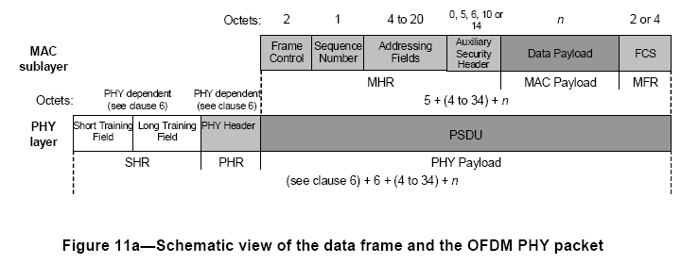

- Propose the composition of PSDU

- Propose the block diagram of PHY header construction

- Propose the Scrambler structure
g(D) = 1 + D¹⁴ + D¹⁵
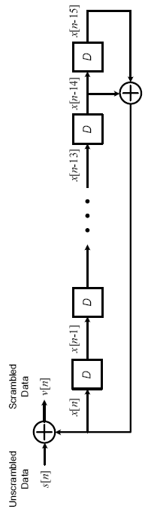

Seed identifier (b₀,b₁) | Seed value (x₁₄ … x₀)
0,0 | 0011 1111 1111 1111
0,1 | 0111 1111 1111 1111
1,0 | 1011 1111 1111 1111
1,1 | 1111 1111 1111 1111

