IEEE P802.15
Wireless Personal Area Networks

Project | IEEE P802.15 Working Group for Wireless Personal Area Networks (WPANs)
Title | LB51 OFDM Comment Res’s for Pilot sets Cycle.
Date Submitted | [24 June 2010]
Source | [Cheolho SHIN, Mikyung Oh and  Sangsung CHOI]  [ETRI] | Voice: [ ]  Fax: [ ]  E-mail:  [chshin@etri.re.kr  ohmik@etri.re.kr  sschoiQetri.re.kr]
Re:
Abstract | Working doc of OFDM Comment Resolutions
Purpose | Comment Resolution
Notice | This document has been prepared to assist the IEEE P802.15. It is offered as a basis for discussion and is not binding on the contributing individual(s) or organization(s). The material in this document is subject to change in form and content after further study. The contributor(s) reserve(s) the right to add, amend or withdraw material contained herein.
Release | The contributor acknowledges and accepts that this contribution becomes the property of IEEE and may be made publicly available by P802.15.

- Propose the Pliot sets Cycle
Proposal 1: No use of Pilot sets Cycle
- Remain Pilot set 1
- Remove Pilot set 2 and 3

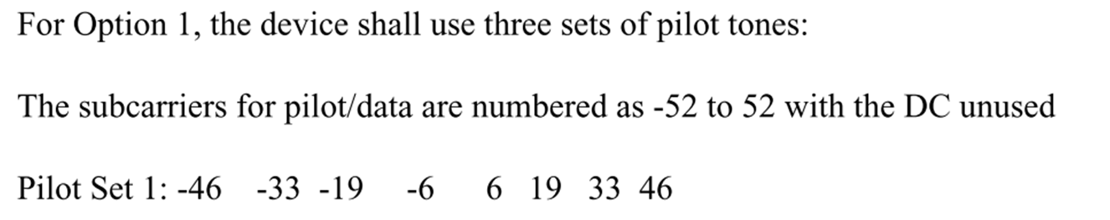

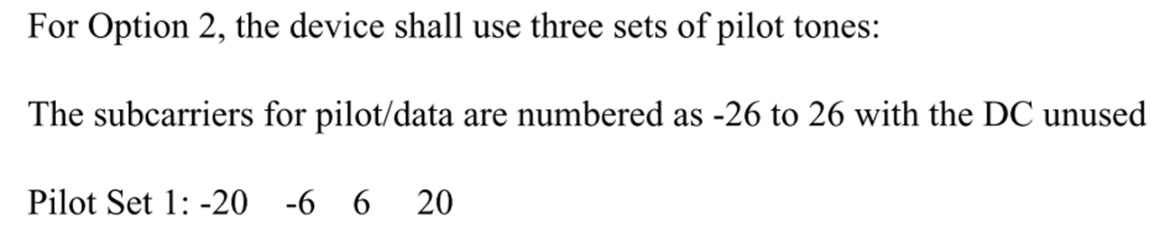
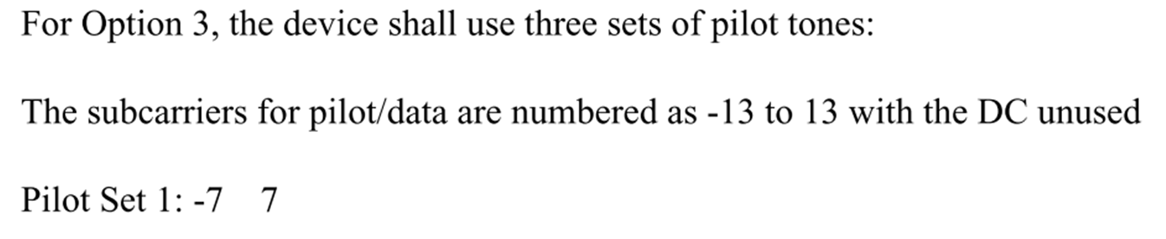
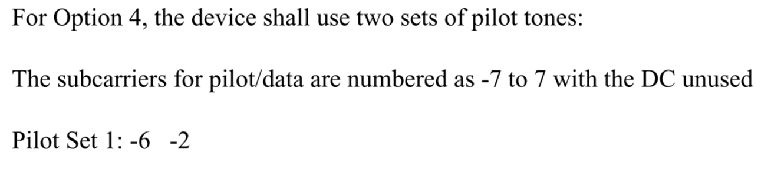
-> Modify from Pilot set : -6 -2 to Pilot set : -6 2
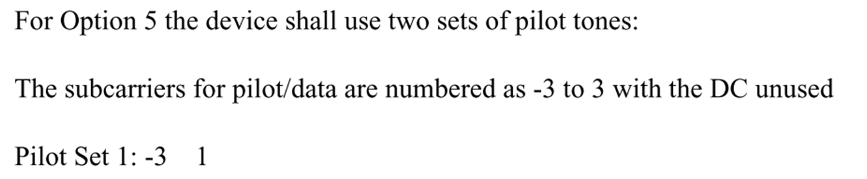
Proposal 2: Modified the Pilot sets Cycle

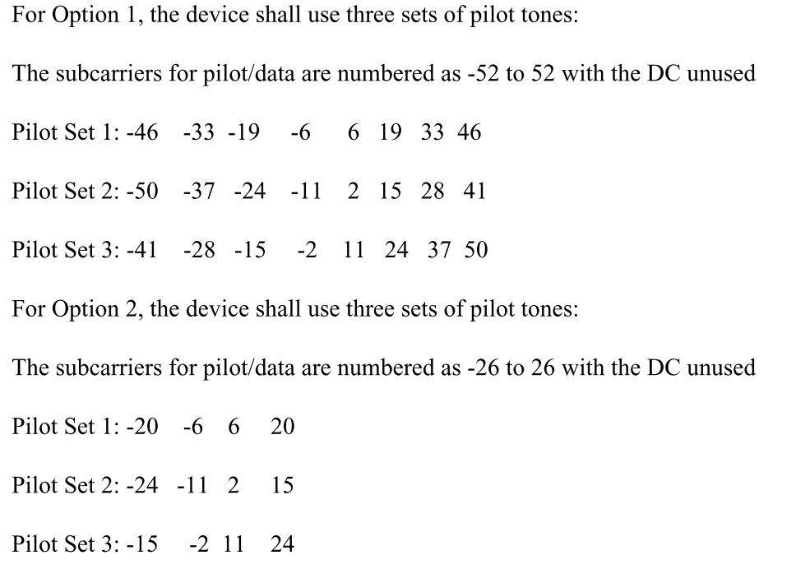
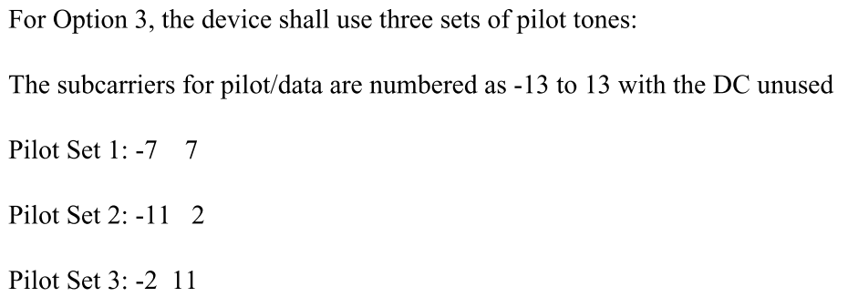
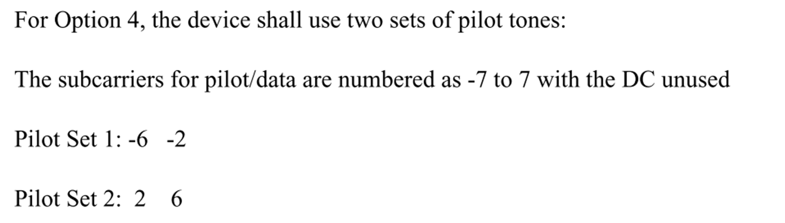
-> Modify from Pilot set1 : -6 -2 to Pilot set1 : -6 2
from Pilot set2 : 2 6 to Pilot set2 : -2 6
