IEEE P802.15
Wireless Personal Area Networks

Project | IEEE P802.15 Working Group for Wireless Personal Area Networks (WPANs)
Title | LB51 OFDM Comment Res’s for Interleaver, Pad bits and the number of symbols.
Date Submitted | [24 June 2010]
Source | [Cheolho SHIN, Byounghak Kim and Sangsung CHOI]  [ETRI] | Voice: [ ]  Fax: [ ]  E-mail:  [chshin@etri.re.kr  byounghak@etri.re.kr  sschoiQetri.re.kr]
Re:
Abstract | Working doc of OFDM Comment Resolutions
Purpose | Comment Resolution
Notice | This document has been prepared to assist the IEEE P802.15. It is offered as a basis for discussion and is not binding on the contributing individual(s) or organization(s). The material in this document is subject to change in form and content after further study. The contributor(s) reserve(s) the right to add, amend or withdraw material contained herein.
Release | The contributor acknowledges and accepts that this contribution becomes the property of IEEE and may be made publicly available by P802.15.

- Modify the Interleaver coefficients

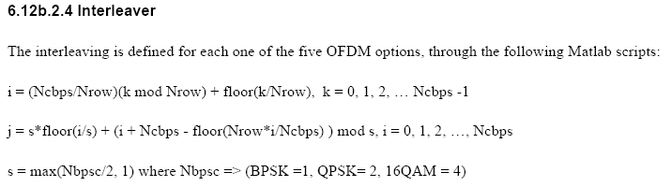

Nrow = 12;
OFDM Option 1:
Ncbps = 96 *Nbpsc
OFDM Option 2:
Ncbps = 48 *Nbpsc
OFDM Option 3:
Ncbps = 24 *Nbpsc
OFDM Option 4:
Ncbps = 12 *Nbpsc
OFDM Option 5:
Ncbps = 6 *Nbpsc

- Propose the generation formulas for PAD bits and the number of symbols

NCBPS = Ncbps
NDBPS = NCBPS * R
NPAD = NDBPS * ceiling ((8*LENGTH + 6)/NDBPS) - (8*LENGTH + 6)
NSYM = NsF * ceiling ((8*LENGTH + 6)/NDBPS)
-R: Coding rate
-NsF: Spreading Factor of FDS
-Ncbps: Coded Bits per OFDM symbol at interleaver
-NCBPS : Coded Bits per NsF OFDM symbols at IFFT
-NDBPS : DATA Bits per NsF OFDM symbols at IFFT

Examples for PHY Header of Option 1 and 2

Option 1
NCBPS= 96
NDBPS= 48
NPAD = 48 * ceil (36/48) - (36) = 12
NSYM = 4 * ceil (36/48) = 4

Option 2
NCBPS= 48
NDBPS= 24
NPAD = 24 * ceil (36/24) - (36) = 12
NSYM = 4 * ceil (36/24) = 4 *2 = 8

- Refer the following document for the detailed explanation.
- 15-10-0501-00-004g-A proposal of Comment resolutions for Interleaver and Pad bits in OFDM Group

