IEEE P802.15
Wireless Personal Area Networks

Project | IEEE P802.15.7 Task Group Visible Light Communication (TG-VLC)
Title | Comment CID 481 and proposed resolution
Date Submitted | 20 June 2010
Source | [Taehan Bae, Jaeseung Son, Sridhar Rajagopal,]  [Samsung Electronics.Co., Ltd.]  [Suwon, Korea] | Voice: []  Fax: []  E-mail: [taehan.bae@samsung.com]
Re:
Abstract | Proposed resolution about comment CID 481 and scrambler definition
Purpose | Contribution to IEEE 802.15.7 TG-VLC
Notice | This document has been prepared to assist the IEEE P802.15. It is offered as a basis for discussion and is not binding on the contributing individual(s) or organization(s). The material in this document is subject to change in form and content after further study. The contributor(s) reserve(s) the right to add, amend or withdraw material contained herein.
Release | The contributor acknowledges and accepts that this contribution becomes the property of IEEE and may be made publicly available by P802.15.

Technical comment CID 481

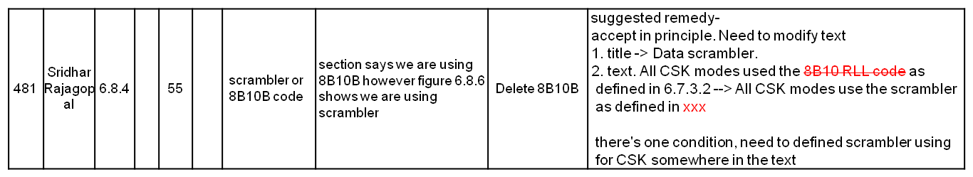

* During the last Conference call,
- agree with “Taehan’s suggested remedy” from 10/386r0
- except the definition of the scrambler
- Need more work: define scrambler
- refe: 15-10-0388-00-0007-concall-minutes-may10-july10.doc

* Suggested definition of the scrambler.
Need correct the table and figure number properly along with D2 draft.

=============================================
Data scrambler

A scrambler shall be used to ensure pseudo-random data for the PHY type 3. The scrambler shall be applied to the entire PSDU. In addition, the scrambler shall be initialized to a seed value dependent on the topology dependent pattern at the beginning of the PSDU. The polynomial generator, g(D), for the pseudo-random binary sequence (PRBS) generator shall be: g(D) = 1 + D¹⁴ + D¹⁵, where D is a single bit delay element. Using this generator polynomial, the corresponding PRBS, x[n], is generated as

x[n] = x[n − 14]x[n − 15], n = 0, 1, 2, …

where “” denotes modulo-2 addition. The following sequence defines the initialization vector, x_{init}, which is specified by the parameter “seed value” in Table 29:

x_{init} = [x_{i}[-1] x_{i}[-2] … x_{i}[-14]x_{i}[-15]], ………….
where x_{i}[−k] represents the binary initial value at the output of the k^{th} delay element. The
scrambled data bits, v_{m}, are obtained as defined in Figure 18:

v[m] = s[m] x[m], m = 0, 1, 2, …

where s[m] represents the non-scrambled data bits. The side-stream de-scrambler at the receiver shall be initialized with the same initialization vector, x_{init}, used in the transmitter scrambler. The initialization vector is determined from the TDP.

The 15-bit initialization vector or seed value shall correspond to the seed identifier as defined in Table 29, corresponding to the TDP pattern. The seed values shall be incremented in a roll-over fashion for each frame sent by the PHY.

Topology Dependent Pattern | Seed Value  xinit = xi[-1] xi[-2]… xi[-15] | PRBS Output  First 16 bits  x[0] x[1] … x[15]
P1 | 0011 1111 1111 111 | 0000 0000 0000 1000
P2 | 0111 1111 1111 111 | 0000 0000 0000 0100
P3 | 1011 1111 1111 111 | 0000 0000 0000 1110
P4 | 1111 1111 1111 111 | 0000 0000 0000 0010

Table 29 - Scrambler Seed Selection

All consecutive packets, including retransmissions, shall be sent with a different initial seed value.

Figure 18. Block diagram of the scrambler

===============================================

