IEEE P802.15
Wireless Personal Area Networks

Project | IEEE P802.15 Working Group for Wireless Personal Area Networks (WPANs)
Title
Date Submitted | July 2010
Source | Mark Wilbur | Voice: 01 440 528 7471  Fax: 01 440 528 7199  E-mail: mwilbur@aclara.com
Re:
Abstract | IEEE 802.15 Task Group TG4g Comment Resolution
Purpose
Notice | This document has been prepared to assist the IEEE P802.15. It is offered as a basis for discussion and is not binding on the contributing individual(s) or organization(s). The material in this document is subject to change in form and content after further study. The contributor(s) reserve(s) the right to add, amend or withdraw material contained herein.
Release | The contributor acknowledges and accepts that this contribution becomes the property of IEEE and may be made publicly available by P802.15.

The document provides resolution for the following comments:
1599-1603,1618-1626,1628,1630-1636,1759,1762-1765

Editorial note: Modify 5.3.9a and 7.3.9a&b&c as follows

5.3.9a Request to Join (RTJ)
The RTJ request defined in 7.3.9a provides a low energy discovery mechanism that can be used by an unassociated device to periodically transmit the RTJ, providing a mechanism for a joining device to make itself known. The RTJ request is used by an unassociated device to communicate to a network associated device or coordinator that it wishes to and is capable of joining an existing PAN. When used, the RTJ command shall be sent by an unassociated device using the CPM defined in 5.2a

5.3.9b Request to Join Response (RTJR)
The RTJR defined in 7.3.9b is issued by a network associated device or coordinator upon receipt of the RTJ request from an un-associated device. The RTJR acknowledges the RTJ request and provides the current PHY mode of operation (phyCurrentSUNPageEntry) currently in use by the network associated device and includes the DefaultHoppingSequence information. Following the successful reception of the RTJR command, the joining device will use the PHY mode attributes received in the RTJR to perform the standard association process defined in7.1.3. The use of a pseudorandom RTJR transmission delay may be utilized to limit the number of simultaneous responses from neighboring nodes. Figure 103c shows an example of a RTJ/RTJR packet sequence using the CPM

5.3.9c RTJR Support for Association in Frequency Hopping Networks
The RTJR response includes a DefaultHoppingSequence field defined in 7.3.9b that is comprised of a sequence of channels that could be used to support the frequency hopping association process defined in 7.1.3. Channel hopping synchronization could be achieved by requiring that the node joining the network monitor the first channel of the RTJR defined DefaultHoppingSequence until the network node transmission is detected. Following the successful association both the network device and the newly associated device may chose to utilize a different unique frequency hopping sequence.

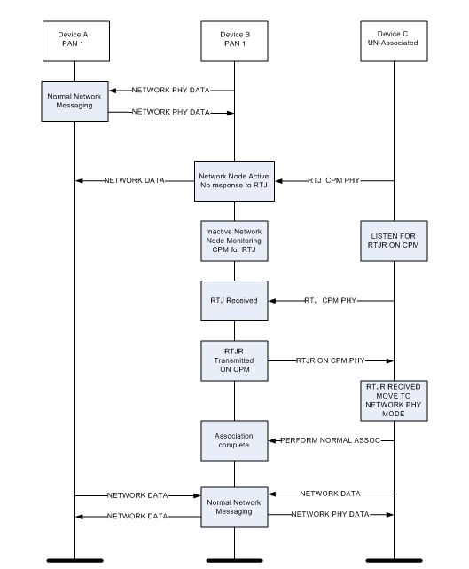

Figure 103c RTJ/RTJR packet sequence

7.3.9a Request to join (RTJ) command
The RJT command is formatted as illustrated in Figure 103a.
octets: (see 7.2.2.4) | 1
MHR fields | Command  Frame Identifier  (see Table 123)

Figure 103a—RTJ command format
7.3.9a.1 MHR fields
The source addressing mode subfield of the frame control field shall be set to three ( 64-bit extended addressing). The destination addressing mode subfield of the frame control field shall be set to two (i.e.,16-bit short addressing).The frame pending subfield of the frame control field shall be set to zero on transmission and ignored upon reception. The acknowledgment request subfield and security enabled subfield shall be set to zero. The destination PAN identifier field shall contain the broadcast PAN identifier (i.e., 0xffff). The destination address field shall contain the broadcast short address (i.e., 0xffff). The Source Address field shall contain the value of aExtendedAddress.
7.3.9b Request To Join Response (RTJR)
The RJTR command is formatted as illustrated in Figure 103b.
octets: (see 7.2.2.4) | 1 | 4 | 4
MHR fields | Command  Frame Identifier  (see Table 123) | phyCurrentSUNPageEntry  (see Tab. 3. 31) | DefaultHoppingSequence  (0 if not hopping)
Figure 103b—RTJR command format
7.3.9b.1 MHR fields
The source addressing mode and destination addressing mode subfields of the frame control field shall both be set to three (i.e., 64-bit extended addressing).The frame pending subfield of the frame control field shall be set to zero and ignored upon reception. The acknowledgment request subfield and security enabled subfield shall be set to zero.. The PAN ID compression subfield of the frame control field shall be set to 1 and the Destination PAN shall contain the broadcast PAN ID (0xFFFF). The destination address field shall contain an extended address equal to the source address of the received RTJ command. The Source Address field shall contain the value of aExtendedAddress.

