IEEE P802.15
Wireless Personal Area Networks

Project | IEEE P802.15 Working Group for Wireless Personal Area Networks (WPANs)
Title | Proposed resolution for MR-FSK FEC Comments
Date Submitted | [June 29, 2010]
Source | [Daniel Popa, Hartman Van Wyk, Gilles Picard]  [Itron, Inc]  [Harada Hiroshi, Alina Liru LU]  NICT] | Voice: [+33 158351760]  Fax: [ ]  E-mail:[{daniel.popa, hartman.vanwyk, gilles.picard}@itron.com]
Re:
Abstract
Purpose | Text contribution for comments resolution on FEC issue.
Notice | This document has been prepared to assist the IEEE P802.15. It is offered as a basis for discussion and is not binding on the contributing individual(s) or organization(s). The material in this document is subject to change in form and content after further study. The contributor(s) reserve(s) the right to add, amend or withdraw material contained herein.
Release | The contributor acknowledges and accepts that this contribution becomes the property of IEEE and may be made publicly available by P802.15.

Sub-clause 6.12a.1.3: Forward Error Correction (proposed text to replace existing text on page 49 lines 30 to 54 and page 50 lines 1 to 54).
The FEC encoder is defined as an RSC or NRNSC encoder. The RSC encoder is shown in Figure y.1 and the NRNSC encoder is shown in Figure y.2. An interleaving scheme, as described in <Insert reference to the subsection describing the interleaving scheme>, may be used in conjunction with the convolutional coding.
For an input sequence of bits with length$N$,$B=\left\{{ b}_{i} , i=0,\text{.}\text{.}\text{.},N−1\right\}$, the $i$ ‘th input bit shall be represented as $b_{i}$. The output sequence$S$comprises $N$code symbols correspondingly, as described in Equation (10).
$S= \left\{s(0), s(1),s(2), …,s(N−1)\right\}=\left\{ u_{0}^{1},u_{0}^{0}, … u_{i}^{1}, u_{i}^{0}, u_{i+1}^{1}, u_{i+1}^{0}, u_{i+2}^{1}, u_{i+2}^{0}, … u_{N−1}^{1},u_{N−1}^{0} \right\}$ (10)
Each code-symbol is denoted by $s(i)=\left\{u_{i}^{1},u_{i}^{0}\right\}, ∀ i=0,…,N−1$, where $s(i)$is the $i$ ‘th output code-symbol due to $i$ ‘th input bit, $u_{i}^{1}$ and $u_{i}^{0}$indicate the first and second output bits of the convolutional encoder, respectively. The code-symbol$s(i)$shall precede the code-symbol $s(i+1)$and the code-bit $u_{i}^{1}$shall precede the code-bit$u_{i}^{0}$.
Figure y.1: The recursive systematic convolutional (RSC) encoder
For the RSC encoder, the first and the second output bits of the encoder shall be generated according to
Equation (11):
$\begin{aligned}u_{i}^{1}=b_{i}⊕(b_{i−1}⊕b_{i−2}⊕b_{i−3})⊕b_{i−2}⊕b_{i−3}, \\ u_{i}^{0}=b_{i}\end{aligned}$ (11)
where $⊕$stands for modulo-2 addition.
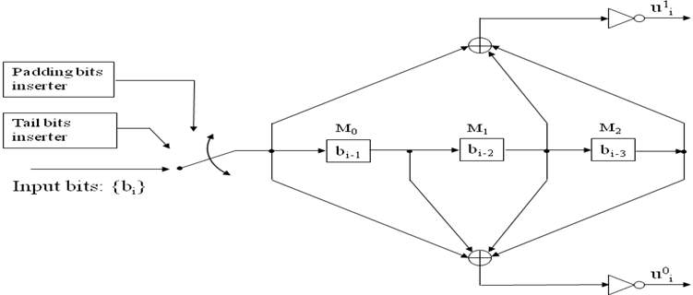
Figure y.2: The non-recursive non-systematic convolutional (NRNSC) encoder.
For the NRNSC encoder, the first and the second output bits of the encoder shall be generated according to
Equation (12)
$\begin{aligned}u_{i}^{1}= \overline{b_{i}⊕b_{i−2}⊕b_{i−3}} \\ u_{i}^{0}= \overline{b_{i}⊕b_{i−1}⊕b_{i−2}⊕b_{i−3}}\end{aligned}$ (12)
where $⊕$stands for modulo-2 addition and wverline stands for complementing the result of the modulo-2 addition.
The total size of bits to be encoded, N, is obtained by summing up the size of PHR $L_{\text{PHR}}$, the length of PSDU $L_{\text{PSDU}}$ (CRC included), the number of tail bits $L_{\text{TAIL}}$, and that of padding bits $L_{\text{PAD}}$. N shall be computed according to Equation (13):
$N_{}=L_{\text{PHR}}+L_{\text{PSDU}}+ L_{\text{TAIL}}+L_{\text{PAD}}$ (13)
Immediately after encoding the PHR and PSDU, a termination sequence with length $L_{\text{TAIL}}$ = 3 bits (the so-called tail bits) shall be inserted into encoder, as shown in Figure y.3. The tail bits are required to return the encoder to the zero state.
PHR
PSDU
Tail bits
(T0 T1 T2)

Figure y.3: Data block extension with tail bits prior to coding.
The value of tail bits are dependent on the coding scheme and shall be set as shown in Table z.1.
Table Z.1: Tail bit patterns for the RSC and NRNSC encoder

Memory state  (M0-M2) | Tails bits
Memory state  (M0-M2) | RSC  (T0 T1 T2) | NRNSC  (T0 T1 T2)
000 | 000 | 000
100 | 100 | 000
010 | 110 | 000
110 | 010 | 000
001 | 111 | 000
101 | 011 | 000
011 | 001 | 000
111 | 101 | 000

When interleaving is used in conjunction with convolutional coding, a padding sequence of $L_{\text{PAD}}$ bits shall be further inserted into the encoder immediately after the tails bits. The padding bits are required to fill up completely the last interleaver buffer, as described in < Insert here reference to clause describing interleaving>. $L_{\text{PAD}}$ shall be computed according to Equation (14).
$L_{\text{PAD}}= \left\{\begin{matrix} 5, \text{when} \frac{{(L}_{\text{PHR}}+L_{\text{PSDU}})}{8} \text{is} \text{odd}\text{.} \\ \text{13}, \text{when} \frac{{(L}_{\text{PHR}}+L_{\text{PSDU}})}{8} \text{is} \text{even}\text{.}\end{matrix}\right.$ (14)

It is strongly recommended to use padding bit patterns that do not contain long series of “1” or “0”. Figures y.5a and y.5b illustrate an example of such patterns.

PSDU
Tail bits
(T0,T1,T2)
PHR
5-bit padding pattern:
01011

Figure y.5a: An example of extension with padding bits prior to encoding, when (L_{PHR} + L_{PSDU})/8 is odd.
PSDU
Tail bits
(T0,T1,T2)
PHR
13-bit padding pattern:
01011 00001011

Figure y.5b: An example of extension with padding bits prior to encoding, when (L_{PHR} + L_{PSDU})/8 is even.

Sub-clause 6.12a.1.4: Code-symbol interleaving (content to replace existing text on page 51 lines 1 to 41)

The interleaver is optional. The interleaver is defined by a permutation of code symbols, where each permuted element contains exactly one code symbol, i.e., a pair of two bits, as defined in <Insert reference to FEC Clause>. The process of interleaving is illustrated in Figure y.4.

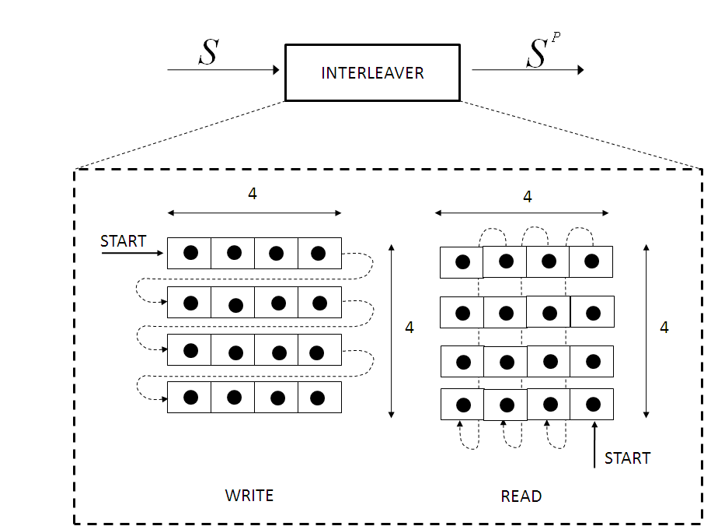

Figure y.4: The interleaving block.

The sequence S = {s(0), s(1), …, s(N-1} exiting the encoder shall be passed to the interleaver as follows: The first sample of code symbols$s(0)$shall be passed to the interleaver first in time, and the last sample of code symbols$s(N−1)$ shall be passed to the interleaver last in time. Additionally, the complete sequence of code symbols
S = {s(0), s(1), …, s(N-1)} is passed to the interleaver as NBLOCK consecutive subsequences, where each subsequence has a size equal to N_{INTERLEAV}/2 code-symbol. All subsequences shall be structured according to Equation (15) and (16).

S = {S⁽⁰⁾, S⁽¹⁾, …, S^{(NBLOCK – 1)}} (15)

S^{(ii)} = {s(j), j = ii*N_{INTERLEAV}/2, ii*N_{INTERLEAV}/2 + 1, …, (ii+1)*N_{INTERLEAV}/2 – 1}, ii = [0, N_{BLOCK} - 1] (16)

N_{BLOCK} and N_{INTERLEAV} values shall be computed according to Equation (17) and (18).

$N_{\text{INTERLEAV}} =\text{32}$ (17)
$N_{\text{BLOCK}} = \frac{\frac{(N)}{r}}{N_{\text{INTERLEAV}}} = \frac{2⋅N}{\text{32}} = \frac{N}{\text{16}}$ (18)
where N is a non-zero integer multiple of 8, with N ≥ 16 (see Equation 13).

For each sequence S^{(ii)} = { s(j), j = ii*N_{INTERLEAV}/2, ii*N_{INTERLEAV}/2+1, …, (ii+1)*N_{INTERLEAV}/2-1} passed to the interleaver, the index of code-symbols before the interleaver process shall be denoted by j, where the sample j =
= ii*N_{INTERLEAV}/2 shall be passed to the interleaving block first in time and the sample j = (ii+1)*N_{INTERLEAV}/2 - 1 shall be passed to the interleaving block last in time. The index k shall be the index after the interleaving process. The subsequence exiting the interleaving block shall be computed according to Equation (19):

$S^{{(\text{ii})}^{P}}=\left\{s(k) , k= ((\text{ii}+1)⋅\frac{N_{\text{INTERLEAV}}}{2}−1)−4⋅\text{mod}(j,4)−\left\lfloor j4\right\rfloor \right\}$, (∀) ii = [0, N_{BLOCK} - 1] (19)
The function ⎣x⎦ = floor (x) returns the largest integer value not greater than x.

The deinterleaver, which achieves the inverse operation, uses the same rules as the interleaver. For an input interleaved subsequence $S^{{(\text{ii})}^{P}}$= {s(k), k = ii*N_{INTERLEAV}/2, ii*N_{INTERLEAV}/2+1, …, (ii+1)*N_{INTERLEAV}/2-1} passed to the deinterleaver, the subsequence exiting the deinterleaving block shall be generated according to Equation (20). The index k shall denote the index of code-symbols before deinterleaving, and index j shall denote the index of code-symbols after deinterleaving.

$S^{(\text{ii})}=\left\{s(j),j= ((\text{ii}+1)⋅\frac{N_{\text{INTERLEAV}}}{2}−1)−4⋅\text{mod}(k,4)−\left\lfloor k4\right\rfloor \right\}$, (∀) ii = [0, N_{BLOCK} - 1] (20)

