IEEE P802.15
Wireless Personal Area Networks

Project | IEEE P802.15 Working Group for Wireless Personal Area Networks (WPANs)
Title | Proposed resolution for MR-FSK FEC Comments
Date Submitted | [May 12, 2010]
Source | [Daniel Popa]  [Itron, Inc] | Voice: [+33 158351760]  Fax: [ ]  E-mail:  [daniel.popa@itron.com]
Re:
Abstract
Purpose | Text contribution for comments resolution on FEC issue.
Notice | This document has been prepared to assist the IEEE P802.15. It is offered as a basis for discussion and is not binding on the contributing individual(s) or organization(s). The material in this document is subject to change in form and content after further study. The contributor(s) reserve(s) the right to add, amend or withdraw material contained herein.
Release | The contributor acknowledges and accepts that this contribution becomes the property of IEEE and may be made publicly available by P802.15.

Sub-clause 6.12a.1.3: Forward Error Correction (proposed text to replace existing text on page 49 lines 30 to 54 and page 50 lines 1 to 54).
The RSC encoder is shown in Figure y.1.

Figure y.1: The recursive systematic convolutional (RSC) encoder
For an input sequence of bits$B=\left\{{ b}_{i} \right\}$, i = 0, 1, 2…L-1, the output sequence of the RSC encoder (code-bits or code-symbols) shall be generated according to Equation (10):
$S= \left\{s_{0}, s_{1},s_{2}, …,s_{L−1}\right\}=\left\{ u_{0}^{1},u_{0}^{0}, … u_{i}^{1}, u_{i}^{0}, u_{i+1}^{1}, u_{i+1}^{0}, u_{i+2}^{1}, u_{i+2}^{0}, … u_{L−1}^{1},u_{L−1}^{0} \right\}$ (10)
i.e., code symbol sample$s_{0}$is preceding sample$s_{1}$and code-bit sample $u_{i}^{1}$is preceding sample$u_{i}^{0}$. The code symbol samples, i.e.,$s_{i}$, shall be generated according to Equation (11):
$s_{i}=\left\{u_{i}^{1},u_{i}^{0}\right\}, ∀ i=0,…,L−1$ (11)

The NRNSC encoder is shown in Figure y.2.

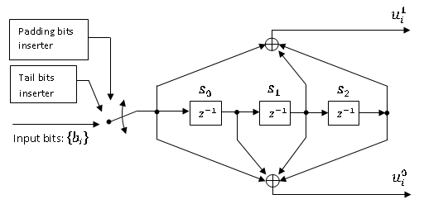
$$\overline{u_{i}^{1}}$$
$$\overline{u_{i}^{0}}$$

Figure y.2: The non-recursive non-systematic convolutional (NRNSC) encoder
For an input sequence of bits$B=\left\{{ b}_{i} \right\}$, i = 0, 1, 2…L-1, the output sequence of the NRNSC encoder (code-bits or code-symbols) shall be generated according to Equation (10.1):
$S= \left\{s_{0}, s_{1},s_{2}, …,s_{L−1}\right\}=\left\{ \overline{u_{0}^{1}},\overline{u_{0}^{0}}, … \overline{u_{i}^{1}}, \overline{u_{i}^{0}}, \overline{u_{i+1}^{1}}, \overline{u_{i+1}^{0}}, \overline{u_{i+2}^{1}}, \overline{u_{i+2}^{0}}, … \overline{u_{L−1}^{1}},\overline{u_{L−1}^{0}} \right\}$ (10.1)
i.e., code symbol sample$s_{0}$is preceding sample$s_{1}$and code-bit sample $\overline{u_{i}^{1}}$is preceding sample$\overline{u_{i}^{0}}$. The code symbol samples, i.e.,$s_{i}$, shall be generated according to Equation (11.1):
$s_{i}=\left\{\overline{u_{i}^{1}},\overline{u_{i}^{0}}\right\}, ∀ i=0,…,L−1$ (11.1)
L represents the size in bits of data to be coded and is obtained by summing the bit-length of PHR and PSDU, with CRC included in the PSDU, according to Equation (12):
$L=L_{\text{PHR}}+L_{\text{PSDU}}$ (12)
Whatever the value of the PIB attribute phyFSKFECInterleaving (i.e., interleaving enabled or disabled), prior to encoding the (PSDU+PHR) data block shall be extended by appending a termination sequence of 3 bits (so-called tail bits), as shown in Figure y.3, in order to return the encoder to the zero state.
PSDU
Tail bits
(T0 T1 T2)
PHR
Figure y.3: Data block extension with tail bits prior to coding.
The value of tail bits are coding scheme dependent and shall be set as shown in Table z.1.
Table Z.1: Tail bit pattern for the RSC and NRNSC encoder

Memory state  (S0-S2) | Tails bits
Memory state  (S0-S2) | RSC  (T0 T1 T2) | NRNSC  (T0 T1 T2)
000 | 000 | 000
100 | 100 | 000
010 | 110 | 000
110 | 010 | 000
001 | 111 | 000
101 | 011 | 000
011 | 001 | 000
111 | 101 | 000

Sub-clause 6.12a.1.4: Code-bit interleaving (content to replace existing text on page 51 lines 1 to 41)

When interleaving is enabled, the output sequence of the encoder, generated according to Equations (10), (10.1). (11), and (11.1), shall be passed to the interleaver as follows: The first sample of code symbols, i.e.,$s_{0}$, shall be passed to the interleaver first in time, and the last sample of code symbols, i.e., $s_{L−1}$, shall be passed to the interleaver last in time.

The interleaver is defined as a permutation. In order to achieve seamless coding and interleaving for both the 2-FSK and 4-FSK modulation schemes, the interleaver is defined as a permutation of code symbols, where each permuted element contains exactly one code symbol, i.e., a pair of two bits, as defined in Equation (11). The process of interleaving a sequence of code symbols is illustrated in Figure y.4.

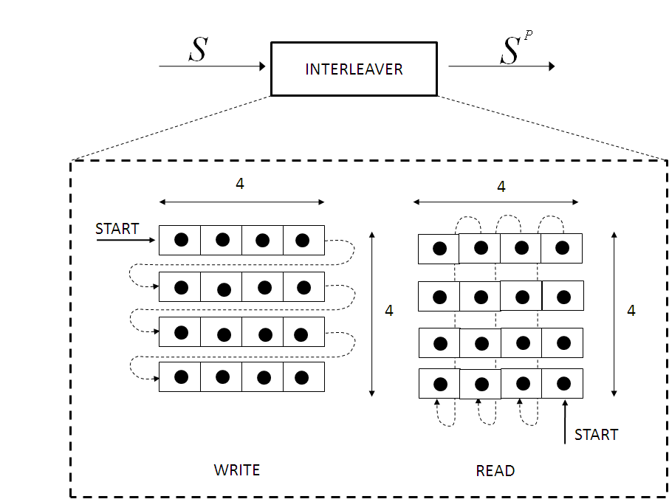

Figure y.4: The interleaving block

The index of code symbols before the interleaving shall be denoted by j, where j = 0 refers to the first sample of code symbol, i.e.,$s_{0}$, and j = $\frac{N_{\text{INTERLEAV}}}{2}−1$= 15 refers to the last sample, i.e.,$s_{\text{15}}$, passed to the interleaver for a given sequence of code symbols. The number of code-bit per interleaving block, $N_{\text{INTERLEAV}}$, is defined in Equation (14). The index k shall be the index after the interleaving.

For an input sequence of symbols S = {$s_{j}$, j = 0, 1…$\frac{N_{\text{INTERLEAV}}}{2}−1$} the output sequence of the interleaver is defined by the rule:

$S^{P}=\left\{{ s}_{k} , k= \text{15}−4⋅\text{mod}(j,4)−\left\lfloor 4j\right\rfloor \right\}$ (13)
The function ⎣x⎦ = floor (x) returns the largest integer value not greater than x.

When the interleaving is enabled, it is necessary to fill up the last interleaver buffer so that a full interleaver block can be transmitted. Prior to encoding and after appending the three-bit tail, a number of padding bits N_{PAD} must be appended. N_{PAD} is computed according to Equation (16):

$N_{\text{INTERLEAV}}=(4×4)×2=\text{32}$ (14)
$N_{\text{BLOCK}}=\left\lceil \frac{\frac{(L+3)}{r}}{N_{\text{INTERLEAV}}}\right\rceil =\frac{2×(L+3)}{\text{32}}=\frac{L+3}{\text{16}}$ (15)

$N_{\text{PAD}}=r×N_{\text{INTERLEAV}}×N_{\text{BLOCK}}−(L+3)=\frac{1}{2}×N_{\text{INTERLEAV}}×N_{\text{BLOCK}}−(L+3)$ (16)
The function ⎡x⎤ = ceiling(x)) returns the smallest integer value not less than x.

The number of padding bits depends on the number of data octets M to be coded. The input bit sequence shall be expanded prior to encoding by appending one of the padding bit patterns described in Figure y.5a and Figure y.5b. The number of data octets M to be coded shall not include the tail bits and shall be computed according to Equation (17):
$M=\frac{L}{8}$ (17)
PSDU
Tail bits
(T0,T1,T2)
PHR
5-bit padding pattern:
01011

Figure y.5a: Block data extension with padding bits prior to encoding, when interleaving is enabled and M is odd.
PSDU
Tail bits
(T0,T1,T2)
PHR
13-bit padding pattern:
01011 00001011

Figure y.5b: Block data extension with padding bits prior to encoding, when interleaving is enabled and M is even.

The de-interleaver, which achieves the inverse operation, uses the same structure as the interleaver, as described in Figure y.4. The input sequence for the de-interleaver is the sequence $S^{P}$= {$s_{k}$, k = 0, 1…$\frac{N_{\text{INTERLEAV}}}{2}−1$} and its output sequence is obtained by using the same rule as for the interleaver, and shall be generated according to Equation (13), by replacing index k with j.

