IEEE P802.15
Wireless Personal Area Networks

Project | IEEE P802.15 Working Group for Wireless Personal Area Networks (WPANs)
Title | Frequency Hopping Support in TG4g
Date Submitted | 24 June, 2010
Source | [Kuor-Hsin Chang, Bob Mason, Emmanuel Monnerie, Ruben Salazar, Ben Rolfe, Daniel Popa]  [Elster, Landis+Gyr, BCA, Itron] | Voice: [ ]  Fax: [ ]  E-mail: [kuor-hsin.chang@us.elster.com, robert.t.mason@us.elster.com, Emmanuel.Monnerie@landisgyr.com, ruben.salazar@landisgyr.com, ben@blindcreek.com, daniel.popa@itron.com ]
Re: | Frequency Hopping Mechanisms for 802.15.4g
Abstract | This document proposes MAC PIB attributes and an informative annex for the 802.15.4g amendment describing how the current standard with the proposed amendment enables Frequency Hopping when required in some regions (cd Appendix G – Section 15.247 of FCC CFR47).
Purpose | Brainstorm the mechanisms needed to support Frequency Hopping in 4g
Notice | This document has been prepared to assist the IEEE P802.15. It is offered as a basis for discussion and is not binding on the contributing individual(s) or organization(s). The material in this document is subject to change in form and content after further study. The contributor(s) reserve(s) the right to add, amend or withdraw material contained herein.
Release | The contributor acknowledges and accepts that this contribution becomes the property of IEEE and may be made publicly available by P802.15.
Proposed changes in 802.15.4g amendment:

7.4.2 MAC PIB Attributes:

Change Table 127 (the entire table is not shown) as indicated:

Attribute | Identifier | Type | Range | Description | Default
macFrequencyHopping |  | Boolean | TRUE or FALSE | TRUE if the system is doing frequency hopping  FALSE if the system not doing frequency hopping
macHopSequenceID | (increment the last value) | Integer | 0x00 – 0xFF | ID of the Hopping Sequence
macHopSequenceLength | (increment the last value) | Integer | 2 – 511 | Number of channels in the hop sequence
macHopSequence | (increment the last value) | Array | An 1 x {2-511}  number array | This is the ordered sequence of channels that make up the hopping sequence.
macFreqHoppingCurrentTime | (increment the last value) | Integer | 0x00000000 – 0xFFFFFFFF | Integer representing the current time of the hopping sequence, relatively to the start time. The accuracy is 1 ms | 0
macFreqHoppingDwellTime | (increment the last value) | Integer | 0x0000 – 0xFFFF | Total dwell time on each channel. Time is specified with a resolution of 20 μs (range = 0.00002 – 1.31 seconds)
macHopTime | (increment the last value) | Integer | 0x0000 – 0xFFFF | Time allocated for the PHY to change to a new frequency. With unit of a symbol time of a 50 kbps system (20 μs) (range = 0 – 5.1 ms). The dwell time includes the hop time, therefore macFreqHoppingDwellTime must be greater than macHopTime

Frequency Hopping Mechanism

X.1 Introduction
Depending on the region they are deployed, SUN devices (as defined in 802.15.4g amendment) may be required operate in a frequency hopping mode to meet regulatory requirements. I don’t think the statement as to why frequency hopping is required is accurate. I believe frequency hopping is required more due to power level than bandwidth. I suggest deleting the last sentence above.

This annex illustrates how frequency hopping can be implemented in the PHY/MAC layer using the services and entities defined in this standard.

X.2 Architecture and relevant attributes
The PHY and MAC layers include the entities and service access points as shown in Figure 1 (see clauses 6.2 and 7.1 for more details):

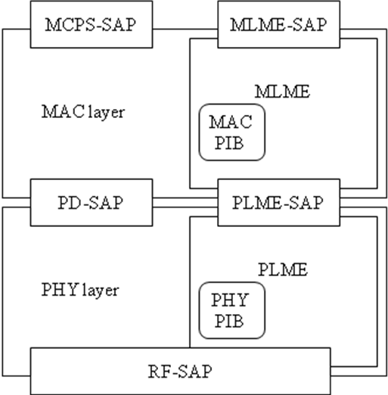

Figure 1 PHY and MAC entities and service access points

The MLME in the MAC layer manages the hopping sequence and provides the current channel information to the PLME in the PHY layer, using the PLME-SAP.

The MAC PIB attributes that are involved in the frequency hopping scheme are:
- Hopping Sequence (macHopSequenceID, macHopSequenceLength and macHopSequence)
- Current Time in the hopping sequence (macFreqHoppingCurrentTime)
- Dwell Time on the channel (macFreqHoppingDwellTime)
- Hop Time (macHopTime)

The PHY PIB attributes that are involved are:
- Current Channel (phyCurrentChannel)
- Current Channel Page (phyCurrentPage)
- phyCurrentSUNPageEntry

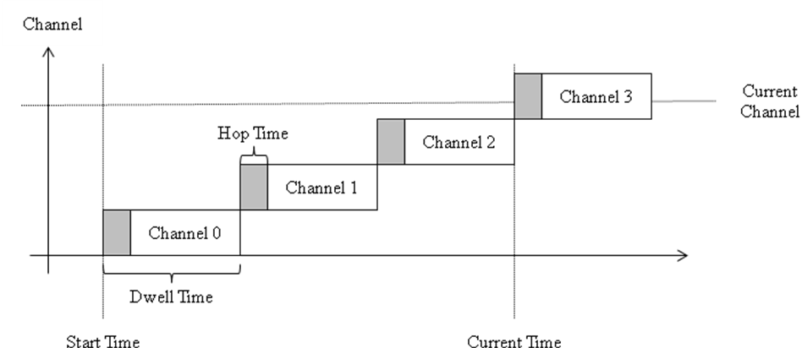
Figure 2 Channels in time domain

The channel index in Figure 2 is the index in the hopping sequence array. The PHY layer provides a list of valid channels, and the frequency hopping list is a subset of this list.

X.3 Frequency Hopping Sequence Setting

The MAC Layer communicates the actual PHY channel to the PHY layer for transmit and receive. The MAC layer maintains the FreqHoppingCurrentTime

X.4 Channel Setting in the PHY Layer

The MAC Layer tracks the current channel based on the current time and the channel dwell time. The current channel is derived from the current frequency hopping time (maxFreqHoppingCurrentTime), the hopping sequence (macHopSequence) and the per channel dwell time (macFreqHoppingDwellTime).

Using the PLME-SET.request service (clause 6.2.2.9), the MAC layer sets the current channel at the appropriate time to cause the transceiver to jump to a new frequency. The PHY stays on the channel set by this request until a new frequency is set. The MAC layer is responsible for computing the timing of the sequence based on the MAC PIB attributes.

When the channel in the PHY Layer is set, the MAC layer is notified via the PLME-SET.confirm service. The MAC layer can assign a timestamp when the transmit and receive confirmation is received and verify that the channel has switched during the time allocated by macHopTime.

X.5 Join the Frequency Hopping Network
In a frequency hopping (FH) system, if an end device wants to join the FH network, it sends a Request-to-Join command to near-by devices to initiate the joining process using Channel[0]. After a Request-to-Join command is sent, the end device switches its radio from TX to RX and waits for a response from near-by devices. If no response is received during the dwell time, the end device will switch its radio from RX to TX to transmit the Request-to-Join command again, where Channel[0] is again used for the transmission. The end device will continue to transmit Request-to-Join commands using Channel[0] until either a response is received or after NumberOfActiveChannels of Request-to-Join commands have been transmitted using Channel[0]. If NumberOfActiveChannels of Request-to-Join commands have been transmitted using Channel[0] but no response is received, the end device will switch to Channel[1] and transmit the Request-to-Join command using following the mentioned procedure until either a response is received or after NumberOfActiveChannel of Request-to-Join commands have been transmitted using Channel[1]. The end device will keep on transmitting Request-to-Join command following the mentioned procedure using different channels until either a response is received or the request has been attempted on all available channels. If all channels (i.e. NumberOfTransmitChannels) have been used to transmit the Request-to-Join command, but no response is received, the MLME of the end device will send a Request-to-Join-Failed signal to the NHL to indicate that the Request-to-Join procedure failed. A time delay (macFHJoinNetworkTransmitDelay) specifies the delay between the last transmission of the Request-to-Join command using Channel[i] before Channel[i+1] is used to transmit the Request-to-Join command.

The channel list (Channel[]) used by the end device to send Request-to-Join commands can be all of the available channels in the operating frequency band or the HopSequence programmed by the system implementer. The NumberOfActiveChannels is the total number of channels in Request-to-Join channel list.

A Request-to-Join command is used to let the neighbors know that the end device wants to join the network and contains limited information. A response for the Request-to-Join command provides the following information:
- FreqHoppingCurrentTime – the time from the start of the hopping sequence
- HopSequence – used by the responding device, the Hop position of the current channel.
- DwellTime – per channel dwell time.

To join the targeted network, the receiving device uses the above information to populate the corresponding MAC parameters and with the time and channel information, the receiving device is now synchronized to the network and can participate in network communications.

