IEEE P802.15
Wireless Personal Area Networks

Project | IEEE P802.15 Working Group for Wireless Personal Area Networks (WPANs)
Title | Frequency Hopping Support in TG4g
Date Submitted | 4 May, 2010
Source | [Kuor-Hsin Chang, Bob Mason, Emmanuel Monnerie, Ruben Salazar, Ben Rolfe, Daniel Popa]  [Elster, Landis+Gyr, BCA, Itron] | Voice: [ ]  Fax: [ ]  E-mail: [kuor-hsin.chang@us.elster.com, robert.t.mason@us.elster.com, Emmanuel.Monnerie@landisgyr.com, ruben.salazar@landisgyr.com, ben@blindcreek.com, daniel.popa@itron.com ]
Re: | Frequency Hopping Mechanisms for 802.15.4g
Abstract | This document proposes MAC PIB attributes and an informative annex for the 802.15.4g amendment describing how the current standard with the proposed amendment enables Frequency Hopping when required in some regions (cd Appendix G – Section 15.247 of FCC CFR47).
Purpose | Brainstorm the mechanisms needed to support Frequency Hopping in 4g
Notice | This document has been prepared to assist the IEEE P802.15. It is offered as a basis for discussion and is not binding on the contributing individual(s) or organization(s). The material in this document is subject to change in form and content after further study. The contributor(s) reserve(s) the right to add, amend or withdraw material contained herein.
Release | The contributor acknowledges and accepts that this contribution becomes the property of IEEE and may be made publicly available by P802.15.
Proposed changes in 802.15.4g amendment:

7.4.2 MAC PIB Attributes:

Change Table 127 (the entire table is not shown) as indicated:

Attribute | Identifier | Type | Range | Description | Default
macHopSequenceID | (increment the last value) | Integer | 0x00 – 0xFF | ID of the Hopping Sequence
macHopSequenceLength | (increment the last value) | Integer | 0x0000 – 0xFFFF | Number of channel in the sequence
macHopSequence | (increment the last value) | Array of macHoppingSequenceLength Integers | {0x0000 – 0xFFFF} | The value at index “n” specifies the PHY channel to be use by channel “n”
macFreqHoppingCurrentTime | (increment the last value) | Integer | 0x00000000 – 0xFFFFFFFF | Integer representing the current time of the hopping sequence, relatively to the start time. The accuracy is 1 ms | 0
macFreqHoppingDwellTime | (increment the last value) | Integer | 0x0000 – 0xFFFF | Total time dwell time on each channel. With unit of a symbol time of a 50 kbps system (20 μs) (range = 0 – 1.31 seconds)
macHopTime | (increment the last value) | Integer | 0x0000 – 0xFFFF | Time allocated for the PHY to change to a new frequency. With unit of a symbol time of a 50 kbps system (20 μs) (range = 0 – 5.1 ms). The dwell time includes the hop time, therefore macFreqHoppingDwellTime must be greater than macHopTime

Annex X (replace X by the appropriate letter)

(informative)

Example usage of Frequency Hopping

X.1 Introduction
SUN devices (as defined in 802.15.4g amendment) may or may not be required to use frequency hopping, depending on the region where they are deployed and the frequency band they are using. For example, in the USA, the use of an 802.15.4g MRFSK device in the 915MHz ISM band will require frequency hopping as the 20 dB channel bandwidth of the signal is less than 500kHz..

This annex illustrates how frequency hopping can be implemented in the PHY/MAC layer using the services and entities defined in this standard.

X.2 Architecture and relevant attributes
The PHY and MAC layers include the entities and service access points as shown in Figure 1 (see clauses 6.2 and 7.1 for more details):

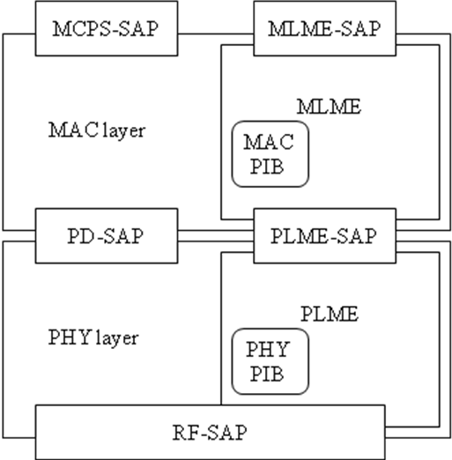

Figure 1 PHY and MAC entities and service access points

The MLME in the MAC layer manages the hopping sequence and provides the current channel information to the PLME in the PHY layer, using the PLME-SAP.

The MAC PIB attributes that are involved in the frequency hopping scheme are:
- Hopping Sequence (macHopSequenceID, macHopSequenceLength and macHopSequence)
- Current Time in the hopping sequence (macFreqHoppingCurrentTime)
- Dwell Time on the channel (macFreqHoppingDwellTime)
- Hop Time (macHopTime)

The PHY PIB attributes that are involved are:
- Current Channel (phyCurrentChannel)
- Current Channel Page (phyCurrentPage)
- phyCurrentSUNPageEntry

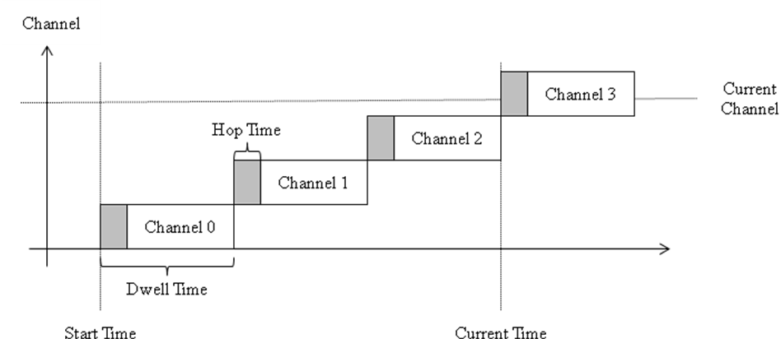
Figure 2 Channels in time domain

The channel number in Figure 2 is the index in the hopping sequence array. The actual physical channel (frequency) that can be used for hopping (phySUNChannelsSupported) are managed by the next higher layer (NHL) based on local regulations and the available useful channels.

X.3 Frequency Hopping Sequence Setting

The NHL Layer provides the hopping sequence related attributes macHopSequenceID, macHopSequenceLength and macHopSequence to the MAC Layer; the MAC Layer communicates the actual PHY channel to the PHY layer for transmit and receive.

X.4 Channel Setting in the PHY Layer

The MAC Layer tracks the current channel based on the current time and the channel dwell time. The current channel is used as an index in the frequency hopping sequence and the value in the array defines the actual PHY channel (the frequency index) to be used.

Using the PLME-SET.request service (clause 6.2.2.9), the MAC layer sets the current channel at the appropriate time to cause the transceiver to jump to a new frequency. The PHY stays on the channel set by this request until a new frequency is set. The MAC layer is responsible for computing the timing of the sequence in accordance to the local regulation. For instance, in the US 915MHz-ISM band, using the MRFSK 50kbps operating mode as an example (< 250 kHz 20dB bandwidth), a device must occupy the same channel for less than 400ms within a 20 second period.

When the channel in the PHY Layer is set, the MAC layer is notified via the PLME-SET.confirm service. The MAC layer can assign a timestamp when the transmit and receive confirmation is received and verify that the channel has switched during the time allocated by macHopTime.

