IEEE P802.15
Wireless Personal Area Network

Project | IEEE P802.15 Working Group for Wireless Personal Area Networks (WPANs)
Title | Normative Text for the UWB-PHY of TG6
Date submitted | March 2010
Source | Marco Hernandez, Kiran Bynam, Igor Dotlic, H.B. Li, R. Kohno, Mikyoung Oh, T. Ikegami, H. Suzuki , Ouvry Laurent, Jean Schwoerer, , Seung Hoon Park, ,HYongsoo Lee, John Farserotu, John Gerris, Jerome Rousselot, Dries Neirynck, Kathleen Philips, Guido Dolmans, Olivier Rousseaux, Noh-Gyoung Kang and Chihong Cho.  ¹Medical ICT Group, NICT, Marco@nict.go.jp, Tel +81-46-847-5439, 3-4 Hikarino-oka, Yokosuka 239-0847 Japan.  ²Samsung Electronics , kiran.bynam@samsung.com , Tel +91-80-23434904.
Resp: | Response to the 802.15.6 UWB PHY definition
Abstract
Purpose | The present document describes the UWB PHY for 802.15.6 body area networks.
Notice | This document has been prepared to assist the IEEE P802.15. It is offered as a basis for discussion and is not binding on the contributing individual(s) or organization(s). The material in this document is subject to change in form and content after further study. The contributor(s) reserve(s) the right to add, amend or withdraw material contained herein.
Release | The contributor acknowledges and accepts that this contribution becomes the property of IEEE and may be made publicly available by P802.15.

Contents
IEEE P802.15 1
General Description 4
Modes of operation 34
Rules for use of modes and options 3
UWB Frame Format 3
UWB PHY Symbol Structure 3
Pulse waveforms 3
Operating frequency bands 3
Transmission bandwidth 3
Data Rates 3
PSDU timing parameters 3
Table of timing Parameters 3
PRF Parameter 3
Basis pulse waveform position parameter 3
Hop Parameter 3
Basis pulse waveform duration parameter 3
Symbol duration parameter 3
Symbol rate parameter 3
FEC rate parameter 3
Modulation mode 1 parameter 3
Bit rate parameter 3
Number of short pulses parameter 3
Peak PRF parameter 3
SHR Preamble 3
Start frame delimiter 3
FEC 3
Hybrid Type II ARQ Mechanism. 3
Pulse Shape Waveform 3
Short Pulse Waveforms 3
Chirp Pulse Waveform 3

1.0 General Description

The IR-UWB-BAN specification is designed to provide robust performance for BAN. Indeed, UWB transceivers allow low implementation complexity (critical for low power consumption). Moreover, the signal power levels are in the order of those used in the MICS band, i.e., safety power levels for the human body, besides of low interference to other devices.
The use of this spectrum combined with novel low complexity transceiver architectures, allow the implementation of low cost and low power devices for BANs. Moreover, such devices provide robust operation in multipath fading and interference.
The band of operation is 7.25 GHz to 8.5 GHz, which is available globally without regulatory restrictions like DAA systems. However, the use of one channel in the low band of UWB (channel 3 IEEE 802.15.4a band plan) and one channel in the high band of UWB are contemplated as mandatory.

1.1 Modes of operation

In order to ensure interoperability, a mandatory mode is required. Therefore, a compliant UWB PHY shall support the following:
One mandatory center frequency in the low band and high band of UWB (see ).
One mandatory bandwidth (see ).
One mandatory data rate (see ).
One mandatory preamble length (see ).
One mandatory FEC (see ). (TBD)
One mandatory HARQ in the high QoS mode(see ).(TBD)

1.2 Rules for use of modes and options

The UWB specification allows operation in the UWB band. Such UWB band is divided in sub-bands or channels (TBD). The implementer is free to select any sub-band for implementation. However, a channel in the low band of UWB and a channel in the high band of UWB are mandatory and the rest are optional.
There are two types of waveforms supported. Namely, a concatenation or burst of short pulses and long pulse shape waveforms are supported. There is not mandatory pulse shape as the architecture of non-coherent and differentially coherent detectors are pulse shape-blind. However, two bits in the PHY header indicate the type of pulse shape employed by the transmitter. Moreover, all beacon preambles are transmitted at the mandatory data rate during association.
For synchronization, the preamble consists of Kasami sequences of length 63 and those can be used for non-coherent and differentially coherent detectors. Therefore, a preamble’s length is mandatory only.
FEC is mandatory at the transmitter, but optional during association (transmission of beacons). Also, it is optional to decode at the receiver as systematic encoding is employed. That is, a receiver simply would ignore parity bits.

A combination of on-off signaling with 64-ary waveform coding and differentially encoded binary/quaternary phase shift keying modulation schemes are used to support non-coherent and differently coherent transceivers. Different data rates are obtained by changing pulse waveform duration and modulation scheme.

1.3 UWB Frame Format

The UWB frame format or physical layer protocol data unit (PPDU) is formed by appending the preamble synchronization header (SHR), physical layer header (PHR) and physical layer service data unit (PSDU), respectively.
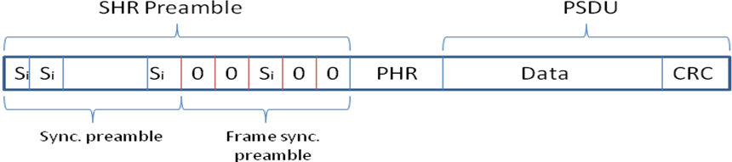
Frame synchronization preamble.
The SHR preamble is formed of repetitions of Kasami sequences for timing synchronization (sync preamble) and frame synchronization preamble for frame synchronization. The physical layer header (PHR) contains information about the data rate of the PSDU, duration of the SHR preamble and length of the payload. The PHR is protected with parity check bits appended at the end against channel errors. The modulation during SHR preamble and PHR is on-off signaling for the non-coherent PHY and DBPSK for the differentially coherent PHY. PHR is transmitted at lowest mandatory data rate.

1.4 UWB PHY Symbol Structure

The UWB symbol structure supports on-off signaling and DBPSK or DQPSK. The modulation has two modes of operation, namely non coherent mode (Mode 1) and differentially coherent mode (Mode 2).
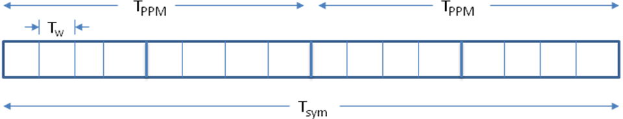
Figure 1. UWB symbol structure.
Each symbol time, , consists of an integer number of basis waveform positions, , each of duration . The symbol duration is divided into two intervals of duration in order to enable on-off signaling.

2 UWB PHY modulations

2.1 Non-coherent Modulation
The non-coherent PHY uses on-off modulation in combination with 64-ary waveform coding. Such modulation strategy assigns b information bits from an alphabet of size with a coded-pulse sequence from a code set of the same size at half rate. This represents the concept of the proposal GPPM (Group PPM).

The non-coherent PHY follows the schematic diagram of Figure 1.1

Figure 1.1

    - Symbol mapper at half rate

A data symbol contains 6 bits (). The transmitting symbol is given by the mapping as indicated in Table 1.1. PHR and payload bits (after FEC) shall be encoded using such symbol mapper.

Table 1.1

Symbol  (data sym.  decimal) | Symbol  (data sym.  binary)  b0,b1..,b5 | Codeword  d0,d1,…,d11 | Symbol  (data )  symbol | Symbol  (data sym.  binary) | Codeword  d0,d1,…,d11
0 | 000000 | 000000111111 | 32 | 100000 | 100110001011
1 | 000001 | 000011011011 | 33 | 100001 | 100101011010
2 | 000010 | 000011101101 | 34 | 100010 | 100100101110
3 | 000011 | 000111000111 | 35 | 100011 | 100011101010
4 | 000100 | 001001010111 | 36 | 100100 | 100001001111
5 | 000101 | 011001110100 | 37 | 100101 | 100001111100
6 | 000110 | 000111111000 | 38 | 100110 | 100100010111
7 | 000111 | 000011110110 | 39 | 100111 | 100010011101
8 | 001000 | 000110011110 | 40 | 101000 | 011011000101
9 | 001001 | 000110110011 | 41 | 101001 | 011011101000
10 | 001010 | 001100011011 | 42 | 101010 | 011101000110
11 | 001011 | 101010010011 | 43 | 101011 | 011101011000
12 | 001100 | 011001001011 | 44 | 101100 | 100001110011
13 | 001101 | 000101101011 | 45 | 101101 | 011110110000
14 | 001110 | 110100011001 | 46 | 101110 | 011101100001
15 | 001111 | 000101011101 | 47 | 101111 | 011110000011
16 | 010000 | 010001011110 | 48 | 110000 | 010001100111
17 | 010001 | 010101101100 | 49 | 110001 | 110010100110
18 | 010010 | 001111010001 | 50 | 110010 | 010010101011
19 | 010011 | 001111100100 | 51 | 110011 | 010010010111
20 | 010100 | 001011011100 | 52 | 110100 | 010100001111
21 | 010101 | 001111001010 | 53 | 110101 | 010100110101
22 | 010110 | 001110101001 | 54 | 110110 | 010010111100
23 | 010111 | 001011100011 | 55 | 110111 | 010011110001
24 | 011000 | 011110001100 | 56 | 111000 | 011000011101
25 | 011001 | 001010001111 | 57 | 111001 | 011000110011
26 | 011010 | 001001111001 | 58 | 111010 | 010111100010
27 | 011011 | 001001101110 | 59 | 111011 | 011011010010
28 | 011100 | 001010111010 | 60 | 111100 | 010100111010
29 | 011101 | 001100110110 | 61 | 111101 | 010101010011
30 | 011110 | 001010110101 | 62 | 111110 | 010111010100
31 | 011111 | 101100100101 | 63 | 111111 | 010111001001

Pulse shaping

The transmitting signal is given by
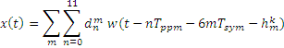
where is the th symbol, , is the symbol time, is a time hopping sequence for the th BAN and

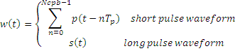
The pulse shape basis waveform,, has duration , where in case of long pulse waveform. is the pulse shape waveform duration for either short pulses (typically 2 nsec) and long pulse waveform.

2.1.3 Interleaver

2.2 Differentially coherent modulation

The transmitted signal is given by

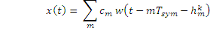

where represents a differentially encoded BPSK or QPSK symbol. It carries either one bit of information (differentially encoded BPSK) or two bits of information (differentially encoded QPSK).
The differentially encoded transmitting symbols are given by
where M=2 for DBPSK and M=4 for DQPSK.
The mapping between information bits onto is given in Tables 1 and 2.

Table 1. Mapping of information bits onto for DQPSK.
1 | 1 | 4
0 | 1 | 2
0 | 0 | 0 | 0
1 | 0 | -2

Table 2. Mapping of information bits onto for DBPSK.
0 | 0 | 0
1 | 2

Differentially encoded modulation with spreading

In order to enhance interference rejection, two optional data rates use differentially encoded BPSK/QPSK and a spreading sequence. The differential encoding is given by
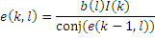
Where is the symbol number, is the number of chip in a symbol, is information phase of the th chip in the th symbol, is a Barker sequence of length 7, is information symbol.

Operating frequency bands

The low band of UWB is divided into sub-bands according to the IEEE 802.15.4a frequency band plan. Channel 3 is mandatory. The high of UWB is divided into sub-bands . Channel 1 is mandatory.

4 Transmission bandwidth

The mandatory bandwidth satisfies the IEEE 802.15.4a spectral mask of 650 MHz at -10 dB.

5 Data rates

Data rates range from 0.5 Mbps up to 10 Mbps. The mandatory data rate is 0.5 Mbps.

6 PSDU timing parameters

The PSDU timing and data rate parameters are given in Table 4. Notice that in case of long pulse shape waveform option, the pulse repetition frequency (number of pulses transmitted in one second) or PRF coincides with the mean PRF (number of pulses transmitted in a symbol period divided by the symbol period) because a single pulse is transmitted per symbol duration. In case of short pulse shape option, the peak PRF is defined as the maximum rate at which a transmitter emits pulses. This definition is not applicable for the long pulse shape option.

Table 4. Timing Parameters

FEC

6.1 PRF parameter
In case of long pulse shape option, PRF indicates the number of pulses transmitted in one second. It is equal to the mean PRF (number of pulses transmitted in a symbol period divided by the symbol period) as one pulse is transmitted per symbol duration.

6.2 Basis pulse waveform position parameter
indicates the number of possible basis pulse waveform positions in a symbol duration ().

6.3 Hop parameter
is the number of basis waveform positions that can contain an active basis pulse waveform.

6.4 Basis pulse waveform duration parameter
is the basis pulse waveform duration. It is computed as . In case of the long pulse shape waveform option is equal 1. Notice is either the short or long pulse shape waveform duration.

6.5 Symbol duration parameter
is the PSDU symbol duration.

6.6 Symbol rate parameter
It is the number of information symbols transmitted per second. It is computed as
.

6.7 FEC rate parameter
It is the channel coding rate, i.e., number of information bits divided by the number of coded bits.

6.8 Modulation mode 1 parameter
It is either, differentially encoded BPSK or QPSK.

6.9 Bit rate parameter
It is the bit rate on the air and computed as in case of DBSPK modulation and in case of DQPSK.

6.10 Number of short pulses parameter
is the number of short pulses such that , where =2 nsec.

6.11 Peak PRF parameter
It is defined as the maximum rate at which a transmitter emits short pulse waveforms. This definition is applicable for the short pulse shape option and it is not applicable for the long pulse shape option.

7 SHR Preamble

In order to perform coarse synchronization, data aided in the form of a preamble is employed. Such preamble is detectable for non-coherent and differential coherent receivers. Kasami sequences of length 63 shall be used as preamble for both the non-coherent and differential coherent PHYs. The SHR preamble shall be modulated with on-off signaling for the non-coherent PHY and DBPSK or DQPSK modulated for the differential coherent PHY.
There are eight Kasami sequences defined in Table 7. Those can be used according to the band plan and the co-existence scheme used. Notice eight logical channels can be used per channel.
The preamble set shall be divided into two pools. Each pool has a set of 4 preambles. The first pool shall be used for odd number of channels . The second pool shall be used for even number of channels . The coordinator might scan all the logical channels and use the preamble with minimum received power level.
Coexistence of piconets and the interference mitigation can be achieved by virtue of the inherent duty cycling in the modulation and the preamble sequences with good correlation properties.

Table 7. Kasami sequences.
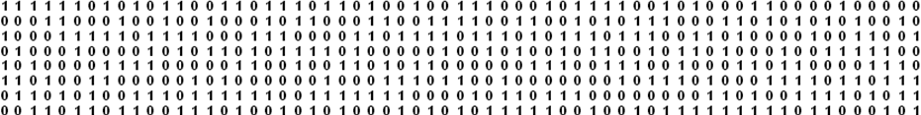

7.1 Start frame delimiter

After the preamble, a start frame delimiter (SFD) is transmitted for frame synchronization. The SFD is balance, i.e., when its correlation window is running through the preamble the output is zero. Thus, the transition of correlation from preamble to SFD does not degrade the detection of SFD.
There is not mandatory pulse shape for the transmission of the preamble and SFD.

8 FEC

9 Pulse Shape Waveform

There is not mandatory pulse shape. However, the basis waveform duration and PRF are mandatory according to the timing parameters of Table 4 in case of long pulse shape option. In case of short pulse shape option, the waveform duration and peak PRF are mandatory according to the timing parameters of Table 4. Notice pulse shape waveforms have to fulfill the spectral mask of IEEE 802.15.4a and regulatory spectral mask where applicable. These fix the maximum transmitting power.

9.1 Criteria for pulse shape waveforms

9.2 Short pulse waveforms
Conventional short pulses defined by IEEE 802.15.4a for UWB transmission are supported.

9.3 Chirp pulse waveform
A chirp pulse waveform is supported and given by
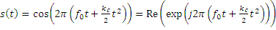
where is the central frequency, is the chirp duration, is the chirp slope defined as
and is the chirp frequency sweep.

Figure 4. Spectral mask for the proposed chirp pulse.

9.4 Chaotic pulse waveform
Chaotic pulses are near constant envelope signals that are produced by mixing 4 different triangular/saw-tooth waveforms. The sum of these triangular or saw-tooth waveforms will be fed as input to the voltage controlled oscillator. This is similar to frequency modulating a carrier signal with the summation of the triangular signals. The center frequency of the oscillator is directly proportional to the DC offset of the VCO.
Figure 5. Chaos waveform generator using triangular waveform.

The width of the triangular pulses and the peak to peak amplitudes are chosen to achieve the 500 MHz bandwidth. The period of the 4 triangular pulses are chosen as 3, 19, 53 and 59 nsec respectively. Amplitudes are chosen in the ratio of 0.5, 0.2, 0.8, 1 respectively .This summation will result in a spectrum shape with 10 dB bandwidth of 500 MHz. The spectrum of the chaotic pulse waveform is given in figure 6.

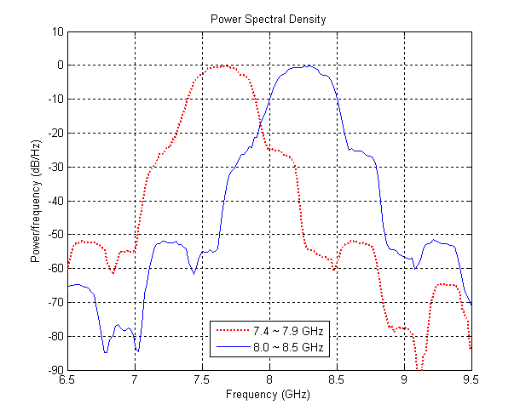

Figure6. Spectrum of chaotic pulses.

10 Hybrid Type II ARQ Mechanism.

In this configuration, only parity bits are sent in each retransmission. Particularly a RS invertible code is proposed. A code is said invertible if knowing only parity bits, the information bits can be determine by an inversion process. Packets detected in error by a CRC code are not discarded, but rather stored for posterior use at the decoder. The coding overhead at the transmitter remains low. This scheme is especially robust to burst and time varying channels. These channel conditions are expected when a subject with a BAN moves, besides that is imperative to reduce latency as much as possible especially in emergency cases.
Figure 4. Schematic diagram of the proposed usage of HARQ for BANs.
Figure 4 illustrates the proposed scheme of HARQ Type II with TG6 BANs. Essentially, devices whose applications require high QoS and low latency are HARQ enable. That is, the FEC and ARQ mechanism in the PHY and MAC follow the flow chart shown in Figure 5. In case of devices are not HARQ enable, simply use the conventional flow of RS coding and ARQ in the PHY and MAC, respectively.
Figure 5. Schematic flow chart of the proposed HARQ Type II.

The cyclic redundancy check code (CRC) is the standardized CRC-16-CCITT. The maximum number of retransmissions is .

11 Definitions of FFDs (coordinators) and RFDs (devices)

Full function devices (FFDs) shall have an IR-UWB radio or IR-UWB plus FM-UWB radios.
Reduced function devices (RFDs) shall have an IR-UWB radio or FM-UWB radio.
Only FFDs shall send beacon frame and coordinate beacon-enabled networks.
Only FFDs shall form non-beacon enabled networks.

11.1 Priority of resources
Priority of resources is bundle around medical and non-medical applications.
Medical applications are given higher priority than non-medical applications in the form of two parameters:
1) If bandwidth of BAN is scarce, medical applications shall give higher priority than non-medical applications.
2) If medical receiver suffers degradation on sensitivity above 1 dB, the coordinator shall enforce non-medical devices to reduce EIRP at transmitter.

12 FM-UWB PHY

FM-UWB is an optional PHY targeting low data rate medical BAN. FM-UWB exploits high modulation index analog FM to obtain an ultra-wide signal. Frequency modulation has the unique property that the RF bandwidth B_{RF} is not only related to the bandwidth f_{m} of the modulating signal, but also to the modulation index β that can be chosen freely. This yields either a bandwidth efficient narrow-band FM signal (β < 1) or a (ultra) wideband signal (β >> 1) that can occupy any required bandwidth.
FM-UWB constitutes an analog implementation of a spread-spectrum system. This constant-envelope approach, where peak power equals average power, yields a flat spectrum with steep spectral roll-off. Instantaneous de-spreading in the receiver makes that the FM-UWB radio behaves like a narrowband FSK radio from a synchronization and detection point-of-view. FM-UWB technology combines low complexity with robustness against interference and multipath. The following sub-sections present the FM-UWB system and its properties.

12.1 System characteristics
FM-UWB radios shall satisfy the system characteristics defined in table 8. Operation shall be in the 7.25 – 8.5 GHz band. Other UWB bands are appropriate for supporting international operation and mobility and in accordance with the relevant regulatory domains.

Table 8: FM-UWB system characteristics.
Parameter | Value
RF center frequency | 6.4 – 8.7 GHz
RF bandwidth | 500 MHz
RF output power | -15 dBm
Subcarrier frequency | 1.0, 1.25, 1.50, 1.75 MHz
Subcarrier modulation | FSK, β = 1
Raw bit rates | 31.25, 62.5, 125 and 250 kbps
Receiver sensitivity | <-85 dBm¹
TX, RX switching time | < 100 μs
RX synchronization time | < 500 μs
- At BER ≤ 10⁻⁶

12.2 Transmitter
Figure 12.2 provides a block diagram of the FM-UWB transmitter. The low modulation index digital Frequency Shift Key (FSK) is followed by high modulation index analog FM, creating a constant-envelope UWB signal [GER1]. The transmitter shall consist of a 1-2 MHz subcarrier oscillator generating a triangular signal that is FSK modulated by the transmit data. This subcarrier signal m(t) modulates the RF VCO, yielding a constant-envelope UWB signal with a flat power spectral density and steep spectral roll-off.
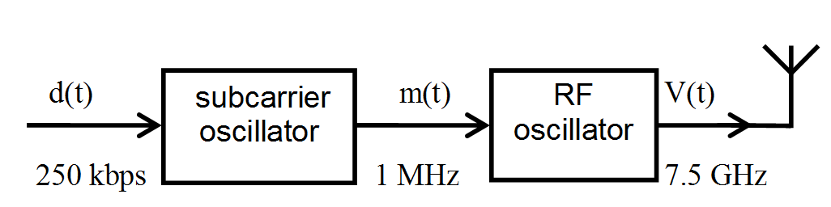
Figure 12.1 FM-UWB transmitter block diagram.
The FM-UWB signal V(t) with amplitude A and carrier frequency f_{c} (ω_{c}=2πf_{c}) is obtained by modulating the RF oscillator with the subcarrier m(t) of frequency f_{m} (ω_{m} = 2π f_{m}) such that

$m(t)=V_{m}M\left(ω_{m}t\right)$.

M represents the triangular waveform of the subcarrier signal. An RF oscillator sensitivity of K_{O} [rad/V-s] yields a deviation Δω = 2πΔf equal to $Δω=K_{O}V_{m}$,resulting in a FM signal V(t) that can be expressed mathematically as

$V\left(t\right)=A\text{sin}\left(ω_{c}t+ϕ\left(t\right)\right)$
$=A\text{sin}\left(ω_{c}t+K_{O}\int_{−∞}^{t}{m\left(τ\right)dτ}\right)$
$$=A\text{sin}\left(ω_{c}t+Δω\int_{−∞}^{t}{M\left(τ\right)dτ}\right)$$

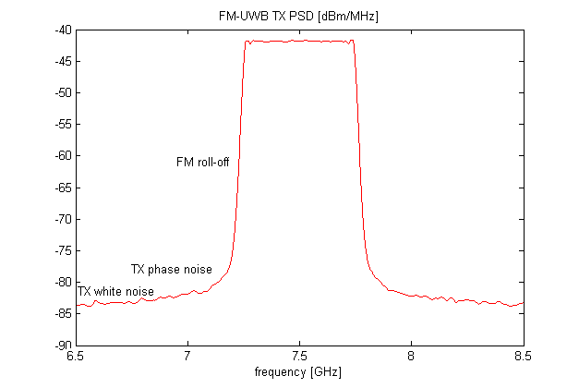
Figure 12.4: Frequency spectrum of FM-UWB signal at 7.5 GHz center frequency.

Figure 12.4 illustrates the power spectral density (PSD) of an ideal FM-UWB signal. The signal shall be compliant with the relevant regulatory limits [IEEE6-IEEE7]. The signal power is –15 dBm (112 mV_{pp} in a 50 Ω load). The subcarrier frequency is 1 MHz and the deviation Δf is 250 MHz, yielding a modulation index β of 250. The –10 dB bandwidth is 500 MHz.
The PSD of a wideband FM signal is determined by and has the shape of the probability density function (PDF) of the modulating signal m(t) [TAUB]. The use of a triangular subcarrier waveform, which is characterized by a uniform PDF, results in a flat RF spectrum. From an implementation point of view the triangular waveform is straightforward to generate using either analog or digital circuit techniques.
The roll-off and noise floor of the FM-UWB signal in a practical circuit realization will be determined by the RF oscillator phase noise and noise floor.

Table 2: Subcarrier frequencies for the case of a 4-user 100 kbps system
Subcarrier | Subcarrier frequency
1 | 1.00 MHz
2 | 1.25 MHz
3 | 1.50 MHz
4 | 1.75 MHz

12.3 RF-UWB signal generation
The subcarrier signal m(t) shall modulate the RF oscillator, that implements FM with high modulation index and yields a constant-envelope UWB signal with a flat PSD and steep spectral roll-off at its output.
Fig. 5 shows a block diagram of a low-complexity transmitter implementation. The FM-UWB signal is generated by a free-running RF VCO that can be calibrated by a PLL frequency synthesizer as shown in Figure 5. This frequency synthesizer ensures the correct center frequency of the UWB signal and the corresponding VCO voltage is measured with an ADC and memorized in an EEPROM. Modulation of the RF VCO with the subcarrier signal occurs in open loop mode. The VCO voltage value that was stored during calibration is now generated by a DAC and the subcarrier signal is added to it.

Transmitter RF center frequencies with 576 MHz channel spacing

Transmitter RF center frequencies with 512 MHz channel spacing (MBOA compatible)

12.4 Receiver architecture
The receiver shall demodulate the FM-UWB signal without frequency translation (i.e., no mixing). Figure 12.8 shows the receiver block diagram. The low complexity receiver comprises a LNA, a wideband FM demodulator, and low-frequency subcarrier filtering, amplification and demodulation circuitry.
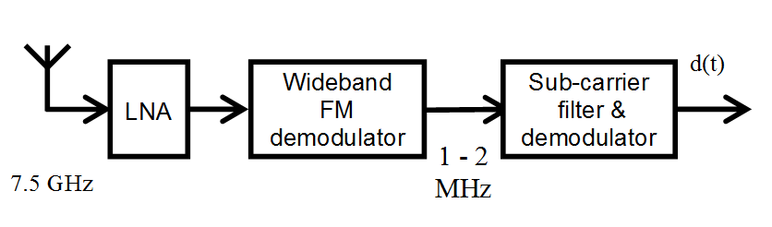
Figure 12.8: FM-UWB receiver block diagram.
The absence of carrier synchronization allows for rapid synchronization as required in ad-hoc networks. Due to the instantaneous de-spreading in the wideband FM demodulator, the system behaves like a narrowband FSK system where synchronization is limited by the bit synchronization time.

