IEEE P802.15
Wireless Personal Area Network

Project | IEEE P802.15 Working Group for Wireless Personal Area Networks (WPANs)
Title | Normative Text for the UWB-PHY of TG6
Date submitted | March 2010
Source | Marco Hernandez¹, Kiran Bynam², et.al.  ¹Medical ICT Group, NICT, Marco@nict.go.jp, Tel +81-46-847-5439, 3-4 Hikarino-oka, Yokosuka 239-0847 Japan.  ²Samsung Electronics , kiran.bynam@samsung.com , Tel +91-80-23434904.
Resp: | Response to the 802.15.6 UWB PHY definition
Abstract
Purpose | The present document describes the UWB PHY for 802.15.6 body area networks.
Notice | This document has been prepared to assist the IEEE P802.15. It is offered as a basis for discussion and is not binding on the contributing individual(s) or organization(s). The material in this document is subject to change in form and content after further study. The contributor(s) reserve(s) the right to add, amend or withdraw material contained herein.
Release | The contributor acknowledges and accepts that this contribution becomes the property of IEEE and may be made publicly available by P802.15.

Contents
IEEE P802.15 1
General Description 3
Modes of operation 3
Rules for use of modes and options 3
UWB Frame Format 3
UWB PHY Symbol Structure 3
Pulse waveforms 3
Operating frequency bands 3
Transmission bandwidth 3
Data Rates 3
PSDU timing parameters 3
Table of timing Parameters 3
PRF Parameter 3
Basis pulse waveform position parameter 3
Hop Parameter 3
Basis pulse waveform duration parameter 3
Symbol duration parameter 3
Symbol rate parameter 3
FEC rate parameter 3
Modulation mode 1 parameter 3
Bit rate parameter 3
Number of short pulses parameter 3
Peak PRF parameter 3
SHR Preamble 3
Start frame delimiter 3
FEC 3
Hybrid Type II ARQ Mechanism. 3
Pulse Shape Waveform 3
Short Pulse Waveforms 3
Chirp Pulse Waveform 3

General Description

The IR-UWB-BAN specification is designed to provide robust performance for BAN. Indeed, UWB transceivers allow low implementation complexity (critical for low power consumption). Moreover, the signal power levels are in the order of those used in the MICS band, i.e., safety power levels for the human body, besides of low interference to other devices.
The use of this spectrum combined with novel low complexity transceiver architectures, allow the implementation of low cost and low power devices for BANs. Moreover, such devices provide robust operation in multipath fading and interference.
The band of operation is 7.25 GHz to 8.5 GHz, which is available globally without regulatory restrictions like DAA systems. However, the use of one channel in the low band of UWB (channel 3 IEEE 802.15.4a band plan) and one channel in the high band of UWB are contemplated as mandatory.

Modes of operation

In order to ensure interoperability, a mandatory mode is required. Therefore, a compliant UWB PHY shall support the following:
One mandatory center frequency in the low band and high band of UWB (see ).
One mandatory bandwidth (see ).
One mandatory data rate (see ).
One mandatory preamble length (see ).
One mandatory basis waveform duration (see ).
One mandatory FEC (see ). (TBD)
One mandatory HARQ in the high QoS mode(see ).(TBD)

Rules for use of modes and options

The UWB specification allows operation in the UWB band. Such UWB band is divided in sub-bands or channels (TBD). The implementer is free to select any sub-band for implementation. However, a channel in the low band of UWB and a channel in the high band of UWB are mandatory and the rest are optional.
There are two types of waveforms supported. Namely, a concatenation or burst of short pulses and long pulse shape waveforms are proposed. There is not mandatory pulse shape as the architecture of non-coherent and differentially coherent detectors are pulse shape-blind. However, a flag indicates the type of waveform employed by the transmitter and data rate. Moreover, all beacon preambles are transmitted at the mandatory data rate during association.
For synchronization, the preamble consists of Kasami sequences of length 63 and those can be used for non-coherent and differentially coherent detectors. Therefore, a preamble’s length is mandatory only.
FEC is mandatory at the transmitter, but optional during association (transmission of beacons). Also, it is optional to decode at the receiver as systematic encoding is employed. That is, a receiver simply would ignore parity bits.

A combination of on-off signaling with 64-ary waveform coding and differentially encoded binary/quaternary phase shift keying is proposed in order to support non-coherent and differently coherent receivers. Different data rates are obtained by changing pulse duration, PRF and modulation scheme.

The non-coherent PHY is mandatory and the differentially coherent PHY is optional. However, in the high QoS mode, the differentially coherent PHY is mandatory as well as HARQ.

UWB Frame Format

The UWB frame format or physical layer protocol data unit (PPDU) is formed by appending the preamble synchronization header (SHR), physical layer header (PHR) and physical layer service data unit (PSDU), respectively.
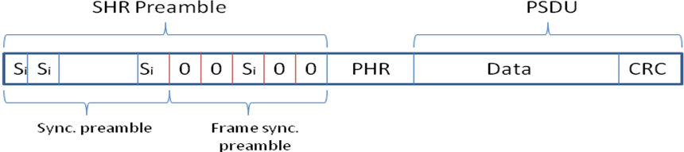
Frame synchronization preamble TBD.

The SHR preamble is formed of repetitions of Kasami sequences for timing synchronization (sync preamble) and frame synchronization preamble for frame synchronization. The physical layer header (PHR) contains information about the data rate of the PSDU, duration of the SHR preamble and length of the payload. The PHR is protected with parity check bits appended at the end against channel errors. The modulation during SHR preamble is on-off signaling. PHR is transmitted at lowest mandatory data rate.

UWB PHY Symbol Structure

The UWB symbol structure supports on-off signaling and DBPSK or DQPSK. The modulation has two modes of operation non coherent mode (Mode 1) and differentially coherent mode (Mode 2) .
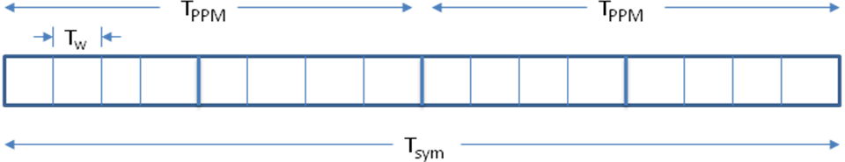
Figure 1. UWB symbol structure.

The transmitted signal is given by
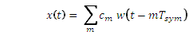
where
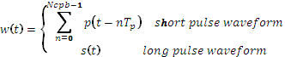
Each symbol time, , consists of an integer number of basis waveform positions, , each of duration . The symbol duration is divided into two intervals of duration 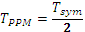 in order to enable on-off signaling. represents a differentially encoded BPSK or QPSK symbol. Finally, is a time hopping sequence for the th BAN.

The pulse shape basis waveform has duration , where in case of long pulse waveform. is the pulse shape waveform duration for either short pulses (typically 2 nsec) and long pulse waveform.

Pulse waveforms
Consider pulse shape waveforms are chirp pulses, chaotic pulses and 4a pulses.

UWB PHY modulation

Non-coherent Modulation

The non-coherent PHY uses on-off modulation in combination with 64-ary waveform coding.
Such modulation strategy assigns b-information bits from an alphabet of size M = 2b with a coded-pulse sequence from a code set of the same size at half rate. This is proposed as GPPM(Group PPM).

The non-coherent PHY follows the schematic diagram of Figure 1.1

Figure 1.1

  - Symbol mapper at half rate

A data symbol contains 6 bits (). The transmitting symbol is given by the mapping
(b0,b1,…,b5)->(d0,d1,…,d11) as indicated in Table 1.1. PHR and payload bits shall be encoded using such symbol mapper.

Symbol  (data sym.  decimal) | Symbol  (data sym.  binary)  b0,b1..,b5 | Codeword  d0,d1,…,d11 | Symbol  (data )  symbol | Symbol  (data sym.  binary) | Codeword  d0,d1,…,d11
0 | 000000 | 000000111111 | 32 | 100000 | 100110001011
1 | 000001 | 000011011011 | 33 | 100001 | 100101011010
2 | 000010 | 000011101101 | 34 | 100010 | 100100101110
3 | 000011 | 000111000111 | 35 | 100011 | 100011101010
4 | 000100 | 001001010111 | 36 | 100100 | 100001001111
5 | 000101 | 011001110100 | 37 | 100101 | 100001111100
6 | 000110 | 000111111000 | 38 | 100110 | 100100010111
7 | 000111 | 000011110110 | 39 | 100111 | 100010011101
8 | 001000 | 000110011110 | 40 | 101000 | 011011000101
9 | 001001 | 000110110011 | 41 | 101001 | 011011101000
10 | 001010 | 001100011011 | 42 | 101010 | 011101000110
11 | 001011 | 101010010011 | 43 | 101011 | 011101011000
12 | 001100 | 011001001011 | 44 | 101100 | 100001110011
13 | 001101 | 000101101011 | 45 | 101101 | 011110110000
14 | 001110 | 110100011001 | 46 | 101110 | 011101100001
15 | 001111 | 000101011101 | 47 | 101111 | 011110000011
16 | 010000 | 010001011110 | 48 | 110000 | 010001100111
17 | 010001 | 010101101100 | 49 | 110001 | 110010100110
18 | 010010 | 001111010001 | 50 | 110010 | 010010101011
19 | 010011 | 001111100100 | 51 | 110011 | 010010010111
20 | 010100 | 001011011100 | 52 | 110100 | 010100001111
21 | 010101 | 001111001010 | 53 | 110101 | 010100110101
22 | 010110 | 001110101001 | 54 | 110110 | 010010111100
23 | 010111 | 001011100011 | 55 | 110111 | 010011110001
24 | 011000 | 011110001100 | 56 | 111000 | 011000011101
25 | 011001 | 001010001111 | 57 | 111001 | 011000110011
26 | 011010 | 001001111001 | 58 | 111010 | 010111100010
27 | 011011 | 001001101110 | 59 | 111011 | 011011010010
28 | 011100 | 001010111010 | 60 | 111100 | 010100111010
29 | 011101 | 001100110110 | 61 | 111101 | 010101010011
30 | 011110 | 001010110101 | 62 | 111110 | 010111010100
31 | 011111 | 101100100101 | 63 | 111111 | 010111001001

  - Pulse shaping. The transmitting signal is given by
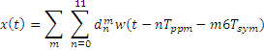

where 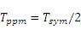 and is the symbol time.

Differentially coherent mode
It carries either one bit of information (differentially encoded BPSK) or two bits of information (differentially encoded QPSK). Thus, is a differentially encoded BPSK or QPSK symbol. In case of data rates with spreading, cm is chip of the symbol.
The differentially encoded transmitting symbols are given by
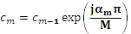
where M=2 for DBPSK and M=4 for DQPSK.
The mapping between information bits onto is given in Tables 1 and 2.

Table 1. Mapping of information bits onto for DQPSK.
1 | 1 | 4
0 | 1 | 2
0 | 0 | 0 | 0
1 | 0 | -2

Table 2. Mapping of information bits onto for DBPSK.
0 | 0 | 0
1 | 2

Two data rates use the spreading sequence. This will enable us to use the properties of two level spreading and help in interference rejection. The encoding of these data rates are given below.
- Current encoded information phase is e(k)
- e(k, l) = (b(l) * I(k))/(conj(e(k-1, l))
- Where k is the symbol number
- l is the number of chip in the symbol
- e(k, l) is encoded chip within the symbol
- b(l), l=1 to 7 Barker sequence

Operating frequency bands (TBD)

Transmission bandwidth

The mandatory bandwidth satisfies the IEEE 802.15.4a spectral mask of 650 MHz at -10 dB (see Figure 4).

Figure 2. Spectral mask for pulse shape waveform

Data Rates

Data rates range from 0.5 Mbps up to 10 Mbps. The mandatory data rate is 0.5 Mbps.

PSDU timing parameters

The PSDU timing and data rate parameters are given in Table 4. Notice that in case of long pulse shape waveform option, the pulse repetition frequency (number of pulses transmitted in one second) or PRF coincides with the mean PRF (number of pulses transmitted in a symbol period divided by the symbol period) because a single pulse is transmitted per symbol duration. In case of short pulse shape option, the peak PRF is defined as the maximum rate at which a transmitter emits pulses. This definition is not applicable for the long pulse shape option.

Table 4. Timing Parameters

PRF Parameter
In case of long pulse shape option, PRF indicates the number of pulses transmitted in one second. It is equal to the mean PRF (number of pulses transmitted in a symbol period divided by the symbol period) as one pulse is transmitted per symbol duration.

Basis pulse waveform position parameter
indicates the number of possible basis pulse waveform positions in a symbol duration (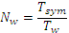).

Hop Parameter
is the number of basis waveform positions that can contain an active basis pulse waveform.

Basis pulse waveform duration parameter
is the basis pulse waveform duration. It is computed as . In case of long pulse shape waveform option . Notice is either the short or long pulse shape waveform duration.

Symbol duration parameter
is the PSDU symbol duration.

Symbol rate parameter
It is the number of information symbols transmitted per second. It is computed as 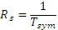.

FEC rate parameter
It is the channel coding rate, i.e., number of information bits divided by the number of coded bits.

Modulation mode 2 parameter
It is either, differentially encoded BPSK or QPSK.

Bit rate parameter
It is the bit rate on the air and computed as in case of DBSPK modulation and in case of DQPSK.

Number of short pulses parameter
is the number of short pulses such that , where =2 nsec.

Peak PRF parameter
It is defined as the maximum rate at which a transmitter emits short pulse waveforms. This definition is applicable for the short pulse shape option and it is not applicable for the long pulse shape option.

SHR Preamble

There are 8 kasami sequences planned and can be used according to band plan and the co-existence scheme used. 8 Logical channels are possible in each band by virtue of duty cycling and using one preamble for each logical channel. However, we may limit the number (tentatively, 5) of channels in order to ensure minimum preformance degradation. The coordinator of the network shall scan all the logical channels and shall use the preamble with minimum received power level.
In order to perform coarse synchronization, data aided in the form of a preamble is employed. Such preamble is detectable for non-coherent and coherent receivers. The kasami sequences shall be used as the preamble for both the PHY using DBPSK and Pulse position modulation. The Length of the Kasami sequence is 63. These Kasami sequences shall be on-off keying modulated while using with the pulse position modulation (Mode 1 of PHY) and DBPSK modulated while using with Mode 2 of PHY. Duty cycling and on-position of the preamble shall be TBD.

The Kasami sequences are defined as below:

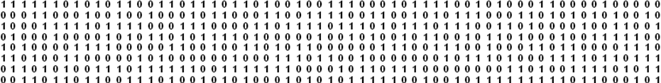

Start frame delimiter

After the preamble, a start frame delimiter (SFD) sequence is transmitted for frame synchronization. The SFD sequence is also balance, i.e., when its correlation window is running through the preamble the output is zero. Thus, the transition of correlation from preamble to SFD does not degrade the detection of SFD.
Table 6. SFD sequences.
There is not mandatory pulse shape for the transmission of the preamble and SFD. The modulation is the same as the modulation employed for the PSDU. The data rate transmission is the mandatory data rate.

FEC

Hybrid Type II ARQ Mechanism.

In this configuration, only parity bits are sent in each retransmission. Particularly a RS invertible code is proposed. A code is said invertible if knowing only parity bits, the information bits can be determine by an inversion process. Packets detected in error by a CRC code are not discarded, but rather stored for posterior use at the decoder. The coding overhead at the transmitter remains low. This scheme is especially robust to burst and time varying channels. These channel conditions are expected when a subject with a BAN moves, besides that is imperative to reduce latency as much as possible especially in emergency cases.
Figure 4. Schematic diagram of the proposed usage of HARQ for BANs.
Figure 4 illustrates the proposed scheme of HARQ Type II with TG6 BANs. Essentially, devices whose applications require high QoS and low latency are HARQ enable. That is, the FEC and ARQ mechanism in the PHY and MAC follow the flow chart shown in Figure 5. In case of devices are not HARQ enable, simply use the conventional flow of RS coding and ARQ in the PHY and MAC, respectively.
Figure 5. Schematic flow chart of the proposed HARQ Type II.

The cyclic redundancy check code (CRC) is the standardized CRC-16-CCITT. The maximum number of retransmissions is two.

Pulse Shape Waveform

There is not mandatory pulse shape. However, the basis waveform duration and PRF are mandatory according to Table 4 in case of long pulse shape option. In case of short pulse shape option, the waveform duration and peak PRF (according to Table 4) are mandatory. Notice all pulse shape waveforms have to fulfill the spectral mask illustrated in Figure 2 and regulatory spectral mask where applicable. These fix the maximum transmitting power.

Short Pulse Waveforms
Conventional short pulses defined by IEEE 802.15.4a for UWB transmission are supported.

Chirp Pulse Waveform
As part of the basis function definition, a chirp pulse waveform is proposed and given by
where is the central frequency, is the chirp duration, is the chirp slope defined as
and is the chirp frequency sweep.

Figure 4. Spectral mask for the proposed chirp pulse.

Chaotic Pulse :
Chaotic pulses are near constant envelope signals that are produced by mixing 4 different triangular/saw-tooth waveforms. The sum of these triangular or saw-tooth waveforms will be fed as input to the voltage controlled oscillator. This is similar to frequency modulating a carrier signal with the summation of the triangular signals. The center frequency of the oscillator is directly proportional to the DC offset of the VCO.

Figure: Chaos Generator using triangular waveform

The width of the triangular pulses and the peak to peak amplitudes are chosen to achieve the 500 MHz bandwidth. The period of the 4 triangular pulses are chose as 3, 19, 53 and 59 nsec respectively. Amplitudes are chosen in the ratio of 0.5, 0.2, 0.8,1 respectively .This summation will result in a spectrum shape with 10 dB bandwidth of 500 MHz. The spectrum of the chaos signal thus generated is given below.

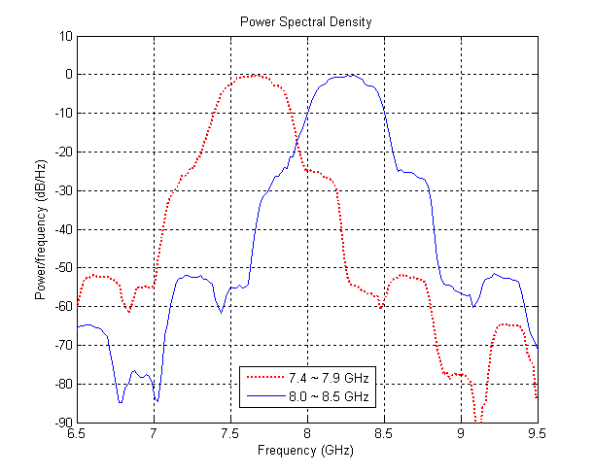

Figure: Spectrum of the Chaos Pulses

FM-UWB

FM-UWB is an optional PHYtargeting low data rate medical BAN.

Definitions of FFDs (coordinators) and RFDs (devices)

Full function devices (FFDs) can have an IR-UWB radio or IR-UWB plus FM-UWB radios.

Reduced function devices (RFDs) can have an IR-UWB radio or FM-UWB radio.

Only FFDs can send beacon frame and coordinate beacon-enabled networks.

Only FFDs can form non-beacon enabled networks.

Priority of Resources

Priority of resources is bundle around medical and non-medical applications rather than PHY technology.

Medical applications are given higher priority than non-medical applications in the form of two parameters:

1) If bandwidth of BAN is scarce, medical applications are given higher priority than non-medical applications.

2) If medical receiver suffers degradation on sensitivity above 1 dB, the coordinator shall enforce non-medical devices to reduce EIRP at transmitter.

Time-sharing of resources (TBD)

