IEEE P802.15
Wireless Personal Area Networks

Project | IEEE P802.15 Working Group for Wireless Personal Area Networks (WPANs)
Title | Candidates text for unified FEC for multi regional FSK (MR-FSK)
Date Submitted | [18 March 2010]
Source | [Hiroshi Harada , Ryuhei Funada]  [NICT]  [Hartman Van Wyk , Daniel Popa]  [Itron] | Voice: [ ]  Fax: [ ]  E-mail:  [harada@nict.go.jp]  [Hartman.VanWyk@itron.com]
Re:
Abstract | Candidate text regarding unified proposal of FEC schemes for 802.15.4g standard that has been presented as 15-10-0139-00-004g
Purpose | Draft text contribution
Notice | This document has been prepared to assist the IEEE P802.15. It is offered as a basis for discussion and is not binding on the contributing individual(s) or organization(s). The material in this document is subject to change in form and content after further study. The contributor(s) reserve(s) the right to add, amend or withdraw material contained herein.
Release | The contributor acknowledges and accepts that this contribution becomes the property of IEEE and may be made publicly available by P802.15.

FEC for multi-regional FSK (MR-FSK)
Forward error correction is optional for the 4g MR-FSK PHY. Depending on the value of the SFD pattern, as described in Table z.1, forward error correction shall be employed on the PHR and PSDU as a single block of data.
Table z.1: The SFD bit pattern and MR-FSK coding option
SFD Pattern | PHR | PSDU | Comments
Value 1 (TBD) | Uncoded | Uncoded | - Mandatory mode.
Value 2 (TBD) | Coded | Coded | - Optional mode.  - PHR and PSDU coded as a single block of data
Two types of forward error correction may be applied: a recursive systematic convolutional (RSC) coding or a non-recursive non-systematic convolutional (NRNSC) coding. The use of RSC or NRNSC coding shall be controlled by the PIB attribute phyFSKFECScheme as described in <Insert reference to sub-clause describing the PIB attributes >.
Interleaving of code-bits can be employed in conjunction with the either RSC or NRNSC coding in order to improve robustness against burst errors and to break correlation of consecutive bits. The use of interleaver is controlled by the PIB attribute phyFSKFECInterleaving, as described in <Insert reference to sub-clause describing the PIB attributes >. No interleaving shall be employed if FEC is not used.
The PIB attribute value indicating the use of the non-systematic or systematic convolution coding as well as the use of interleaving may be exchanged between devices or may be implemented in the devices in advance if the PIB is not exchange between devices.
When SFD pattern has a value of <Value 2 / TBD>, forward error correction shall be employed on the PHR and PSDU bits, applying either a ½ rate systematic or non-systematic convolution coding with constraint length K = 4 and using the generator polynomials shown in Equation (x.1) and Equation (x.2).
$G_{0}(x)=1+x^{}+x^{2}+x^{3}$ (x.1)
$G_{1}(x)=1+x^{2}+x^{3}$ (x.2)

The RSC encoder is shown in Figure y.1.
Figure y.1: The recursive systematic convolutional (RSC) encoder
The NRNSC encoder is shown in Figure y.2.
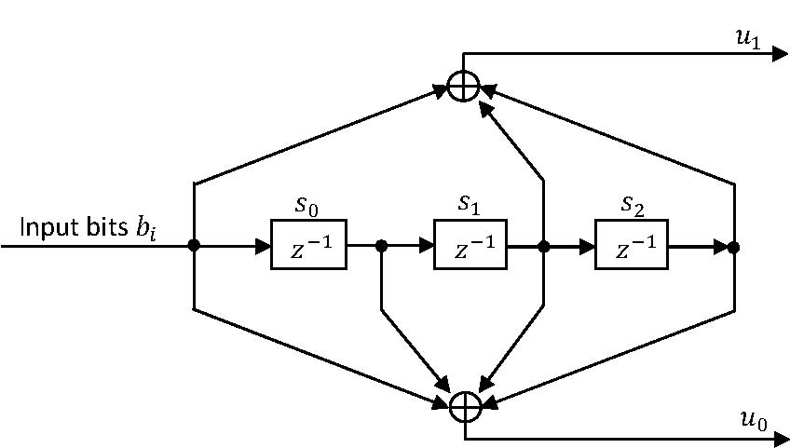

Figure y.2: The non-recursive non-systematic convolutional (NRNSC) encoder
For an input sequence of bits {b0, b1, b2… bj…}, j = 0, 1, 2…L-1, the output sequence of code-bits shall be generated according to Equation (x.3):
$\prod{}\left\{ u_{0}^{0},u_{0}^{1}, … u_{k}^{0}, u_{k}^{1}, u_{k+1}^{0}, u_{k+1}^{1}, u_{k+2}^{0}, u_{k+2}^{1}, … u_{2⋅L−1}^{} \right\} = \left\{π_{0}, π_{1},π_{2}, …,π_{D−1}\right\}$ (x.3)
, where
$D=2⋅L$ (x.4)
L is the size in bits of data block to be coded and is obtained by summing bit-length of PHR and PSDU, with CRC included in the PSDU.
Prior to encoding, the (PSDU+PHR) data block shall be extended by appending a termination sequence of bits (so-called tail bits) as shown in Figure y.3, in order to return the encoder to the zero state.
PSDU
Tail bits
PHR

Figure y.3: (PHR+PSDU) data block extension prior to convolutional coding.

The value of tail bits are coding scheme dependent and shall be set as shown in Table z.1.
Table Z.1: Tail bit pattern for the RSC and NRNSC encoder

Memory state  (S0-S2) | Tails bits
Memory state  (S0-S2) | RSC  (T0 T1 T2 T3) | NRNSC  (T0 T1 T2)
000 | 000 | 000
100 | 100 | 000
010 | 110 | 000
110 | 010 | 000
001 | 111 | 000
101 | 011 | 000
011 | 001 | 000
111 | 101 | 000

Code-bit interleaving

When interleaving is enabled, the output sequence of the encoder, generated according to Equation (x.3), shall be passed to the interleaver as follows: The first sample, i.e.,$π_{0}$, shall be passed to the interleaver first in time, and the last sample, i.e., $π_{D−1}$, shall be passed to the interleaver last in time.
M = 8
M = 8
START
Ω = 4

Ω = 4
WRITE
START
READ

Figure y.4: Interleaver

When interleaving is enabled, it is necessary to fill up the last interleaver buffer so that a full interleaver block can be transmitted. Here, prior to encoding, the (PHR+PSDU) data bits shall be expended by appending one of the bit terminations described in Figure y.5a and Figure y.5b, as a function of the (PHR + PSDU) length in octets, M.

PSDU
Tail bits
PHR
Stuffing bits
01011

Figure y.5a: (PHR+PSDU) extension prior to encoding, when interleaving is enabled; (PHR + PSDU) length, M, in octets is odd (i.e., M = 2k+1, k=0, 1, 2 …).
PSDU
Tail bits
PHR
Stuffing bits:
01011 00001011

Figure y.5b: (PHR+PSDU) extension prior to encoding, when interleaving is enabled; (PHR + PSDU) length, M, in octets is even (i.e., M = 2k, k = 0, 1, 2 …).

PIB Attributes
Insert the following text in Table 31 (PHY PIB attributes), Sub-clause 6.4.2:
Attribute | Identifier | Type | Range | Description
phyFSKFECScheme |  | Integer | 0 = NRNSC coding  1 = RSC coding
phyFSKFECInterleaving |  | Integer | 0 = Disabled  1 = Enabled

