IEEE P802.15
Wireless Personal Area Networks

Project | IEEE P802.15 Working Group for Wireless Personal Area Networks (WPANs)
Title | Candidates text for unified FEC for multi regional FSK (MR-FSK)
Date Submitted | [16 March 2010]
Source | [Hiroshi Harada , Ryuhei Funada]  [NICT]  [Hartman Van Wyk , Daniel Popa]  [Itron] | Voice: [ ]  Fax: [ ]  E-mail:  [harada@nict.go.jp]  [Hartman.VanWyk@itron.com]
Re:
Abstract | Candidate text regarding unified proposal of FEC schemes for 802.15.4g standard that has been presented as 15-10-0139-00-004g
Purpose | Draft text contribution
Notice | This document has been prepared to assist the IEEE P802.15. It is offered as a basis for discussion and is not binding on the contributing individual(s) or organization(s). The material in this document is subject to change in form and content after further study. The contributor(s) reserve(s) the right to add, amend or withdraw material contained herein.
Release | The contributor acknowledges and accepts that this contribution becomes the property of IEEE and may be made publicly available by P802.15.

FEC for multi regional FSK
The PHR and PHY payload with 4 tail bits appended may be encoded with the FEC encoder, and then interleaved. This is shown in Figure 1.
The following sections provide detailed specifications of the FEC encoder and interleaver.
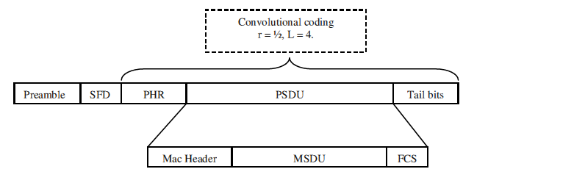

Figure 1: Frame format

- FEC encoder
Convolutional encoding is an optional feature that allows devices to extend the transmission range. Two types of convolutional encoder may be applied based on receiver capability: systematic or non-systematic convolutional encoder. Since devices can decode the receiving encoded data without convolutional (Viterbi) decoder and can support broadcasting to both devices with FEC and without FEC, the systematic encoder is used to achieve flexible receiver configuration or a choice of flexible decoding methods corresponding to different transmission range. The non-systematic convolutional encoder is used to realize unique receiver configuration. PHR and payload data with 4 tail bits appended may be encoded with either systematic convolutional encoder of code rate 1/2 or non-systematic convolutional encoder of code rate 1/2. Either convolutional encoder shall be applied by using PIB. The PIB that indicates non-systematic or systematic convolution code may be exchanged between devices or may be implemented in the devices in advance if the PIB is not exchange between devices.

- Systematic convolutional encoder
The convolutional encoder shall use constraint length K = 4, delay memory 3, connection vectors g₀ = {1,1,1,1} and g₁ ={1,0,1,1}, of mother code rate 1/2, and the feedback connection vector shall be set to be g₀ as shown in Figure 2. In the encoder, the tail bits T₀–T₃ shall be appended according to the delay memory values S₀-S₂ in Table 1 in order to return the encoder to the zero state the end of every payload, i.e., PHR and payload appending tail bits.
- Non-systematic convolutional encoder
The convolutional encoder shall use constraint length K = 4, delay memory 3 with connection vectors g₀ = {1,1,1,1} and g₁ ={1,0,1,1}, of mother code rate 1/2. A detailed schematic diagram of the non-systematic convolutional encoder is shown in Figure 3. The bit denoted as “u₀” shall be output from the encoder before the bit denoted as “u₁”. For the non-systematic convolutional encoder, 4 “zero” tail bits shall be appended. The initial value of the delay memory shall be zero at the beginning of every header.

Figure 2: A possible implementation of the Systematic convolutional encoder

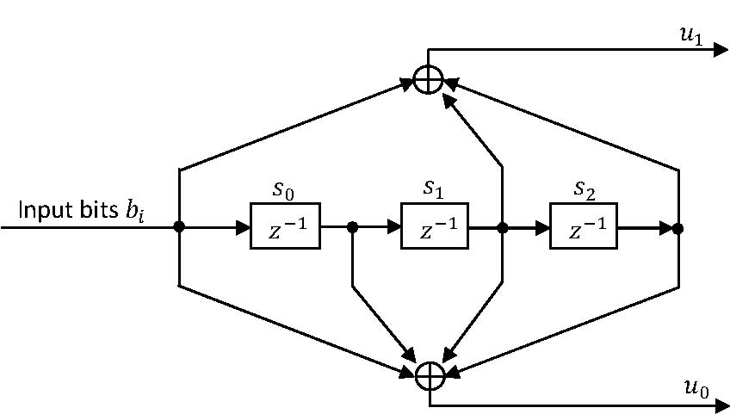

Figure 3: A possible implementation of the non-systematic convolutional Encoder

Table 1: Tail bit pattern for the systematic convolutional Encoder

S0-S2 | T0-T3
000 | 0000
100 | 1000
010 | 1100
110 | 0100
001 | 1110
101 | 0110
011 | 0010
111 | 1010

- Interleaver
All data bits encoded with either convolutional encoder may be interleaved with write/read buffers. Figure 4 shows the interleaver in which write/read buffers are represented as 4x4 matrices, where each cell of the matrix has a size of 2 bits (i.e., one encoded output symbol). To fill up the interleaver buffer, some additional stuffing bits for the last block of data shall be appended. To use interleaver or not shall be applied by using PIB. The PIB may be exchanged between devices or may be implemented in the devices in advance if the PIB is not exchange between devices
From encoder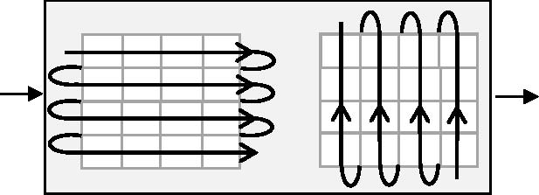To modulator

Figure 4: A possible implementation of interleaver

